INTERNATIONAL TELECOMMUNICATION UNION |  |  |  | Focus Group On IPTV
TELECOMMUNICATION  STANDARDIZATION SECTOR  STUDY PERIOD 2005-2008 |  |  | FG IPTV-C-0951
 |  |  | English only
WG(s): 2 |  | 6th FG IPTV meeting:  Tokyo, Japan, 15-19 October 2007
CONTRIBUTION
Source: | Pixelmetrix Corporation
Title: | Suggested changes to FG IPTV-DOC-0121 “Performance Monitoring for IPTV”
Introduction: Suggested additions to the output document FG IPTV-DOC-0121 – “Performance monitoring for IPTV”.

Proposal to change section 7.4.3.1 with the following:

7.4.3.1 IGMP internal processing delay

IGMP internal processing delay represents the amount of time elapsed between the first packet of the IGMP leave request arrives at the source making the decision (i.e. A router) till the time it starts forwarding the first media packets for the requested content.

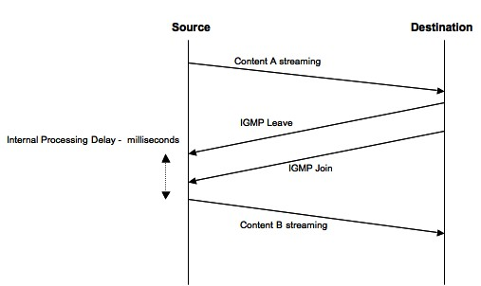
Figure 1: IGMP Internal Processing Delay

It is measured in milliseconds (ms).

Proposal to add 7.4.3.4 subsection: Network Latency in Channel zap
Network latency in Channel zap can be defined as sum of:
- Time elapsed between the ‘IGMP Leave’ is sent by the destination (STB) till the time the request arrives the Source (i.e. A router). Represented in the figure as ‘A”, measured in milliseconds
- Time elapsed between the first media packet of requested channel leaving the source till the time it arrives at the destination (i.e. STB). Represented in the figure as ‘B’, measured in milliseconds

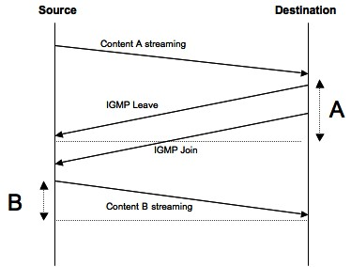
Figure 2: Network Latency in Channel zap

Proposal 3: Proposal to change section 7.5.4 with the following:

7.5.4 Ancillary channel associated attributes

7.5.4.1 Subtitles
Subtitles can be defined as textual versions of the dialog in films and television programs, usually displayed at the bottom of the screen. Subtitling information is commonly passed as metadata to the program content.
The parameters to be monitored for subtitling are:
- Language: The language of subtitling.
- Extension: Subtitles can be created as files with multiple extensions (i.e. aqt, jss etc.). Each extension has multiple properties associated to it:
- Type: Type of Subtitle: passed as mainly Text-based, HTML based or XML information
- Timing Precision: How accurate is the timing precision of the inserted subtitles. The metric is milliseconds. Timing precision is also dependent on bit stream and frame encoding.

Proposal to remove section 7.5.4.2 Closed captions: Is the American term for closed subtitles specifically intended for people who are deaf and hard-of-hearing. Closed subtitle is set of separate instructions, usually a marked-up text with timestamp information sent along the program content.

7.5.4.3 Descriptive Audio

7.5.4.4 Conditional access/scrambling considerations
The MPEG-2 transport stream packet contains the MPEG-2 payload along with the header information. This section assumes the transport stream is in the clear and the conditional access section can be accessed.
The parameters that need to be monitored are part of the conditional access section of the MPEG-2 payload.
The monitoring sub-system must be able to decode the conditional access tables in the MPEG-2 transport stream. The Presence/ Absence of the conditional access can also be derived from the table decode of the MPEG-2 Transport stream.
Multiple proprietary flavours of conditional access are available, each applying the encryption services at different layers of the protocol stack.

Proposal to replace Section 7.6.1 with the following
Content on Demand (VOD/KOD) request performance
Similar to channel zap time the performance of on-demand content can be measured as the time elapsed between the user pressing the remote control button to request content till the time the video first leaves on the screen.
Multiple factors contribute towards the request performance of content on demand, comprising but not limited to
- RTSP Signalling latency
- Middleware response time – Including payment gateway processing duration
- Buffering Delay by Receiver
- Internal processing delay of Streaming Server

_____________

