INTERNATIONAL TELECOMMUNICATION UNION |  |  |  | Focus Group On IPTV
TELECOMMUNICATION  STANDARDIZATION SECTOR  STUDY PERIOD 2005-2008 |  |  | FG IPTV-C-0941
 |  |  | English only
WG(s): 2 |  | 6th FG IPTV meeting  Tokyo, Japan, 15-19 October 2007
CONTRIBUTION
Source: | NTT Corporation, NEC Corporation, Sumitomo Electric
Title: | Comments on the latest Working Document DOC-0118 “ Quality of Experience Requirements for IPTV”
Abstract
This contribution provides comments on the latest working document DOC-0118 “Quality of Experience Requirements for IPTV” with some proposed resolutions.

1. Introduction
The source companies jointly reviewed the latest working document DOC-0118 “Quality of Experience Requirements for IPTV” to brush it up as an Output Document towards the completion of FG-IPTV period. The following section provides comments with some proposed resolutions.
The reviewing activities have been motivated by IPTV Working Group, TTC (the Telecommunication Technology Committee) in Japan and the source companies have voluntarily participated in this effort.

2. Comments with some Resolutions
The followings are comments raised though the review activities on DOC-0118.
(1) In section 3 “Definitions”, the word of VCR is used in the definition of VOD Trick Modes, but this word is not be defined in the section 4 “abbreviations and acronyms” .
It is proposed adding the sentence in the section 4.
Proposed sentence:
VCR Video Cassette Recording

(2) In section 4 “Abbreviations and acronyms”, it is proposed that the following sentences should be modified: underline below “International Telecommunication Union” should be removed if these underlines have no the specific meanings.
Original sentence:
ITU-R International Telecommunication Union Radiocommunication Sector
ITU-T International Telecommunication Union Telecommunication Standardization Sector
Proposed revision:
ITU-R International Telecommunication Union Radiocommunication Sector
ITU-T International Telecommunication Union Telecommunication Standardization Sector

(3) In section 6 “Introduction to QoE”, the sentence of “The following text is taken from [DSL TR-126]:” should be removed or give a comment as “Editor’s note”.
Proposed revision:
Editor’s note: The following text is taken from [DSL TR-126]:

(4) The sentences after the second paragraphs from a bottom of P.21 of the original document are related not only to the High Definition TV (the section 7.2.3). If it is correct, the sentences after the second paragraphs from a bottom of P.21 should be changed to the new section 7.3.

(5) Description about short duration on the Severe error limits for SD and HDTV services of P.24, "less than 10 seconds", are lack of the reason. If there is not clear grounds to be able to be described, the output document should avoid explicit numerical value expression.

(6) In section 9.1 “QoE requirements for channel zapping time”, the figure 9-1 shows the sequence of channel zapping process for description of three components of channel zapping time. However, this is such as one of the framework, and there can be other multicast points than that shown in figure 9-1. To make clearly the figure, it is proposed to replace the title of figure 9-1 to “An example of Channel Zapping Process”.
In addition, it should be defined that "IGMP processing delay" is the time when receive the first picture packet after starting a demand in STB side. It is proposed to move the description of “IGMP Internal Processing Delay” to the STB side and remove the word of “Internal” to “IGMP Processing Delay”.

Original figure:
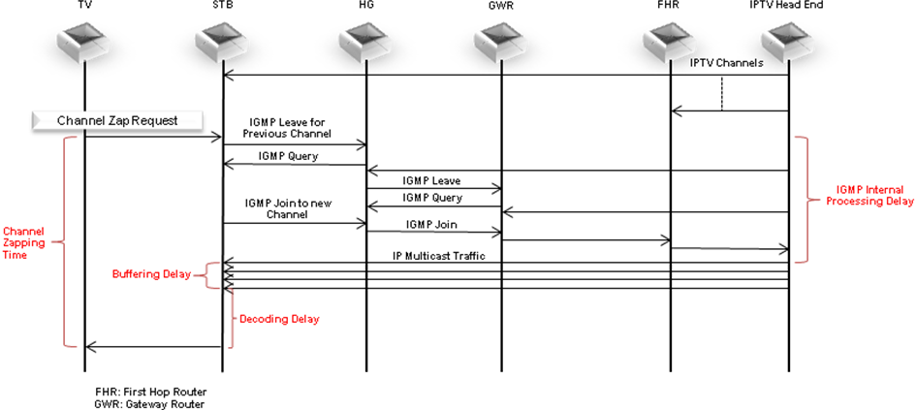
Figure 9-1: Overall Channel Zapping Process

Proposed figure:

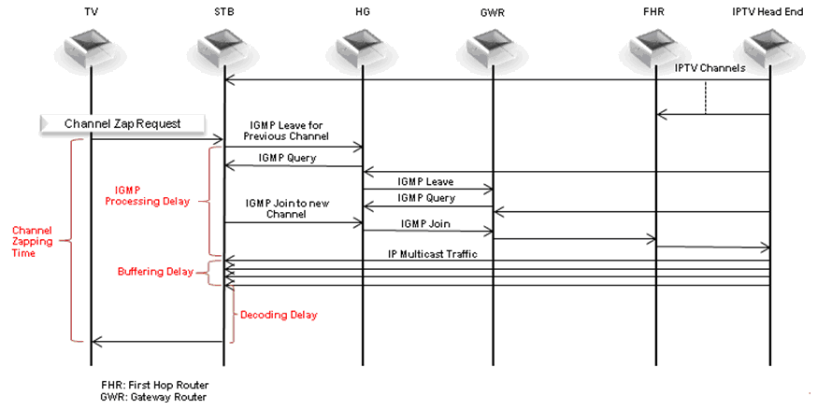
Figure 9-1: An example of Channel Zapping Process

(7) It is proposed that these sentences of section 10.1, 10.2, 10.3 should be replaced with the following.
Original sentence:
10.1 QoE requirements for EPG
The following items is recommended to be considered as part of the definition of QoE for IPTV.
Proposed revision:
10.1 QoE requirements for EPG
The following items are recommended to be considered as part of the definition of QoE for IPTV.

Original sentence:
10.2 QoE requirements for Metadata
The following points is recommended to be considered as important factors for QoE.
Proposed revision:
10.2 QoE requirements for Metadata
The following points are recommended to be considered as important factors for QoE.

Original sentence:
10.3 QoE requirements for Browser
If a browser, such as those for BML or HTML, is used to provide the user an interactive content from the service provider, the following points is recommended to be taken into account.
Proposed revision:
10.3 QoE requirements for Browser
If a browser, such as those for BML or HTML, is used to provide the user an interactive content from the service provider, the following points are recommended to be taken into account.

(8) In section 10.2 “QoE requirements for Metadata”, the figure 10-1 Television Service Quality was not related to the content of “Correctness”. It is proposed modify the figure 10-1 and remove the figure to under the title of section 10.2
Proposed revision:
10.2 QoE requirements for Metadata
The figure 10-1 constitutes the component of Metadata. The following points are recommended to be considered as important factors for QoE.
Metadata
Subtitles

EPG

Parental control

Figure 10-1: Component of Metadata

(1) Availability
High availability is recommended to be ensured in transmitting the metadata on network.
(2) Data size
Metadata is recommended to be transported in such a way that the size of the transported data would be sufficiently small, relative to such factors as the number of the total services, the number of the contents, and network bandwidth.
(3) Correctness
The service provider should ensure the metadata tagged to a particular content is correct.
An example to illustrate the importance of metadata is the correctness of “rating” of content. The correct rating on content is directly related to what the customer expects. An incorrect parental rating e.g. a “family” rating for an adult movie can have serious implications for the customer experience and business of the service provider.

(9) In the section 12 “Service support”, the following sentence was not clarified. It is proposed that if there are no proposals to descript the concept of “Interactive support”, the sentence should be removed.
“The proposal is also to introduce the concept of “Interactive support” utilizing the always-on two-way nature of IP networks.”
Original sentence:
- Accessibility
Customers want multiple and easy methods to access support. The proposal is also to introduce the concept of “Interactive support” utilizing the always-on two-way nature of IP networks.

Proposed sentence:
- Accessibility
Customers want multiple and easy methods to access support.

(10) The following list of words should be replaced in the DOC-0118.
a) To replace the word of “set top box” to “Set-top box”
b) To replace the word of “VOD” to “VoD”

3. Summary
It is proposed to consider and resolve the comments presented in section 2 of this contribution.

_____________

