INTERNATIONAL TELECOMMUNICATION UNION |  |  |  | Focus Group On IPTV
TELECOMMUNICATION  STANDARDIZATION SECTOR  STUDY PERIOD 2005-2008 |  |  | FG IPTV-C-0893
 |  |  | English only
WG(s): 5 |  | 6th FG IPTV meeting:  Tokyo, Japan, 15-19 October 2007
CONTRIBUTION
Source: | China Telecom
Title: | Proposal on the NW-TD Interface of IPTV TD Architecture

1 Introduction

In the output document of WG5 at last meeting, a terminal functional architecture was presented. And the interface between the network side and terminal are represented by two lines which are both named with “NW-TD”. In this contribution, we make an introduction and a clarification about this interface.

2 Discussions

The Working Document: Aspect of IPTV End System – Terminal Device presents a functional architecture of end system as below.

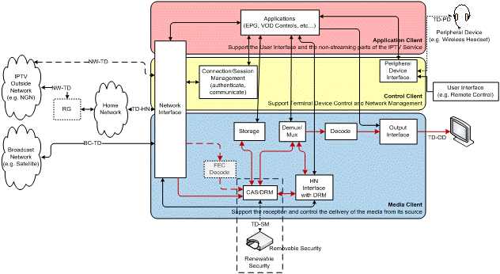
NW-TD1
NW-TD2

The NW-TD interface is a virtual interface between terminal device and the network. And it is represented by two lines which are marked with NW-TD1 and NW-TD2 in the diagram.

NW-TD1 is Bridge mode that the IPTV terminal connects to the IPTV-specified network provider via the RG. Then the network side should maintain two logical connections (PVC), one for IPTV and another for other services. At the end system side, the IPTV connection is maintained by IPTV terminal device, and the other connection is maintained by other device, such as RG itself.

NW-TD2 is NAT mode that RG has only one connection to the network provider, and the IPTV terminal device shares the connection with other HN devices. And the connection is maintained by RG.

The Bridge mode could provide better quality for the IPTV service since the other services would not cause much influence to the transport of IPTV service data. And the NAT mode is simple to IPTV TD since it needs no network access configuration when transferred to other home network.

3 Proposals

It is proposed to add the description text about the NW-TD text into working document for information.

