Background
INTERNATIONAL TELECOMMUNICATION UNION |  |  |  | Focus Group On IPTV
TELECOMMUNICATION  STANDARDIZATION SECTOR  STUDY PERIOD 2006-2008 |  |  | FG IPTV-C-0866
 |  |  | English only
WG(s): 6 |  | 6th FG IPTV meeting:  Tokyo, Japan, 15-19 October 2007
CONTRIBUTION
Source: | China Netcom Group, P.R.China
Title: | Proposal changes to sub-clauses 5.2.1 of FG IPTV-DOC-0129ex0097
At the last meeting, the “FG IPTV-DOC-0129ex0097 (23-31 July 2007), working document: IPTV Middleware” sub-clauses 5.2.1 appears “Editor Note: we should also take into consideration existing ITU middleware architectures and harmonize with other IPTV middleware architecture (see J.200).” and the “Note: the generic diagram should be inline with the WG1’s”.This contribution provide a architecture harmonizing with the architecture of WG1 and J.200.
Furthermore, this contribution proposes supplement text for sub-clauses 5.2.1 of “FG IPTV-DOC-0129ex0097 (23-31 July 2007), working document: IPTV Middleware” in order to accomplish the document and improve its quality.
IPTV architecture defined by FG IPTV WG1 introduces four domain aspects, as shown and described Figure 1 below, to support IPTV architecture.

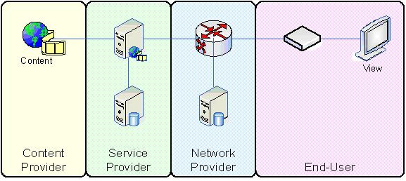
Figure 1: Basic IPTV Service and IPTV Domains

- Content Provider: The entity that owns content or is licensed to sell content or content assets.
- Service Provider: The entity that provides the IPTV Service to end user. Typically, the Service Provider acquires or licenses content from Content Providers and packages this into a service that is sold to end user.
- Network Provider: The entity providing that connects the Customers and the Service Providers. The Service Provider and the Network Provider could be the same entity.
- End-user: The entity that consumes and pays for the IPTV Service.

According to the architecture of WG1 and J.200, a generic middleware architecture is presented as figure 2:
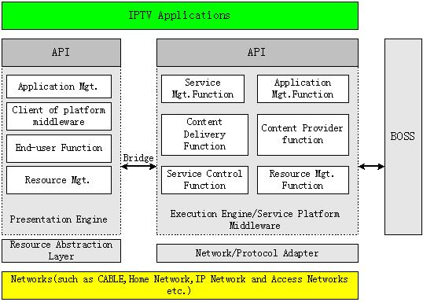
Figure 2 IPTV generic architecture

Proposal
It is proposed that Figure 1 of FG IPTV-DOC-0129ex0097 should be replaced by the above Figure 2 and the following supplement text should be added into sub-clauses 5.2.1 of FG IPTV-DOC-0129ex0097.

ITU-T J.200 recommendation describes common middleware architecture: an Execution Engine (EE), a Presentation Engine (PE) and a Bridge that connects the two engines. As depicted by Figure 2, the IPTV middleware architecture proposed here could seamlessly fit this scope. Here,the Execution Engine can be service platform middleware(figure 1/DOC-0129), and Presentation Engine here extended the function of PE/J.200. And proper Bridges are used to link Presentation Engine and Execution Engine.So, Figure 2 here is an IPTV generic architecture, it can be suitable for IPTV terminal and services of IPTV networks.
- Network/Protocol Adapter
Network/Protocol adapter is mainly to shield each kind of network and resources in the lower layer, and provides the transparent interfaces for upper layer.
- IPTV Execution Engine/Service platform middleware
IPTV Execution Engine include APIs and Service Mgt. Function, Application Mgt. Function, Content Delivery Function, Service/Application Provision function, Service Profile, Service Control Function and Resource Mgt. Function. It invokes the lower layer network interfaces to control service network resources, and provide application functions (APIs) for upper layer. At the same time, it also can integrate quickly other systems, such as BOSS. It includes the following functional module:
- Service/Application Management Functions, functional modules as defined in IPTV functional architecture. They include functions of Subscriber Management System (SMS),Services/Application Lifecycle monitor&management , etc, referring to IPTV DOC-0115 for detailed description.
- Content Delivery Functions, a functional module as defined in IPTV functional architecture. This function can be referred as CDN, including functions of content distributions, content storage, content streaming, and etc, refering to IPTV DOC-0115 for detailed description.
- Content Provider Functions, a functional module as defined in IPTV functional architecture. This function includes functions of content process, content encoding, content injection, and etc, referring to IPTV DOC-0115 for detailed description.
- Service Control Functions. This function includes functions of Service Navigation System, and etc, referring to IPTV DOC-0115 for detailed description.
- Resource Management Function, a functional module to manage system resource in IPTV terminals and servers. This function is in addition to the functional module as defined in IPTV functional architecture.
- Application Management Function, a functional module to manage the life cycle of the application and interaction operation between applications. This function is in addition to the functional module as defined in IPTV functional architecture.
- IPTV Applications
Application layer is the layer where operators and 3rd parties provide services and applications. These services and applications includes Service Navigation Application; VoD, Live TV, PVR, games, Internet application as well as other value-added services and so on.
- Interact with other systems
Because BOSS is already existent systems, and operators need it to realize Billing/accounting.
- IPTV Presentation Engine
The IPTV Presentation Engine here is more then PE/J.200,it is a part of generic architecture and compliance with “5.3.1 Generic Terminal Middleware Architecture of FG IPTV-DOC-0129ex0097”, and interaction with Execution Engine/service platform middleware through proper Bridges. The IPTV Presentation Engine includes the following functional module:
- Application Management, a functional module to manage the life cycle of the application and interaction operation between applications. This function is in addition to the functional module as defined in IPTV functional architecture.
- Client of platform middleware residing in an IPTV server on the network side.
- End-user Function, which can be inherited from IPTV terminal middleware and now become a part of IPTV middleware platform, reference to IPTV DOC-0115 for detailed description.
- Resource Management, a functional module to manage system resource in IPTV terminals and servers. This function is in addition to the functional module as defined in IPTV functional architecture.

___________________

