INTERNATIONAL TELECOMMUNICATION UNION |  |  |  | Focus Group On IPTV
TELECOMMUNICATION  STANDARDIZATION SECTOR  STUDY PERIOD 2005-2008 |  |  | FG IPTV-C-0816
 |  |  | English only
WG(s): 1 |  | 5th FG IPTV meeting:  Geneva, 23-31 July 2007
CONTRIBUTION
Source: | Korea (Republic of)
Title: | Proposal for physical configuration of IPTV architecture
1. Discussions

The IPTV architecture document (FG IPTV-DOC-0084) describes the IPTV functional architecture including a basic description of IPTV roles, services and a high level functional model. Most of parts in this document describe functions for end-user, application/service control and present the relevant architecture. However, from the current high-level architecture, it is difficult to understand the overall operation of content creation, control and delivery in IPTV domains of the real world that consist of content provider, service provider, network provider and end user.

In the case of ATIS, the document for high level architecture on IPTV provides a high level architectural framework for end-to-end systems’ implementation and interoperability for the supporting network design. The last part (i.e., Section 10) of this document includes the relevant descriptions and figures on the IPTV physical network.

In addition to the logical architecture, it is required to consider the physical configuration in the architecture document of WG1. Accordingly, we hope to include the physical configuration for IPTV service architecture. From the physical configuration, we can easily understand the flow procedure of content delivery in the network.

This contribution provides the physical configuration of IPV architecture in the content delivery perspective. So, we would like to discuss the proposed texts in the following page.

2. Proposal
After discussion at the WG1 meeting, we would like to insert the proposed texts on physical configuration of IPTV architecture in the new Section 9 of current IPTV architecture document.
______________________________
9. Physical configuration of IPTV architecture
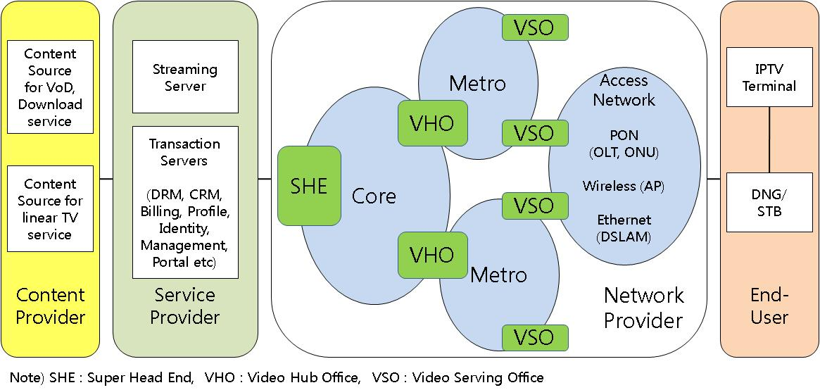
Figure 9-1. Physical configuration of IPTV architecture

Figure 9-1 provides the physical configuration of IPTV architecture. This figure includes a network hierarchy as media and control flows from the content provider to the end-user.
Content provider has two types of content source; content source off-line for on-demand service and content source off-air for linear/broadcast TV.
Service provider has streaming server and transaction servers. Transaction servers of the service provider are composed of servers for DRM, CRM, billing, profile management, identity management, web or IPTV portal etc.
In network provider domain, there are three types of network nodes;
- Super Head End (SHE) - the locations for acquisition and aggregation of region-independent (national-level) linear/broadcast TV programming. SHEs are also the central point of on-demand content insertion.
- Video Hub Office (VHO) - the video distribution points within a demographic market area National content is received from each SHE. Local content is acquired and encoded. Insertion of local content is also performed in the VHO. IPTV services are provided from the VHO via the aggregation/access network.
- Video Serving Office (VSO) – the VSO (typically a Central Office) hosts or connects all access systems for interconnection to consumers. In addition, the VSO contains aggregation equipment to enable efficient and reliable interconnection to the VHO.
Various access networks may provide PON, wireless, Ethernet interfaces to delivery IPTV content to the residential subscriber.
End user is composed of IPTV terminal and DNG/STB. DNG provides traffic management and routing between the access network and the home network.
______________________________

