INTERNATIONAL TELECOMMUNICATION UNION |  |  |  | Focus Group On IPTV
TELECOMMUNICATION  STANDARDIZATION SECTOR  STUDY PERIOD 2005-2008 |  |  | FG IPTV-C-0806
 |  |  | English only
WG(s): 4 |  | 5th FG IPTV meeting:  Geneva, 23 – 31 July 2007
CONTRIBUTION
Source: | Korea (Republic of)
Title: | Overlay multicast scheme for Internet streaming service (FYI)
DISCUSSION

Recently the public broadcasting activity is no longer assumed as a monopoly of TV stations. Because with the development of end-user’s equipment, a user can create her own contents and distribute them through Internet; UCC (User-Created Contents) is one of good examples of the change of Internet broadcasting service or Internet streaming service.
The ways of supporting Internet streaming service can be various; one server may store contents and then sends them to multiple receivers like VoD(Video on Demand) service; or a sender sends the contents to multiple users simultaneously like live broadcasting. Among the possible delivery scenarios, we focus the case when a user is to streaming contents to large number of receivers simultaneously.
The best efficient mechanism to support Internet streaming service to large number of receiver at a same time will be pure IP multicast mechanism; because multicast mechanism can efficiently utilizes the resource of network’s as well as of server’s. But the current Internet still does not fully deploy IP multicast mechanism because of several deployment issues; cost, management, security, and so on.
With the reason, several alternative multicast schemes are being introduced such as CDN, overlay multicast and so on. In the last FGIPTV meeting, insertion of several possible multicast delivery solutions is agreed.
This contribution is to present overlay multicast scheme for Internet streaming service as FYI (For Your Information). Because ITU-T SG17 is developing a series of overlay multicast scheme for past few years and we have been verifying the possibility of overlay multicast scheme for Internet streaming service.
We have considered the possibilities of applying SG17’s overlay multicast solution to deliver IPTV contents. The intention of this document is to give clearer understanding in overlay multicast and to show the possibility of Internet streaming service with overlay multicast scheme.

CONTENTS

1. BRIEF INTRODUCTION OF SG17’S OVERLAY MULTICAST SOLUTION 3
2. IMPLEMENTATION 8
3. INTERNET STREAMING SERVICE 9
4. INTERNET STREAMING SERVICE WITH NETWORK FAULT 13
5. CONCLUSION 15

BRIEF INTRODUCTION OF SG17’S OVERLAY MULTICAST SOLUTION
For past few years ITU-T SG17 develops RMCP-2 (Relayed MultiCast Protocol – Part 2: for simple group applications) for one-to-many group services such as VoD (Video on Demand), Multimedia conference, E-learning, Bulk file dissemination, IPTV and etc.
In addition, there has been verifying RMCP-2 protocols works by implementing RMCP-2 functionalities.
RMCP-2 defines two different protocol entities; Session Manager (SM) and Multicast Agent (MA).
SM provides session initiation, admission control, session monitoring, and session termination function. The type of implementation of SM can be as a dedicated system or as a daemon process within a MA system. We are implementing RMCP-2 SM as a separate dedicated system for the simplicity. We are implementing SM on Windows application over Desktop system.
MA, which covers both SMA and RMA, provides session subscription, map discovery, tree join, tree leave, maintenance, and termination function. Currently we are implementing MA on MS Windows application simultaneously.

RMCP-2 topology
The RMCP-2 is an application-level protocol that uses multicast agents (MAs) and a session manager (SM) to support and manage a relayed multicast data transport over a unicast-based Internet. With the help of the SM, the RMCP-2 begins by constructing a relayed multicast control tree that consists of MAs. Consequently with the preconfigured control tree, each MA connects appropriate data channels with each other.
Figure 1 shows very simple service topology served by RMCP-2.

Figure 1 - RMCP-2 service topology

Session Manager (SM)
In RMCP-2, SM provides the following functionalities;
- For a new session initiation, SM creates new session and generates a session ID (SID) by session profile. We implements SM to create globally unique SID to distinguish the session according to the RMCP-2 draft.
- When SM receives subscription request message from MA, SM needs to have an admission function, authentication, neighbour list creation, data profile negotiation functions. We implemented admission, neighbour list function, except authentication and data profile negotiation. The data profile negotiation needs SM to support quality of service such as bandwidth, system capacities. So we will implement data profile negotiation function later.
- SM can also collect status information of an entire or a part of a session. In this case, the SM sends a status collected request message to the top MA of the part. Upon receiving the status collect request message, the MA should send a status answer back to the SM with appropriate information on the MA and its children. When the session size is large, the use of this mechanism for the entire session may cause overloading the network and system resources. To limit the scope of the monitoring, the status collect message should contain an option for the depth.
- The SM’s on-going session may terminate by two reasons: 1) administrative request and 2) SMA’s leave. Because a RMCP-2 session can continue only when the SMA is alive, the SMA must notify its leaving to SM. Being notified SMA’s leaving, the SM should terminate the session promptly.

Multicast Agent (MA)
In RMCP-2, each MA provides the following functionalities;
- In the beginning, MA subscribes the session by sending SUBSREQ and receiving SUBSANS to SM. Subscription message contains extended headers about authentication information and system information such as number of children it can serve, possible bandwidth, etc. Subscription function was implemented.
- To discover physical network topology, RMCP-2 provides map discovery procedure which enables each MA to learn about RMCP-2 session. Because a RMCP-2 session is a logical network in which every MA is inter-connected logically, it is difficult for MAs to learn the exact network condition. So map discovery procedures enable MA to discover and measure the RMCP-2 network. MA processes map discovery with HSOLICIT/HANNOUNCE in local network, and with PPROBREQ/PPROBANS outside over local network. This procedure was implemented to find parent MA based on neighbour list which gets from neighbour list contained SUBSANS extended message.
- Tree join is the procedure where MA tries to attach the subscribed RMCP-2 session. MA operates to send RELREQ message to PMA. In case when all of the nodes do not want to relay, the joining MA can retry to join the session. Tree join procedure is implemented.
- RMCP-2 MA may leave the session during the session. RMCP-2 considers four kinds of leave: three MA’s leaving such that SMA’s leaving, MA leaving, and MA leaving because of kick from its PMA or SM. The last is when it is to handle SMA’s session leave. When SMA leaves the current session, SM closes the session. If MA leaves, the CMAs of the MA tries to find there PMA using their neighbour list it holds. MA may be kicked out from PMA and SM because of network performance. Tree join and leave procedure was implemented.
- Maintenance procedure is tree maintenance, state monitoring, fault detection/recovery, and tree improvement. To maintain the constructed RMCP-2 tree and to monitor the current state of MA, heartbeat mechanism is used. Heartbeat contains ROOTPATH which includes a relayed data path over the tree hierarchy. If MA does not receive for a period time, MA acknowledges that the tree may be broken and it will try to find a new PMA. Status monitoring procedure is to acquire one or more specific types of status information from more than one MA. This procedure was implemented.
- MA detects network fault and recovers the session tree, for which MA provides a mechanism with ROOTPATH on HB message to detect and recover the abnormal situation. Because ROOTPATH is the path trace from SMA to itself, the duplicated hop in the ROOTPATH means loop has formed. Whenever loop has occurred, MA performs loop recovery mechanism as follows. Tree improvement is the procedure where MA tries to find more efficient PMA and then switches to the PMA. It continues the map discovery mechanism during the session to find the optimised PMA using map discovery mechanism Procedure. This function was implemented.
- SMA terminates the session to send TERMREQ message to SM. SM sends TERMANS message to SMA and closes the session. Upon receiving TERMANS from SM, SMA sends TERMREQ message to its CMAs. This is also implemented.

Internet streaming service considered in RMCP-2
This overlay multicast service scenario for Internet streaming service is extracted from the ITU-T X.603 | ISO/IEC 16512-1: RMCP-Framework.

This section explains the role of RMCP inside the group multicast services. It is chosen Internet Live TV service which could be an example of group communications service supported by RMCP.
Assume that the Internet Live TV service illustrated here consists of contents provider, web server, media server, and RMCP clients as shown in figure 9. In this scenario, a service user gets information about Internet Live TV service schedules served by contents provider via web server and starts Internet Live TV application which invokes RMCP protocol entity (RMA) to receive broadcasting stream from media server. The detailed descriptions of this service scenario will be as follows.
Figure 9 – Example scenario of Internet Live TV service using RMCP
From the sequence 1 to 2 in figure 9, a contents provider contacts with Session Manager. The contents provider asks SM to initiate the RMCP service by offering information such as media characteristics, session name, group addresses and so on. As the response of success, the SM allocates SID for each session and sends SID to the CP. SID. The contents provider announces via web server for the Internet Live TV schedule and some additional information if needed such as name of the services, group address, media characteristics and so on.
A series of procedures to prepare Internet Live TV media server is described in the sequence from 3 to 6. According to the schedule announced before, the contents provider invokes Internet Live TV Media Server which follows by Media Server's invocation of SMA. SMA starts session joining procedure with SM.
From the sequence 7 to 9, a prospective contents user's accessing sequence to the Internet Live TV service sequence is illustrated. Any prospective contents user gets information about the broadcasting schedule from web server. To use the service, the service user logs into service page, and undergoes authentication procedure. After the successful user's authentication, a series of session information necessary for the RMCP session join can be acquired from the web server.
A series of service user's local calls to invoke RMA is illustrated by the sequence from 10 to 11. After the user's invocation of Internet live TV player application with the session information acquired from contents provider, RMA is invoked.
From the sequence 12 to 13, a series of RMA's session joining sequence is illustrated. The RMA starts joining request to the SM firstly. The SM examines whether the RMA is fully qualified to join the session. If it is acceptable, the SM responses the RMA with available PMA list, otherwise the SM rejects the joining request with reasons of the failure.
From the sequence 14 to 17, a series of RMA's efforts to construct and manages multicast data delivery path are illustrated. After the joining request is successful, the RMA selects best PMA among the PMA list in aspects of the network distance, the data delivery channel cavity and so on. RMA asks the selected PMA whether it can relay data. If it can, a relayed multicast data delivery path and data channel between the RMA and PMA are established. After this stage the RMA completes joining to the session. After the data delivery path construction is finished, along the constructed relayed paths data can be delivered from media server to one or more end applications i.e. media player. After multicast data flows along the data delivery path, the SM can collect each MA's status with the purpose of monitoring the whole session status. The MA should reply according to the SM's query. To maintain the data delivery path stable RMCP should be equipped with error recovery mechanism for an unexpected error may has occurred, but the detailed mechanism is out of scope of this document.
To provide a contents user's leave from the service, the contents user's leaving from RMCP session is illustrated in the sequence from 18 to 19. When the service user wants to stop receiving Internet Live TV stream, it can leave at any time. The related RMA can finish its role according to the condition whether it acts as PMA or not. If the RMA has no CMA, it can leave the RMCP session promptly. Otherwise it tells its CMAs implicitly or explicitly of it's leaving the session and they need to find new PMA ASAP. Finally, Contents user log out from the web server.
The scope of RMCP covers from the enrolment phase to the data transfer phase defined in ITU-T Recommendation X.601, Multi-Peer Communications Framework.

IMPLEMENTATION

SM
Figure 2 shows the screen shot of SM’s main window. SM is implemented by using Visual C++ over windows XP. The SM main window shows MAID (Multicast Agent Identification), IP address, Port, SM address, status. And main windows have buttons for start, stop, refresh MAID, remove MAID and exit button.
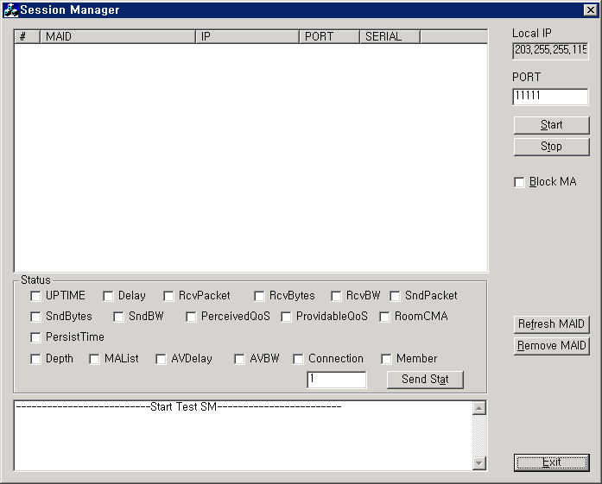
Figure 2 - SM screenshot

MA
Figure 3 shows MA window which covers both SMA (Sending MA) and RMA (Receiving MA). It is implemented on MS windows and it contains MA main window and new session window for session subscription.
MA’s main windows shows a current session status and it contains the field for session name, SID, SM address, Group address, source address, local address, connection status, start time and stop time for information.
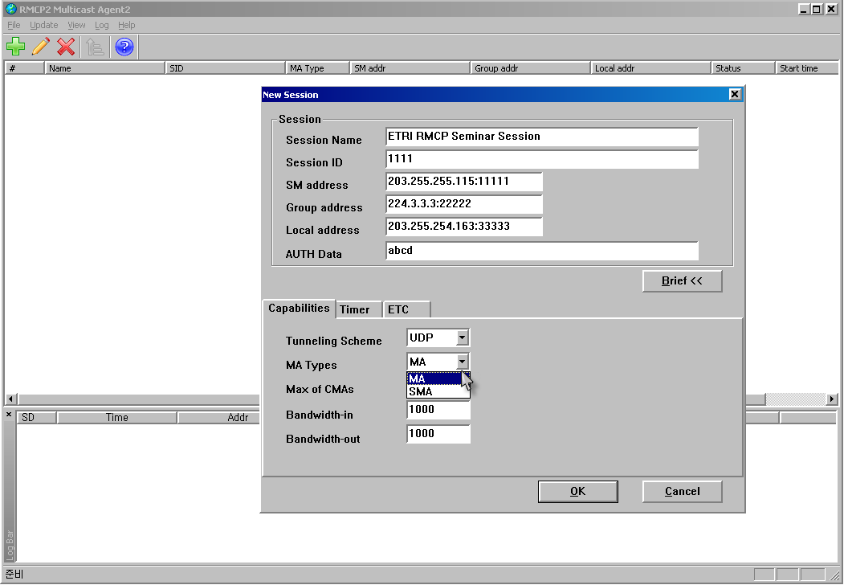
Figure 3 - MA Screenshot

A user uses new session window to subscribe a session. The new session window needs to fill in the information required for session subscription; such as session name, SID, SM address, Group address, Local address, and authentication data field. And also MA’s capacity tab has data transport scheme, node type, maximum number of CMA, and bandwidth. It will be simplified for user to need to insert manually when session directory web server is implemented later. If a new user clicks OK button, MA control module tries to subscribe the session.

INTERNET STREAMING SERVICE
This section focuses to show the usability of RMCP-2 implementation in best environment; i.e., without error and with maximum network speed.
The desktop PCs used in the test are equipped with Pentium 4 2.4Ghz, 1G RAM and 100 Mbps LAN card.

Network Topology
Multicast Agents used in this test has been developed in Microsoft window XP machine. They are designated just in three subnets of ETRI for the fault detects and recovery test as shown in Figure 4.

Figure 4 - Topology of test bed

Each Multicast Agent has GUI application to manage itself. Interface between Multicast Agent and the GUI application observes RMCP API defined in RMCP-2 document. Message trapper catches and analyzes RMCP-2 control messages in the same machine.
Session Manager also has been developed in MS Windows machine. Following test scenarios observes service scenario in RMCP framework.

DVD-quality multicast streaming test with VLC
For SMA to send the DVD multicast stream, we choose VLC media player and setup as shown in Figure 5.
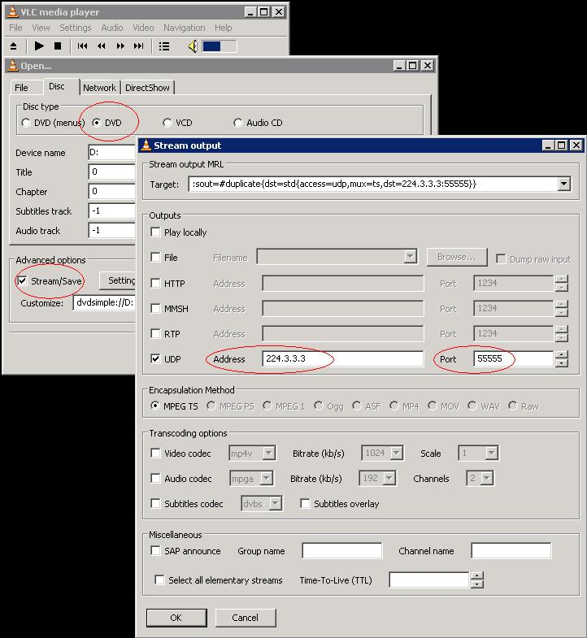
Figure 5 - Multicast stream data setup at VLC sender

For clients to receive and play the multicast stream, we also utilized VLC media player. Figure 6 shows Stream and Media Information of bitrates on receiver in network # 2.
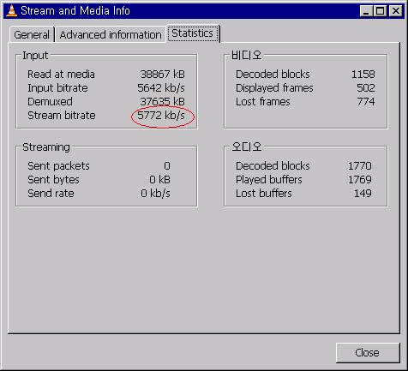
Figure 6 - Bit rate of Client in network # 2

Figure 7 shows the network traffic caused by DVD stream in network #2.
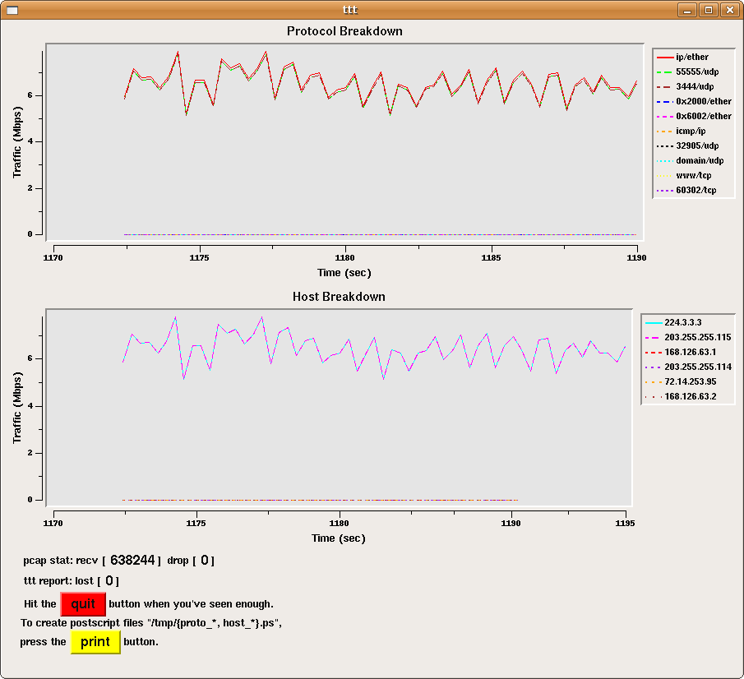
Figure 7 - Overall Traffic in network # 2

Figure 8 shows a Captured Screen Image played on network # 2

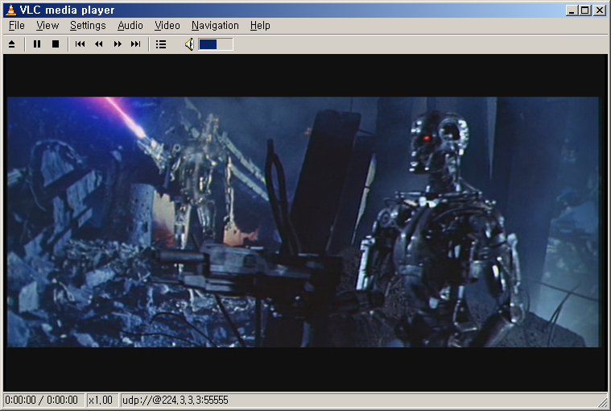
Figure 8 - Captured Screen Image of DVD by VLC in network #2

HD-quality video streaming service with RMCP-2
For server to send the HDTV multicast stream, we used VLC media player as streaming source as well as receiver. The HDTV sources are from HD VOD for Korea HDTV web site (http://hdtv.nm.gist.ac.kr/v2/main.php)
For clients to receive and play the HDTV multicast stream, we also used VLC media player.

Figure 9 shows a captured screen image played on MA in network # 1.
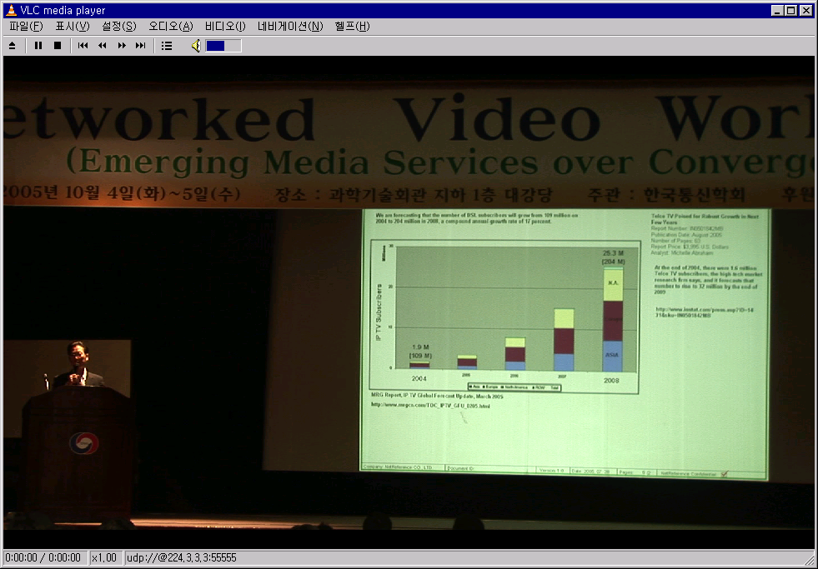
Figure 9 - Captured Screen Image of HDTV by VLC in network #1

And the Figure 10 shows stream and media iinformation on bitrates on receiver in network # 1.
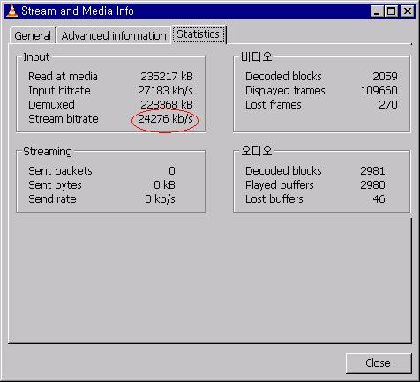
Figure 10 - Bit rate of Client in network # 1

INTERNET STREAMING SERVICE WITH NETWORK FAULT
Because overlay multicast environment is configured by normal desktop PCs, it is very difficult to have robust overlay multicast environment without network fault detection and recovery mechanism.
For testing fault recovery mechanism, we used VLC media player and disconnect network #2 cable as shown in Figure 11.

Figure 11 - Testing topology to cause network fault

Originally, the DVD stream is relayed from network #3 to network #1 (network #3 => network #1 => network #2). Although only network #1 is disconnected from its parent MA in the network #3, the network #2 cannot receive the DVD stream. In this case, the MA in network #2 should detect the link failure and recover the connection by switching to available MA. Figure 12 shows the conceptual network topology when network fault has occurred.

Figure 12 - Conceptual network topology (network fault has occurred)

Figure 13 shows that there is no traffic in network #1 and #2.
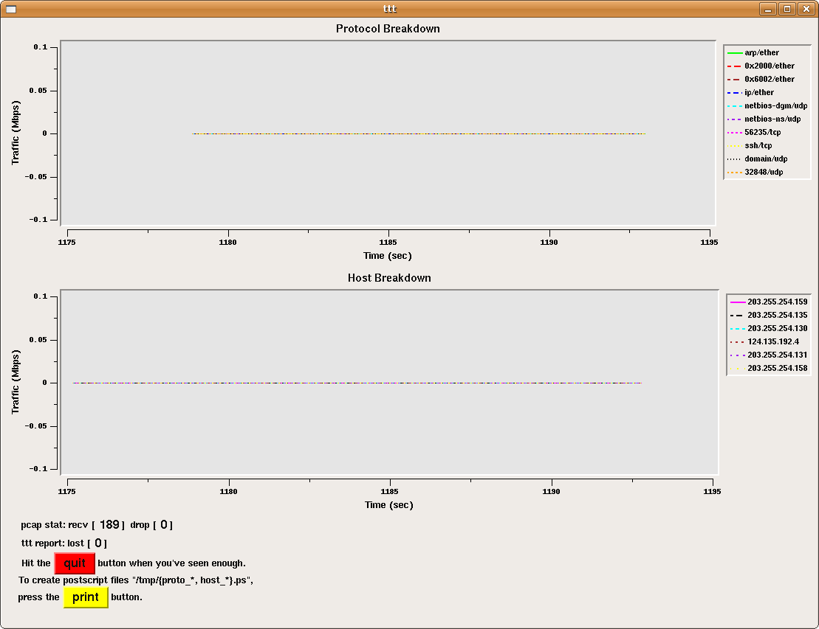
Figure 13 - Overall traffic in network # 1 and 2

Whenever an MA fails to receive the HB message for a certain time, the MA assumes that it is partitioned from the tree. The time should be set for sufficient time to allow for a network delay. A link failure can occur whenever one of the partition’s associates fails. The MA detects the source of the partitioning by contacting its associates; the MA then solves the problem. Figure 14 shows when RMCP-2 recovers network fault by changing its parent MA.

Figure 14 - Conceptual network topology (network fault has recovered)

Figure 15 shows a captured screen image played on network # 2 after finishing recovery processing.
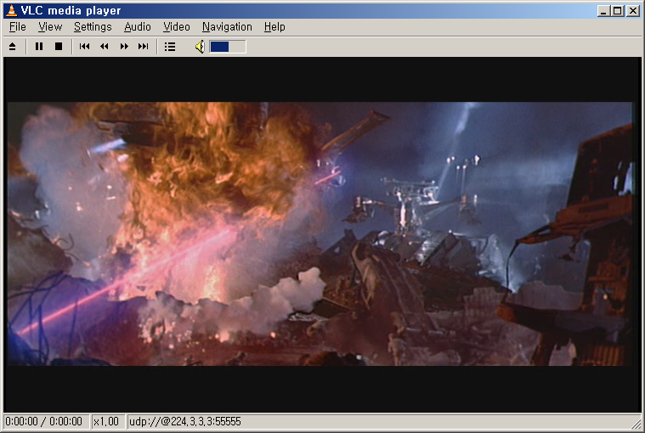
Figure 15 - Captured Screen Image of DVD by VLC in network #2

Figure 16 shows overall traffic in network # 2. This figure shows the fault recovery processing time as indicated in this Figure 16. The network fault recovery time can be adjustable from 1.5 sec to 20 sec.

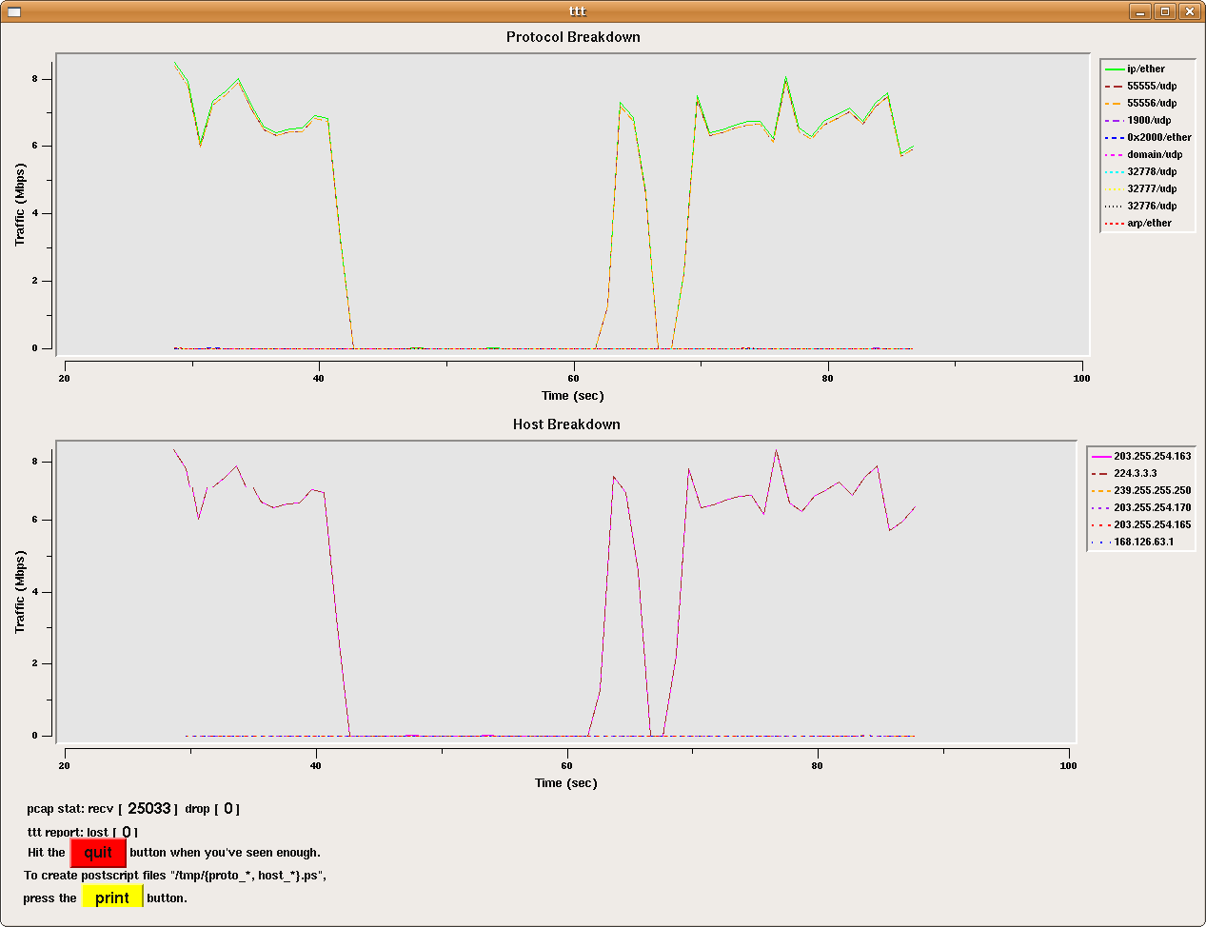
Fault Recovery Processing time

Figure 16 - Overall traffic in network # 2

CONCLUSION
By now, we presented how overlay multicast mechanism can be applied when to deliver Internet multicast streaming service. With the progress of end-user equipment’s performance, to meet the increasing requirement for personal broadcasting service, overlay multicast can be a good candidate.

_________________

