- Introduction
INTERNATIONAL TELECOMMUNICATION UNION |  |  |  | Focus Group On IPTV
TELECOMMUNICATION  STANDARDIZATION SECTOR  STUDY PERIOD 2005-2008 |  |  | FG IPTV-C-0793
 |  |  | English only
WG(s): 3 |  | 5th FG IPTV meeting  Geneva, 23-31 July 2007
CONTRIBUTION
Source: | Huawei Technologies Co., Ltd.
Title: | A Common DRM Interoperable Architecture
This contribution focuses on DRM Interoperable Architecture. Two example scenarios are given to illustrate current DRM interoperable solutions. Then a Common DRM interoperable architecture is presented. Some inner function blocks of DRM Interoperable System are suggested and discussed in details.

- Discussion
  - Background
Several important DRM interoperability elements have been proposed in the Input Document (FG IPTV-ID-0086) and included in the Working Document (FG IPTV-DOC-0090, Page 15). According to the original description, DRM interoperability scenarios are classified into at least three modes: DRM End to End (DRM-EE), DRM Bridging (DRM-B) and DRM Interchange (DRM-IX). DRM interoperability requires that DRM clients from different DRM system securely access media content and consume it according to the granted rights. As an important factor for IPTV interoperability, DRM interoperability needs an architectural view in order to cover many major DRM interoperable scenarios.

Content Protection Architecture, mentioned in the Working Document Figure 9-2, mainly focuses on the case of running one DRM system. When considering showing DRM Interoperable Architecture in the same figure, it is difficult to express interchanges between different DRM realms and inner details of DRM interoperable system.

This contribution alternatively presents a common DRM Interoperable Architecture (Fig. 3), which separates from original Content Protection Architecture. This newly added DRM interoperable architecture is based on the summary of commercial DRM interoperable systems and DRM interoperability requirements in the Working Document. Some inner blocks are discussed in details to further clarify the functionality of DRM Interoperable System.

  - Some DRM Interoperable Scenarios
    - A Typical DRM Interoperable Scenario from Coral Consortium

The following figure shows a simplified scenario for DRM Interoperability. The original scenario was published on Coral Consortium website as a Coral presentation slide [Coral Scenario].

In this simplified scenario, one customer has two end devices which support two different DRM systems. When a piece of media content is redistributed from DRM Device A to DRM Device B through local network, it is not necessary to have another purchase transaction in order to consume the media content in Device B. The Coral Interface requests a rights transfer from a Rights Mediator. Then Rights Mediator triggers Domain Validation and Right Validation processes to validate customers’ rights. After mapping rights, Rights Mediator cooperates with License Server B to create a native license in DRM Realm B. Finally, DRM Device B can acquire this native license using native mechanisms.

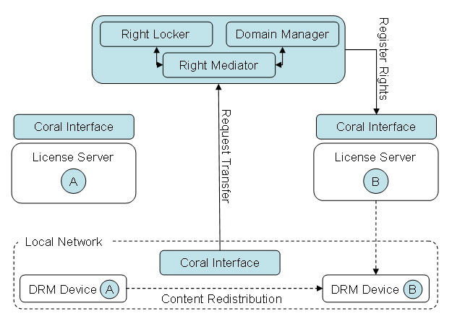
Figure 1: A Typical DRM Interoperable Scenario from Coral Consortium

    - Marlin – OMAv2 Gateway
This scenario is shown in Marlin – OMAv2 Gateway Specification [Marlin-OMAv2 Gateway]. Marlin OMAv2 Gateway represents Marlin client as an OMA DRM agent. The gateway provides a translation of OMAv2 information (such as “device, domain and license information”) to Marlin System. Through this way, Marlin client can reach OMA entities (e.g. Right Issuer) and access OMA based services.
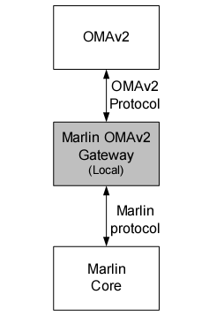
Figure 2: OMAv2 Marlin Gateway

  - A Common DRM Interoperable Architecture

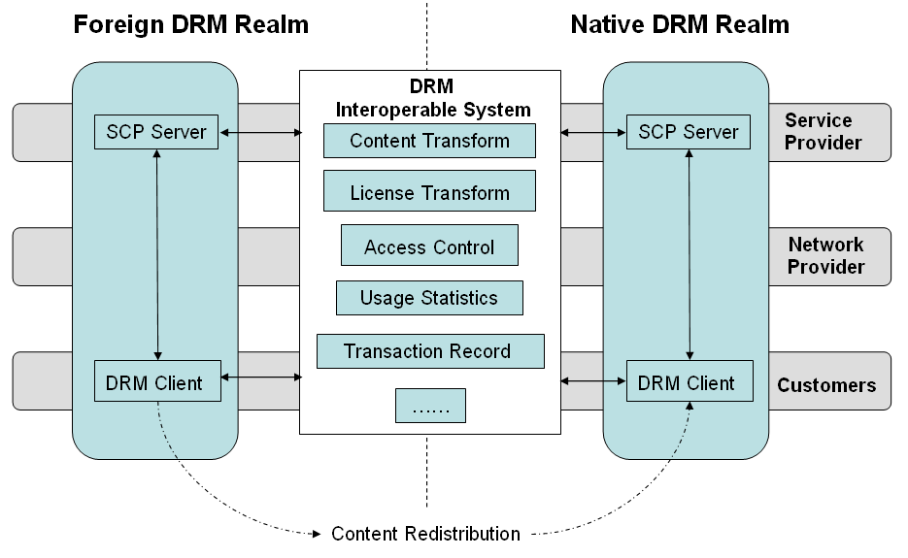
Figure 3: A Common DRM Interoperable System

Function Blocks of DRM Interoperable System:
As illustrated in Figure 3, DRM Interoperable System locates at the boundary of two DRM realms. DRM Interoperable System can bridge necessary information from different DRM realms. A DRM interoperable system may support several functions: Content Transform, License Transform, Access Control, User Statistics, Transaction Record, etc.

Content Transform: Content Transform converts media content from one format into another. If media content is encrypted and integrity-protected, these transforms may include cryptographic encryption and decryption process. Given several pre-defined encryption algorithms will facilitate these processes.

License Transform: License Transform is the most challenging part in the DRM Interoperable System. License Transform should output a native licenses based on the input of foreign licenses from other DRM realms. The new license should maintain almost same permission behaviours (media assets & consumption permission pair) as the original license defined. A set of right mapping (rights expression mapping and semantic mapping) may be included in the License Transform. Also, License Transform may be responsible for repackaging right information (such as Right Object in OMA DRMv2) and securely delivering it to native DRM clients.

Access Control: Access Control component acting as an authentication point deals with user’s requests. It is possible to create a mutual authentication between DRM Interoperable System and end user (or DRM client). Access Control component may further coordinate native or foreign DRM realms and make an association of customer logging information.

Usage Statistics: When media content is distributed to and consumed by a large scale of users, Usage Statistics component may contribute to generating statistical usage information (such as, number of times content is downloaded and typical licenses customers are willing to purchase). This statistical information can be forward to foreign DRM server and subsequently reported to foreign Service Provider and original Content Provider.

Transaction Record: Transaction Record Component may be used to register (or proxy) client payment information. This component may interact with DRM client, Access Control component and Payment component in the original DRM realm.

Other Functions: DRM Interoperable System can optionally support above requirements. Some other functions can also perform by DRM Interoperable System, such as Tracking Function, Non-repudiation Record, etc. For example, Service Provider can use Tracking function to trace content abuse and piracy in massive content distribution.

- Proposals
- We propose that WG3 may add a common DRM interoperable architecture in regard to the consideration of DRM interoperable problems. It may be helpful to orient further research in this field.
- Figure 3 in this contribution may be a reference figure for final DRM interoperable architecture.

- References
[Marlin-OMAv2 Gateway] Marlin – OMAv2 Gateway Specification, Version 1.1 Final, Marlin Engineering Workgroup, September 2006.
[Coral Scenario] A Scenario, Coral Consortium, February 2006, http://www.coral-interop.org/main/faqs/Coral.Scenario.pdf

_________________

