Context
INTERNATIONAL TELECOMMUNICATION UNION |  |  |  | Focus Group On IPTV
TELECOMMUNICATION  STANDARDIZATION SECTOR  STUDY PERIOD 2005-2008 |  |  | FG IPTV-C-0784
 |  |  | English only
WG(s): 1 |  | 5th FG IPTV meeting:  Geneva, 23-31 July 2007
CONTRIBUTION
Source: | Huawei Technologies Co., Ltd.
Title: | Proposed changes to IPTV Architecture FG IPTV-DOC-0084 Section 8.1 and 8.1.1.1
This contribution proposes changes to the working document: “IPTV Architecture” FG IPTV-DOC-0084 produced at the 4th FG meeting in May.
Discussion
These changes are to improve the alignment of the above document with the working document produced by WG5. The definition of Home Network refers to J.190 in “Aspects of Home Network supporting IPTV services” working document of WG5. It will introduce confusion that the function providing IP connectivity is defined as Home Network Function.
Proposal
Changes below are in section 8.1 and section 8.1.1.1

High Level Architecture of IPTV

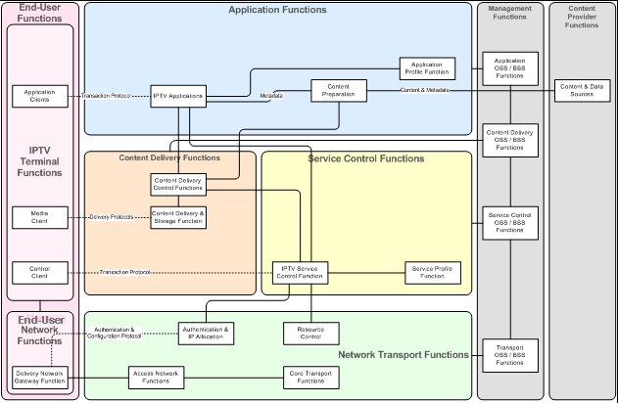
Figure 8-1 Functional Architecture for IPTV

End-User Network Functions
The functions used by the customer to provide connectivity between the IPTV Terminal Functions and the Access Network Functions.

___________

