Abstract
INTERNATIONAL TELECOMMUNICATION UNION |  |  |  | Focus Group On IPTV
TELECOMMUNICATION  STANDARDIZATION SECTOR  STUDY PERIOD 2005-2008 |  |  | FG IPTV-C-0737
 |  |  | English only
WG(s): 6 |  | 5th FG IPTV meeting:  Geneva, 23-31 July 2007
CONTRIBUTION
Source: | France Telecom (France)
Title: | Comments on DOC-0095 (WD on IPTV Middleware, Application and Content Platforms) on "Content provisioning" section
It is felt that Section 10 Content Provisioning goes really too far in showing also part of Service Provider architecture. It is proposed to focus only on "Content provisioning" and not to include elements from the service provider architecture.

Contribution
Here is the "Functional Content provisioning architecture" figure taken from DOC-0095

This figure is considered to be too detailed for the "Content provisioning" section. It contains also parts of the "Service Provider Architecture" which raises questions not relevant to this section.
As an example, here is another functional architecture, different from the previous one, but not less realistic.

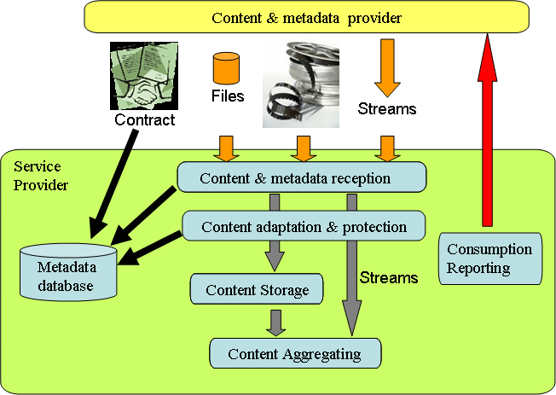
Figure 1. Same scope as the figure in the OD-0095
However, it is felt that this "content provisioning" section should contain a far more simpler figure to clarify the issue addressed here, as proposed below:

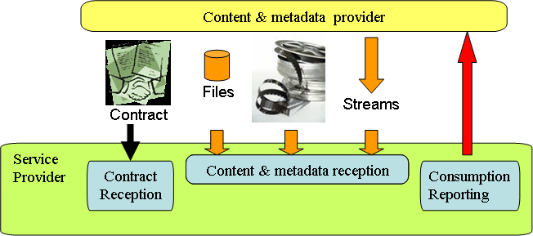
Figure 2. Interface between Content Provider & Service Provider
In line with this functional architecture, only a limited number of interfaces are identified:
- Contract exchange (not to be standardised)
- Content & metadata provisioning interface including:
  - File format for content provisioning (e.g. ISO/IEC 14496-12: ISO base media file format)
  - File format for metadata provisioning (e.g. XML file validated by metadata provisioning schema to be defined)
  - File format for combined content & metadata provisioning (e.g. ISO/IEC 14496-12: ISO base media file format)
  - Stream format for channel/content provisioning (e.g. MPEG-2 TS)
  - Stream format for combined channel/content & metadata provisioning (e.g. EN 300 468: Specification for Service Information (SI) in DVB systems, TS 102 323: Carriage and signalling of TV-Anytime information in DVB transport streams)
- Consumption reporting

Standards are needed for the Content & Metadata Provisioning interface.
The metadata elements for provisioning are recommended to be as common as possible with the metadata elements made available to the end-user, however with elements specific to the relation between Content provider" and "Service Provider" (such as distribution conditions).

_______________

