INTERNATIONAL TELECOMMUNICATION UNION |  |  |  | Focus Group On IPTV
TELECOMMUNICATION  STANDARDIZATION SECTOR  STUDY PERIOD 2005-2008 |  |  | FG IPTV-C-0717
 |  |  | English only
WG(s): 6 |  | 5th FG IPTV meeting:  Geneva, 23-31 July 2007
CONTRIBUTION
Source: | ZTE Corporation
Title: | Proposal on perfecting the Service navigation system generic architecture and functional entity
Abstract
This contribution provides proposals on the perfecting the Service navigation system generic architecture and functional entity which was expatiated in section 5 of “FG IPTV-DOC-0098 (7-11 May 2007), Working Document: Working Document: Service Navigation System” in order to enhance its correction and integrity. The main proposals are adding two interfaces to the Service Navigation System generic Architecture and correcting some spellings and grammatical errors.

Discussion
Reference
[1] FG IPTV-DOC-0091 (7-11 May 2007), Working Document: IPTV Network Control Aspects
[2] FG IPTV-DOC-0098 (7-11 May 2007), Working Document: Service Navigation System
[3] FG IPTV-DOC-0084 (7-11 May 2007), Working Document: IPTV Architecture
Proposal

Service navigation system generic architecture and functional entity
Editor’s note:
Work is needed to make it really generic

5.1 Service navigation system generic architecture

Figure 5.1: Service Navigation System generic Architecture
Interface A: An interface between Content Provision(s)/Service Provider(s) and service navigation system, through which service information, service metadata, content metadata etc. are sent to the service navigation system.
Interface B: An interface between Terminal Device (e.g. set-top box) and service navigation system, through which user login authentication request, channel/program query request, user’s VOD program query request, user information query request etc. are sent to the service navigation system.
Interface C: content serving URL re-location request is sent to the service navigation system.
[Comments begin]
The “content provision and service provider(s)” have fulfilled the discovery of SP(s) and their services. In fact, in the view of operators, service discovery and selection are replaced by “content management system” and “service management system” (please see Figure 1 from IPTV-ID-0089). The “Content Delivery Network” are Content Delivery Functions which are described in FG IPTV-DOC-0084 (7-11 May 2007), Working Document: IPTV Architecture. They fulfil the content delivery control, content delivery and content storage functions.
Note: Figure 5.2 (i.e. Figure 1 in IPTV-ID-0089 is substituted by the figure below. The main difference is that media streaming service system is substituted by Content Delivery Network. From the figure 5.1 above, we can see that there exists interface between EPG system and Content Delivery Network. From FG IPTV-DOC-0091 (7-11 May 2007), Working Document: IPTV Network Control Aspects, we can see from section 8.1 that Content Delivery Network mainly include the functional network entities such as Media Delivery Manager(s), Media Delivery Agents and Stream media servers. Stream media servers can be seen as part of Content Delivery Network. In the figure 5.2, the Content Delivery Network includes media streaming service systems.
Here, I don’t use the two phrases because the IPTV architecture hasn’t detailed determine. The content provision aggregate contents and extract content metadata (such as program id, program name, content_id etc.) to the metadata DB. The service provider(s) pack the contents with price, service_id, service name etc. to provide all sorts of services or products to consumer(s). This information is transferred to service navigation system.

Figure 5.2: Service Navigation System referenced Architecture
[Comments end]

5.2 Service navigation system generic functional entity
The service navigation system generally includes two parts. The first part is service/application management Functional Entity; It receives and manages service and content metadata, account/bill data and service-order relationship information. At the same time, it responds to the request of the user’s VOD, live TV and time-shift TV as well as other services and applications.
Mainly, service/application management Functional Entity fulfil logical processing of users’ requests. More details are considered by the realization method. The second part is navigation Functional Entity (Portal & page production and presentation), which is the man-machine interface of user’s interacting with the IPTV platform. Service navigation system’s generic functional requirements are as follows:
[Comments begin]
It is difficult to provide general functional requirements, because there are many requirements. I think the following are some basic functional requirements. They are listed simply for illustrating the service navigation system architecture and its functional entity.
[Comments end]

5.2.1 Service/application management Functional Entity (navigation backstage) general functional requirements:
(1) Service/application management
(2) Metadata DB management
(3) Respond to user’s request and accomplish service/application logical processing
(4) Live TV channel management
(5) ……

5.2.2 Navigation Functional Entity (navigation front stage) general functional requirements:
(1) Based on browser or middleware/application method
- Based on HTML/XML mechanism or a scripting language（e.g. Java Script）
- A sole(unified) entry Portal
- Permission to integrate Internet Portal and other value-added portal
- Pages presentation(including services and channel list)
- Value-added services list
- …….

5.2.3 Metadata flows in Service Navigation System
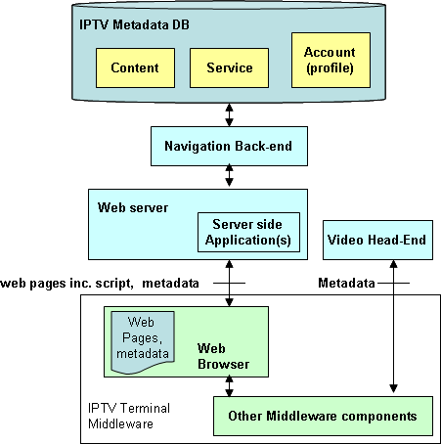
Figure 5.3: Metadata flows in Service Navigation System

Web Browser is IPTV client module that loads and renders web pages encoded in a mark-up language mostly based on HTML/XML, and a scripting language.
Web server serves navigation information (e.g. metadata) and client side scripts which request from client side application in IPTV client.
Metadata can also be received from a video head-end which is cached or processed in middleware.
Web Browser is executed locally to control the navigation user interface. Web Browser can retrieve metadata directly from Web server or through other middleware components from local cache.

______________

