Introduction
INTERNATIONAL TELECOMMUNICATION UNION |  |  |  | Focus Group On IPTV
TELECOMMUNICATION  STANDARDIZATION SECTOR  STUDY PERIOD 2005-2008 |  |  | FG IPTV-C-0716
 |  |  | English only
WG(s): 4 |  | 5th FG IPTV meeting:  Geneva, 23-31 July 2007
CONTRIBUTION
Source: | ZTE Corporation
Title: | Proposal on the definition of Overlay multicast
This contribution provides proposals on the definition of overlay multicast which was noted in section 13 of “FG IPTV-DOC-0092 (7-11 May 2007), Working document: IPTV Multicast Frameworks” in order to enhance its integrity.

Discussion

Section 13 of “FG IPTV-DOC-0092 (7-11 May 2007), Working document: IPTV Multicast Frameworks” is as follows.

13 Overlay Networking
Editor Note: Require definition of Overlay multicast
NET_58: IPTV network is recommended to support Overlay multicast mechanism as one of IPTV delivery mechanisms for contemporary media destined to large sized group
NET_58: Overlay multicast based IPTV media delivery systems is recommended to be supported
So it is proposed to define Overlay multicast.
The figure below is overlay network architecture. The entities which are connected by blue lines are network routers in IP layer. The entities which are connected by red lines are overlay edge nodes in application layer. Nodes in the overlay can be thought of as being connected by virtual or logical links, each of which corresponds to a path, perhaps through many physical links, in the underlying network.
Also paper [2] also gives a definition of overlay network as follows,
An overlay network is a virtual network of nodes and logical links that is build on top of existing network with the propose of implement a network service that is not available in the existing network.

In IPTV systems, the main purpose of overlay network is supplying multicast ability in application lay which may not be supported by IP lay. The proposal gives definition of overlay network and overlay multicast network.
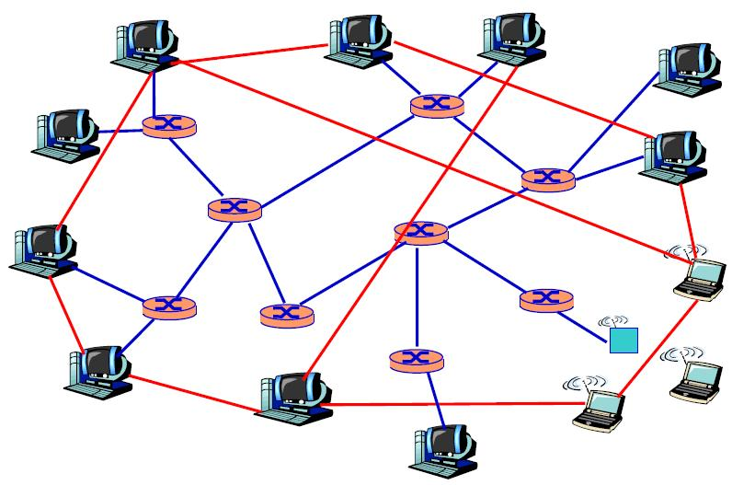
Overlay Network Architecture

Reference
[1] FG IPTV-DOC-0091 (7-11 May 2007), Working Document: IPTV Network Control Aspects
[2] http://www.cs.virginia.edu/~cs757/slidespdf/757-09-overlay.pdf
Proposal
From the discussion above, definition of Overlay Network and Overlay Multicast Network are proposed.
Overlay Network: A virtual network of nodes and logical links that is built on top of the general network infrastructure with the purpose of implement a network service that is not available in the general network infrastructure.

Overlay Multicast Network: One type of overlay network that provides multicast services to end users on top of the general network infrastructure.

Notes: The general network infrastructure is network infrastructure currently which may not supply multicast ability of routers in IP layer.
The proposal is also recommended to be inserted in “FG IPTV-DOC-00100 (7-11 May 2007), Working Document: IPTV vocabulary of terms”

_________________

