INTERNATIONAL TELECOMMUNICATION UNION |  |  |  | Focus Group On IPTV
TELECOMMUNICATION  STANDARDIZATION SECTOR  STUDY PERIOD 2005-2008 |  |  | FG IPTV-C-0600
 |  |  | English only
WG(s): 4 |  | 4th FG IPTV meeting:  Bled, Slovenia, 7-11 May 2007
CONTRIBUTION
Source: | ETRI
Title: | Proposed QoS and Resource Control Function for IPTV Overlay Networks
- Introduction

This contribution proposes the requirements of overlay multicast network to control QoS in IPTV overlay network be included in the section 12 of Working Document of FG IPTV-DOC-0068 (IPTV Network Control Aspect) and appropriate section of Working Document of FG IPTV-DOC-0068 (IPTV Multicast Frameworks).

2. Requirements to QoS Control at Overlay Multicast Network for IPTV Services
  - Functional Position of Resource Control
If the information on IPTV transport networks is directly collected and managed by IPTV overlay nodes to establish overlay transport route and configuration trees, it will be serious burden to handle overheads in IPTV overlay networks. It is assumed that resource control functions for IPTV overlay network is located between IPTV overlay network and physical transport network, and it performs collection of information about network resource and provides QoS control to transport network.
As shown in Figure 1, it is necessary that resource control function is introduced to provide interface function for IPTV overlay multicast QoS control between physical transport and IPTV overlay network. This function performs collection and management of transport network resource (e.g., DiffServ) via specified interface (e.g. SNMP). And overlay network nodes create tree topology and optimized route to support QoS requirements of IPTV users through information collected by Resource Control function.
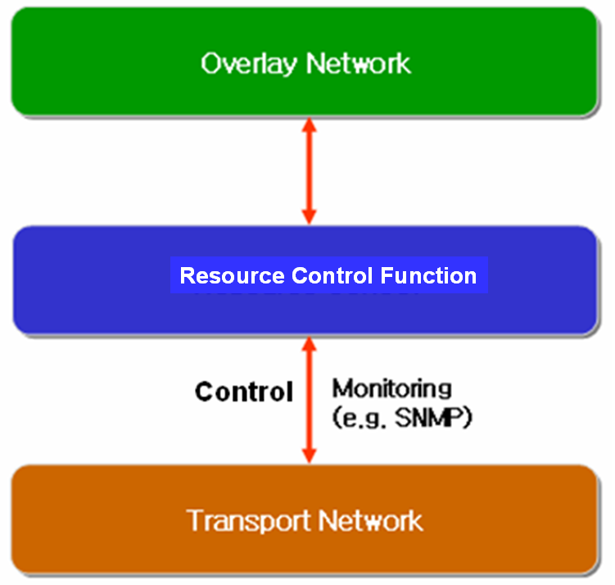

Figure 1. Resource Control Architecture in IPTV Overlay Network

2.2 Requirements of Resource Control Function
The requirements for resource control are as follows
- The Resource Control Function will collect information for resource control from transport network with periodic or aperiodic. According to initiation of overlay network nodes, Resource Control function collects data for resource and QoS control.
- Resource control should be able to communicate with Resource Control Function in heterogeneous or other network.
- The following information collected is transferred to overlay network, and then overlay network creates route and optimized tree to support QoS for IPTV overlay network.
- Link State Information: it includes available bandwidth information, delay, packet loss and jitter of link.
- Routing Information: it includes routing algorithm that is used to transport network equipments and routing information of them (e.g. neighbour routing information, routing table .etc)
- Multicast Traffic Information: it includes multicast traffic parameters (e.g. channel information, type of service, user profile, source content information) per channel or session of IPTV multicast.

2.3 Resource Control Function for Overlay QoS Control in Heterogeneous Networks.

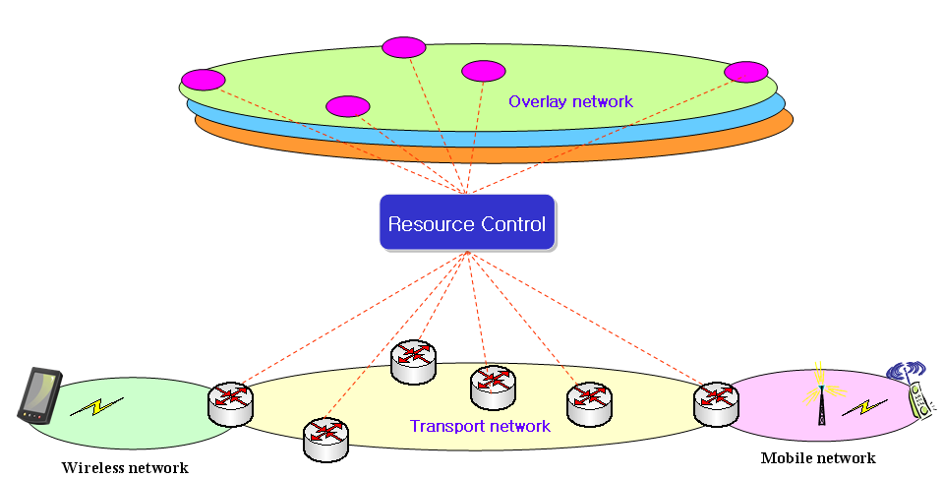

Figure 2. Application of Resource Control Function in Heterogeneous Networks for Overlay

QoS Control

The Session Manager configure routes among IPTV overlay network nodes and optimize tree topology for multicast sessions according to information of Resource Control Function. Figure 2 shows an application of Resource Control Function for wired and wireless/mobile networks.
Figure 3 shows an example for application of Resource Control Function for different service providers. Because of sharing the related service information or network information in terms of SLA, optimal sessions for IPTV overlay multicast will be configured in accordance with the information collected by Resource Control Function, and the sessions will be optimized with QoS requirements of IPTV users.
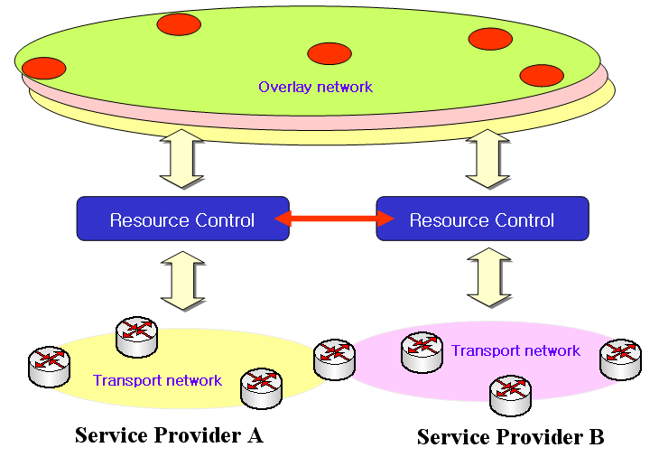

Figure 3. Application of the Resource Control Functions in different multiple ISPs for Overlay QoS Control

3. Proposal
Resource Control Function for overlay multicast network has been proposed, and its functions are described according to transport network configurations in this contribution. And it is proposed the requirements of overlay multicast network to control QoS in IPTV overlay network be included in the section 12 of Working Document of FG IPTV-DOC-0068 (IPTV Network Control Aspect) and appropriate section of Working Document of FG IPTV-DOC-0068 (IPTV Multicast Frameworks).

