INTERNATIONAL TELECOMMUNICATION UNION |  |  |  | Focus Group On IPTV
TELECOMMUNICATION  STANDARDIZATION SECTOR  STUDY PERIOD 2005-2008 |  |  | FG IPTV-C-0544
 |  |  | English only
WG(s): 1 |  | 4th FG IPTV meeting:  Bled, 7 – 11 May 2007
CONTRIBUTION
Source: | Korea (Republic of)
Title: | A service scenario for on demand-based IPTV services
1. Introduction
The on demand-based IPTV service is one of the most important IPTV services that provide video/audio/data streaming service triggered by user’s selection, i.e., on demand. The target contents for on demand service are various from simple data to highly processed multimedia entities and this implies that lots of IPTV services can be provided as on demand-based service. It is usually provided as multiple independent unicast viewing sessions for the chosen content. It has few variations based on the billing/charging policy or add-on functions. Based on the service type, Near VoD (NVoD), Real VoD (RVoD) and Push VoD are the examples and based on the contents, Video-on-demand (VoD), Music-on-demand (MoD) and Gamd-on-demand (GoD) are also the examples for the on demand-based IPTV services. (However, the GoD is not considered for this service scenario because GoD has some additional features and more varieties.)
Those services’ procedures are not supposed to be a regulated or standardized. However, considering the fact that we are working for a global guidance of IPTV services, we need a certain, agreed reference procedure to provide them. This service scenario also helps to figure out the required functions to provide the service. Therefore, in this contribution, we propose a service scenario for on demand-based IPTV services with IPTV service functions for each player.

2. On demand-based IPTV service scenario
Here, we have the on demand-based IPTV service scenario:
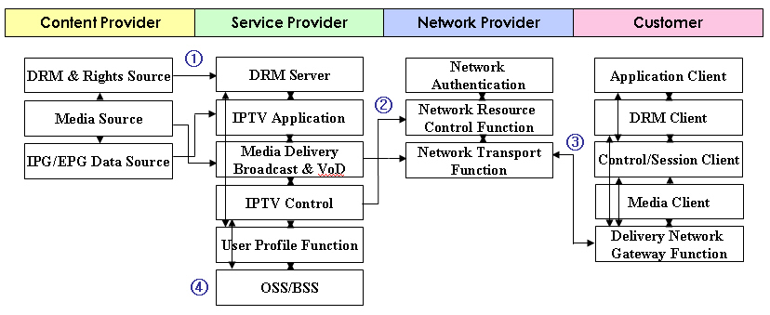
Figure 1. On demand-based IPTV service scenario

- Contents (video, audio, data, etc) with its metadata that are produced and managed by Contents Provider are provided (delivered) to the Service Provider’s domain. It can also include specific contents information (i.e., contents packaging, additional security information, etc).
- Then Service Provider transmits the received contents to the proper storage components through the Media Delivery interacting with the IPTV Control after additional processes such as service product managing, contents encryption, etc. Then, the contents list and relevant information are distributed to the network and customers.
- When a customer selects any on demand contents via its Application Client, the customer’s IPTV terminal receives the content’s stream through proper authentication, SLA and access process. Then the received stream is displayed by the Media Client under the requested interaction with DRM Client. According to the service type, the procedure is divided as followings:
i) NVoD (Near VoD): The Delivery Network Gateway Function access contents through multicast join/leave and the connection is managed by the Control/Session Client.
ii) RVoD (Real VoD): The Delivery Network Gateway Function access contents through unicast request and the connection is managed by the Control/Session Client.
iii) Push VoD: STB or Mobile terminal receives the contents in each storage advance, then, when some degrees of content are received, contents are displayed.
- According to the customer’s request, the OSS/BSS changes the status of customer for CRM and charges the service price. OSS/BSS may also analyze the contents access frequency information with user profile for advanced service.

3. Consideration for the alignment with WG1 to WG6 to support the suggested scenario
- WG1: The functional entities that are suggested above needs to be aligned with functional entities in the IPTV architecture with their functional relationships. Additionally, the storage functions for on demand-based IPTV services can be considered.
- WG2: The mechanisms for performance monitoring and traffic management for channel-based IPTV services need to be awarded of this proposed service procedure.
- WG3: IPTV security architecture and mechanisms need to be able to support the various types of on demand-based IPTV services. Under this point of view, the security architecture and mechanisms are identified and aligned with proposed scenario and the security related functions in the figures.
- WG4: The overall controlling aspects and multicast/unicast transition framework standardization for the on demand-based IPTV services needs to be aligned with the suggested service scenario.
- WG5: The functional entities and their relationships in the customer’s domain need to be aligned with that of the Aspects of IPTV End Systems working document.
- WG6: The metadata and middleware should be standardized as they could support the varieties of the on demand-based IPTV service types.

4. Proposal
In this contribution, we are proposing a reference service scenario for on demand-based IPTV services with required functions and alignment considerations with other WGs. We hope that our reference service scenario in the section 2 would be adopted for the section 15, “Services scenarios with flows between functions of players” in the IPTV service scenarios working document and the section 3 could be used as alignment checking guidance for other WGs.
________________

