Scope
INTERNATIONAL TELECOMMUNICATION UNION |  |  |  |  | Focus Group On IPTV
TELECOMMUNICATION  STANDARDIZATION SECTOR  STUDY PERIOD 2005-2008 |  |  |  | FG IPTV-C-0537
 |  |  |  | Original: English
WG(s): |  | 1 | 4th FG IPTV meeting:  Bled, 7-11 May 2007
CONTRIBUTION
Source: | Korea (Republic of)
Title: | Proposed 3rd Party Value-Added IPTV Services Using Open Interface
This contribution identifies and defines a new class of IPTV service, namely 3rd party value-added service.

References
[1] ITU-T Recommendation Y.2012 (2006), Architecture and Requirement of the NGN
[2] Parlay X Web Services White Paper (2002)
[3] FG IPTV-DOC-0062, Working Document: IPTV Architecture
[4] FG IPTV-DOC-0060, Working Document: IPTV Service Requirements
[5] 3GPP TS 29.199-20 v7.0.0, OSA Parlay X Web Services; Part 20: Multimedia Multicast Session Management

Abbreviations
This contribution uses the following abbreviations.
IPTV Internet Protocol TV
NGN Next Generation Network
IMS IP Multimedia Subsystem
OSA Open Service Architecture

Introduction
A list of IPTV services has already been proposed since the 1st IPTV FG in Geneva.
This contribution aims at:
- defining 3rd party value-added services such as community TV, family finder on TV, caller-Id on TV, and call-log on TV. These new services to be considered in IPTV services can be easily created by open interface (e.g., Telecom Web Services) for 3rd party applications.
- adding these new services to existing IPTV services defined in Working Document: IPTV service scenarios (FG IPTV-DOC-0055)

3rd Party Value-Added Services using Open Interface
Recently the converged services for communication and broadcasting have been emerged due to broadband convergence network. IPTV, a typical example of the converged services, promises to deliver television shows over high speed packet-based network. This broader convergence provides the communications industry with revenue opportunities through creating new exciting services. Actually, most voice and data service providers are deploying or planning to deploy IPTV services for taking advantage of the chance. To realize this good revenue opportunities, the most important thing is that new and innovative IPTV services can be easily created by highly simple method. The most promising approach is OSA. OSA is a paradigm for service development by opening up the networks through a standardised open interface (e.g. The Parlay X Web Services) that enables network operator and 3rd party application to make use of network functionalities including NGN and IPTV subsystem.
Open interface for 3rd party applications are intended to stimulate the development of NGN by IT developers who not are necessarily experts in telephony or telecommunications. This open interface is powerful yet simple, highly abstracted, imaginative, building blocks of telecommunications capabilities and streaming service (i.e., IPTV) capabilities that developers and IT community can both quickly comprehend and use to generate new and innovative converged applications.
3rd party value-added service is an application provided by 3rd party service provider invokes a standardized open interface to make use of NGN facilities and IPTV subsytem. This open interface can accelerate the creation and deployment of new and innovative IPTV applications by highly abstracted manner.
Unfortunately, there are no explicit components and interfaces for OSA in the current IPTV Architecture [3]. Furthermore, there are no explicit requirement statements for OSA in the current IPTV Service Requirements [4]. To foster these 3rd party application services, the current architecture and requirements for IPTV service should be changed. The Architecture and Requirements have to adopt the concept of OSA explicitly. Proposed IPTV architecture and requirements for 3rd party value-added service are presented by other contributions. The following sections describes the representative 3rd party IPTV services including community TV, family finder on TV, caller-Id on TV, and call-log on TV.

Community TV
This service gives users virtual community environment for watching TV together. The user is able to enjoy watching TV with feeling that his or her buddies are watching together. With this service, audience can share opinions and feeling with friends over packet-based network while watching TV.
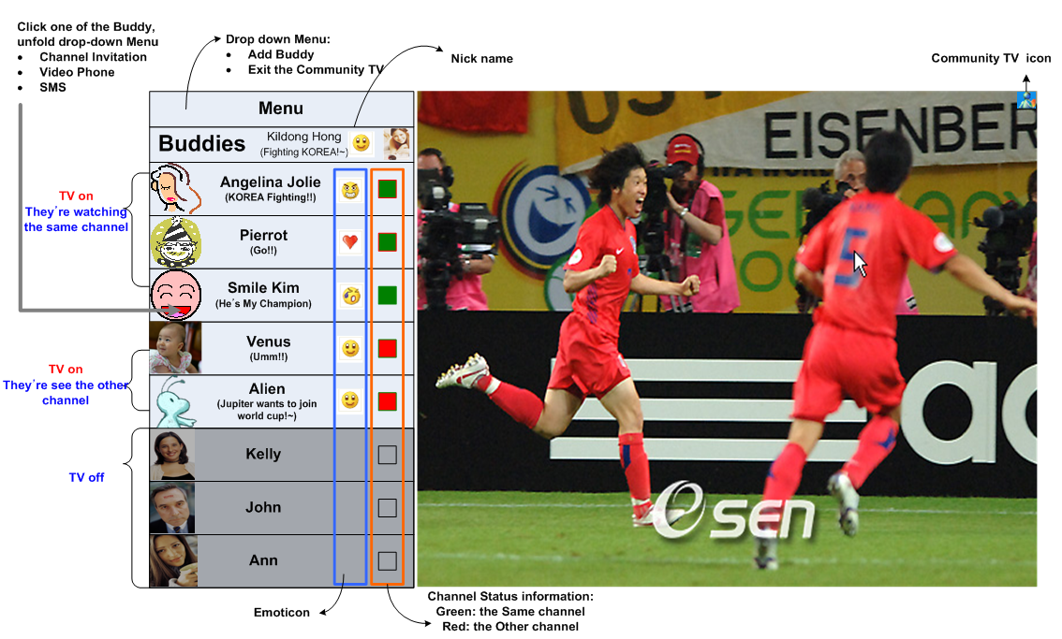
Figure 1: Community TV service.

Family Finder on TV
This service shows the location of family member or friends on IPTV terminal. For example, when a housewife is worried about her husband or child, she can find their location on TV based on geographic information of their cellular phone.
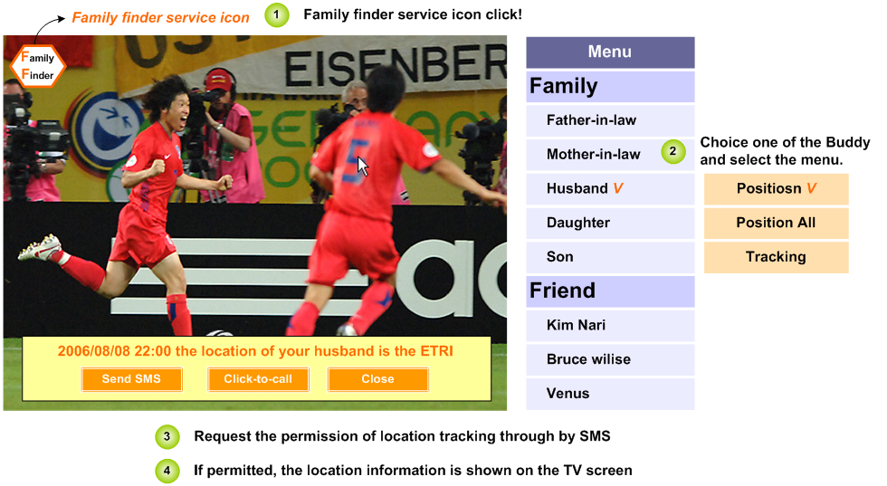
Figure 2: Family Finder on TV service.

Caller-Id on TV
This service enables a member who is watching the TV to receive voice call identification on the TV screen and then provides the option for pausing, and recording the video stream for the duration of the call.
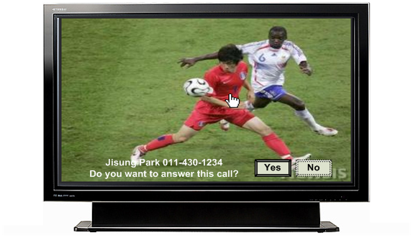
Figure 3: Caller-Id service.

Call-Log on TV
This service leaves the call history. This service can be useful when the user wants to know who was calling during his absence.
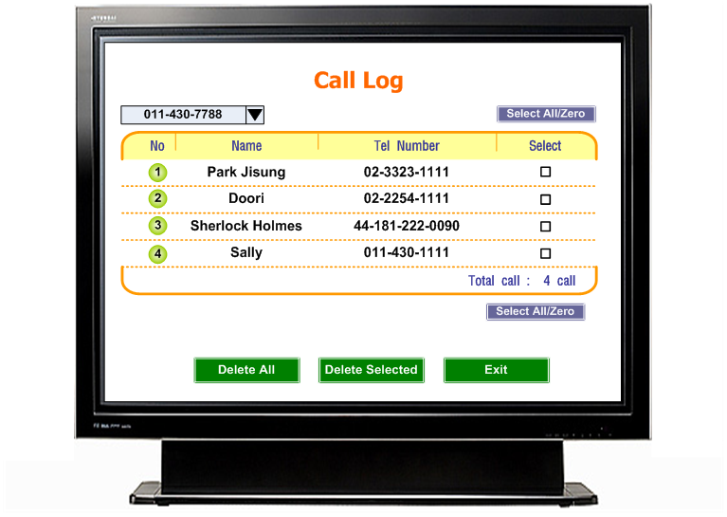
Figure 4: Call Log on TV service.

