INTERNATIONAL TELECOMMUNICATION UNION |  |  |  | Focus Group On IPTV
TELECOMMUNICATION  STANDARDIZATION SECTOR  STUDY PERIOD 2005-2008 |  |  | FG IPTV-C-0527
 |  |  | English only
WG(s):1 |  | 4th. FG IPTV meeting:
CONTRIBUTION
Source: | Cisco Systems, Inc.  Motorola, Inc.
Title: | DNG Network Attachment
Introduction
There are at least two types of devices in the consumer domain that need to attach to the network to establish IP layer connectivity, over which management, control, and user plane data can flow. The two devices are the Delivery Network Gateway (DNG) and the IP Terminal Function (ITF) device. This document addresses the DNG attachment to the network. The ITF device attachment is addressed in the joint Cisco-Motorola contribution labelled “ITF Network Attachment”

Discussion

Delivery Network Gateway (DNG)

Setup and Initial Configuration (pre-configuration)
In some network deployments the DNG and ITF devices are preconfigured with all or part of the network attachment information. For example, a DNG or an ITF device could use the procedure described below to get its own IP address, and then proceed directly to communicate with a remote configuration server based on some hard-coded addressing information, or based on some plug-in methods, such as smart card.
In lack of such pre-configuration information, the device needs to follow the procedures listed in this document.

DNG Network Attachment
The term ‘Network Attachment’ refers to the activities associated with the DNG establishing Layer-3 connectivity to an IP-network. Once the network attachment activities have been completed, the DNG will be capable of transmitting and receiving IP packets, and establishing a management session with a remote configuration server. Subsequently the remote configuration server, such as an auto-configuration server (ACS) defined in TR-69, can be used to provision the DNG with access-network specific parameters.

DHCP
The most prevalent automatic method currently used to attach to the network is the DHCP protocol. Using this protocol, the DNG acquires its WAN IP address, and can also learn the address of the remote configuration server.
The figure below shows the sequence of events that take place when the DNG is powered up or initialized.
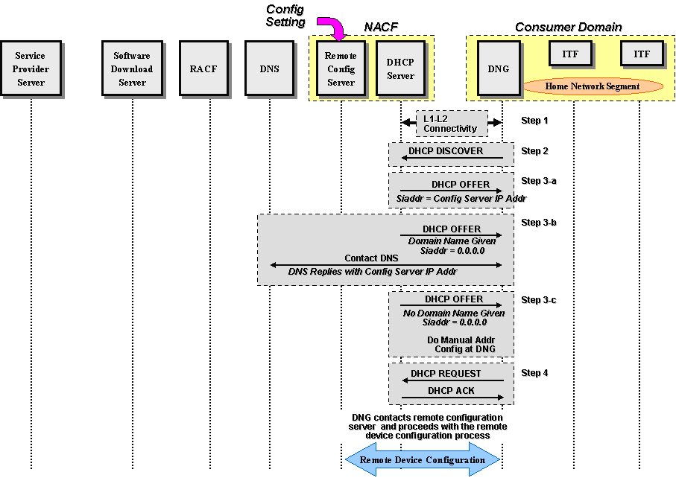
Figure 1 : DNG Network Attachment

Specifically, the following procedure takes place:
- The DNG establishes L1 and L2 connectivity with the network. The specific steps depend on the type of the access network (DSL, PON, Wireless) and are beyond the scope of this document.
- The DNG issues a DHCP DISCOVER message toward the network that must include all the mandatory DHCP options, per RFC 2131. If the DNG device supports the Container option, it must request that option in option 55 (parameter request list).
- The network provider DHCP server replies to the DNG with a DHCP OFFER message that must include all the DHCP mandatory options, per RFC 2131. The DHCP server must provide the following information to the DNG:
  - DNG WAN IP address
  - DNG network mask
  - DNS IP address
  - If configured, the container option to convey specific information to the ITF (defined in Cisco contribution labeled “Container Option for Server Configuration”).
  - If configured, the remote configuration server addressing information (see possibilities below).
There are three possibilities at this point, reflected in the content of the DHCP OFFER message:
  - If the DHCP server is provisioned with the remote configuration server IP address, then it must include it in the siaddr field of the OFFER message. This is shown as step 3-a in the figure above.
  - If the DHCP server is provisioned with the remote configuration server domain name but not its IP address, then it must set siaddr = 0.0.0.0 and provide the remote configuration server domain name to the DNG. The DNG must interact with the DNS to resolve the remote configuration server IP address. This is shown as step 3-b in the figure above,
  - If the DHCP server is not provisioned with the remote server addressing information (IP address or domain name) and therefore does not provide the remote configuration server IP address or its domain name, then the DNG needs to be configured manually by the end user. This is shown as step 3-c in the figure above.
4) The DHCP protocol sequence completes with the standard DHCP REQUEST and DHCP ACK messages.
After acquiring the IP address of the remote configuration server, the DNG interacts with the remote configuration server to acquire needed configuration parameters.

Proposal
It is proposed that this contribution be added under sub-section 1 of a new proposed section labeled ‘IPTV Consumer Domain Attachment and Initialization Specification’ of the Architecture document.

