1. Introduction
INTERNATIONAL TELECOMMUNICATION UNION |  |  |  | Focus Group On IPTV
TELECOMMUNICATION  STANDARDIZATION SECTOR  STUDY PERIOD 2006-2008 |  |  | FG IPTV-C-0477
 |  |  | English only
WG(s): 6 |  | 4th FG IPTV meeting:  Bled, Slovenia, 7-11 May 2007
CONTRIBUTION
Source: | China Netcom Group (P.R.China)
Title: | Proposal on the service platform middleware architecture
On the 3rd meeting at Mountain View, USA, 22-26 January 2007,there is suggestion about C-0296 that “C-0296 proposes a diagram explaining IPTV system middleware architecture. WG6 recognizes that it is a good starting point to clarify what middleware is, but we need to modify the diagram according to the definition of middleware we adopted.” from WG 6 meeting report.
This document will further confine the system middleware as a service platform middleware, and gives some explanation, comments and modification to the C-0296 based on the new definition of middleware.

2. Reference
FG IPTV-C-0296: “Proposal on IPTV system middleware architecture and its functional requirements”.

3. IPTV service platform middleware architecture

According to the new definition of middleware from C-0070: middleware is a layer of software between applications and resources, which consists of a set of service enablers that allow multiple functionalities running on one or more devices in an IPTV system to interact across a network. A service platform middleware architecture is presented(see figure 1),and it’s functional module are described.
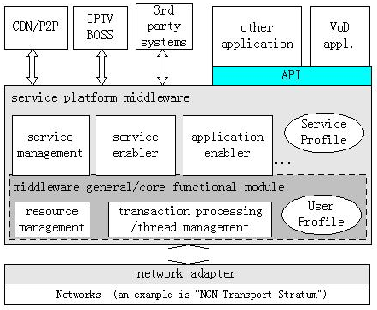
Figure 1 IPTV service platform middleware architecture
  - Network adapter
Network adapter is mainly to shield each kind of network and resources in the lower layer,and provides the transparent interfaces for upper layer.
  - Service platform middleware
Service platform middleware is consist of service management,service/application enabler components, database and so on(independent to operating system), mainly dispatch and control resources, manage the transaction and threads as well as service/application logic processing and each kind of strategy processing. It invokes the lower layer network interfaces to control service network resources, and provide application functions (APIs) for upper layer to be called. At the same time, it also can integrate quickly other systems, such as CDN/P2P,BOSS, 3rd party systems and so on. It includes the following functional module.

2.2.1 Middleware general/core functional module
It manages the resources of service platform, processes the transaction and threads. Through User Profile, it combines closely the user's general attribute with the network resources, the application threads and control mechanism. This module is a universal module. In the view of software, it’s instances are called by upper service management and service/application enabler. Core functional module can be extended to satisfy the application requirements.

2.2.2 Service management module
The objects of service management include customers,services and SP/CPs.It fulfil performance management, configuration management, customer management, SP/CP management,service custom-made and service safety management.

2.2.3 Service/application enablers
The service/application enabler use Service Profile to fulfill the specific service/application logic. There are some enablers to realize universal functions,and specific enablers corresponds to specific logic. These enablers provide application APIs for upper application layer to realize application independent to network and platform.
  - API layer
The category and definition of APIs are closely related with service/application enablers, and depend on concrete applications.
  - Application layer
Application layer is the layer where operators and 3rd parties provide services and applications. These services and applications includes EPG application; VoD, BTV, time-shift TV, games, videophone as well as other value-added services and so on.
  - Interact with other systems
In order to integrate quickly with operators’ existent systems and 3rd party systems, it is necessary for IPTV service platform middleware to link with other systems. There are three methods to do the job. They are listed as following:
(1) Interfaces defined to link service platform middleware with CDN/P2P,BOSS and 3rd party systems. Document C-0296 presents some interfaces to illustrate this method.
(2) Service platform middleware provide APIs to integrate CDN/P2P,BOSS and 3rd party systems. That is,in another word,service platform middleware provide APIs for all applications and systems integration.
(3) C/S mode is used. Service platform middleware is the server(S),and it’s clients reside in the CDN/P2P,BOSS and 3rd party systems.
Here we recommend to use C/S method to integrate CDN/P2P,BOSS and 3rd party systems.
Because these systems are already existent systems, and operators need to make fully use of these systems, if all these functional entity are implemented by middleware, then it is a complex software.In fact,we need a flexible and extendable middleware. Further, the existent systems and third party systems are usually changeable, if they are changed, we only need to change middleware client software, and these changes will not influence other systems and APIs.

3. Relation with STB middleware
In order to grasp entirely the IPTV service platform middleware, as well as the relationship with STB middleware, figure 2 presents the corresponding relation model between service platform middleware and STB middleware. Because the middleware is confined to application layer, the service control also be confined to the application control, session control and streaming control. At the same time, VoD application control is exampled.
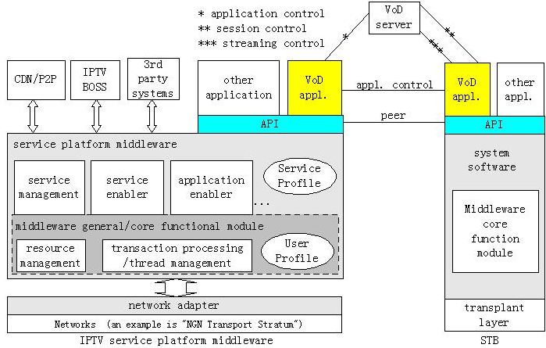
Figure 2 The corresponding relation model between service platform middleware and STB middleware

Proposed structure of IPTV service platform middleware architecture:
(1) Definition of IPTV service platform middleware
(2) Service platform middleware general requirement
(3) Scope of service platform middleware
(4) Service platform middleware generic architecture
(5) Functionality and classification of service platform middleware Enablers/APIs

4. Proposal
We propose that the figure 1 is the generic architecture of IPTV service platform middleware.

___________________

