Abstract
INTERNATIONAL TELECOMMUNICATION UNION |  |  |  | Focus Group On IPTV
TELECOMMUNICATION  STANDARDIZATION SECTOR  STUDY PERIOD 2005-2008 |  |  | FG IPTV-C-0435
 |  |  | English only
WG(s): 1 |  | 4th FG IPTV meeting:  Bled, Slovenia, 7-11 May 2007
CONTRIBUTION
Source: | Nortel Networks (Canada)
Title: | Comments on clause 7 of FG IPTV–DOC-0062
This contribution provides a replacement for clause 7 of “FG IPTV-DOC-0062 (22-26 January 2007), Working document: IPTV architecture” in order to enhance its accuracy and quality.
Background and discussion
At the most recent FG IPTV meeting, i.e. 22-26 January 2007, significant progress was made on the IPTV architecture document. However, more work is needed to enhance its accuracy and appearance. Clause 7 of the working document is presenting IPTV architectural views as well as examples of IPTV services. Traditionally examples are placed in an appendix which is proposed in this contribution. Also some editorial changes need to be made to clause 7 to make it easier to understand and enhance its accuracy. This contribution proposes replacement for clause 7 for the aforementioned purpose.
Reference
FG IPTV-DOC-0062 (22-26 January 2007), working document: IPTV architecture
Proposals
Proposal 1
It is proposed to replace clause 7 of FG IPTV-DOC-0062 with the following.

6. IPTV concepts and roles
Figure 6-1 shows the main roles that different components are involved in for the provision of IPTV services.
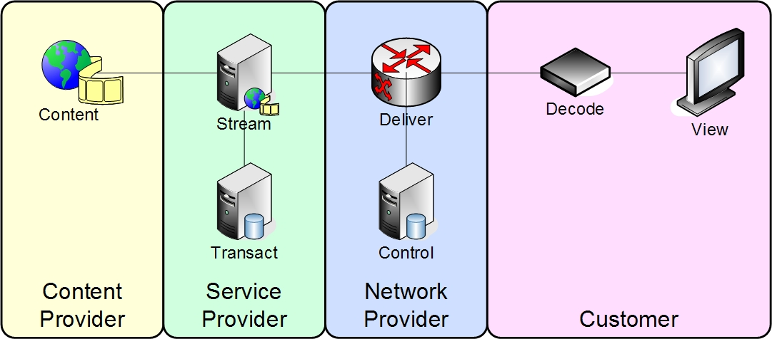
Figure 6-1: Basic IPTV concept
The four roles are as described below [ATIS-0800002]
Content Provider: The entity that owns or is licensed to sell content or content assets.
Service Provider: The entity that provides the IPTV Service to the Consumer.
Typically, the Service Provider acquires or licenses content from Content Providers and packages this into a service that is sold to the Consumer.
Network Provider: The entity connecting the Consumers and the Service Providers.
Consumer: The entity that consumes and pays for the IPTV Service.
Appendix I provide examples of roles played by the above components to provide basic IPTV services

Proposal 2
It is proposed to accept the following as appendix I of the working document.
Appendix I: Examples of IPTV concepts and roles

IPTV Service Types
Describing roles that different components of the basic architecture play are useful for the description of the basic IPTV Service types.

I.1 Linear TV with Local PVR
A key part of a typical IPTV Service is the delivery of Linear TV. This is received, from the existing broadcast transmission from a Content Provider, trans-coded and multicast by the Service Provider. The multicast streams are delivered by the Network Provider, via the Consumer’s Network to the Consumer’s IPTV device.
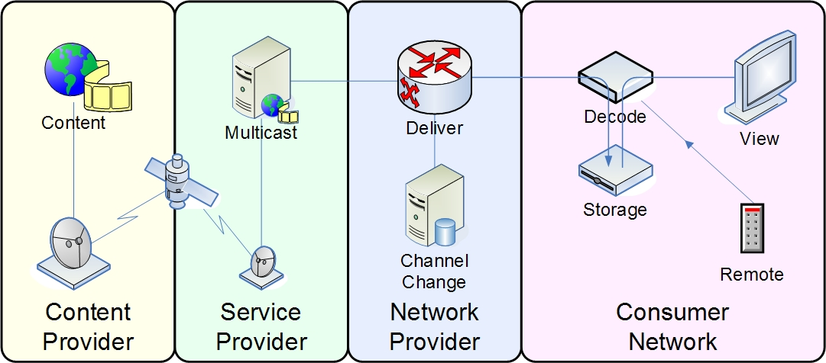
Figure I-1: Linear TV with Local PVR

I.2 Content on Demand
The second part of a typical IPTV Service is the delivery of On-Demand Content. The content is normally received from a Content Provider in the form of physical media, such as a digital video-tape. This is then trans-coded and stored by the Service Provider and made available as unicast streams. The unicast streams are delivered by the Network Provider, via the Consumer’s Network to the Consumer’s IPTV device.
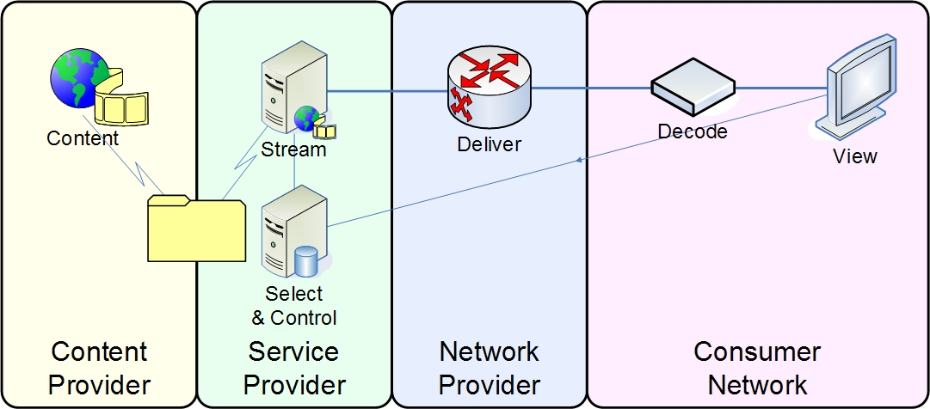
Figure I-2: Content on Demand

I.3 Hybrid: Online and Off-air TV Delivery
An alternative approach for the delivery of Liner TV is to enable the customers IPTV device to directly receive the broadcast signal from the Content Provider. This will then be combined with On-Demand content delivered over the network from the Network Provider.
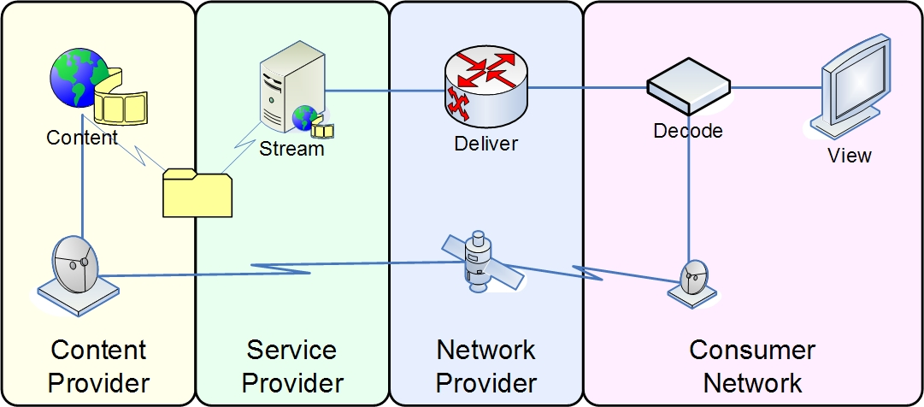
Figure I-3: Hybrid: Online and Off-air TV Delivery

______________________________

