Abstract
INTERNATIONAL TELECOMMUNICATION UNION |  |  |  | Focus Group On IPTV
TELECOMMUNICATION  STANDARDIZATION SECTOR  STUDY PERIOD 2005-2008 |  |  | FG IPTV-C-0434
 |  |  | English only
WG(s): 1 |  | 4th FG IPTV meeting:  Bled, Slovenia, 7-11 May 2007
CONTRIBUTION
Source: | Nortel Networks (Canada)
Title: | Comments on clauses 1 to 6 of FG IPTV–DOC-0062
This contribution provides replacement for clauses 1 to 6 of “FG IPTV-DOC-0062 (22-26 January 2007), Working document: IPTV architecture” in order to enhance its accuracy and quality.
Background and discussion
At the most recent FG IPTV meeting, i.e. 22-26 January 2007, significant progress was made on the IPTV architecture document. However, more work is needed to enhance its accuracy and appearance. Clause 1 did not have any text, and other clauses needed some changes also Clause 6 of the working document is presenting only a figure which is more appropriate to be part of clause 5. This contribution proposes replacement for clauses 1 to 6 for the aforementioned reasons and purposes.
Reference
FG IPTV-DOC-0062 (22-26 January 2007), working document: IPTV architecture
Proposal
It is proposed to replace clauses 1 to 6 of FG IPTV-DOC-0062 with the following.

Scope
This working document describes general principles applicable to Internet protocol television (IPTV) as well as a basic reference model for IPTV. The general reference architecture described in this working document should enable the support of the overall IPTV as described in IPTV services requirements [IPTV.REQ]. This working document describes specifically “NGN-based” and “IMS-based”, “NGN-based” and “non-IMS-based” and “Non-NGN-based” architectures.

References
The following ITU-T Recommendations and other references contain provisions, which, through reference in this text, constitute provisions of this working document. At the time of publication, the editions indicated were valid. All Recommendations and other references are subject to revision; users of this working document are therefore encouraged to investigate the possibility of applying the most recent edition of the Recommendations and other references listed below. A list of the currently valid ITU-T Recommendations is regularly published.
The reference to a document within this working document does not give it, as a stand-alone document, the status of a Recommendation
[Y.2012] ITU-T Recommendation Y.2012 (2006), Architecture and Requirement of the NGN

[ATIS-0800002] ATIS-0800002 (2006), IPTV Architecture Requirements
[Y.2021] ITU-T Recommendation Y.2021 (2006), IMS for Next Generation Networks
[IPTV.REQ] ITU-T FG IPTV working document (xxxx), IPTV service requirements

Definitions
3.1 This working document uses the following terms defined elsewhere:
3.1.1 Functional entity [Y.2012]: An entity that comprises an indivisible set of specific functions. Functional entities are logical concepts, while groupings of functional entities are used to describe practical, physical implementations.
3.1.2 Functional architecture [Y.2012]: A set of functional entities and the reference points between them used to describe the structure of an NGN. These functional entities are separated by reference points, and thus, they define the distribution of functions.
NOTE: The functional entities can be used to describe a set of reference configurations. These reference configurations identify which reference points are visible at the boundaries of equipment implementations and between administrative domains.
3.1.3 Reference point [Y.2012]: A conceptual point at the conjunction of two non-overlapping functional entities that can be used to identify the type of information passing between these functional entities.
NOTE: A reference point may correspond to one or more physical interfaces between pieces of equipment.
3.2 This working document defines the following terms:
3.2.1 Linear TV: Linear TV is the television service where a scheduled TV program is provided at a particular time and on a particular channel. Linear TV which is today’s TV service is also called broadcast TV.

Abbreviations and acronyms
This working document uses the following abbreviations and acronyms.
BSS Business Support Systems
CAS Conditional Access
DNG Delivery Network Gateway
DRM Digital Rights Management
EPG Electronic Programme Guide
FE Functional Entity
HSS Home Subscriber Server
IMS IP Multimedia Subsystem
IPG Interactive Program Guide
IPTV Internet Protocol TV
NGN Next Generation Network
OSS Operational Support System
PVR Personal Video Recorder
SIP Session Initiation Protocol
URL Universal Resource Locator
VoD Video on Demand

IPTV architectural Overview
IPTV architecture provides capability to support IPTV services such as broadcast TV or video on demand (VoD) over a broadband network. Considering existing networks and their evolution to next generation network (NGN) two approaches are identified for the architecture of IPTV. One based on NGN and another one non-NGN based.

5.1 NGN based IPTV architecture
Two cases are considered:
5.1.1 NGN-based and IMS based architecture
In this case the IPTV service component is drawn on top of the other NGN service components in NGN architecture. The IPTV service component is achieved by using IP multimedia subsystem (IMS) capabilities.
Note: This is Figure 1/Y.2021 [Y.2021] with the addition of “IPTV service component”

Figure 5-1: IMS-based architecture for IPTV

IMS-based IPTV implies that the system will use session initiation protocol (SIP) for session control, and the IMS could be used for authentication and authorization of subscribers, as well as admission control and resource reservation.
IMS as a control mechanism can provide a number of functions that will be required by the IPTV architecture. For the IMS-based IPTV architecture these IMS functions must be evaluated to determine if/how they can provide required IPTV functionality. The functions that will be considered in this context include:
- Service integration: integration of IPTV services with IMS communication services, such as multimedia telephony, messaging etc. can use IMS capabilities..
- Security: this could be provided by making use of the IMS built-in identity management, authentication, authorization, and service access protection functions.
- QoS: IMS mechanisms could be used to support the delivery of multiple services over the common managed transport with a controllable quality of service (QoS).
- User preferences: IMS mechanisms could be used to support interactivity and personalization of IPTV services.
- Charging: IMS standardized charging capabilities, both off-line and on-line could be re-used within the context of an IMS based IPTV solution
- Roaming: IMS mechanisms to support roaming could be used to provide roaming for IPTV.

    - NGN based and non-IMS based architecture
For this case an IPTV service component is drawn on top of the other NGN service components in NGN architecture [Y.2012]. The IPTV service component is achieved without using IMS.

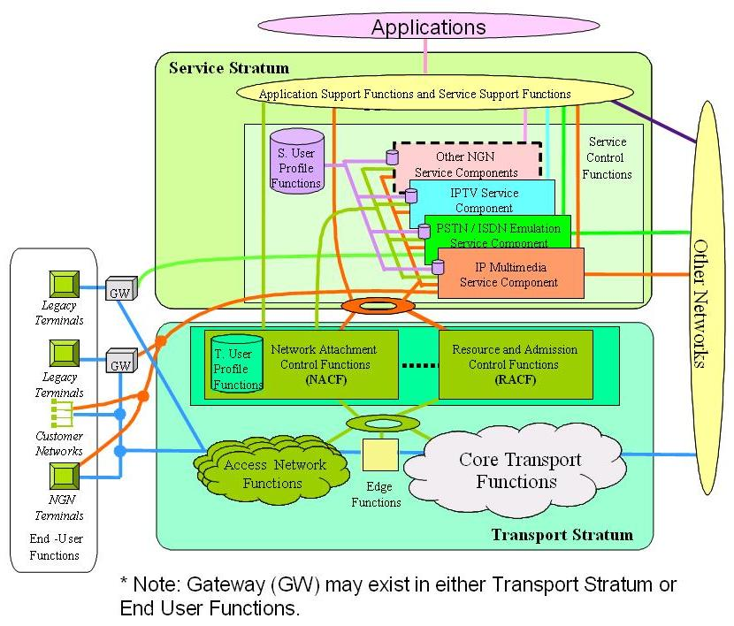

Note: This is Figure 8/Y.2012 [Y.2012] with addition of “IPTV service component”

Figure 5-2: NGN and its service components

5.2 Non-NGN based IPTV architecture
For this case the IPTV architecture does not depend on NGN architecture.

Figure 5-3: Non-NGN based IPTV components

__________________________

