INTERNATIONAL TELECOMMUNICATION UNION |  |  |  | Focus Group On IPTV
TELECOMMUNICATION  STANDARDIZATION SECTOR  STUDY PERIOD 2005-2008 |  |  | FG IPTV-C-0420
 |  |  | English only
WG(s): 4 |  | 3rd FG IPTV meeting:  Mountain View, USA, 22-26 January 2007
CONTRIBUTION
Source: | Korea (Republic of)
Title: | Consideration on multicast interfacing for IPTV service between IP multicast and application layer multicast
In the 2nd meeting, there was necessity of overlay multicast for IPTV media delivery. (Living List #Multicast-3 of WG4, contribution #221)
This document proposes adoption of Multicast Middleware from EuQoS for harmonized IPTV service delivery system between IP multicast and overlay multicast.

- Motivation
From the efficient point of view, for the media delivery system, multicast can play a key role in the service network. Since if the system adopts unicast instead of multicast, a source should send the target data n times for n receivers. This activity makes the service network burdensome. However, by duplication of the data, IP multicast router can achieve high performance. This ordinary kind of multicast is called as IP multicast or native multicast.
For IPTV, multicast can be also the best solution to transport media service. However, unfortunately, there exists another reserved problem when we adopt IP multicast in IPTV system. That is, IP multicast can be implemented over multicast-enable routers only. Nevertheless, most of routers do not have the capability supporting multicast. Therefore many routers should be replaced with multicast-enabled ones but, because still ISPs have not shown being willing to pay for that, practically multicast have difficulty to be widely spread.
Alternatively we can replace IP multicast with overlay multicast (also called as application level multicast). In an overlay or end-system multicast approach participating peers organize themselves into an overlay topology for data delivery. Each edge in this topology corresponds to a unicast path between two end-systems or peers in the underlying network. All multicast-related functionality is implemented at the peers instead of at routers. (The difference between native multicast and overlay multicast is shown on Figure 1.)

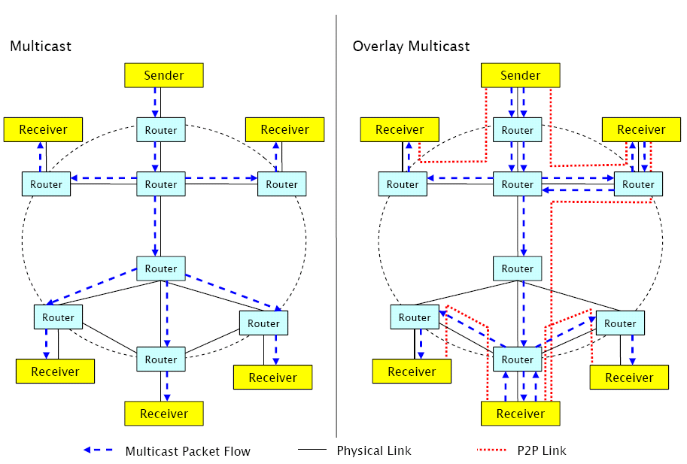
Figure 1. Native Multicast VS. Overlay Multicast _{[2]}

However there still remains a difficulty that should be noticed. Owing to the lack of standardization, each application layer multicast has its own API and addressing scheme which prohibits already existing multicast-aware application from using the application layer multicast _{[1]}. Also, how brides overlay multicast with IP multicast should be considered. There should be a possible standard that makes seamless implementation. In EuQoS, there exists one possible multicast interface, Middleware Multicast, which can adequately solve the previous two problems.
In this document, we propose appliance of “Multicast Middleware” with overlay multicast.

- Multicast Middleware _{[1]}

  - IP Multicast and Application Layer Multicast
We propose a solution called Multicast Middleware, which uses Application Layer Multicast for transporting multicast traffic. However it also offers a standard multicast interface for the applications. The Multicast Middleware is also aware of limitations regarding connectivity on the network layer.

  - Concept
The IP Multicast interface for the applications is usually offered by the operating system. The operating system on the other side communicates with a multicast-enabled router in the local network using IGMP for signaling. Sending IP multicast traffic is not different from sending IP unicast traffic. The only difference is the reserved source/address range, which denotes different multicast groups (groups of multicast traffic receivers). On the network layer, multicast traffic is handled differently. For example, in Ethernet the IP packets with a multicast group as a destination address get an Ethernet multicast address assigned. To provide an IP Multicast interface for the whole system (including services integrated in the operating system’s kernel), we propose to use a virtual Ethernet device (also known as TAP device – a software analogy of a wiretap). The TAP interface is a special kind of network interface, which is seen by the operating system as a normal Ethernet device. However instead of forwarding the Ethernet frames to a hardware device, the TAP interface forwards the received Ethernet frames to a user-space process. On the other side, the TAP interface forwards all Ethernet frames received from the user-space process as incoming frames to the operating system’s kernel. TAP support exists for all major operating systems.

Using a TAP interface, Multicast Middleware makes processing of multicast traffic transparent to all applications. This includes the multicast functionality integrated in the operating system’s kernel. This approach does also not require any modification of application code. Multicast traffic originating from an end-user host can be routed through the TAP device. This device forwards the packets (encapsulated in Ethernet frames) to a user-space process (which we call the Multicast Middleware) for processing. The Multicast Middleware acts as a multicast router by implementing IGMP and transporting the multicast data.

IP Multicast enabled applications must subscribe to different multicast groups to receive video broadcast announcements and audio/video streams. The multicast group subscription is usually a system call, which instructs the operating system’s kernel to send IGMP membership report messages to the IP Multicast router. In our case, the IGMP membership reports are sent via the TAP interface to the Multicast Middleware. The Multicast Middleware interprets the IGMP membership reports and notifies the neighbor peers about the changes in the multicast routing table. This information (depending on the multicast routing protocol used in the overlay network) is propagated to other peers. The flow of the multicast subscription as described before can bee seen in a figure 2.

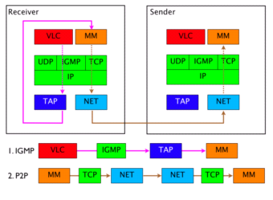
Figure 2. Receiver initiated Multicast Group join _{[2]}

In the network, video broadcast announcements and audio/ video streams are handled in the same way: they are delivered as multicast data packets. Sending multicast traffic does not differ from sending unicast traffic. The only difference is the destination address, which is in the case of the multicast traffic the address of an IP Multicast group and not of a host. After a data packet has been sent by the application, it is forwarded by the operating system’s kernel to the appropriate multicast-enabled network device (in our case the TAP device). The Multicast Middleware process receives the outgoing multicast traffic via the TAP device. The received multicast traffic is then encapsulated into Application Layer Multicast messages. The IP Multicast destination address of the packets is translated into Application Layer Multicast addresses to which the messages are sent.

After receiving an encapsulated IP Multicast packet by Application Layer Multicast, the Multicast Middleware encapsulates the IP Multicast packet into an Ethernet frame. The Multicast Middleware then sends the Ethernet frame via the TAP interface to the operating system’s kernel for processing. The operating system’s kernel delivers the data to the video application. The delivery of multicast traffic from the sender through the Multicast Middleware to the receiver is presented in figure 3.

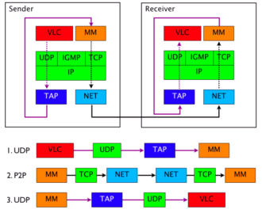
Figure 3. Sender controlled Broadcasting of UDP Multicast Traffic _{[2]}

  - Video Broadcasting
Using the proposed solution, we can provide a video streaming service for a very large group of Internet users without the need for large investments in infrastructure. Certain requirements for sender and clients must be fulfilled. The sender of a video stream must have a Multicast Middleware installed on a computer, which is connected to the Internet. The Internet connection should support at least the bandwidth for sending the stream once. Any application
supporting streaming using IP Multicast can be used (for example VLC or VLS). Each client, which wants to receive a video stream must install the Multicast Middleware on his computer and must have an Internet access. Any video application with IP Multicast support (like VLC) can be used for receiving the video stream.
The session announcement protocol (SAP) can be used to announce running or scheduled video broadcasts over IP Multicast. The SAP announcements include session description protocol SDP stream descriptions encapsulated in UDP packets and are sent to a predefined IP Multicast group (for example IPv4 global scope session announcements are sent to 224.2.127.254) and port (9875). Since the Multicast Middleware enables IP Multicast on the end-host, SAP can be used for announcing video broadcast transmissions.

  - Multicast Middleware for IPTV media service
IPTV media service will also deliver variety of video based streaming services. Therefore here still exists equivalent necessity to adopt application level multicast with IP multicast properly; Multicast Middleware in IPTV delivery network will play a key role in those solutions.

- Proposal
In the working document of WG 4 (IPTV Network Control Aspect), section 12 “overlay multicast” notates about its concept. As we shown above, to implement overlay multicast, there should be consideration interfacing among different multicast schemes.

  - Agreement on Subsection of Section 12 “Overlay Multicast”
We hereby propose to supplement:

12.x Overlay multicast interfacing / Multicast Middleware
To implement seamless among different multicasts, overlay multicast based IPTV delivery system should consider multicast interfacing.

  - Agreement on New Section “Multicast Interfacing”
It might be also possible to append the subsection after arrangement of overlay multicast clearly otherwise it can be also put the item on the list as different section:

x. Multicast interfacing / Multicast Middleware
To implement seamless among different multicasts, overlay multicast based IPTV delivery system should consider multicast interfacing.

- Reference
[1] Video Broadcasting using Overlay Multicast, Dragan Milic, Marc Brogle, Torsten Braun, 2005
[2] EuQoS Multicast Middleware: Basic Architecture Overview and Concepts
[3] EuQoS (End-to-end Quality of service support over heterogeneous networks), official website at http://www.euqos.org
[4] A case for end system multicast, Yang-Hua Chu, Sanjay Rao, Hui Zhang, 2000
[5] Requirements for overlay multicast based IPTV media delivery system, T05-FG.IPTV-C-0221!!MSW-E.doc, ETRI, Republic of Korea, October 2006
_____________

