Introduction
INTERNATIONAL TELECOMMUNICATION UNION |  |  |  | Focus Group On IPTV
TELECOMMUNICATION  STANDARDIZATION SECTOR  STUDY PERIOD 2005-2008 |  |  | FG IPTV-C-0238
 |  |  | English only
WG(s): 1 |  | 2nd FG IPTV meeting:  Busan, 16-20 October 2006
CONTRIBUTION
Source: | France Telecom
Title: | Roles and players for IPTV services
WG1 started work on IPTV roles and players identifying the following roles:
- Content providers
- Application providers
- Content aggregators
- Service providers
- Network providers
- Consumers (subscriber, viewer, etc.)
- Regulators
This contribution aims at detailing these aspects.

First about terminology.
"Service provider" is a so broad and so often used term that we should try to find another one more specific, such as:
- IPTV operator
- IPTV Provider

France Telecom IPTV solution players
France Telecom started the deployment of TV services over ADSL access end of December 2003.
France Telecom has now more than 450 000 subscribers end of September 2006.
The new STB are now H.264 capable and HD-ready. The high-end STB features PVR functions.
To illustrate the relations between players in the operation of IPTV services, here are the different players in the France Telecom IPTV service.

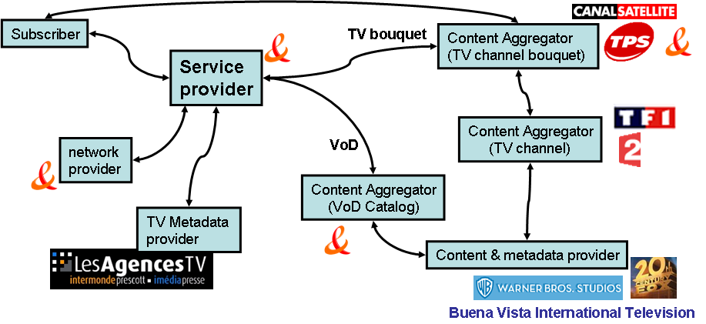
Figure 1. Players in the France Telecom IPTV Service
Notes:
LesAgencesTV is a company providing metadata related to TV Channels
TPS and CanalSatellite are companies providing a bouquet of TV Channels. France Telecom provides its own bouquet
Buena Vista International Television, Warner Bros Studios and 20th Century Fox are companies providing movies (under contract with France Telecom) to be included in the France Telecom VoD Catalog.

France Telecom plays different roles in the delivery of IPTV Services:
- Content aggregator
  - It creates its own TV Bouquet combining individual TV channels (TF1, 2, M6, etc.) and metadata coming from a TV channel metadata provider (Les Agences TV),
  - It creates its own VoD Catalog combining contents negotiated with content providers such as Warner Bros Studios, 20th Century Fox, etc.
- Service provider
  - It offers the subscription to its own TV bouquet and VoD Catalog.
  - It operates the IPTV architecture (TV Head-End, CDN, VoD servers, etc.) over its own network

Identification of metadata provider role
Content providers have of course metadata about their contents, so content providers are also metadata providers.
However, it exists also pure metadata providers (as illustrated in the France Telecom IPTV players) which provides metadata about contents but not the contents themselves.
Among the pure metadata providers we can find the EPG providers, newspapers, freelance journalists, individuals.
For example, they provide comments, opinions or critics about movies.

Model for relations between roles
The distribution of roles among the players in the France Telecom IPTV Service is not the only one possible.
So here is a proposal for a generic IPTV Service model.
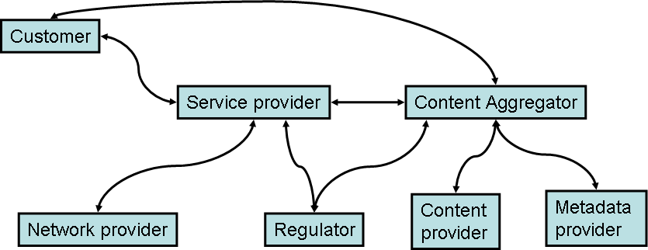
Figure 2. IPTV Service mode for relations between roles
A player may play different roles as shown in the France Telecom IPTV service (service provider, content aggregator, etc.) .

______________

