Abstract
INTERNATIONAL TELECOMMUNICATION UNION |  |  |  | Focus Group On IPTV
TELECOMMUNICATION  STANDARDIZATION SECTOR  STUDY PERIOD 2005-2008 |  |  | FG IPTV-C-0177
 |  |  | English only
WG(s): 1 |  | 2nd FG IPTV meeting:  Busan, 16 to 20 October 2006
CONTRIBUTION
Source: | China Netcom Group
Title: | A multi-level service operation platform architecture for service provider
This contribution describes a segmentation of IPTV architecture by the role of service provider, named as service operation platform, and proposes its basic functions. In view of IPTV system implementation, a multi-level service operation platform architecture is also described.

Terminology
SOP: Service Operation Platform, a platform system provides IPTV service by service provider.
CMS: Content Management System
SMS: Service Management System
CNS: Content Navigation System
SES: Service Enabling System
CP: Content Provider
SP: Service Provider
OP: Operator

Informative Reference
- FG IPTV-OD-0027, Draft Architecture Document
Fig.1, FG IPTV-OD-0027 Draft architecture for IPTV by roles.

SOP Architecture for IPTV System
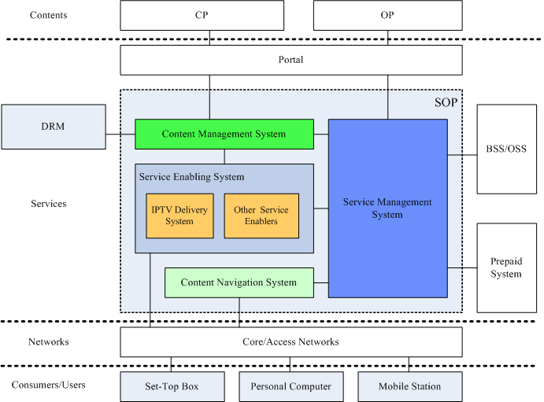

Fig.2 A proposed architecture for IPTV by the role of service provider

As Fig. 2 has illustrated, a user can access IPTV and other relevant services via set-top box, personal computer, mobile station, etc. The core networks are based on IP and access networks can be wired or wireless, the only requirement of which is that they have enough bandwidth to feed the services. Service Operation Platform (SOP), cooperating with BSS/OSS and maybe some other prepaid system, provides supports for IPTV services. SOP provides content provider with CP portal, through which CP can apply for deploying contents, managing them, removing them and query their usage statistics. SOP also provides operator with OP portal, through which operator can manage all of its contents and products.
SOP includes four essential function systems: content management system, content navigation system, service management system and service enabling system. The four function systems and some major relevant are briefly introduced below.
Content Management System (CMS) is responsible for content asset injection, workflow management, and content management that implements content deployment, review, distribution and deletion, etc.
Service Management System (SMS) is responsible for user management, product management, SP/CP management, system management and terminal management. It stores users’ subscriptions and provides a unified authentication, authorization and accounting function for IPTV and other services. It also provides interface to portals.
Content Navigation System (CNS), often known as EPG, provides users with a unified, friendly access interface through which users can discover, search, order and begin to watch program IPTV provides. CNS can give user different interface depending on what terminal a user is using.
Service Enabling System (SES) includes IPTV delivery system (IPTV service enabler) and other services enablers such as gaming, messaging, etc. A service enabler (SE), which enables service as its literal meaning, is an entity that can accomplish one or several specific services on its own. It should also trigger requests to SMS for users’ authentication, authorization and accounting (AAA).
SES’s point is service realization and it is service-specific. IPTV enabler, for example, realizes services such as broadcasting TV, video on demand, time-shift TV, etc., so it must solve the problems including coding and decoding audio and video, streaming, storing and distributing them, scheduling and interacting with users, etc. However, the above realization is not enough for a profitable operation, and that is why other systems are needed.
CMS, SMS and CNS are common entities independent of services. IPTV, like other services, is just one of manageable services SMS can support. So is the CMS. CMS can provide content management not only for IPTV but also for other services such as messaging, gaming, etc. As the same, CNS gives users an integrated channel on which they can find all the services they can obtain from service provider.
It is important to separate SES (i.e., service enablers) from other systems (CMS, SMS, and CNS). Different roles have their different attention. Streaming server provider may pay attention to making IPTV enabler workable and yet service provider may focus more on making IPTV service operational. Moreover, CMS, SMS and CNS should be shared by various enablers, or there will be too many entities implementing similar functions in the scope of service provider and it is not only costly but also unmanageable.
STB/PC/MS are IPTV user terminals, which connect to SOP to obtain services provided by service provider. Meanwhile, they are responsible for media format transform.
BSS/OSS is responsible for customer relationship management, integrated accounting and billing, prepaid management, network management, etc.
Some service providers isolate Prepaid System (PPS) from BSS/OSS. Basically, prepaid system maintains users’ account balance.

Multi-level SOP architecture for IPTV System
In section 4, basic SOP logical functionalities are described. This section depicts a multi-level SOP architecture proposal (example).
For some small service providers, maybe one-level SOP can satisfy the requirement of operation. However, for some large service providers that span a vast area and serve millions of users, a multi-level architecture is needed. A less or equal than three-level SOP architecture is proposed.
As Fig. 3 shows, two domains exist. SES belongs to service enabling system domain while other systems belong to service supporting system domain.
Typically, the SOP can be implemented in three levels: top level, second level and third level. Each level may provide all or parts of functions SOP defines. In the top level, the SOP function is simple and may focus itself on high capacity of media storage and statistic data collection. The SOP of this level usually doesn’t equip with content navigation or portal interface, neither does it serve customers directly. The second level provides a complete set of SOP functions. Compared with other two levels, management functionality is stronger. The level receives top level’s contents and service information, sometimes can provide service to customers directly, and distributes media to third level. In the third level, SOP’s management function is weak and probably only SES is required. What SOP does is to provide service to customer (pushing media stream to users’ end systems, for example) and give a convenient CNS.
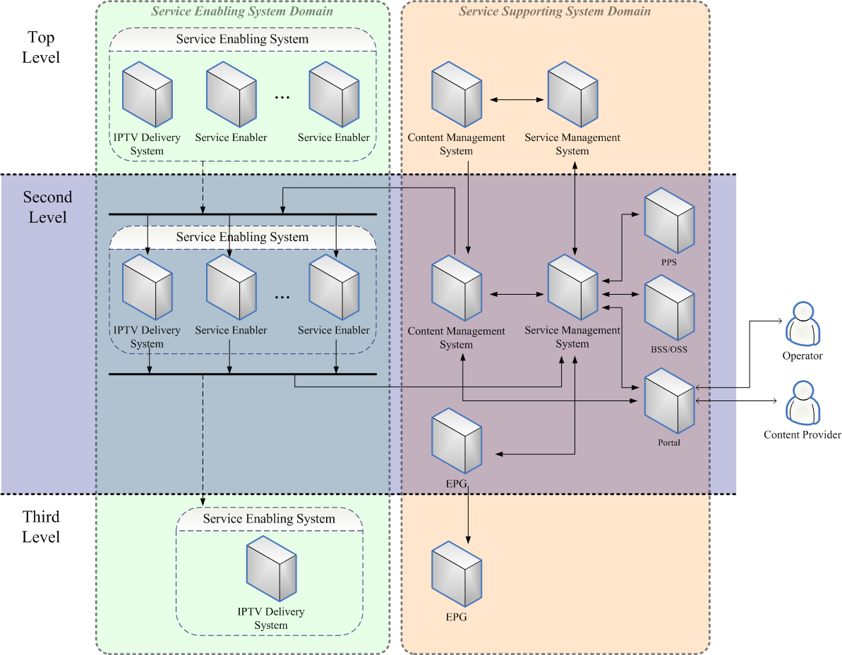

Fig.3 Multi-Level SOP architecture for IPTV system
This document describes a basic SOP architecture for IPTV system and recommends FG IPTV to take a good consideration of this direction for future IPTV architecture and requirements.
____________________

