1. Introduction
INTERNATIONAL TELECOMMUNICATION UNION |  |  |  | Focus Group On IPTV
TELECOMMUNICATION  STANDARDIZATION SECTOR  STUDY PERIOD 2005-2008 |  |  | FG IPTV-C-0148
 |  |  | English only
WG(s): WG5, WG6 |  | 2nd FG IPTV meeting:  Busan, 16–20 October 2006
CONTRIBUTION
Source: | Samsung Electronics
Title: | Requirements for hybrid terminal devices

Today, we see more and more service scenarios where operators wish to provide using a mix of broadcast and broadband networks simultaneously, for providing a more enhanced experience to the TV viewer. It is because of advantages such as faster time to market and reusable contents and infra from existing broadcast services. This contribution includes the requirements of terminal devices which provide both broadcast and broadband interfaces, and are capable of handling mixed services efficiently. And for the purpose of getting more efficient execution of applications in both environments and support of the re-transmitted data broadcasting contents, there are requirements of middleware for application platform also.

2. Requirements of hybrid broadcast-broadband terminal devices
2.1. Definition

For discussions and clear consensus about hybrid terminal device, this contribution suggests a definition of the term. And the abstract architecture of hybrid service model is shown in Figure 1.
Hybrid terminal device: a terminal device that has both broadcast and broadband interfaces
and capable of handling broadcast terrestrial/satellite/cable and
broadband IPTV services synchronously

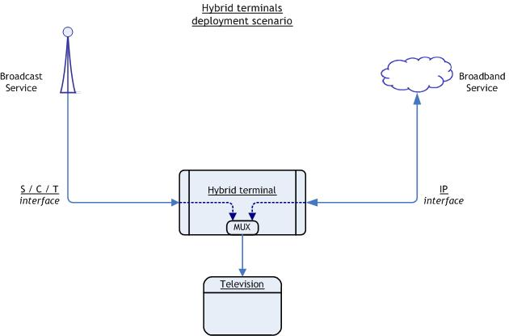
Figure 1. Hybrid terminals deployment scenario

2.2. Data broadcasting middleware
In a hybrid device there is a requirement of appropriate execution of data applications which are included in broadcasted contents through satellite/cable/terrestrial interfaces. This raises requirement for the data broadcasting middleware such as MHP, OCAP and ACAP middleware that are based on GEM application platform. When the IPTV broadband services re-transmit this content over an IP interface, it is also possible to deliver the service bound applications through both interfaces but the need of application platform is remained. For efficient execution of applications or AV program bound data service, the GEM based middleware has considerable strength and market proven coverage of TV oriented data service due to its wide distributions. This provides API sets for vast scope and it also can be used as a common application platform for broadcast and broadband services.

2.3. Content description
For providing convenience and a consistent interface for the users, hybrid terminal devices should be interoperable between both broadcast and broadband interfaces. Thus providing necessary metadata information of the content coming across each connection could be important for us. For instance, the user should be able to select a broadcast or broadband TV services using a contents guide which consists of gathered and unified contents description data.

2.4. Use cases
Attached document is showing some example service scenarios which use hybrid terminal devices.
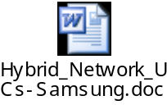

3. Proposal
This contribution proposes some requirements and statements for the hybrid terminal devices
- Consideration of GEM based middleware for the common application platform
- Requirement statement 1: The hybrid broadcast/broadband terminal devices shall have interoperability between both interfaces for contents guide which provides service lists and other information to the user
- Requirement statement 2:
- For the reference of related architecture: From ‘ATIS-080002’, IIF.ARCH.SERVICE.63 ‘The IPTV Architecture shall provide a means for the service provider to provide an integrated presentation of content received at the ITF via out-of-band (to IP) delivery methods and via IP networks – i.e., hybrid methods.’

___________

