INTERNATIONAL TELECOMMUNICATION UNION |  |  |  | Focus Group On IPTV
TELECOMMUNICATION  STANDARDIZATION SECTOR  STUDY PERIOD 2006-2008 |  |  | FG IPTV-C-0129
 |  |  | English only
WG(s): 6 |  | 2nd FG IPTV meeting:  Busan, 16-20 October 2006
CONTRIBUTION
Source: | China Netcom Group, P.R.China
Title: | Service and content navigation system metadata proposal
Proposal
Telecom EPG system, the DVB EPG system and Internet Portal are unified to form a comprehensive service application navigation system. We define it as the service and content navigation system.
Three kind of metadata are defined: Telecom EPG metadata, DVB EPG metadata as well as Internet metadata. From the viewpoint of navigation system, the Internet metadata only needs to know the URL address. Telecom EPG metadata include content and network metadata, user and service metadata. The content and the network metadata are delivered to the content management system, the user and the service metadata are delivered to the service management system.All these metadata be delivered to navigation application server after being processed, and are managed and used by each function module in navigation application server.
The DVB metadata is also delivered to the content management system.
Internet URL is delivered to the WEB server to form the linkage on the navigation page.
All metadata use the XML language to describe.

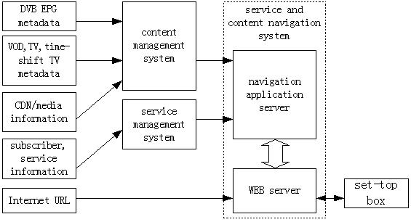

Figure 1 metadata flow and management
- Telecom EPG metadata(typical audiovisual contents)
 | EPG content metadata
Live TV channel | Channel_ID, channel_name,name_length, start_time,end_time,  play_mode,statue,station_ID,time_zone,country/area/city,language,introduction,  SP_code, copyright information,stream_type
VOD/Time-shift TV | Program_ID,program_name, content_ID name_length,SP_code,upload_time,  episode_index, duration ,country/area,language,price,issue_time,  first_play_time, genre,rank,director, actor,actress,preview_begin_time,  preview_end_time,producer,play_writer,product_company,publish_company,  caption,awards,product_time, start_time,end_time,summary,search_key,  screen_format, video_format,audio_format, copyright information
CDN/media streaming information | IP_address,port,channel_URL,bitrate, video codec type and level,  audio codec type and level,video_profile,audio_profile
- Subscriber,service metadata
 | subscriber,service metadata
Channel schedule | EPG_ID,parent, channel_ID,name, comment,logo ,content_ID,  content_name, summary,rank,start_play_time,end_play_time,action,statue
Service entity | Service_ID,service_name, action
Internet Portal | Internet URL
Value-added service | Service_ID,SP_ID
Subscriber information | Name,User_ID, password
- DVB EPG metadata
 | DVB EPG metadata
Network information | network_id, network_name_descriptor,  multilingual_network_name_descriptor, linkage_descriptor
Network information | transport_stream_id,satellite_delivery_system_descriptor,  cable_delivery_descriptor,terrestrial_delivery_system_descriptor,  frequency_list_descriptor,service_list_descriptor,  network_information_section,linkage_descriptor
Service bouquet information | bouquet_id,bouquet_name_descriptor,  multilingual_bouquet_name_descriptor,CA_identifier_descriptor,
Service bouquet information | Service_list_descriptor(service_id,service_type),  bouquet_association_section,linkage_descriptor,
Service description  information | Service_id,service_descriptor,multilingual_service_name_descriptor,  bouquet_name_descriptor,linkage_descriptor,NVOD_reference_descriptor,  time_shifted_service_descriptor, mosaic_descriptor,  CA_identifier_descriptor,multilingual_service_descriptor
Event  information | Event_id,start_time,duration,running_status,content_descriptor,  component_descriptor,multilingual_component_descriptor,  parental_rating_descriptor,short_event_descriptor,  extended_event_descriptor,linkage_descriptor,CA_identifier_descriptor,  time_shifted_event_descriptor,event_information_section
_________________

