INTERNATIONAL TELECOMMUNICATION UNION |  |  |  | Focus Group On IPTV
TELECOMMUNICATION  STANDARDIZATION SECTOR  STUDY PERIOD 2006-2008 |  |  | FG IPTV-C-0128
 |  |  | English only
WG(s): 6 |  | 2nd FG IPTV meeting:  Busan, 16-20 October 2006
CONTRIBUTION
Source: | China Netcom Group, P.R.China
Title: | Service and content navigation system architecture and it’s function requirements
Discussion
“Three networks Convergence”, refered to the telecom network, the CATV network and Internet,include network layer Convergence, application and service layer Convergence,and the Convergence architecture is the so-called NGN architecture. In the service and application layer, it is needed to have a unified service navigation system.It is proposed that the telecom EPG system, the DVB EPG system and Internet Portal are unified to form a comprehensive service application navigation system. We define it as the service and content navigation system.
In order to realize the unified service and the content navigation system, three kind of abstract TV channels( services navigation entrance )on the homepage could be defined for users’ convenience and experience. For instance, telecom EPG defined as the TV channel 1, DVB EPG defined as the TV channel 2, Internet Portal defined as the TV channel 3. If the telecom service platform and the DVB service platform are combined into one, then user's request may be processed by the same backstage system. Then comes a sole service and content navigation system.

Abbreviation
service and content navigation system-----SCNS
navigation application server----NAS

Architecture and function requirements:
The service and content navigation system(SCNS) architecture in the IPTV platform includes two major parts: navigation application server(NAS) and WEB server(see Figure 1).
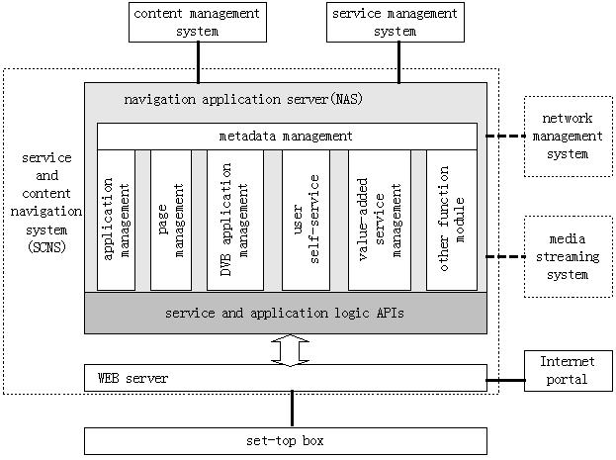

Figure 1 The IPTV service and content navigation system architecture

1 Function requirements of WEB server( refer to FGIPTV-ID-0089e )
a. The production of SCNS pages and page Cache
b. The parse and response of the user’s request
c. Portal of Internet service entrance

2 Navigation application server(NAS) ( refer to FGIPTV-ID-0089e )

2.1 Service and application logic APIs

2.2 Function requirements of NAS
a. Page management module
*b. (Telecom)Application management module
Application management module responds the request of the user’s VOD and live TV,time-shift TV, manages advertisements, browsing and other services, what’s more, to provide interfaces to user’s service management system and network management system etc. Application management module also fulfills monitoring to all application process.
*c. DVB application management module
DVB application mainly includes DTV,other value-added services.The DVB application management module is responsible for the DVB application management, and provides the invoke interfaces of DVB service. If at the same time telecommunication operator also manages DVB service, then the DVB application management module could be put into the above application management module.
*d. Value-added service managememt module
As to the colorful and ever changing value-added service, there are two ways to visit and manage it. One way is directly to set up the linkage on Web Server, and click on the linkage point directly to enter the value-added service system. Another way is to set up an value-added service management module.The module provides some API function to be called by the Web server. If the value-added service management platform be separated from the IPTV basic service management platform, then this module be needed solely to provide APIs to complete the service backstage logic processing. If value-added service be managed by IPTV service management platform, then this module be replaced by the above application management module.
e. User’s self-service module
f. Other function module
g. Metadata management module
h. Interfaces with other systems

3 China Netcom Proposal
It is proposed that the telecom EPG system, the DVB EPG system and Internet Portal are unified to form a comprehensive service application navigation system. Then it is the service and content navigation system.
_________________

