INTERNATIONAL TELECOMMUNICATION UNION |  | Focus Group on ICT&CC
TELECOMMUNICATION  STANDARDIZATION SECTOR  STUDY PERIOD 2005-2008 |  | FG ICT&CC-C-19
English only
Original: English
 |  | Geneva, 1-3 September 2008
CONTRIBUTION
Source: | BT
Title: | Delivering Carbon Savings from ICT

Background
With our current dependence on fossil fuels almost all manufactured products have a carbon footprint determined by the type of product, the designer’s choice of materials, transportation of the finished product, in use emissions and disposal. However, some products can enable CO₂ emission reductions in other sectors during the “in life” phase of the product life cycle. The measuring of the embedded CO₂ in products is an area of ongoing research with organisations including the British Standards Institute and the Carbon Trust seeking to develop a global standard.
The ICT sector’s own emissions are expected to increase to 1.43 GtCO2e in 2020. But specific ICT opportunities could lead to emission reductions five times the size of the sector’s own footprint by the same date. Many of these CO₂ emission reductions are in fact driven by behaviour changes in the way we communicate and the way we work. For example face to face meetings can be replaced with audio and web conferencing thus avoiding travel and a more flexible work style can also reduce the office space required. The challenge for the ICT industry is to ensure that CO₂ emission measurement and reporting standards recognise this contribution.
Reporting
To increase consistency and transparency in Greenhouse Gas (GHG) accounting and reporting among organisations the measurement of GHG emissions must be consistent with the reporting guidelines that are adopted globally. BT’s Carbon Impact Assessment (CIA) has been developed to complement the most widely used global standard for corporate GHG reporting the Greenhouse Gas Protocol.
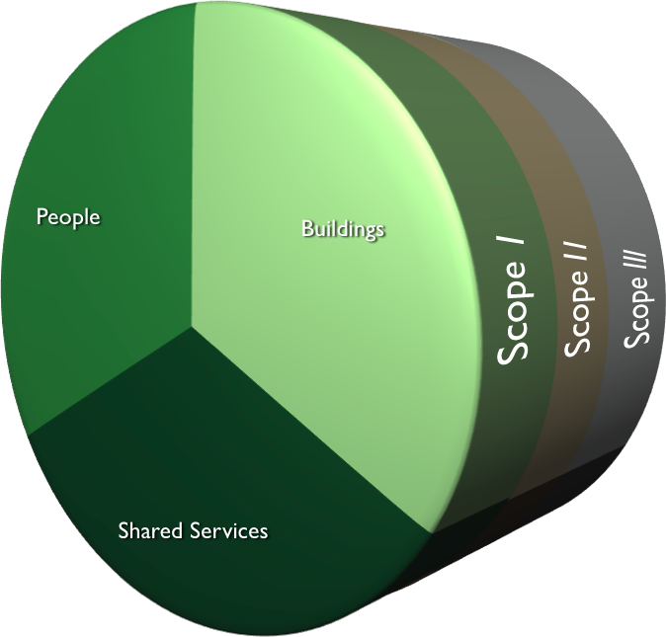

BT’s CIA was developed to measure an organisation’s CO₂ emissions from its business processes associated with all three scopes of GHG emissions identified in the GHG protocol as:
Scope 1: Direct GHG emissions
Direct GHG emissions occur from sources that are owned or controlled by the company, for example, emissions from combustion in owned or controlled boilers, furnaces, vehicles, etc.;
Scope 2: Electricity indirect GHG emissions
Scope 2 accounts for GHG emissions from the generation of purchased electricity consumed by the company.
Scope 3: Other indirect GHG emissions
Scope 3 is an optional reporting category that allows for the treatment of all other indirect emissions. Scope 3 emissions are a consequence of the activities of the company, but occur from sources not owned or controlled by the company.
Organisations that are required to report emissions using the GHG Protocol are mandated to report scope 1 and 2 emissions and optionally scope 3 emissions. Therefore excluding commuting travel, business travel and the home office environment which are all considered in scope 3. Similarly the proposed Carbon Reduction Commitment which will impose a cap and trade scheme on the largest organisations in the UK will include only emissions from energy use in buildings. If this trend continues ICT will only be considered as a net contributor to CO₂ emissions and the benefits to other parts of an organisation and other sectors ignored.
Measurement of CO2 Emissions
Reporting CO₂ emissions from the entire organisation will help to show the benefit of ICT, but organisations must first baseline current emissions and set targets for CO₂ reduction. BT’s Carbon Impact Assessment does just this by measuring CO₂ emissions from buildings, people and external services coupled with a bottom up and top down approach this methodology setting is a gold standard in CO2 emission measurement for corporate organisations.
People
People are assessed for their contribution to CO₂ emissions from travel and devices and are given a work style carbon footprint based on the way they work. Examples of carbon footprints for different work styles are given below.

Measuring these footprints is difficult and is probably the reason that new Cap and Trade schemes and many companies don’t report in this area. One of the reasons for this complexity lie in the level of detail required for assessing emissions from travel (see recommendations). Should the commute of staff from an organisation be reported as an average? Or should a survey be sent to all staff for a more accurate picture of emissions? The latter requires more effort and should create a more comprehensive view of CO₂ emissions associated with commuter travel against which to show improvements over the coming years. It’s important to get this right; one of BT’s government sector customers travelled ten million business miles a year and without a detailed travel survey it would be very difficult to estimate where and for what purpose those miles were incurred. When emissions associated with travel are understood ICT solutions can be recommended. The chart below demonstrates how replacing face to face meetings could reduce CO₂ emissions and cost, based on the activities of a UK government sector organisation.

Buildings
Buildings are assessed for their contribution to the organisation’s carbon footprint and include the energy used for heating and lighting, and any business processes that occur in that building. BT’s Carbon Impact Assessment enables organisations to baseline current emissions and discovers the areas where CO₂ emissions and costs can be reduced by using ICT. Data centres are increasingly coming under scrutiny as an area where quick wins for both reductions in CO₂ emissions and cost can be achieved.

Shared or External Services

Many organisations rely on services provided by others for the day to day running of their business. In these instances the carbon footprint reaches beyond buildings and people to the CO₂ emissions of service providers. Excluding external services from carbon foot printing methods enables organisations to outsource their CO₂ to others and could drive the off shoring of business impacted by in country CO₂ emission Cap and Trade schemes. Reporting and measurement in this area can be achieved through benchmark data for CO2 emissions from different sectors

Recommendations
It is proposed that the Greenhouse Gas Protocol a Corporate Accounting and Reporting Standard is a suitable method for measuring and reporting the contribution that ICT makes to CO₂ emissions. Further investigation and discussion would be welcomed.
A global standard for measuring the CO₂ emissions associated with ICTs must include a definition of the level of detail required for both in use and embodied CO₂. This requires further investigation by the Focus Group.
Benchmarks from CO₂ emission foot printing work maybe useful to allow harmonisation of methodologies between organisations, especially across international boundaries where the mix of fossil and non-fossil fuels is different. A central repository is required for this purpose, where could this be held and how would it be administered. Further investigation and discussion would be welcomed.

About BT
BT has a long tradition in reducing its CO₂ emissions and sees ICT as a key enabler to achieving medium term energy reductions. Organisations are seeing large reduction in costs from the appropriate use of ICT for example BT has made £365m worth of environmental savings since 2004 and has a target to reduce CO₂ emissions by 80% from 1996 levels by 2020.

SMART 2020: Enabling the low carbon economy in the information age, the climate group and the Global e-Sustainability Initiative, 2008
The Greenhouse Gas Protocol – a Corporate Accounting and Reporting Standard by the World Business Council for Sustainable Development and the World Resources Institute - 2004

