INTERNATIONAL TELECOMMUNICATION UNION |  | Focus Group On  "From/In/To Car Communication"
TELECOMMUNICATION  STANDARDIZATION SECTOR  STUDY PERIOD 2005-2008 |  | FG FITCAR-C-9
English only
Original: English
 |  | Geneva, 25 June 2007
CONTRIBUTION
Source: | Volkswagen, Braunschweig Technical University
Title: | Digital Interface Concept Section for Inclusion into the HF Specification
Digital Interface Concept Section for Inclusion into the HF Specification

Summary
On the last meeting in Ulm, Germany, on March 15, 2007, the focus group encouraged the preparation of a section “Digital Interface Concept for Development and Debugging” for inclusion into the Draft Hands-Free Communication Specification. Taking up the focus group’s ideas for even further digital access points, we propose the following text for inclusion into the specification.

Digital Interface Concept for Development and Debugging
For the purpose of development, testing and debugging of a HF system a number of digital interfaces should be realized. Digital interfaces allow to record and investigate signals at the specified access points. Some of the digital interfaces at access points before the HF system processing should also allow for writing/adding a digital signal to the signal path. This is true for the sending as well as for the receiving path.
Depending on the access point, any of the following three access means should be possible:
- READ: Writing the respective signal into a file
- WRITE: Replacing a certain signal in the system by a digital signal from a file
- ADD: Adding a digital signal from a file to a certain signal in the system
Figure 3 gives an overview to the digital interfaces that are useful for development and debugging.
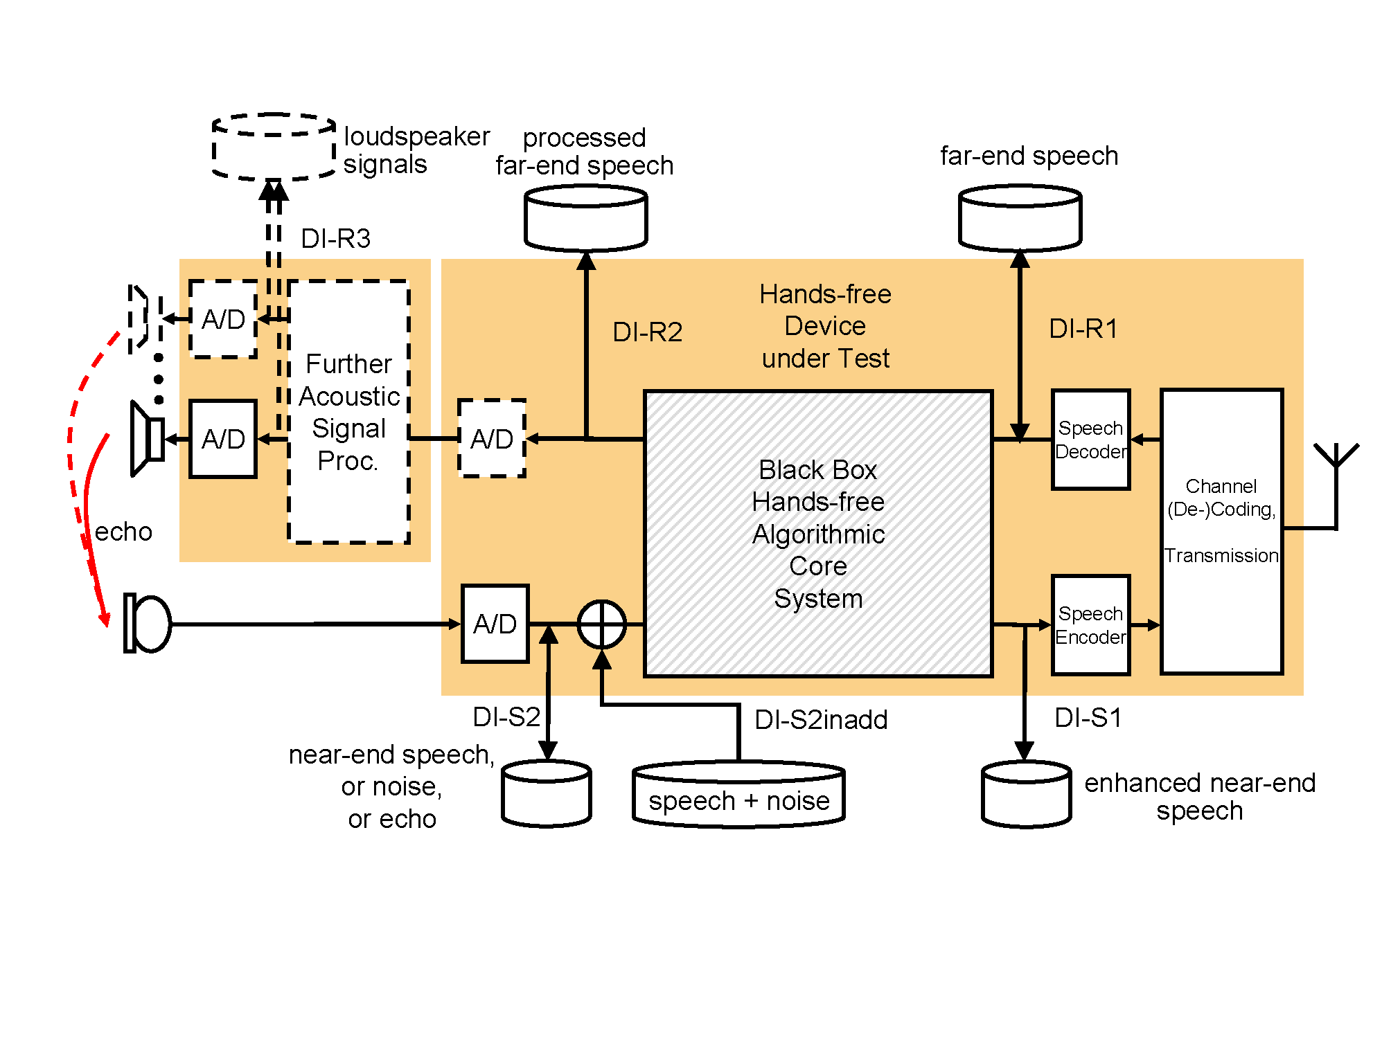
Fig. 3: Digital Interface Concept
The digital interfaces (DI) are called DI-{R | S}n with R standing for receiving path and S standing for sending path. The number n is used to distinguish between different digital interfaces in sending and receving path, respectively.
DI-R1 can be used to record transmitted far-end speech (READ) or to test the hands-free device under test using recorded signals without actual involvement of a system tester (WRITE).
DI-R2 in comparison with DI-R1 can be used to evaluate the HF systems core algorithms in the receiving path. Here only READ access should be realized.
In some systems further digital signal processing may be used, connected digitally or analog to the HF algorithmic core system. In this case DI-R3 yields useful signals to evaluate this system component. Such further acoustic signal processing may comprise an artificial bandwidth extension, or it may comprise typical audio processing functions related to a number of loudspeakers used (equalizers, room effects).
In the sending path, DI-S2 is the access point of highest interest. If any of the digital access points is realized, this one shall be realized as well. It allows recording (READ) of any test case signals after the AD converter. Developers and testers may choose this access point to pre-record all near-end noises in their test szenario, stemming from real driving situations or from a background noise playback arrangement. Also they may choose to pre-record all near-end speech or speech-like signals in their test szenario. DI-S2 should also allow WRITE access.
Given unchanged analog processing and AD conversion in the sending path, the recorded noise and near-end signals can then be used to repeat test cases in an efficient way. This becomes possible by digital offline addition of near-end speech and noise, and by feeding this signal back into the sending input path to the HF system DI-S2inadd (ADD). In such case only the echo needs to be available in the car cabin. Therefore, no exact positioning of the HATS is required, or no HATS at all is necessary. A major reduction in test effort is achieved by avoiding background noise simulation or even testing with real driving noise.
Finally, DI-S1 allows to access the HF system output signal in sending direction (READ). This signal gives important information about the core HF system’s functionality: Namely acoustic echo cancellation and noise reduction. In end-to-end test simulations (near-end to far-end) it is sometimes hard to relate problematic HF equipment behavior to the HF system stand-alone, or to its interaction with speech codec or network-sided voice enhancement devices. Investigation of signals recorded via DI-S1 may give an answer to this question.
One of the following formats should be supported:
- 16 bit linear PCM
- G.711 A law
- G.711 mu law
The sampling frequency of the digital interfaces should be 8 kHz, except where processing in the HF system is performed at different sampling rates.

_________________

