INTERNATIONAL TELECOMMUNICATION UNION |  | Focus Group On  "From/In/To Car Communication"
TELECOMMUNICATION  STANDARDIZATION SECTOR  STUDY PERIOD 2005-2008 |  | FG FITCAR-C-6
English only
Original: English
 |  | Geneva, 26 January 2007
CONTRIBUTION
Source: | HEAD Acoustics GmbH
Title: | Intelligibility of Hands-free Phone Calls Outside the Vehicle

Motivation
The intelligibility of telephone conversations outside the vehicle is a very important aspect. Users are not always aware of this situation although it happens often: the telephone conversation is finished on the parking side in front of the office, pedestrians can follow a conversation from a vehicle waiting at the traffic light…. The reason for this undesired effect is elementary: the downlink signal of a telephone conversation, typically being played back via the built-in loudspeakers in the front door, excites the door structure. The whole surface emits the audible sound outside on the vehicle.
Many users and drivers are not aware of this effect. They don’t take notice that “third parties” witness their conversation. This is especially annoying if confidential content is exchanged. Privacy is not anymore guaranteed. Moreover this also implies a political aspect: a huge effort is taken by legislation in order to lower the external vehicle sound produced e.g. by motors, exhausting systems and tires [1]. This aspect, the audible telephone conversations and music playback via the internal audio systems has – so far – not been addressed.

Introduction
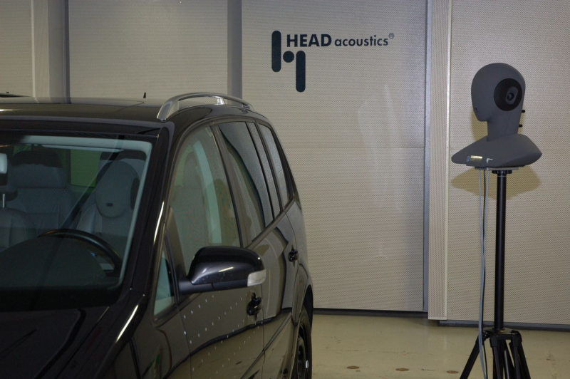
Fig. 1: Intelligibility outside vehicles
From the customers point of view the intelligibility of telephone conversations outside the vehicle can be regarded as a “telecommunication problem”. However a closer inspection immediately points out that this problem also needs to be addressed by the audio system engineers and audio system providers. The acoustical and/or structure-born coupling between the loudspeakers and the chassis needs to be evaluated in detail in order to verify the transmission paths and individual contributions in an individual car. Combined measures like level and spectral analyses, intelligibility and perceptual measures as well as vibration analyses are necessary in order to document it and evaluate the effect of modifications – reason enough to address this problem and setup appropriate test methods to solve it.
A test setup to measure the acoustically relevant parameters is shown in figure 2. An artificial head measurement system (Head and Torso Simulator, HATS [2]) is positioned on the drivers’ seat. This system is used to adjust and measure relevant parameters inside the vehicle like playback volume, frequency responses, speech intelligibility and listening speech quality scores. The hands-free telephone installed in the test car is accessed via a radio tester (e.g. GSM network simulation). The connected test system ACQUA (HEAD acoustics) guarantees an automatic test run. This system provides the full VDA specification [3] testing capability and is also suited to be used for different applications – like speech intelligibility measurements outside the car.
Fig. 2: Test setup to assess speech quality and speech intelligibility parameters inside and outside the vehicle

A HATS is positioned outside the car cabin. Measurements are carried out in a distance of e.g. 1 and 2 m from the B-pillar. The HFT playback setting is adjusted in order to use only the front speaker in the drivers’ door. All other speakers are muted. Tests are carried out exemplarily in one vehicle. This car (VW Touran) is selected for practical reasons; it is available in the company car pool.

Assessment Methods
Fig. 3: Sensitivity characteristics in receiving, inside (green) and outside (red) the vehicle at nominal level | Fig. 4: Speech intelligibility index inside (green) and outside (red, with speech level +8dB) in a simulated noise scenario depending on the level of background noise (blue curve)
The intelligibility outside the vehicle is a problem that addresses different technical groups - telecommunication, audio, construction and development. Combined measures are therefore necessary to provide the different information. A set of descriptive tests is necessary to document the current status and to provide a baseline to verify the effectiveness of modifications.
In a first step the spectral characteristics of the transmitted speech is measured between the GSM network interface (radio tester) and the artificial head’s right ear inside and outside the vehicle. Figure 3 shows the two curves (inside: green and outside: red) in a distance of 1 m with the ear plane orthogonal to the drivers’ door. The level difference between both ear signals (inside and outside recordings) is approximately 22 dB for this car. The comparison of both curves in figure 3 provides a first indication of the coupling between the loudspeaker and the car chassis.
The speech intelligibility index [4], a spectrally weighted analysis method comparing average speech and noise spectra is applied in order to verify its suitability in this scenario. Figure 4 shows the two curves measured inside and outside the vehicle (green respectively red). These measures are carried out in free-field anechoic test conditions (see figure 1). In order to simulate the influence of background noise on the speech intelligibility ambient noise is simulated. The noise used for that purpose is a “Hoth Noise [5]” (spectrally shaped random noise) with increasing level. The level is indicated on the left hand y-axis. The comparison of both SII curves clearly indicates that the intelligibility outside the testing vehicle is lower than inside – even though the level of the speech signal in the car is increased by 8 dB which represents a typical level adjusted by the driver while driving. Typically this level is not changed during a call, even if the car is stopped e.g. at a traffic light. As shown in figure 4 the speech intelligibility outside the car is high in this situation. With increasing noise level (e.g. due to traffic noise outside) the speech intelligibility decreases. This principle is probably valid for other cars as well, but the speech signal level as well as the spectral content are definitely car dependent. The results shown are indicative and require more detailed investigation, the results should be regarded with some care. Moreover it should be noted that the intelligibility of a conversation may be higher than indicated by the SII measurement to the context information given in sentences. Further precautions need to be considered when applying the SII: The method is based on a weighted spectral distance between average speech and noise spectra. Consequently it may lead to inaccuracies if is applied for low speech levels.
Besides these speech-based analyses a laser scan of the drivers’ door links the intelligibility to the technical source of the emitted signal - a vibration analysis (see figure 6). A sweep excitation signal is used and the door’s amplitude and velocity is analyzed. As an example the amplitude spectrum averaged over all approximately 150 target points spread over the drivers’ door is shown in figure 7.

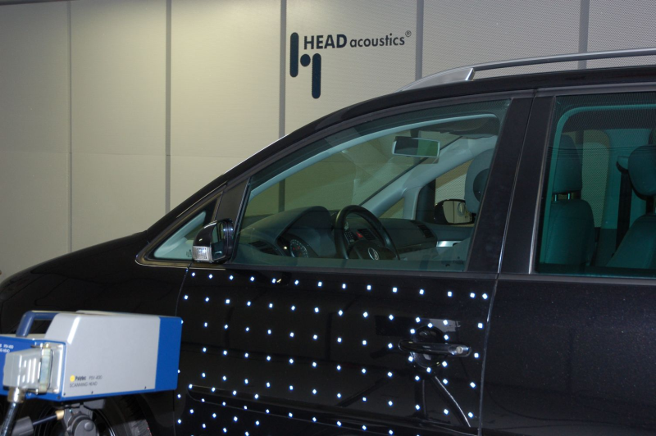 | 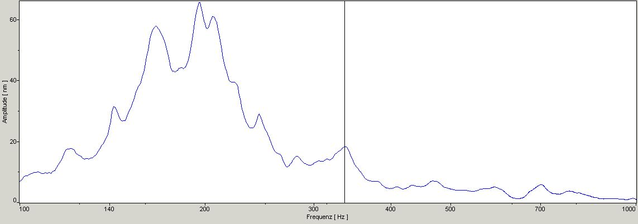
Fig. 6: Laser scan | Fig. 7: Amplitude spectrum
Dominant components and frequency peaks like the 336 Hz door resonance (marked by the vertical line in figure 7) can be detected as well as notches. Dynamical, time variant vibration analyses can then be used to analyze surface vibrations in detail in order to estimate the gain of –typically expensive- door modifications. Figure 8 and 9 show two isolated 2D laser scan plots of these analyses. The loudspeaker is excited by a sweep, the example given is analyzed for the 336 Hz frequency. The vibration amplitude is color coded between -100 nm (light green) and +100 nm (light red).
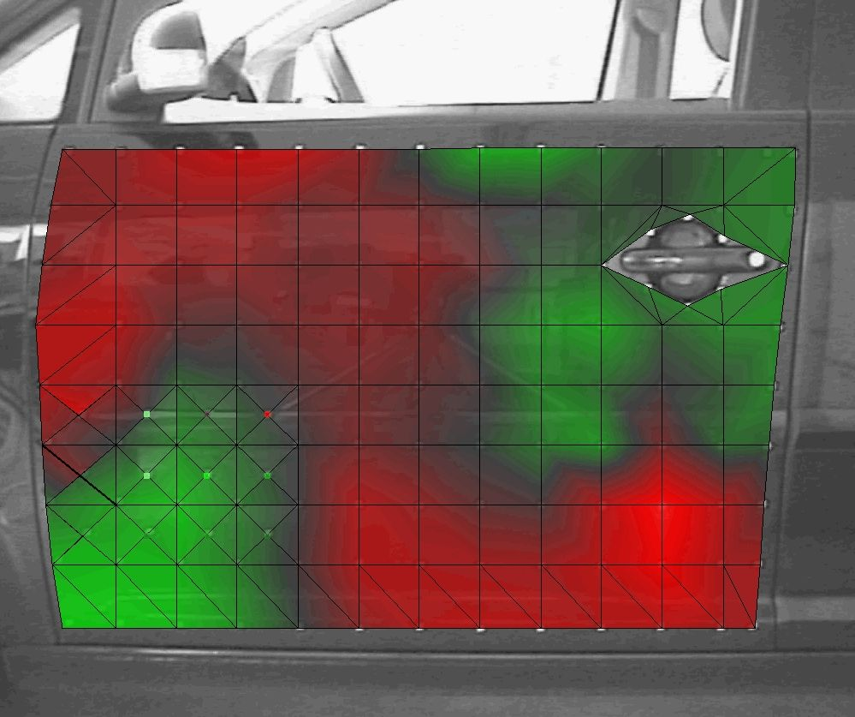 | 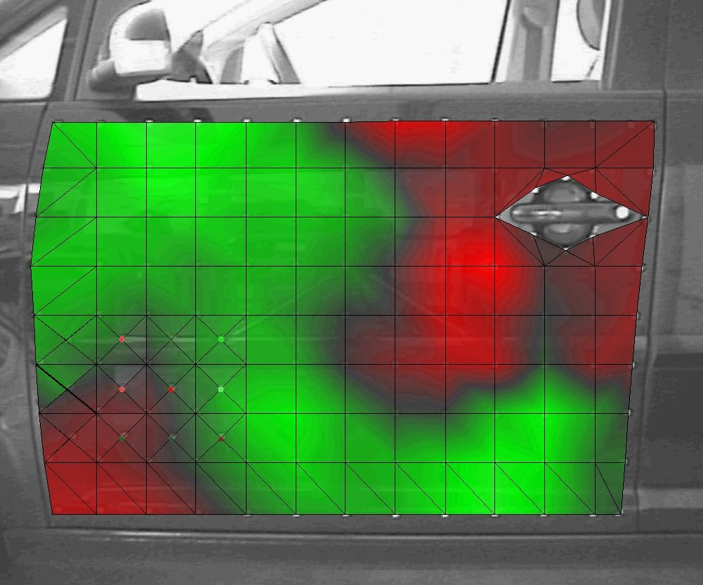
Fig. 8: Laser scan 1 (336 Hz) | Fig. 9: Laser scan 2 (336 Hz)

Further tests focusing on the potential improvement gained by damping material or modified loudspeaker mountings in this car are conducted. The analyses are ongoing but -as a first approach- the evaluations in this test car bring up the conclusions, that the major contribution is caused by acoustical coupling instead of structure-born coupling.

Outlook
A set of tests suitable to cover not only the speech intelligibility parameters itself but also additional vibration analyses is currently established. The intention is
- to provide objective measures necessary to document the current status and verify the effectiveness of modifications,
- to derive hints and ideas on how to solve or at least limit the intelligibility outside the car
- to use these objective data as a basis for a cost estimate to decide about modifications.

A suggestion for reasonable limits for these analyses can be derived from a simple practical approach - the intelligibility of driver’s voice outside the car.

[1] 70/157/EWG - Richtlinie des Rates zur Angleichung der Rechtsvorschriften der Mitgliedsstaaten über den zulässigen Geräuschpegel und die Auspuffvorrichtung von Kfz, 6. Feb. 1970
[2] ITU-T Recommendation P.58, Head and Torso Simulators for Telephonometry
[3] VDA Specification for Car Hands-free Terminals, Draft Version 1.5, August 2004
[4] ANSI S3.5-1997 - Methods for Calculation of the Speech Intelligibility Index
[5] Methoden zur Messung der Sprachgüte I: Verfahren zur Bestimmung der Satz- und Wortverständlichkeit, J.Sotschek, Der Fernmeldeingenieur, 1976

_____________

