INTERNATIONAL TELECOMMUNICATION UNION |  | Focus Group On  "From/In/To Car Communication"
TELECOMMUNICATION  STANDARDIZATION SECTOR  STUDY PERIOD 2005-2008 |  | FG FITCAR-ADM-11
English only
Original: English
 |  | Göteborg, 24 January 2008
ADMIN DOCUMENT
Source: | FG Chairman
Title: | Invitation to the 6th Focus Group Meeting FITCAR

Aachen, 28 July 2026
Invitation to the 6th Focus Group Meeting to be held
January 24 in Göteborg (Gothenburg)
Link to registration & meeting documents
http://www.itu.int/ITU-T/studygroups/com12/fgfit/index.html
Dear Colleague,
On behalf of the ITU-T focus group FITCAR I have the pleasure of informing you about the arrangements for the above-mentioned meeting hosted by Ingenjörsfirma Mats Forsén Data AB.
Address of the meeting |  | Ullevi Restaurang & Konferens  Paradentrén  SE-41140 GÖTEBORG  Phone: +46 31 739 09 50  Mats Forsén  Phone: +46 733 47 12 41  Email: mats(at)forsen.se
mEETING SCHEDULE |  | The meeting will start on January, 24, 2008 at 09.00.  The meeting will end on January, 24, 2008 at 17.00.
REGISTRAtion |  | Please register at the focus group Website before January, 22, 2008
Documents for the meeting |  | Please upload meeting documets in advance to the meeting to the focus group Website
Hotel Information |  | Please see:
How to find the meeting place | See:  http://www.hitta.se/ViewDetailsPink.aspx?Vkiid=F004PTQitOZ08IYLd9qS6g%3d%3d&vad=Ullevi&var=G%f6teborg  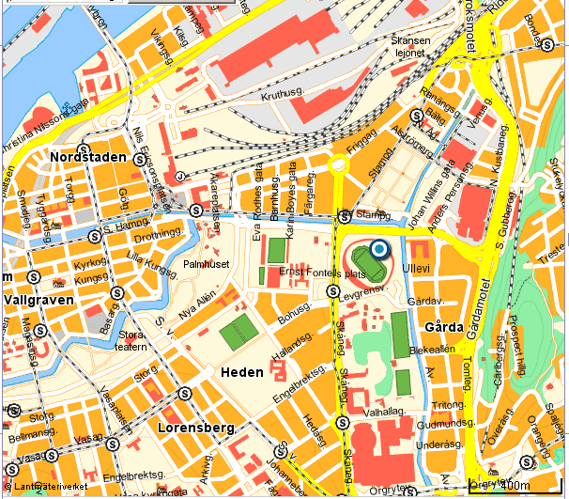  Detail:  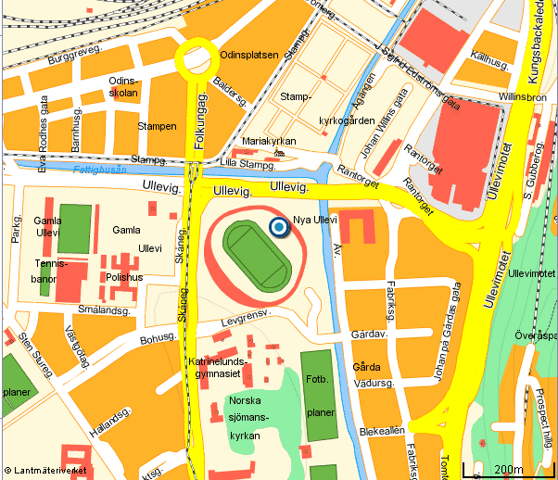
I look forward to seeing you in Göteborg
Yours sincerely
Hans W. Gierlich

______________

