INTERNATIONAL TELECOMMUNICATION UNION |  | Focus Group On  "From/In/To Car Communication"
TELECOMMUNICATION  STANDARDIZATION SECTOR  STUDY PERIOD 2005-2008 |  | FG FITCAR-ADM-7
English only
Original: English
 |  | Nürnberg, 12 September 2007
ADMIN DOCUMENT
Source: | FG Chairman
Title: | Invitation to the 4th Focus Group Meeting FITCAR

Aachen, 31 July 2026
Invitation to the 4th Focus Group Meeting to be held
September 12 in Nürnberg
Link to registration & meeting documents
http://www.itu.int/ITU-T/studygroups/com12/fgfit/index.html
Dear Colleague,
On behalf of the ITU-T focus group FITCAR I have the pleasure of informing you about the arrangements for the above-mentioned meeting hosted by DELPHI GRUNDIG.
Address of the meeting | DELPHI GRUNDIG  Dieter Bräunig (Dipl.- Ing.)  Entertainment & Communications Europe  Delphi Delco Electronics Europe GmbH  Beuthener Strasse 41  D-90471 Nuernberg  Phone: +49 (911) 703 8924  Fax: +49 (911) 703  Email: dieter.braeunig@delphi.com
mEETING SCHEDULE | The meeting will start on September, 12, 2007 at 09.00.  The meeting will end on September, 12, 2007 at 17.00.
REGISTRAtion | Please register at the focus group Website before September, 10, 2007
Documents for the meeting | Please upload meeting documets in advance to the meeting to the focus group Website
Hotel Information | Please see:  www.grand-hotel.de  http://www.maritim.de/typo3/index.php?id=700  http://www.tagungshotel.com/hotel_1080713387.htm
How to find the meeting place |  | See: http://www.delphigrundig.de/index.php?id=55&L=0  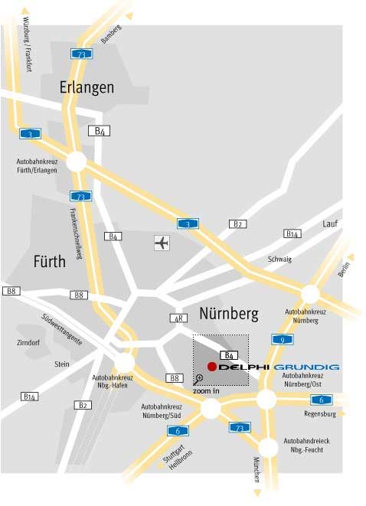  Detail:  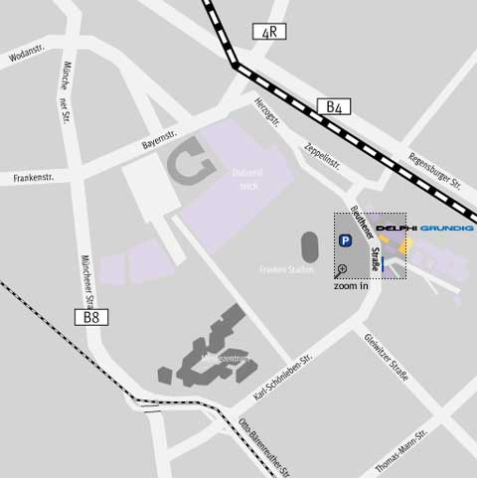
I look forward to seeing you in Nürnberg
Yours sincerely
Hans W. Gierlich

______________

