INTERNATIONAL TELECOMMUNICATION UNION |  |  |  |  |  | Focus Group On "From/In/To Cars Communication II"
TELECOMMUNICATION  STANDARDIZATION SECTOR  STUDY PERIOD 2005-2008 |  |  |  |  |  | FG CarCom-ADM-5
English only
Original: English
 |  |  |  |  |  | Aachen, 18-19 December 2008
ADMIN DOCUMENT
Source: |  |  |  | FG Chairman
Title: |  |  |  | Invitation to the 3rd Meeting of Focus Group CarCom
Invitation to the 3rd Meeting of Focus Group CarCom
to be held from 18-19 December 2008, in Aachen
Link to registration & meeting documents:
http://www.itu.int/ITU-T/studygroups/com12/fgcarcom/index.html
Dear Colleague,
On behalf of the ITU-T Focus Group CarCom I have the pleasure of informing you of the arrangements for the above-mentioned meeting hosted by HEAD acoustics.
 | Address of the meeting |  |  |  | HEAD acoustics GmbH Phone: +49 (241) 57726  Ebertstrasse 30a Fax: +49 (241) 577 99  D-52134 Herzogenrath-Kohlscheid Email: maria.kuck@head-acoustics.de
 | mEETING SCHEDULE |  |  |  | The meeting will start on 18 December 2008 at 14.00.  The meeting will end on 19 December 2008 at 15.00.
 | REGISTRAtion |  |  |  | Please register at the Focus Group website before November 25, 2008
 | Documents for the meeting |  |  |  | Please send meeting documents in advance of the meeting to TSB for uploading to the Focus Group website.
 | Hotel Information |  |  |  | For the meeting we have booked a limited contingent of rooms at the “Mercure am DOM” in Aachen from December 18 to December 20, see below. If you would like to stay at this hotel please let us know by email until November 26 at the latest, as the reservation is limited. We will then book the hotel room for you. Please indicate if you will stay for one or two nights. The confirmation of the hotel booking will be sent to you immediately after booking. We are looking forward to seeing you at the CarCom meeting at HEAD acoustics. Should you need further information please contact us.  For directions please see:  http://www.mercure.com/mercure/fichehotel/de/mer/5326/fiche_situation.shtml

How to find the meeting place | See: http://www.head-acoustics.de/de/approach.htm  Directions from the hotel to the meeting place:  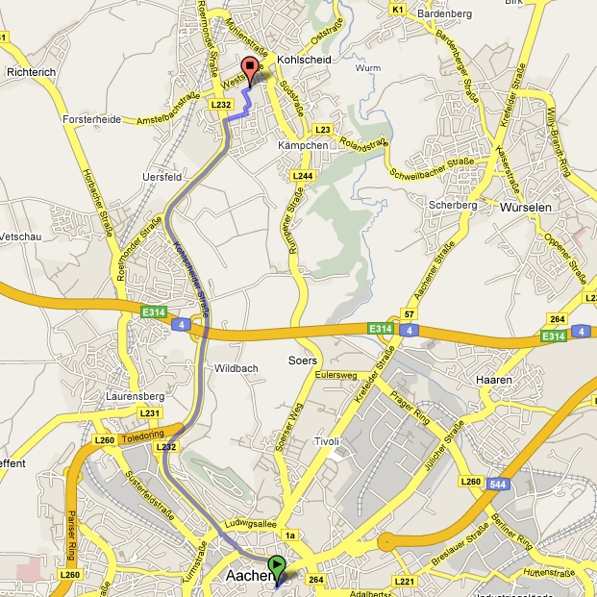
I look forward to seeing you in Herzogenrath-Kohlscheid
Yours sincerely
Hans W. Gierlich

______________

