INTERNATIONAL TELECOMMUNICATION UNION |  | Focus Group On "From/In/To Cars Communication II"
TELECOMMUNICATION  STANDARDIZATION SECTOR  STUDY PERIOD 2005-2008 |  | FG CarCom-ADM-1
English only
Original: English
 |  | Nærum, 12 June 2008
ADMIN DOCUMENT
Source: | FG Chairman
Title: | Invitation to the First Meeting of the Focus Group CarCom

Aachen, 28 July 2026
Invitation to the 1st Meeting of the Focus Group CarCom to be held
on 12 June in Nærum, Denmark
Link to registration & meeting documents
http://www.itu.int/ITU-T/studygroups/com12/fgcarcom/index.html
Dear Colleague,
On behalf of the ITU-T Focus Group CarCom I have the pleasure of informing you of the arrangements for the above-mentioned meeting hosted by Brüel & Kjaer.
Address of the meeting | Brüel & Kjær  Skodsborgvej 307  2850 Nærum, Denmark  Phone: +45 45 800 500  http://www.bksv.com  Lars Birger Nielsen  +45 77 412 601  Email: lbnielsen@bksv.com
mEETING SCHEDULE | The meeting will start on 12 June, 2008 at 09.00.  The meeting will end on 12 June, 2008 at 17.00.
REGISTRAtion | Please register at the Focus Group website before 09 June, 2008
Documents for the meeting | Please send meeting documents in advance of the meeting to TSB for uploading to the Focus Group website.

Hotel Information | Hotel in centre of Copenhagen  Copenhagen Admiral Hotel  Toldbodgade 24-28  1253 København K  +45 3374 1414  http://www.admiralhotel.dk  If you take a taxi from this hotel to Brüel & Kjær – ask the taxi driver to take the scenic route by the sea – it is call the “Strandvejen”.  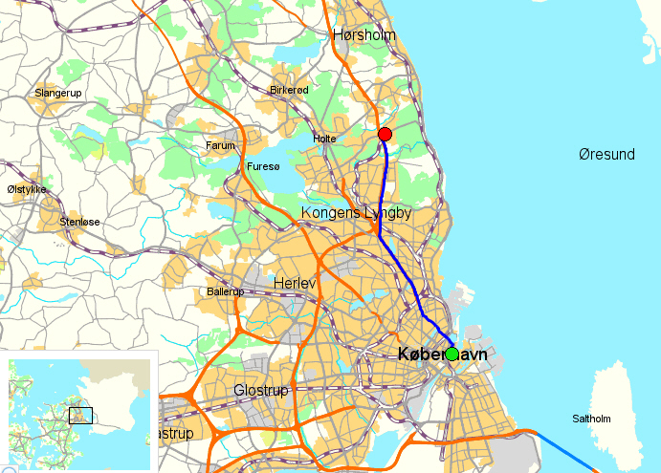  Hotel near to Brüel & Kjær Headquarters  Skodsborg Kurhotel & Spa A/S  Skodsborg Strandvej 139  2942 Skodsborg  +45 4558 5800  http://www.skodsborg.dk  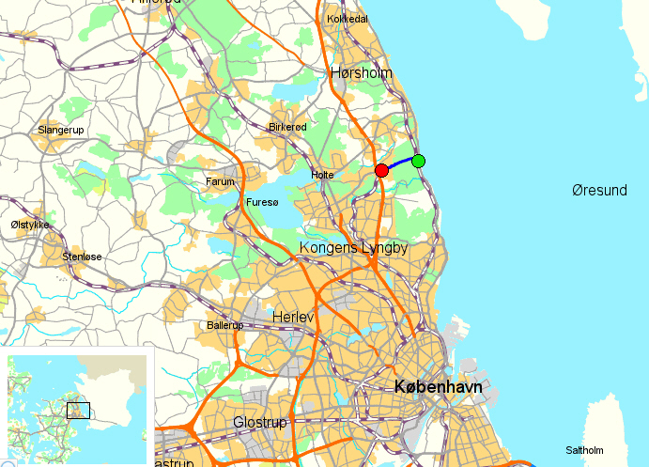
I look forward to seeing you in Nærum,
Yours sincerely
Hans W. Gierlich

_____________

