Geneva, 1 April 2003
INTERNATIONAL TELECOMMUNICATION UNION
Telecommunication
Standardization Bureau

Ref: | TSB Circular 150 | - To Administrations of Member States of the Union;  - To ITU-T Sector Members;  - To ITU-T Associates
Tel:  Fax:  E-mail: | +41 22 730 5851  +41 22 730 5853  tsbdir@itu.int | Copy:  - To the Chairman of TSAG;  - To the Director of the Telecommunication Development Bureau;  - To the Director of the Radiocommunication Bureau  Also copy:  - To ISO Secretary General;  - To IEC General Secretary

Subject: | Standards Management Training Programme and its Questionnaire
Dear Sir/Madam,
The last meeting of the World Standards Cooperation (WSC), which consists of the management team members of ITU-T, ISO and IEC, took place in Geneva on 19 February 2003. TSAG, at its meeting from 24 to 28 February 2003, took note of the report of the last WSC meeting, and endorsed the continuation of WSC collaboration with ISO and IEC for joint promotion activities, ref. TSAG-R 27, clause 5 “World Standards Cooperation (WSC) activities”.
Among joint activities discussed, the WSC agreed to propose to the members of the three organizations a standards management training programme. A convening letter, jointly signed by the executives of the three organizations, together with the proposed programme and questionnaire are provided in Annex 1. ITU-T Members are kindly requested to return their replies preferably before 30 April 2003 to Mr. Greg Jones (e-mail: greg.jones@itu.int - fax: +41 22 730 5853).
Yours faithfully,
H. Zhao
Director of the Telecommunication
Standardization Bureau
Annex (original language only): 1
ANNEX 1
(to TSB Circular 150)

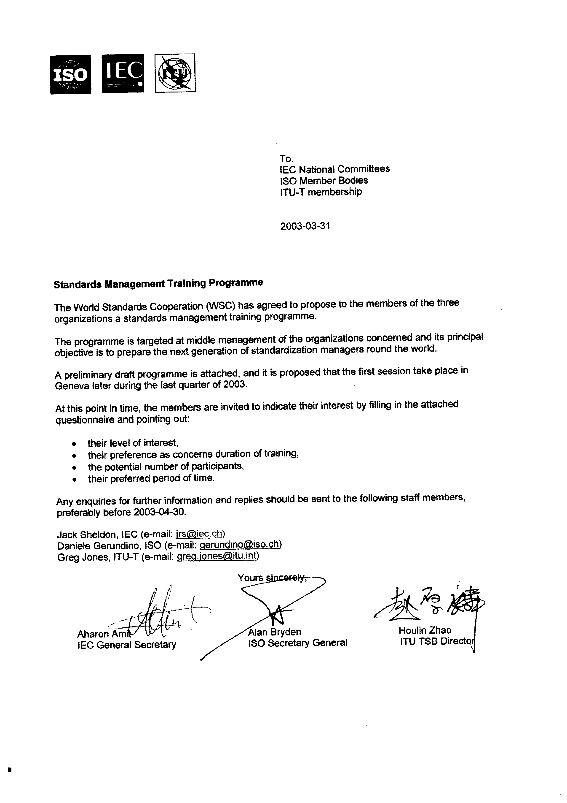
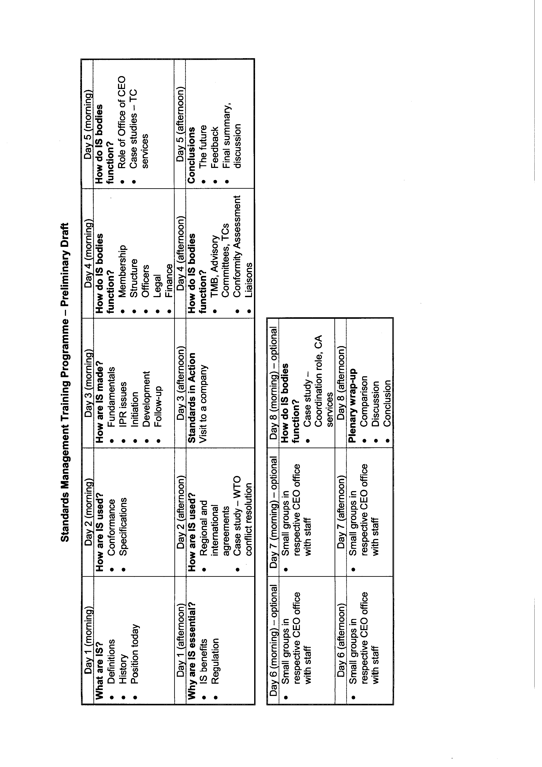

 |  |  |  | QUESTIONNAIRE

STANDARDS MANAGEMENT TRAINING PROGRAMME
Please answer the following questions and return the form by e-mail to:

Daniele Gerundino (ISO): gerundino@iso.org  Jack Sheldon (IEC) jrs@iec.ch  Greg Jones (ITU-T) greg.jones@itu.int | by 2003-04-30

1 Your level of interest in the above activity?

Comments:

2 Your preference as concerns the duration of the training?

3 Potential number of participants you would intend to send to the first session?

4 Preferred period of time during the last quarter of 2003?
……………………………………….

_________________________________
* Days: 1 to 5 in the preliminary draft of the Standards Management Training Programme
** Days: 1 to 8 in the preliminary draft of the Standards Management Training Programme

