Geneva, 5 March 2002
INTERNATIONAL TELECOMMUNICATION UNION
Telecommunication
Standardization Bureau

Ref: | TSB Collective-letter 4/TAS
Tel:  Fax:  E-mail: | +41 22 730 5989  +41 22 730 5853  tsbsg3@itu.int | - To the members of the Tariff Group for Asia and Oceania (TAS Group)

Subject: | Questionnaire on the movement of accounting rates

Dear Sir/Madam,
1 In order to monitor the progress of the implementation of Recommendations D.500R, seven studies were carried out in the past seven years. They produced significant results and were found by TAS Group to be extremely useful.
2 At its meeting in Abu Dhabi from 21 to 23 May 2001, TAS Group unanimously recognized that continuing to monitor the situation of accounting rates in the Region Asia and Oceania would be useful for the harmonious implementation of cost orientated accounting rates in this region. Then, TAS Group agreed to continue the monitoring and requested TSB to dispatch the new questionnaire for year 2002.
3 The questionnaire developed by TAS Group to collect the necessary information is attached to this Collective letter (Annexes 1 and 2 concern the measurement of meeting Recommendation D.500R and Annex 3 concerns the category of difficulties faced in meeting the recommended rates). I should be grateful if you would complete Annexes 1, 2 and 3. To facilitate the preparation of your answers, a table showing the distances between capitals of countries and territories in Asia and Oceania has been prepared by TSB (see Annexes 4A and 4B).
4 The duly completed questionnaire should be returned to TSB no later than 25 April 2002 to the following address:
The Director
Telecommunication Standardization Bureau (TSB)
Place des Nations
CH-1211 GENEVA 20
Switzerland
Fax: +41 22 730 5989
E-mail: tsbsg3@itu.int

5 Although I am aware of the additional administrative workload that the preparation of replies entails for every Administration and recognized operating agency, I wish to stress how desirable it is for as many of them as possible to reply to the questionnaire, so that the results of the study are statistically significant and may be regarded as representative of the Region.
6 It is fully understood that all the replies received will be treated as strictly confidential by TSB, which will analyze and consolidate them. The results will be published as a delayed contribution and will be discussed at the next TAS Group meeting scheduled in May 2002.
Yours faithfully,
H. Zhao
Director of the Telecommunication
Standardization Bureau
Annexes: 4
Please return this table completed Complete and return by 25 April 2002
to the following address :
Telecommunication Standardization Bureau /ITU
Place des Nations
CH-1211 GENEVA 20
Switzerland
fax. : 41 22 730 5853
E-mail: tsbsg3@itu.int
ANNEX 1
(to TSB Collective letter 4/TAS)
Measurement of meeting Recommendations D.500 R by number of relations
Administration/ROA: ..........................................
Contact point/name: ........................................….
Tel.: .........................................………………….
E-mail: …………………………………………..
Telephone Direct Relations

Category | Maximum total  accounting rates | As at 1 January 2002  number of relations in  each category | As at 1 January 2002  number of relations still  above maximum rate | As at 1 January 2002  maximum accounting  rate still in force (in SDR)
0 to 3 000 km  3 001 to 6 000 km  over 6 000 km | 0.55 SDR  0.58 SDR  0.59 SDR | ________________  ________________  ________________ | _________________  _________________  __________________ | _________________  ________________  ________________

Telephone Switch relations

Category | Maximum total  accounting rates | As at 1 January 2002  number of relations in  each category | As at 1 January 2002  number of relations still  above maximum rate | As at 1 January 2002  maximum accounting  rate still in force (in SDR)
0 to 3 000 km  3 001 to 6 000 km  over 6 000 km | 0.55 SDR  0.58 SDR  0.59 SDR | ________________  ________________  ________________ | _________________  _________________  __________________ | _________________  ________________  ________________

Please return this table completed Complete and return by 25 April 2002
to the following address :
Telecommunication Standardization Bureau /ITU
Place des Nations
CH-1211 GENEVA 20
Switzerland
fax. : 41 22 730 5853
E-mail: tsbsg3@itu.int
ANNEX 2
(to TSB Collective letter 4/TAS)
Measurement of meeting Recommendations D.500 R by number of bothway traffic
Administration/ROA: ..........................................
Contact point/name: ............................................
Tel.: .........................................…………………
E-mail: …………………………………………
Telephone Direct Relations

Category | Maximum total  accounting rates | Total number of bothway traffic (in 2001) | Total number of bothway traffic in 2001 settled at a rate above Maximum rate | As at 1 January 2002  maximum accounting  rate still in force (in SDR)
0 to 3 000 km  3 001 to 6 000 km  over 6 000 km | 0.55 SDR  0.58 SDR  0.59 SDR | ________________  ________________  ________________ | _________________  _________________  __________________ | _________________  ________________  ________________

Telephone Switch relations

Category | Maximum total  accounting rates | Total number of bothway traffic (in 2001) | Total number of bothway traffic in 2001 settled at a rate above Maximum rate | As at 1 January 2002  maximum accounting  rate still in force (in SDR)
0 to 3 000 km  3 001 to 6 000 km  over 6 000 km | 0.55 SDR  0.58 SDR  0.59 SDR | ________________  ________________  ________________ | _________________  _________________  __________________ | _________________  ________________  ________________

Please return this table completed Complete and return by 25 April 2002
to the following address :
Telecommunication Standardization Bureau /ITU
Place des Nations
CH-1211 GENEVA 20
Switzerland
fax. : 41 22 730 5853
E-mail: tsbsg3@itu.int
ANNEX 3
(to TSB Collective letter 4/TAS)

Category of difficulties faced
in meeting the recommended rates

Yes () Number of
relations

- Regulatory obligations
- Protracted negotiations
- Negotiations not yet initiated
- High costs
- Effect on net settlement
- Administrative difficulties
- Universal Service obligations financing
low capacity utilization (economy of scale)
- High interconnection cost
- Other reasons:
Please specify: _________________________________________________________________________________________________________________________________________________________________________________________________________________________________________________________________________________________________________________________________________

ANNEX 4 A
(to TSB Collective-letter 4/TAS)
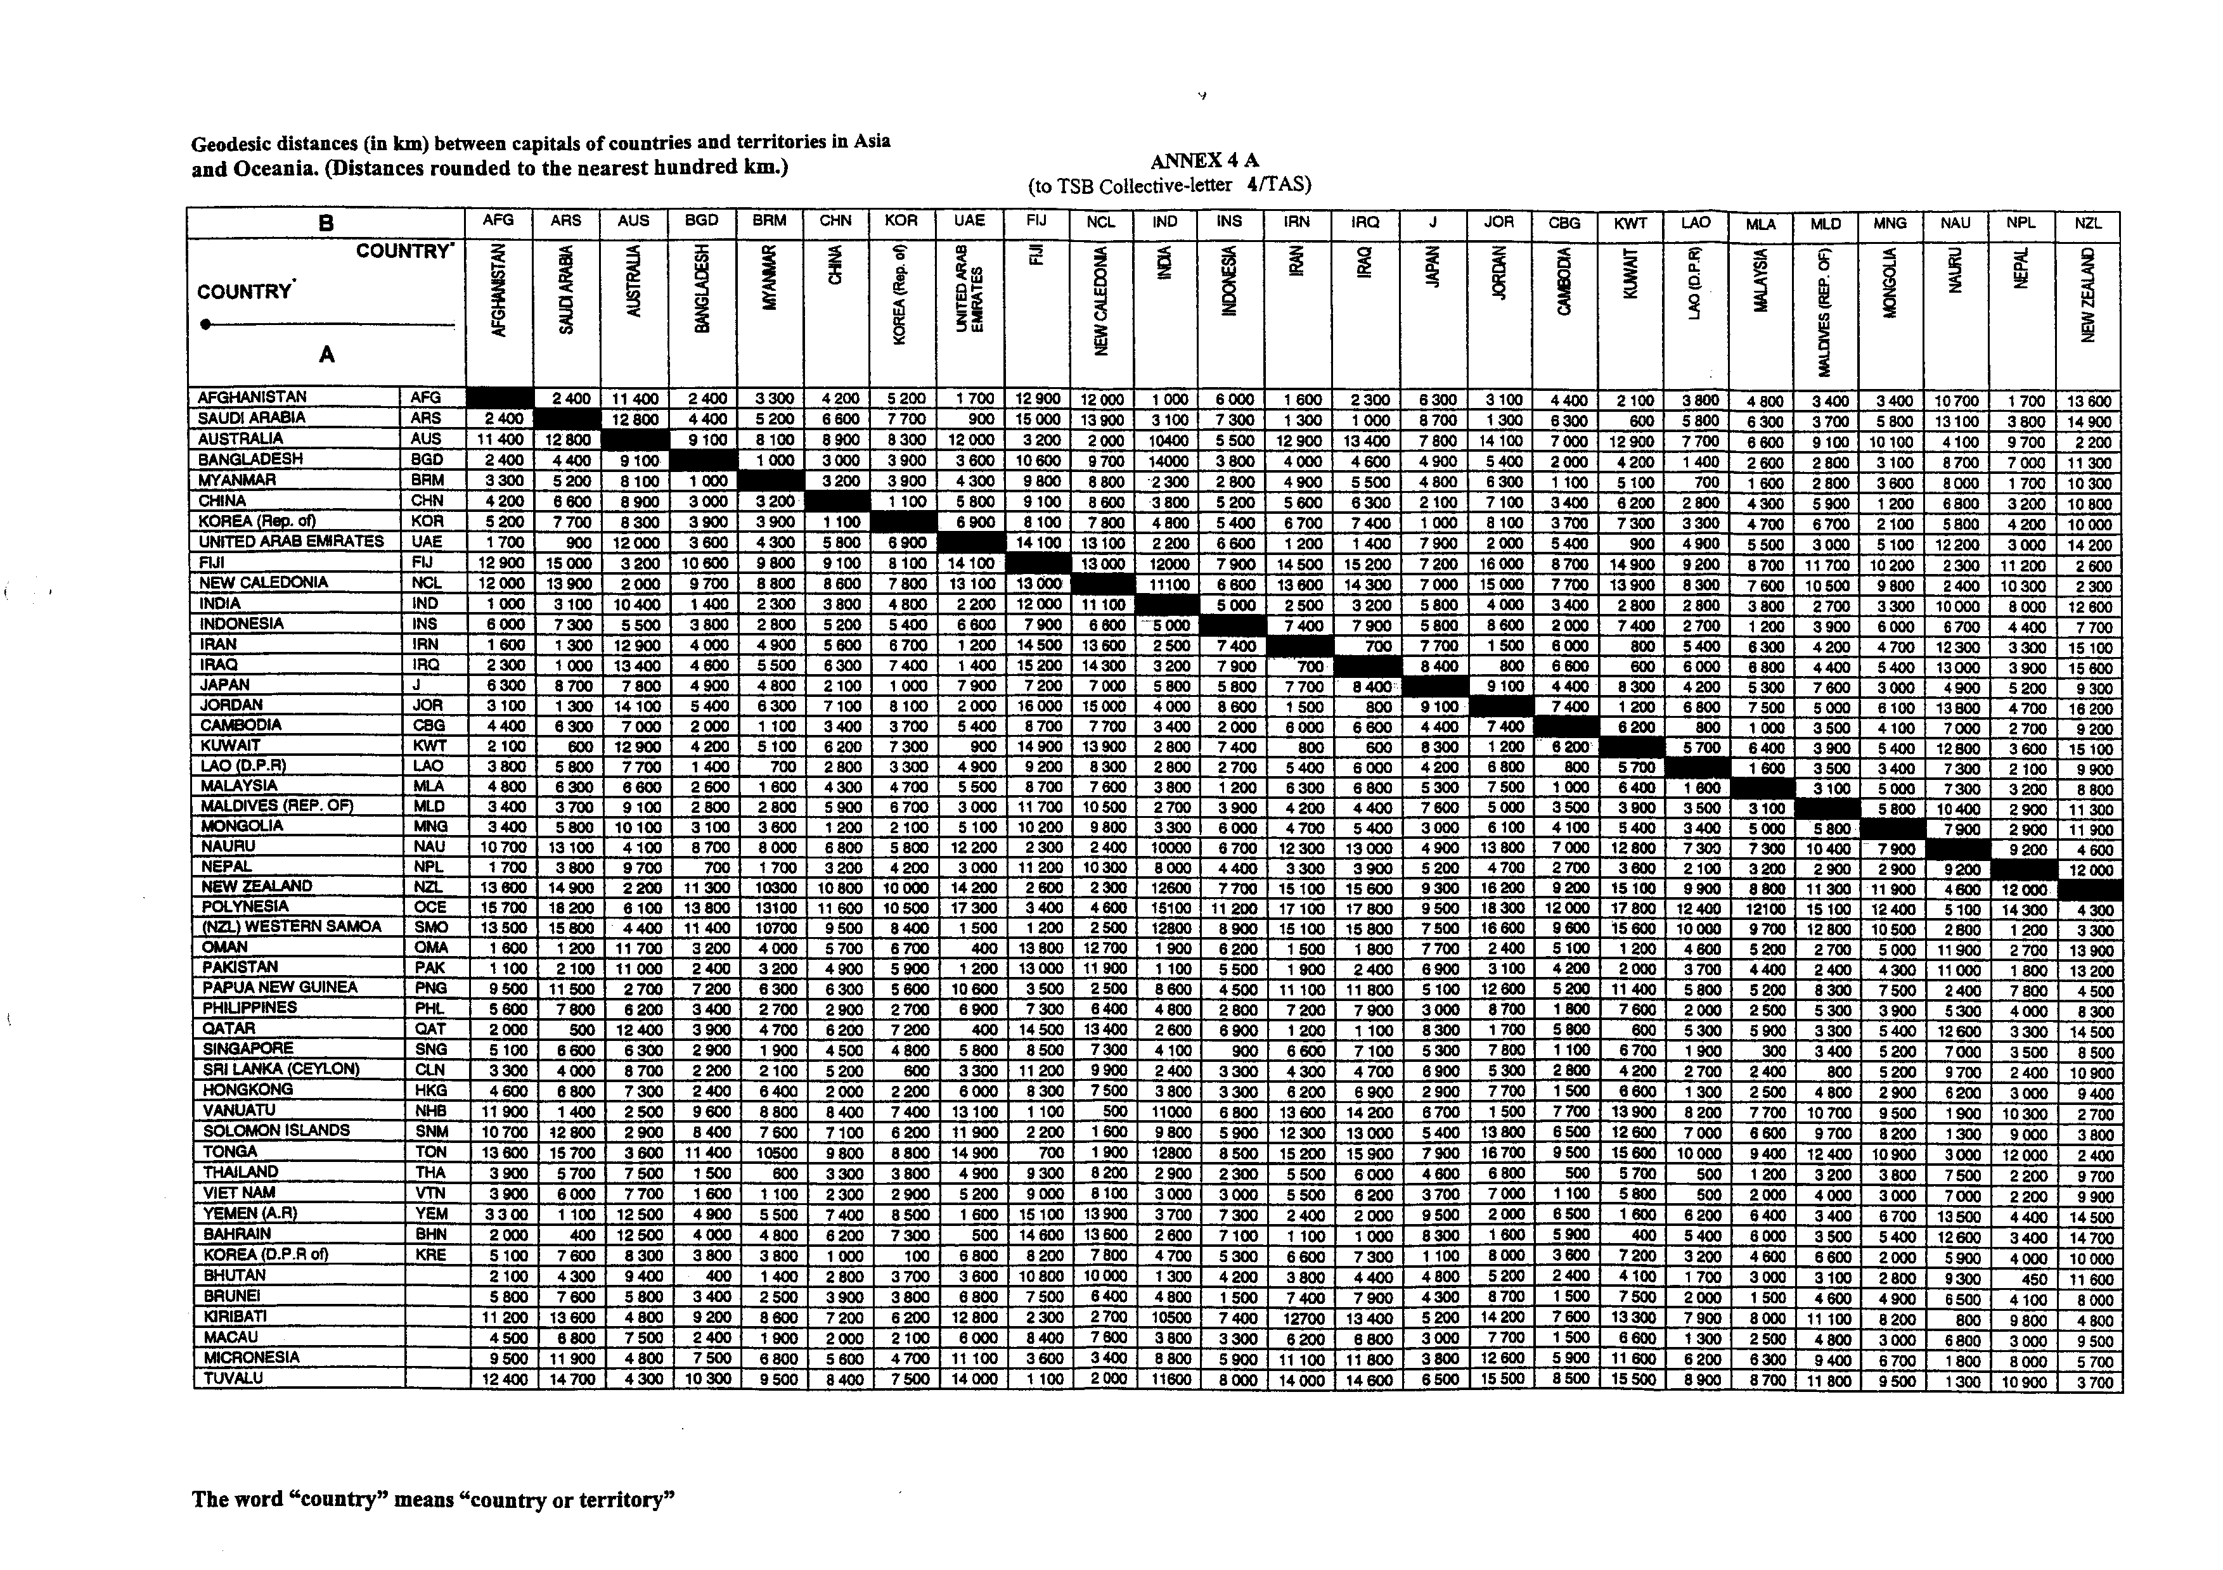
ANNEX 4B
(to collective letter TSB 4/TAS)
