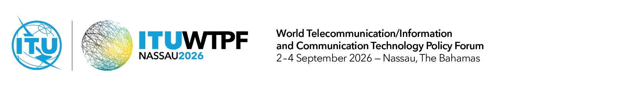
Document WTPF-26/ADM/9
2 September 2026
English only
Note by the Secretary-General
STRUCTURE OF THE FORUM

Group | Chair | Vice-Chair(s) | Secretaries
Plenary | Mr Randol Dorsett  Chairman, Utilities Regulation and Competition Authority (URCA),  The Bahamas | Ms Roberta dos Santos Pereira Hakme  (Brazil)  Mr Muath S. AlRumayh  (Saudi Arabia)  Ms Cynthia Leungo Lesufi  (South Africa)  Mr Haji Jailani Haji Buntar  (Brunei Darussalam)  Mr Tobias Kaufmann  (Germany) | Executive Secretary  1 Ms Nur Sulyna Abdullah  Secretaries  2 Ms Beatrice Pluchon  3 Mr Preetam Maloor
Working Group 1:  Bridging Digital Divides | Ms Roberta dos Santos Pereira Hakme  Brazilian National Telecommunications Agency (ANATEL), Brazil | Mr Kirk Sookram  Telecommunications Authority of Trinidad and Tobago (TATT) | 1 Mr Preetam Maloor  2 Ms Gretchen Bueermann
Working Group 2:  Green Digital Transformation | Mr Muath S. AlRumayh  Communications, Space and Technology Commission (CST), Saudi Arabia | Mr Ahmed Riad Ismail  Huawei | 1 Mr Preetam Maloor  2 Ms Sadhvi Saran
Working Group 3:  Building Resilient ICT Infrastructure | Ms Cynthia Leungo Lesufi  Permanent Mission of South Africa | Mr Nate Davis  American Registry for Internet Numbers (ARIN) | 1 Mr Preetam Maloor  2 Ms Sadhvi Saran
Working Group 4:  Space Connectivity | Mr Haji Jailani Haji Buntar  Authority for Info-communications Technology Industry of Brunei Darussalam (AITI), Brunei Darussalam | Ms Natalia Vicente  Global Satellite Operators Association (GSOA) | 1 Mr Preetam Maloor  2 Ms Gretchen Bueermann
Working Group 5:  Strengthening ICT-centric Innovation Ecosystems | Mr Tobias Kaufmann  Senior Policy Officer, Federal Ministry for Digital Transformation and Government Modernization, Germany | Mr Mark C. Reynolds  Caribbean Association of National Telecommunication Organizations (CANTO) | 1 Ms Sadhvi Saran  2 Ms Gretchen Bueermann

______________

