Document CWG-LANG-17/2
11 December 2025
English only
Report by the Secretary-General
IMPLEMENTATION OF RESOLUTION 154 (REV. BUCHAREST, 2022) AND RESOLUTION 1372 (C15, LAST AMENDED C24)
Purpose
This report provides an update to the Council Working Group on the use of the six official languages of the Union (CWG-LANG) on the implementation of Resolution 154 (Rev. Bucharest, 2022) regarding the use of ITU’s six official languages on an equal footing in accordance with Council Resolution 1372, as revised in 2024.
Action required
The Council Working Group on the use of the six languages of the Union is invited to note this document.
_______________
References
CWG-Lang website; PP Resolution 154 (Rev. Bucharest, 2022); Council Resolution 1372 (C15, last amended, C24); Guide to current and future practices in multilingualism in ITU; Document C22/INF/7; Report by the Chair of CWG-LANG to Council on outcomes of 16th meeting

1 Evolution of the budget for translation of documents to the six official languages since 2019
As requested by the Plenipotentiary Conference, budget figures for translation and interpretation services are hereby submitted (Annex 1, Table 1), divided into three categories: translation and associated-service budget and expenses; interpretation-service budget and expenses; and total language-service budget and expenses. The total budget as of today remains well within the CHF 85M cap for language services for the period 2024-2027 as set out in Decision 5 (Rev. Bucharest, 2022). As requested by CWG-LANG, Annex 1, Table 2, to this document includes information on the translation volumes per language over the same period, with translation volumes reflecting the equality of treatment of all six ITU official languages.

2 Procedures adopted by other international organizations inside and outside the United Nations system
ITU participates actively in the International Annual Meeting on Language Arrangements, Documentation and Publications (IAMLADP) and its working groups and task forces, including the International Annual Meeting on Computer-Assisted Translation and Terminology (JIAMCATT).
Discussions at IAMLADP 2025 focused on the impact of technological evolution in areas such as translation, translation workflows, speech recognition and automated speech transcriptions and the need to combine language tools with human professional excellence; addressing training, flexibility, skills upgrade and diversification needs; assessing and crediting new types of working; and identifying new tools and platforms.
ITU continues to engage with IAMLADP working groups and task forces on interpretation-specific matters; publishing and digital content; machine translation management; digital solutions for conference services and virtual meetings; accessibility of meeting services; and sustainable meetings.
In addition, ITU has also contributed to a proposal within the UN High-level Committee on Management (HLCM) portfolio of far-reaching efficiency initiatives (FREI) aimed at reducing fragmentation and costs across the UN system, enhancing reliability and promoting voluntary participation. Following a special session in February 2025 highlighting escalating needs and dwindling resources, the Committee collected over one hundred proposals, ultimately prioritizing eighteen key initiatives through rigorous discussion and coalition-building. Detailed project plans, governance frameworks, and terms of reference have been established, with implementation now underway and first results anticipated in 2026. These reforms seek to consolidate mature capabilities and foster collaboration, ensuring efficiency supports but does not replace essential investment to fulfil the UN’s mandates.
ITU worked closely with the UN Department of the General Assembly and Conference Management and ICAO on the development of the O2 Common Mechanism for Policy and Technical Solutions for AI-Powered Language Services initiative. This initiative proposes a UN-wide mechanism to coordinate AI-powered language services, aiming to reduce duplication, cut costs, and expand multilingual content. It will operate through two workstreams: one for identifying and implementing AI use cases, and another for developing shared policies on translation, interpretation, and related services. Rather than a centralized solution, the mechanism supports voluntary collaboration on specific projects— such as shared tools, vendor evaluations, and post-editing standards—tailored to each entity’s needs. It builds on existing tools like eLUNa, and WIPO and ITU’s machine translation tools, and aligns with Member States’ interest in AI for multilingualism. Initial implementation begins in 2025, with early deliverables including an inventory of tools, shared policies, and pilot use cases. The initiative targets 20–75% cost reductions in translation workflows and aims to introduce AI interpretation in at least 10% of meetings, subject to Member States approval, or for meetings where interpretation is not otherwise provided.

3 Initiatives undertaken by the General Secretariat and the three Bureaux to increase efficiencies and cost savings in the implementation of Resolution 154 (Rev. Bucharest, 2022) of the Plenipotentiary Conference and Council Resolution 1372 (C15, last amended C24)

3.1 Implementation of measures and principles for translation and interpretation
Document C22/INF/7 on measures and principles for translation and interpretation in ITU, was reviewed by Sector advisory groups and the General Secretariat and updated and endorsed by the Council at its 2022 session. It has been systematically implemented by the secretariat in the delivery of translation and interpretation services for ITU conferences, assemblies, meetings, documents, webpages and publications. Given the increased use of machine translation for webpages, documents and publications, the document may be reviewed by the secretariat and Sector advisory groups and updated accordingly for submission to a future session of CWG-LANG.

3.2 Use of new technologies in translation services
The General Secretariat continues to develop and improve the ITU Translate neural machine translation tool in accordance with the strategy outlined in the Guide on multilingualism.
Activities have including completing the training on-premises models used by internal translators; completing and deploying of fine-tuning the MS Azure Custom Translation model; migration of all ITU Translate APIs to the MS Azure cloud; and performance enhancements to handle high traffic. Large-scale deployment of ITU Translate across the sectors continues to be supported, including for all ITU-T study groups, several ITU-R groups and the entire WTDC website and related documents on the document management system. The ITU Translate dashboard and delegate document translation platforms have been updated to align with the ITU design system, accessibility requirements and mobile responsiveness; and costs are monitored and reported for all traffic sources.
ITU translators continue to make use of ITU Translate internally for segment and document translation, alongside computer-assisted translation tools such as eLUNa and UNTERM, the United Nations system terminology database. The gDoc 2.0 document workflow management application has been implemented as part of ITU’s approach to align working methods with those of other United Nations agencies and international organizations. In addition, a new document formatting tool is being piloted using an AI agentic approach to automatically edit and format documents translated by eLUNa in line with the rules predefined by ITU translators for each language and set out in the ITU Style Guides.
Statistics and analysis on the use of ITU Translate in the year November 2024 to November 2025 are included in Annex 2 to this report.
A major update for 2026 will move ITU Translate from a neural machine translation basis to an LLM RAG basis to make use of real-time translation memory and save costs on training. In parallel, website translation engines will be reassessed to ensure that the response time remains suitable for real-time translation; website translation quality will be improved by addressing style change segmentation; and ITU Translate will be fully integrated into the new website project.
The post-editing tool for ITU Translate has been updated and finalized. It provides the option for automatic post-editing of machine translations for professional translators, as well as enabling real-time post-editing of specific words or phrases on webpages translated by machine translation. The caching mechanism now enables a given post-edit to be reflected on the individual webpage or globally on the entire ITU website. Feedback from users to ling-it-support@itu.int is addressed immediately.

3.3 Use of new technologies in interpretation services

Remote Simultaneous Interpretation (RSI)
RSI solutions have been tested extensively in recent years for use in ITU meetings, working with RSI companies (procurement approach)>. RSI offers a viable, cost-effective alternative to onsite simultaneous interpretation when onsite interpretation is not feasible. RSI enables interpreters to work remotely, thereby reducing travel-related costs. Since October 2025, ITU has recruited local and national interpreters to work remotely on Zoom for ITU meetings on a trial basis. The combination of recruitment and procurement approaches can be used to maximise savings and flexibility whilst ensuring high quality.
In addition, a formal proposal for Member States to collaborate on the creation of a pool of local and national interpreters has been submitted to CWG-LANG (Document CWG-LANG-17/3). The proposal invites Member States to nominate qualified local and national conference interpreters and sets out minimum standards required in line with United Nations guidelines, including requisite language combinations, qualifications and experience in conference interpretation. It also includes a call for universities to help in the training of qualified interpreters in local communities.

Artificial intelligence solutions
Cloud-based artificial intelligence (AI) interpretation solutions have been tested and are being evaluated for quality and suitability for informal ITU meetings where no professional interpretation is offered. Initial feedback indicates that the quality of interpretation is not yet sufficient for formal meetings, including those with negotiations and nuanced content. The risks of using AI-powered interpretation services have been evaluated with the involvement of the potential service providers, and mitigation measures established or proposed, in accordance with the general ITU policy on the use of AI tools, services and systems.
ITU will continue to test AI-based interpretation tools and identify new opportunities, given that technologies are evolving quickly, with new digital features, tools and platforms available on a regular basis. AI interpretation tools will be evaluated for longer duration under live conditions and in multiple environments to ascertain operational viability. In addition, ITU will continue to collaborate with other UN organizations to share experiences in areas such as quality, data protection and technical readiness.

3.4 Terminology work in ITU
The ITU Coordination Committee for Terminology (CCT) is continuing its work in harmonizing terminology and definitions within ITU, based on proposals submitted by ITU study groups and working parties in English and validating their translation into the other five official languages of the Union in accordance with Council Resolution 1386 (C17, last amended C25) and the relevant Sector Resolutions.
The CCT has held seven meetings in 2025 and considered over 150 input contributions. Due to the significant number of terms and definitions received, a new mechanism to progress the work between meetings has been implemented, enabling the CCT secretariat to classify terms and definitions received into three categories: 1) clear and conforming to editorial guidelines; 2) clear but requiring adaption to the editorial guidelines; and 3) requiring clarification and further discussion.
This mechanism has yielded positive results, including more efficient meeting time management, faster validation of the terms and definitions which comply with the editorial guidelines and smoother liaison with relevant Study Groups and Working Parties for editorial adjustments.
In addition, 132 terms and their definitions have been translated into the official languages of the Union through the collaboration between ITU’s Conferences and Publications Department (C&P) and its partner institutions cooperating on terminology and language-related matters (Communication, Space and Technology Commission (CST) of Saudi Arabia, China Institute of Communications (CIC), M.I. Krivosheev National Research Centre for Telecommunication (NCRT) of Russia, and Colegio Oficial de Ingenieros de Telecommunicación (COIT) of Spain).
The ITU Terms and Definitions database has also been enhanced and presented in a more user-friendly manner in MyWorkspace. It also incorporates an option to filter the terms which are validated by the CCT.
The CCT website has also been updated to align with the look and feel of study group websites, and further internal technical adjustments are being made to standardize the mechanism for downloading files.
The CCT endorsed the proposed revision of Council Resolution 1386 on the ITU Coordination Committee for Terminology as approved by the June 2025 session of Council. Council Resolution 1386 (C17, last amended C25) includes a new Annex 2, which was developed in conjunction with the CCT, that harmonizes the responsibilities of rapporteurs for vocabulary across the three Sectors of the Union. The CCT also concluded the revision Recommendation ITU-R V.431, which was subsequently adopted and approved by the membership.

3.5 Harmonization of ITU websites in the six official languages, incorporating multilingualism into communications, knowledge exchange and social media
The New Website Project was launched following the approval of Council (Document C24/53) with the aim of developing a modern, mobile-responsive, secure, and multilingual website, with strong search capabilities, user-friendly navigation, and consistent branding and messaging. As the project is a cross-cutting issue with financial implications, it is discussed in parallel at meetings of the Council and of the Council Working Group on financial and human resources (Documents CWG-FHR-21/11 and CWG-FHR-22/17) in addition to its presentation to this Council Working Group as Document CWG-LANG-17/4.
The project is progressing in line with the planned timeline and budget. Following a successful Request for Proposals, a partner vendor was selected for the Information Architecture and Taxonomy (including UX) phase and began working in September 2025. A second RFP for Website Development will take place once the requirements emerging from this first phase have been clarified. Research, analysis and a comprehensive website audit have been conducted to evaluate systemic challenges and provide actionable recommendations, including the establishment of ITU’s first comprehensive web governance framework. The scope of the minimum viable product (MVP) for delivery by PP-26 has now been defined based on findings and recommendations.

4 Additional actions following the revision of Resolution 154 (Rev. Bucharest, 2022)

4.1 ITU Editing Tool
A new ITU Editing Tool has been developed to improve the quality and consistency of ITU texts in the English language by proposing improvements to a section of text in line with the ITU English Language Style Guide. The tool is designed to assist in drafting clear and concise ITU documents, as well as providing cleaner documents to improve the quality of the output of ITU Translate in the other five languages of the Union, and reduce the time needed for professional editing and translating.
The ITU Editing Tool uses GPT 5.1 with reasoning set up to allow the user to select the most relevant balance between speed and quality (allowing the user to select, if relevant, a more robust response which takes more time). It includes options to create specific prompts, modifies tone and style for official documents or more general web and communication writing, and compresses the length of the text. Currently in Beta evaluation phase, the ITU Editing Tool is available on a TIES-protected page with the Council website for testing and feedback at council.itu.int/2026/en/documents/electronic-tools/. Future development plans include adding support for document editing, so that documents can be uploaded directly, and expanding to support all six official ITU languages with their respective style guides to ensure it is a versatile resource for a global audience.

4.2 In-house AI captioning project
The ITU IS department has completed the first phase of its in-house AI captioning project and has piloted the solution in several meetings, including previous CWG sessions and side events, TSAG side event sessions, the ITU-R SSF Forum, WTIS, EGTI and EGH. The next steps include the provision of live English captions during the next cluster of CWG meetings as a formal pilot; analysis of this pilot; progressive integration into the webcast platform (live and archive); and expansion to additional meeting rooms.
In-house, AI-based language interpretation builds on a robust AI captioning layer. It is therefore still in an early piloting stage and will be tested during Q2/Q3 2026.

4.3 Publications
A new ITU E-publication Tool has been developed in house allowing web access to over 1 000 ITU publications, including 850 ITU-T Recommendations, as augmented e-publications. The e--publications are indexed by Google Analytics, greatly increasing online visibility and findability, and can be linked to ITU Translate to enable translation into all six languages. Testing is ongoing on features including AI-generated publication synopses, Search Engine Optimization keywords and audio summaries to increase accessibility and engagement by audience segment. E-publications are stored in a structured database with access through APIs, facilitating seamless integration and wider distribution. Work is ongoing in 2026 to increase the number of ITU-T Recommendations available as e-publications as well as finalizing templates and modelling to convert all ITU-R Recommendations. Translation of augmented e-publications by ITU Translate is currently limited due to budgetary considerations but may be made available subject to request. Work is ongoing to refine machine translation with post-editing to ensure sufficient quality before making machine translation more widely available.

Annex 1
Table 1
Evolution of language-service budget and expenses (in 000 CHF), 2019-2024
 | 2019 | 2020 | 2021 | 2022 | 2023 | 2024 | 2025*
Translation & associated-service budget | 14 488 | 13 048 | 12 999 | 16 189 | 15 485 | 13 752 | 13 028
Actual translation & associated-service expenses | 13 223 | 12 252 | 12 541 | 14 706 | 13 163 | 11 445 | 11 028
Interpretation budget | 3 457 | 1 408 | 1 392 | 2 910 | 2 842 | 1 529 | 1 575
Actual interpretation expenses | 2 698 | 1 338 | 1 522 | 1 957 | 2 149 | 1 248 | 1 233
Total language-service budget | 17 944 | 14 455 | 14 390 | 19 099 | 18 327 | 15 281 | 14 604
Total actual language-service expenses | 15 922 | 13 589 | 14 063 | 16 663 | 15 312 | 12 693 | 12 261
Savings | 2 023 | 866 | 328 | 2 436 | 3 015 | 2 588 | 2 342
* Data as of 10.11.2025.
Note that 2022 is considered an exceptional year as three major conferences (WTSA, WTDC, PP22) were held following the disruption caused by the COVID-19 pandemic in 2020 and 2021.
Figure 1
Evolution of language-service budget and expenses (in 000 CHF), 2019-2024

Figure 2
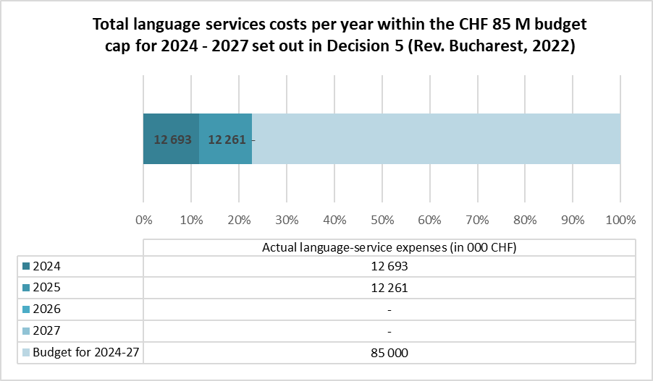
Table 2
Evolution of translation volumes per language (pages), 2019-2025
Language | Translation volumes/year  (pages)
Language | 2019 | 2020 | 2021 | 2022 | 2023 | 2024 | 2025*
Arabic | 8 892 | 8 400 | 7 843 | 8 962 | 10 316 | 8 246 | 7 155
Chinese | 9 030 | 8 818 | 7 717 | 9 240 | 9 680 | 9 030 | 7 595
English | 2 044 | 1 827 | 1 608 | 1 339 | 1 651 | 1 354 | 932
French | 10 173 | 8 811 | 8 531 | 9 800 | 10 601 | 8 424 | 7 411
Russian | 8 706 | 8 463 | 7 501 | 8 202 | 9 691 | 7 955 | 6 523
Spanish | 8 928 | 8 215 | 8 072 | 9 174 | 10 049 | 7 773 | 7 609
TOTAL: | 47 773 | 44 534 | 41 272 | 46 717 | 51 988 | 42 784 | 37 225
* Data as of 13.11.2025.

Figure 3
Evolution of translation volumes per language (pages), 2019-2025

Annex 2
Usage of ITU Translate
November 2024 – November 2025

1 Usage of ITU Translate on webpages
ITU Translate has been used on 4 849 unique webpages and triggered 1 719 276 times from November 2024 to November 2025.
Total translation requests for machine translation of a webpage using ITU Translate per target language (November 2024 – November 2025)
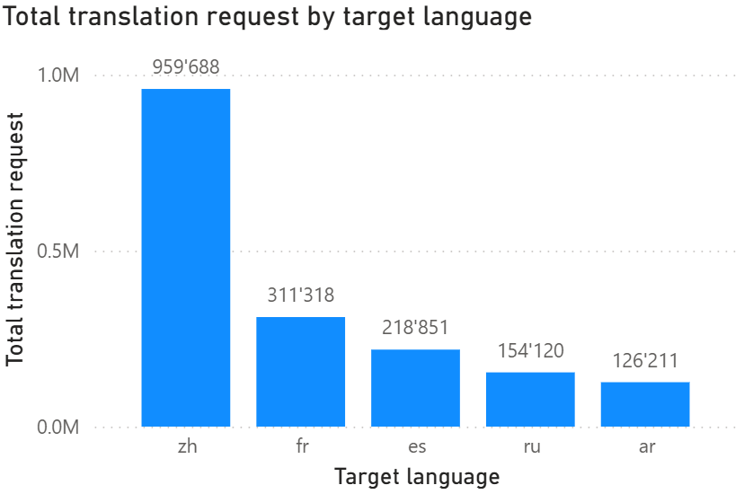

2 Top ten URLs translated by ITU Translate (November 2024 – November 2025)
Rank | Website | URL | Request count | Percentage (of total)
1 | ITU Home page | https://www.itu.int | 1 156 165 | 66.74
2 | ITU Hub pages | https://www.itu.int/hub/ | 159 731 | 9.22
3 | Space Sustainable Forum pages | https://www.itu.int/ssf/ | 158 945 | 9.18
4 | ITU-T page | https://www.itu.int/en/ITU-T/ | 59 950 | 3.46
5 | AI for Good pages | https://aiforgood.itu.int/ | 41 009 | 2.37
6 | ITU About page | https://www.itu.int/en/about/Pages/default.aspx | 12 795 | 0.74
7 | WTDC-25 pages | https://www.itu.int/itu-d/meetings/wtdc25/ | 11 878 | 0.69
8 | Council pages | https://council.itu.int/ | 7 743 | 0.45
9 | TDAG pages | https://www.itu.int/en/ITU-D/Conferences/TDAG | 3 647 | 0.21
10 | WTISD pages | https://www.itu.int/wtisd/ | 2 987 | 0.17

Summary
• Total requests: 1 732 304
• Top 10 Requests: 1 614 850 (93.22% of total).

3 Usage of ITU Translate on documents
Number of documents translated by ITU Translate per month
(November 2024– November 2025)
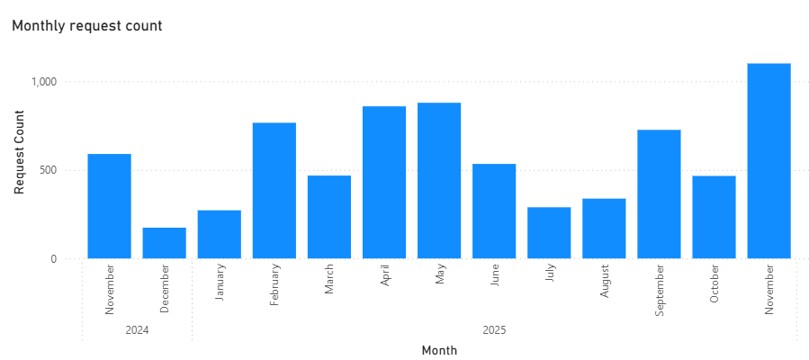
Documents translated by ITU Translate by language per month
(November 2024 – November 2025)
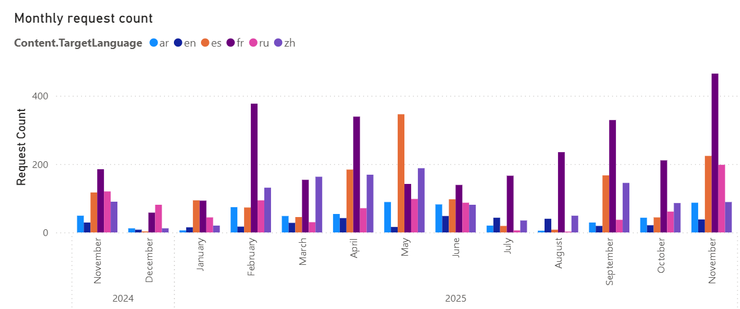
Machine translation of documents is provided on several different platforms: the Document Management System (DMS), either at the foot of each page or directly at the level of the document; ITU’s MyWorkSpace; and the professional translator platform, which may also be used internally by other ITU staff. In addition, ITU Translate is available for delegates’ use on TIES-protected platform accessible through the ITU Council website at https://council.itu.int/2025/en/documents/electronic-tools/.
Document translation at the level of the DMS is provided as an interim measure for documents which have not yet been provided by the professional translation service and for documents which are not otherwise provided in translation (such as ITU Council information documents).

4 Cost of ITU Translate
The cost of using ITU Translate is closely monitored and provides a reliable index of usage trends on webpages and documents combined. The standard cost as charged by the service provider is USD 40 per million characters.
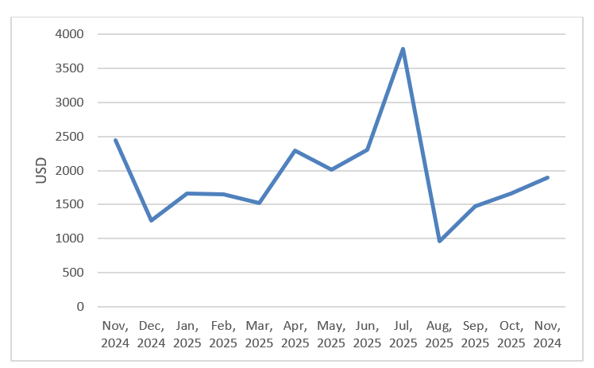

______________

One page equals 330 words.

