Revision 2 to
Document CWG-LANG-17/1
16 January 2026
English only
DRAFT AGENDA
COUNCIL WORKING GROUP ON LANGUAGES
Tuesday, 20 January 2026, 0930-1230 and 1430-1730 hours
Room A, ITU Headquarters, Geneva
Item | Title | Document
1 | Opening of the meeting and approval of the agenda | CWG-LANG-17/1(Rev.2)
2 | Introductory remarks by the DSG
3 | Report by the Secretary-General pursuant to Resolution 154  (Rev. Bucharest, 2022) and Resolution 1372 | CWG-LANG-17/2(Rev.1)
3 | – Contribution by Russian Federation: Proposals for the revision of PP Resolution 154 (Rev. Bucharest, 2022) | CWG-LANG-17/6
3 | – Contribution by Russian Federation: Proposals for the revision of Council Resolution 1386 (C17, last amended C25) – ITU Coordination Committee for Terminology (ITU CCT) | CWG-LANG-17/5
3 | – Multi-country contribution: Proposal on supporting the use of ITU's six official languages on an equal footing through cooperating with the six principal Regional Telecommunication Organizations | CWG-LANG-17/7
4 | Update on the new ITU website project | CWG-LANG-17/4
5 | Proposal for creation of pool of local and national interpreters in collaboration with Member States | CWG-LANG-17/3
5 | – Multi-country contribution: Proposal on establishing the pilot project on the identification and development of qualified local interpreters and continuation of the project to support the translation of Union documents | CWG-LANG-17/8
6 | Any other business | –
Rebecca Mukite
Chair
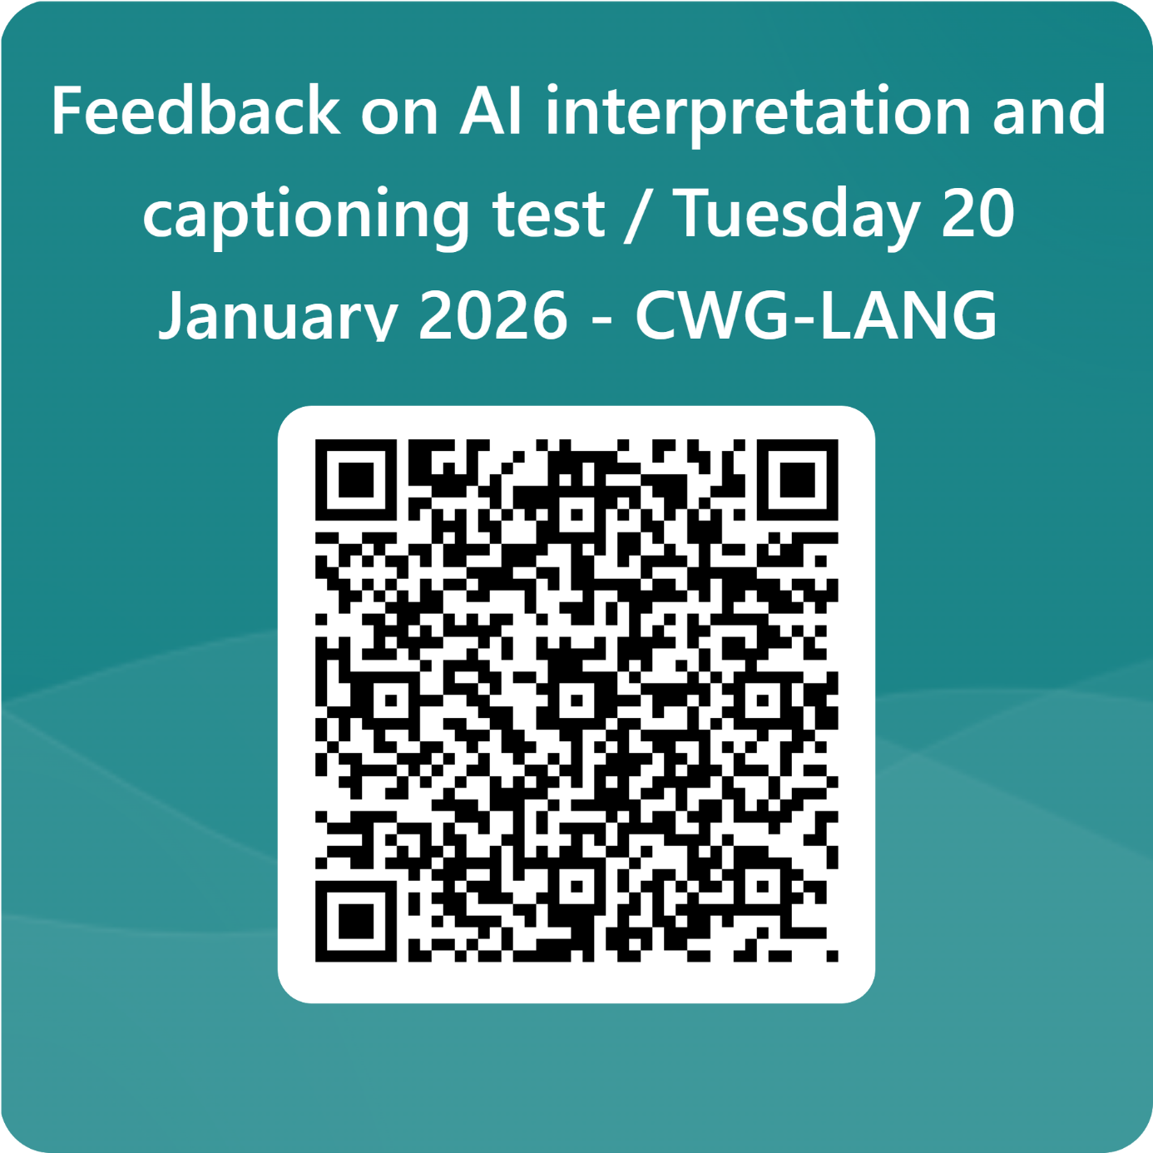
Feedback on AI interpretation and captioning test / Tuesday 20 January 2026 - CWG-LANG – Fill out form

______________

