
PLENARY MEETING | Addendum 33 to  Document 81-E
 | 16 October 2026
 | Original: English
Member States of the Inter-American Telecommunication Commission
(CITEL)
Proposed modifications to Decision 5

Abstract
CITEL proposes revisions to Decision 5 to strengthened efforts by the ITU to reduce expenses, find cost efficiencies and increase impact of ITU activities given resource constraints.
The proposal focuses on increasing budget efficiencies, reducing expenses and strengthening transparency around impact of ITU activities in advancing the strategic goals of the Union. The proposal specifically targets business class travel by ITU and also adds language to ensure adequate funding support for ITU activities related to internal controls and risk management.

MOD IAP/81A33/1
DECISION 5 (REV. Doha, 2026)
Revenue and expenses for the Union for the period 2028-2031
The Plenipotentiary Conference of the International Telecommunication Union (Doha, 2026),
considering
a) the strategic plan for the Union for 2028-2031, including the strategic goals, priorities and product and service offerings of the Union, pursuant to Resolution 71 (Rev. Doha, 2026) of this conference;
b) Resolution 91 (Rev. Guadalajara, 2010) of the Plenipotentiary Conference, on general principles for cost recovery;
c) Resolution 191 (Rev. Bucharest, 2022) of this conference, on strategy for the coordination of efforts among the three Sectors of the Union and enhancing coordination and collaboration among the three Bureaux and the General Secretariat, with a view to avoiding internal duplication of effort and optimizing the use of resources,
considering further
a) that, in the consideration of the draft financial plan for the Union for 2028-2031, the challenge to use the Union's resources efficiently in order to achieve the strategic goals and priorities in the strategic plan and increase revenues in support of programme demands is substantial;
b) the need to link strategic, financial and operational planning in ITU,
noting
Resolution 151 (Rev. Bucharest, 2022) of this conference, on improvement of results-based management in ITU, an important component of which relates to planning, programming, budgeting, monitoring and evaluation, and the implementation of which should facilitate further strengthening of the management system of the Union, including financial management,
noting further
that Resolution 48 (Rev. Bucharest, 2022) of this conference stresses the importance of management and development of the human resources of the Union for the fulfilment of its strategic goals, priorities and product and service offerings,
decides
1 that the ITU Council is authorized to draw up the two biennial budgets of the Union in such a way that the total expenses of the General Secretariat and the three Sectors of the Union are balanced by the anticipated revenue, on the basis of Annex 1 to this decision, taking into account the following:
1.1 that the amount of the contributory unit of Member States for the years 2028-2031 shall remain unchanged at CHF 318 000;
1.2 that expenses for interpretation, translation and text processing in respect of the official languages of the Union shall not exceed CHF 85 million for the years 2028-2031;
1.3 that, when adopting the biennial budgets of the Union, the Council may decide to give the Secretary-General the possibility, in order to meet unanticipated demand and based on quantifible data regarding projected changes, to increase the budget for products or services which are subject to cost recovery, within the limit of the revenue from cost recovery for that activity;
1.4 that, in preparing the biennial budgets of the Union, the allocation of resources among the General Secretariat and the three Sectors should take into account the importance of funding activities carried out in accordance with the priorities of the strategic plan for the Union for 2028-2031, especially those related to the use of the radio-frequency spectrum, and relevant rules for its implementation;
1.5 that the Council shall each year review the revenue and expenses in the budget, the different activities and the related expenses, as well as key financial indicators relevant for the Union;
1.6 that the Council shall take measures to maintain at the appropriate level all types of reserve funds of ITU intended to ensure the Union's business continuity;
2 that, if no plenipotentiary conference is held in 2030, the Council shall establish the biennial budgets of the Union for 2032-2033 and 2034-2035 and thereafter, having first obtained approval for the budgeted annual values of the contributory unit from a majority of the Member States of the Union;
3 that the Council may authorize expenses exceeding the budget for conferences, meetings and seminars if such expenses can be compensated by savings from previous years or charged to the following year, subject to compliance with the provisions of the ITU Financial Regulations and Financial Rules;
4 that the Council shall, during each budgetary period and with the support of the secretariat, assess the changes that have taken place and the changes likely to take place in the current and coming budgetary periods under the following items:
4.1 salary scales, pension contributions and allowances, including post adjustments, established by the United Nations common system and applicable to the staff employed by the Union;
4.2 the exchange rate between the Swiss franc and the United States dollar insofar as this affects the staff costs for those staff members on United Nations salary scales;
4.3 the purchasing power of the Swiss franc in respect of non-staff items of expenses;
4.4 the interest rate applicable to ITU accounts;
5 that the Council shall have the task of effecting every possible economy, in particular taking into account the measures for enhancing efficiency in the use of available financial resources and reducing expenses contained in Annex 2 to this decision, and considering the possible funding gaps, and that it shall establish the lowest possible detailed balanced budget commensurate with the needs of the Union, taking into account the requirements established by decides 1 above;
6 that the following minimum guidelines should be applied in relation to any reductions in expenses with a view to ensuring the Union's business continuity and performance:
6.1 the financial control functions of the Union should continue to be maintained at a strong and effective level including by ensuring that staffing and budgetary resources allocated to internal audit, risk management and internal control functions remain adequate;
6.2 there should be no reductions in expenses which would affect cost-recovery revenue and in funding activities directly linked to the implementation of the Radio Regulations and associated studies;
6.3 fixed costs related to the reimbursement of loans shall not be reduced;
6.4 fixed costs related to after-service health insurance (ASHI) should be maintained at a level consistent with decisions taken by other organizations in the United Nations common system of salaries and benefits;
6.5 expenses in regular maintenance costs for ITU buildings which would be required to ensure the security and health of staff should be optimized;
6.6 the information services function in the Union should be maintained at an effective level, including by ensuring that the ITU website is properly maintained in view of the provisions of Resolution 154 (Rev. Bucharest, 2022) of this conference, on use of the six official languages of the Union on an equal footing;
6.7 that, except as provided in Annex 2, item 17bis, of this decision, no officials or staff of the Union, nor delegates or representatives funded by the Union, shall be authorized to travel on duty in business class or any class of service above economy/coach fare;
7 that the Council shall aim in all circumstances to keep the Reserve Account at a level above 6 per cent of total annual expenses,
instructs the Secretary-General, with the assistance of the Coordination Committee
1 to prepare draft balanced biennial budgets for the years 2028-2029 and 2030-2031, on the basis of the associated guidelines in decides above, the annexes to this decision and all relevant documents submitted to the Plenipotentiary Conference;
2 to draw up and implement a programme of appropriate revenue increases, cost efficiencies and reductions across all ITU operations so as to ensure a balanced budget;
3 to implement the aforementioned programme as soon as possible,
instructs the Secretary-General
1 to provide to the Council, no less than seven weeks before its 2027 and 2029 ordinary sessions, complete and accurate data as needed for the development, consideration and establishment of a balanced biennial budget;
2 to implement, monitor and propose improvements to the risk-management policy, comprising all elements of the systematic and comprehensive risk-management and accountability frameworks, and to report annually to the Council;
3 to make every effort to achieve balanced biennial budgets, and to bring to the attention of the membership, through the Council Working Group on financial and human resources (CWG-FHR), any of its decisions that may have a financial impact likely to affect the achievement of such a balance, including the annual reporting on enterprise risk management maturity referred to in instructs the Secretary-General 2 above and on compliance with the prohibition on business-class travel set out in decides 6.7 and Annex 2, item 17, of this Decision, and to report annually to the Council;
4 to ensure coherence between the financial plan, the strategic plan, the operational plans and the biennial budgets in the pursuit of the Union's statutory activities, including by ensuring that activities funded through voluntary contributions and trust funds align with the strategic goals and priorities of the Union;
5 to develop an ITU-wide financial resource mobilization strategy to address the need for additional funding to meet organizational strategic goals and priorities and present it to the Council for review and guidance on its implementation,
instructs the Secretary-General and the Directors of the Bureaux
1 to provide to the Council, on an annual basis, a report on ITU budget implementation for the previous year and anticipated implementation of the ITU budget for the current year and outlining savings achieved through the implementation of each item in Annex 2 to this decision;

2 to make measurable, targeted efforts to achieve cost reductions and to include in the above report to the Council: a) the specific measures taken to achieve such reductions; b) the amount of savings achieved as a result of each such measures; and c) where anticipated savings were not achieved, an explanation of the reasons and a revised plan for achieving them;
3 to include in the above report to the Council a report on extrabudgetary activities and related expenses and an explanation of how those activities align with the strategic goals and priorities of the Union,
instructs the ITU Council
1 to review and approve the balanced biennial budgets for 2027-2028 and 2028-2029, giving due consideration to the associated guidelines in decides above, the annexes to this decision and all relevant documents submitted to the Plenipotentiary Conference;
2 to authorize the Secretary-General, in accordance with Article 27 of the current Financial Regulations and Financial Rules, in the event that a surplus is achieved during budget implementation, to prioritize allocating an appropriate amount to the ASHI Fund, with a view to keeping the ASHI Fund at a sustainable level;
3 to authorize the Secretary-General, in the event that a surplus is achieved during budget implementation, to allocate an appropriate amount to the New Building Project Fund and/or the Risk Register Fund for the new building, subject to approval by the Council, to finance costs that cannot be financed through the loan agreement concluded with the host country;
4 to consider further appropriations in the event that additional sources of revenue are identified or savings achieved;
5 to examine programmes aimed at increasing revenues, enhancing efficiency in the use of financial resources and reducing the costs of ITU drawn up by the Secretary-General with the assistance of the Coordination Committee;
6 to take account of the impact of any cost-reduction programme on the staff of the Union, and to continue implementing, as needed, a mutually agreed separation scheme, funded to the extent possible by budgetary surplus, but also through a withdrawal from the Reserve Account, for an amount up to but not exceeding CHF 6 million;
7 in considering measures that could be adopted to strengthen control of the finances of the Union, including to take into account the financial impact of such issues as ASHI funding and the medium- to long-term maintenance and/or replacement of buildings at the premises of the Union;
8 to request the external auditor, the Independent Management Advisory Committee and CWG-FHR to continue to develop recommendations to ensure greater financial control of the finances of the Union, taking into account, inter alia, the issues identified in instructs the ITU Council 7 above;
9 to consider the reports relating to the matter, and report to the next plenipotentiary conference, as appropriate,
invites the ITU Council
to fix, to the extent practicable, the preliminary amount of the contributory unit for the period 2032-2035 at its 2029 ordinary session,
invites Member States
to announce their provisional class of contribution for the period 2032-2035 before the end of the calendar year 2029.
ANNEX 1 TO DECISION 5 (REV. Doha, 2026)
Table 1
Financial plan for the Union for 2024-2027 – Revenue and expenses
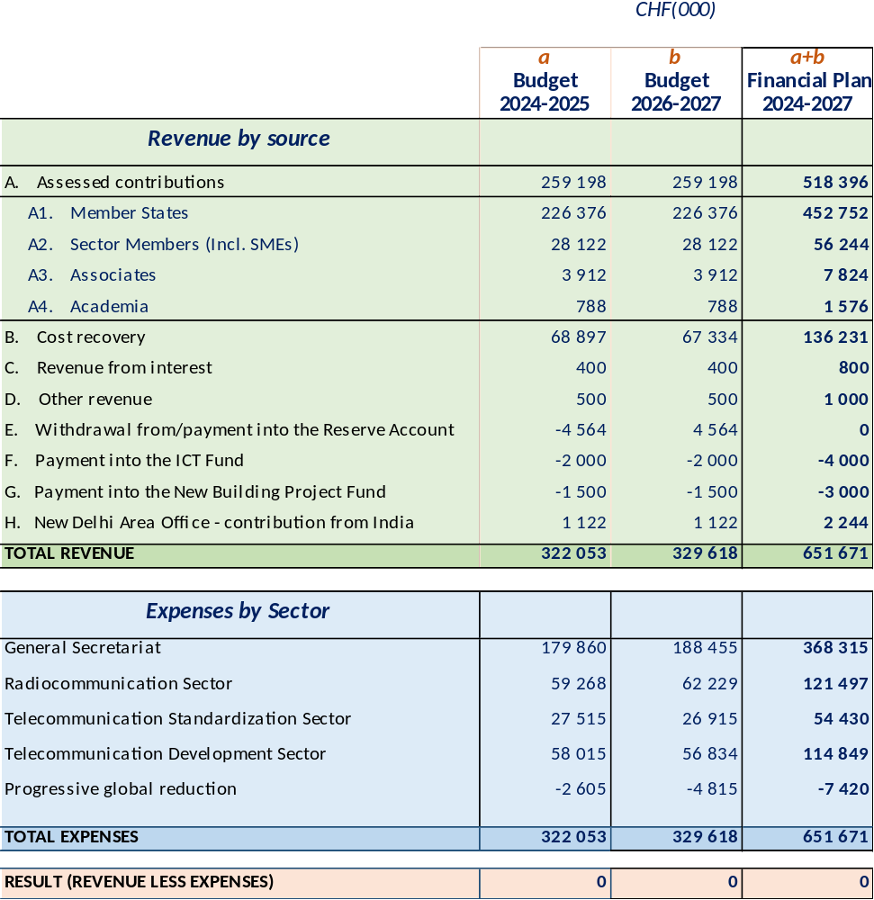
Table 2
CHF (000)
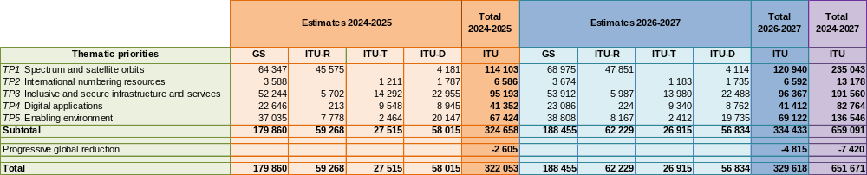
ANNEX 2 TO DECISION 5 (REV. Doha, 2026)
Measures for improving ITU's efficiency and reducing its expenses
1) Regular assessment by the Secretary-General of the level of achievement of the strategic goals and priorities with a view to increasing efficiency through budget reallocation, when necessary.
2) Member States, Sector Members and other ITU members taking all possible measures to settle/eliminate arrears to the Union, consistent with reporting on debts owed to the Union required under Article 9 of the Financial Regulations and Financial Rules.
3) Identification and elimination of all forms and instances of duplication of functions and activities between all ITU structural bodies and measures. Coordination, harmonization and closer cooperation among the Sectors, including optimization of management methods, logistics, coordination and support by the secretariat as well as centralization of finance and administrative tasks.
4) Coordination and harmonization of all seminars, workshops and cross-Sector activities by the secretariat's Inter-Sectoral Coordination Task Force (ISC-TF) in order to avoid duplication of topics, to optimize management, logistics, coordination and secretariat support and to benefit from synergy between the Sectors and a holistic approach to the subjects covered.
5) Enhanced efficiency in respect of the regional presence, including regional and area offices, in implementing the strategic goals and priorities of ITU as a whole, including in the use of local experts and local networks of contacts and resources. Maximum coordination of activities with regional organizations in the rational use of existing financial and human resources, including savings on travel costs and costs associated with the planning and organization of events held outside Geneva.
6) Rational use of staff and savings from attrition, redeployment of staff and review and possible reduction of grades of vacant posts, in particular in non-sensitive parts of the General Secretariat and the three Bureaux and where there is no increased risk of a drop in performance, in order to reach optimal levels of productivity, efficiency and effectiveness.
7) Prioritizing staff redeployment for the implementation of new or additional activities. New hiring should be the last option, while taking into account gender balance, geographical distribution and new skill requirements.
8) The use of consultants should only occur when the relevant skills or experience cannot be found among existing staff and after confirmation of this requirement in writing by senior management.
9) Upgrading the capacity-building policy to qualify staff, including staff in regional and area offices, for multi-Sector proficiency, in order to improve staff mobility and their flexibility for redeployment to new or additional activities.
10) Reduction by the General Secretariat and the three Sectors of the Union of the cost of documentation by, among other measures, conducting paperless conferences and meetings of all kinds and at all levels; encouraging staff to avoid printing of e-mails and documents; reducing the archiving of additional paper documentation; pursuing initiatives aimed at making ITU a fully paperless organization; and fostering the adoption of innovative information and communication technology (ICT) solutions as viable and sustainable substitutes for paper, without any significant decrease in the quality of the information provided to event participants or to ITU staff in the course of their day-to-day work.
11) Reducing to the absolute minimum necessary the printing and distribution of ITU promotional/non-revenue-generating publications, including by using the ITU website to its fullest potential, in line with the provisions of Resolution 154 (Rev. Bucharest, 2022) of the Plenipotentiary Conference.
12) Implementation of practicable measures for making savings in the provision of interpretation and the translation of ITU documents, including minimizing the length of documents, and in the preparation of publications for events of all kinds and at all levels, without prejudice to the goals of Resolution 154 (Rev. Bucharest, 2022), as well as through optimization of resource use in the language services, including the use of alternative translation procedures, while maintaining translation quality and the accuracy of telecommunication/ICT terminology.
13) Increasing the efficiency of World Summit on the Information Society (WSIS) programme activities and activities aimed at achievement of the Sustainable Development Goals, consistent with the financial plan and the biennial budget and, as appropriate, through cost recovery and voluntary contributions, in accordance with the ITU Financial Regulations and Financial Rules. Participation by the regional and area offices, in collaboration with other United Nations agencies, in WSIS activities being carried out at the regional level.
14) Optimization of the number and duration of meetings, and holding such meetings with the aid of telecommunication/ICT capabilities. Reduction of the number of groups to the minimum necessary through their restructuring and/or termination of their work in the absence of any outcomes and/or where there is duplication of activities, while avoiding any risk, in particular, of failure to fulfil the strategic and operational goals and objectives of the Union. Provide enhanced reporting on impact and results of events to guide prioritization and reduction in number.
15) For new activities or those having additional financial resource implications, a "value-added" assessment shall be made and implemented in order to improve efficiency and to avoid overlap and duplication and to confirm that such activities are consistent with the strategic goals and priorities of the Union.
16) Sound consideration of the size of, location of and resources allocated to regional initiatives, outputs and assistance to members; the regional presence, both in the regions and at headquarters; as well as those actions resulting from the outcome of the World Telecommunication Development Conference and the ITU Telecommunication Development Sector action plan, and financed directly as activities from the Sector budget.
17) Reduction of the cost of travel on duty, by developing and implementing criteria in order to reduce travel costs. The criteria should prohibit business travel and minimize travel costs, by prioritizing the allocation of staff from the regional and area offices, by limiting time on mission, through joint representation in meetings, and by rationalizing the number of staff sent on mission from various departments/divisions of the General Secretariat and the three Bureaux. Notwithstanding any other provision of the Union's Staff Regulations, Staff Rules, Financial Regulations or Financial Rules, all air travel undertaken on behalf of the Union by staff, officials, elected officers, consultants, delegates or any other person whose travel is funded in whole or in part from the Union's budget or extrabudgetary resources shall be booked in economy/coach class only, regardless of the duration or number of segments of the flight, unless the traveller is required, on the basis of a documented medical certification of disability, to travel in a higher class.
17bis) The Secretary-General shall amend the ITU Staff Rules and the ITU Financial Rules, as necessary, to implement the prohibition on business-class travel set out in item 17 above and shall report to the Council no later than its first ordinary session following adoption of this Decision on the steps taken to achieve full implementation.
18) Appeals to Member States to reduce to a reasonable number the issues raised in order to save on the amount of time devoted to their consideration at all conferences, assemblies and other meetings, and to make broader use of interregional discussions during the preparatory process with a view to a greater alignment of positions.
19) Continued implementation by the Union of the comprehensive plan to improve the stability and predictability of the financial base of the Union, mobilizing the necessary resources and, inter alia, improving the management of internal corporate projects requiring significant long-term investments.
20) Optimization of expenses related to maintenance, routine repair and renovation/reconstruction of the ITU buildings and facilities and to the provision of safety in accordance with applicable United Nations system standards.
21) Increased use of virtual meetings and remote participation in physical meetings in order to reduce and/or eliminate travel to meetings being held interactively online and, preferably, captioned, with interpretation where necessary, including remote presentation of documents and contributions.
22) Use of innovative cross-cutting means and working methods for improving the effectiveness of the Union's activities.
23) Discontinuing to the greatest extent possible communications by fax and traditional postal mail between the Union and Member States, and replacing them with modern electronic communication methods.
24) Continuing the efforts to simplify, harmonize or eliminate, as appropriate, internal administrative processes, for subsequent digitalization and automation.
25) Active pursuit of further sharing of some common services with other United Nations organizations, including at ITU’s Geneva premises, and implementation of such sharing where beneficial to the Union, with the Secretary-General reporting annually to the Council on opportunities identified and arrangements implemented.
26) Appeals to Member States, to the extent possible, with the support of the secretariat, to include in their proposals to ITU conferences an annex with relevant information in order to allow the Secretary-General/Directors of the Bureaux to identify the probable financial implications of such proposals in order to comply with Article 34 of the ITU Convention, on financial responsibilities of conferences.
27) Any additional measures adopted by the Council and the ITU management, including measures to increase the efficiency of the internal audit function, institutionalize evaluation functions, assess and minimize the risk of fraud and other risks, implement external auditor, internal auditor, Independent Management Advisory Committee and United Nations Joint Inspection Unit recommendations within the required time-frame for implementation of the strategic and financial plans of the Union.

