
PLENARY MEETING | Document 72-E
 | 5 October 2026
 | Original: English
Report by the Secretary-General
AFTER-SERVICE HEALTH INSURANCE (ASHI) LIABILITY UPDATE

Summary
Update on the status of the ASHI liability, including the implementation of the related recommendations of the External Auditor, to inform discussions on the financial plan for the period 2028-2031 at the Plenipotentiary Conference (Doha, 2026). The External Auditor recommended that ITU should, in consultation with Members, develop an overarching policy and strategy for its After-Service Health Insurance liability. This should include a target level for a funded reserve.

Action required
The Plenipotentiary is invited to take note of this report.
Financial implications
N/A
______________

References
Council Documents C26/116 (§ 14), C26/46 and C26/41

1 Executive summary
1.1 As at 31 December 2025, the ASHI liability stood at CHF 378.8 million, while assets dedicated to funding these obligations amounted to only CHF 15 million, and the Net assets of the Union were negative for CHF 279.8 million. Over 96 per cent of the liability remains unfunded and the Union's financial position is significantly affected and impaired by its large unfunded After-Service Health Insurance (ASHI) liability.
1.2 As highlighted by the external auditors, the unfunded ASHI obligation alone exceeds the Organization's negative net asset position, demonstrating that ASHI remains the principal driver of the Union's weakened balance sheet and its most significant long-term financial risk.
1.3 While recent actuarial developments have led to a reduction in the reported liability, these improvements are primarily attributable to changes in financial assumptions rather than to structural funding measures. Consequently, the underlying financial challenge remains largely unchanged.
1.4 The purpose of this paper is to provide a detailed analysis of ASHI, including updated actuarial analysis and benchmarking to stimulate support from Member States to start the journey to implementation of a comprehensive long-term funding strategy.

2 Current financial situation
2.1 The evolution of the ASHI liability over recent years demonstrates its significant sensitivity to external economic and actuarial assumptions.

 | 2021 | 2022 | 2023 | 2024 | 2025
Discount rate | 0.50% | 2.50% | 1.90% | 1.40% | 1.80%
Increase in medical costs | 2.50% | 2.80% | 2.60% | 2.40% | 2.20%
Salary increase | 3.00% | 3.00% | 3.10% | 3.10% | 3.10%
ASHI liability at year-end | 564 636 | 344 102 | 375 271 | 415 835 | 378 824

2.2 The decline observed in 2025 was driven primarily by favourable movements in the discount rate and medical inflation assumptions. Similar fluctuations have occurred in previous years. While such developments are welcome, they do not represent a structural solution because they are largely outside the Organization's control and may reverse in future periods. Sustainable financial improvement cannot rely on favourable actuarial movements but requires a deliberate and long-term funding strategy.
2.3 The relationship between the Unfunded ASHI obligation and the Organization's overall financial position is particularly significant.

Year | Unfunded ASHI Liability  (CHF million) | Net Assets  (CHF million) | Unfunded ASHI /  Net Assets
2021 | 551.6 | (410.8) | 134%
2022 | 330.1 | (213.1) | 155%
2023 | 361.3 | (257.4) | 140%
2024 | 400.8 | (318.0) | 126%
2025 | 363.8 | (279.4) | 130%

2.4 The table above demonstrates that the unfunded ASHI liability consistently exceeds the Organization's assets. In practical terms, the Union's negative net asset position is largely attributable to the absence of adequate funding for post-employment benefit obligations.
2.5 Other employee’s entitlements such as annual leave (CHF 11.2 million) and repatriation (CHF 12.3 million) are funded.
2.6 As for pension, given ITU participates in the United Nations Joint Staff Pension Fund (UNJSPF), the financial risks and exposures are managed directly by the Fund, a funded, multi-employer defined benefit plan and are not included in the Union’s balance sheet in accordance with IPSAS 39, as a defined contribution plan. The contributions historically paid by ITU to the Fund have been around 1% of total contributions received by the Fund.

3 Acknowledging the Progress Already Made
3.1 The Council has already taken important and commendable steps towards addressing this challenge, including the creation and gradual funding of a dedicated ASHI reserve through:
– the allocation of CHF 1 million per biennium to the ASHI fund;
– the introduction, effective 1 January 2026, of a payroll-based funding mechanism equivalent to 5.35 per cent of base salary for newly recruited staff.
3.2 These decisions represent prudent and responsible actions. They signal recognition of the issue and establish an initial framework for future funding.
3.3 However, both the External Auditor and recent actuarial analyses have highlighted that the current measures, while positive, do not yet constitute a comprehensive long-term funding strategy capable of materially reducing the funding gap within a reasonable timeframe. Para 1.21 of the External Auditor’s report on the ITU’s 2025 financial statements reads: “This is a prudent measure and has been approved by Council 2026. While this will address some of the future liability, given it is the most significant financial risk facing the Union, an overarching policy and strategy for the After-Service Health Insurance liability should be developed”.
3.4 As shown in the chart below, current measures clearly do not allow ITU to achieve a sufficient funding target within a reasonable timeframe.
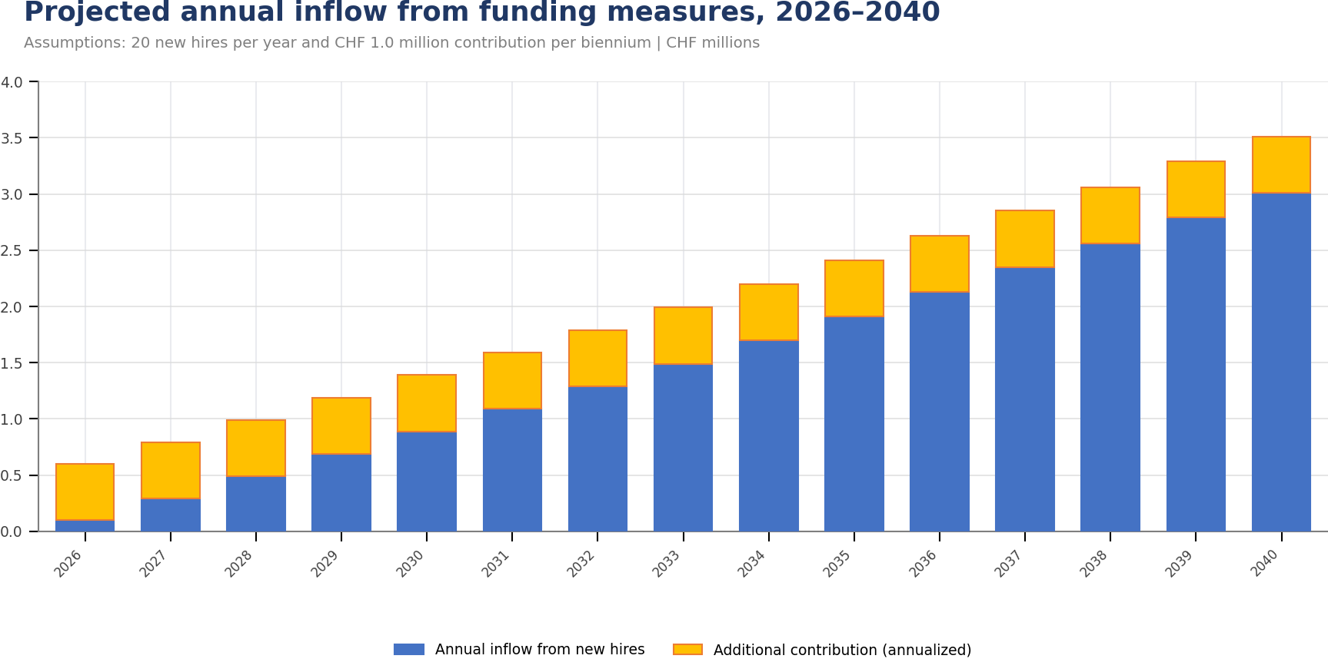

4 Why Action is Required

Financial Sustainability
4.1 The issue is not whether the Organization can continue to meet its current benefit payments. It can. The issue is whether the Organization should continue to carry a substantial unfunded liability that weakens its balance sheet, exposes it to external stakeholders’ scrutiny and increases future financial pressures.
4.2 More importantly, pay-as-you-go will increase and future service cost and interest will increase even further, inevitably increasing the gap between the current strategy and future accrued service obligations, therefore further increasing the unfunded gap and the need of future resources.
4.3 The chart below shows the expected trend in the benefit payments and the related percentage over annual payroll. In absence of new measures, the annual payments will increase from the current 3% of total annual payroll expense to nearly 10% in 30 years, representing approximately up 9% of budget and further up afterwards.
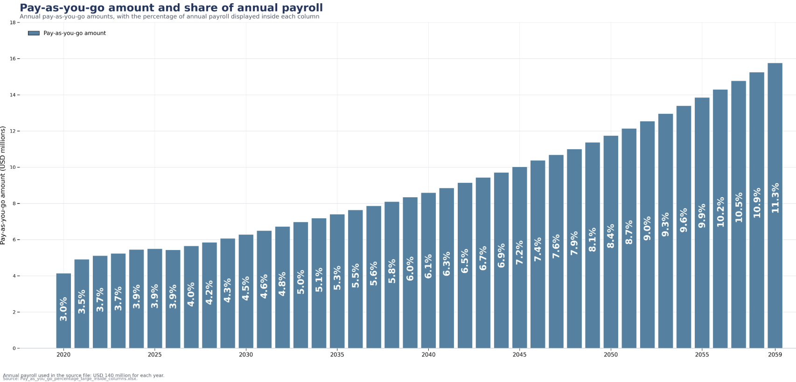
4.4 A stronger funding strategy would:
– improve the Organization's net asset position;
– reduce long-term financial risk;
– improve resilience against adverse actuarial developments;
– improve external auditors and external stakeholders’ confidence;
– demonstrate prudent financial management and stewardship of Member States' contributions.

Intergenerational Equity
4.5 ASHI benefits are earned through service rendered today but paid many years into the future. A key principle of sound financial governance is that obligations should be funded progressively as they are earned, rather than transferred to future generations of Member States.
4.6 A structured funding approach would ensure a more equitable sharing of costs across generations and reduce the risk of significant future funding requirements. This approach is consistent with internationally recognized public-sector financial management principles.

Alignment with International Practice
4.7 The challenge of funding post-employment benefit obligations is not unique to the Union. Across the United Nations system and among other international organizations, many entities have already adopted formal ASHI funding strategies. These organizations have progressively accumulated dedicated assets through combinations of budget contributions, payroll-based funding mechanisms, investment returns and reserve transfers.
4.8 Benchmarking among UN Organizations and Agencies demonstrates examples of organizations targeting funding levels ranging from partial coverage to full funding, with some entities having already achieved high or complete levels of coverage of their obligations.
4.9 Establishing a structured strategy would therefore also represent a positive convergence of ITU with the growing trend among the United Nations to address post-employment obligations through structured and sustainable funding arrangements.
4.10 As shown in the chart below, ITU’s ASHI funding level remains significantly below that of major organizations with comparable liabilities. Considering Organizations in the UN ecosystem with ASHI liability of more than 50 million in their respective reporting currency at the end of 2025, the following aspects shall be noted:
– average coverage stands at 64%, while ITU is at 4%,
– Organizations with higher ASHI liability than ITU have an average coverage of 68%,
– only 6 Organizations, have a funding coverage lower than ITU.

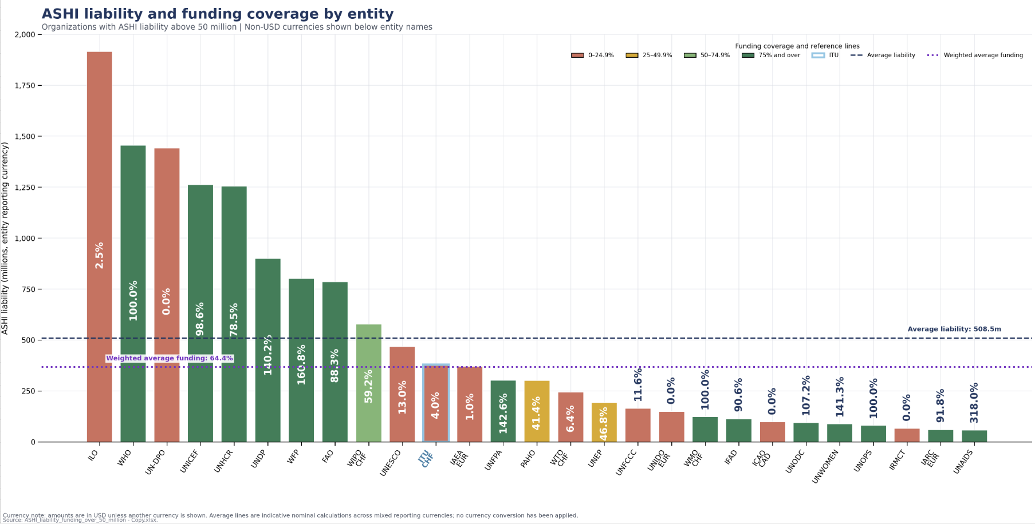

5 Proposed funding strategy and framework
5.1 Recognizing current budget constraints, the objective should be established along a realistic and measurable long-term roadmap.

Establish Funding Targets and illustrative scenarios
5.2 Member States should consider adopting a formal funding objective supported by intermediate milestones and periodic monitoring.
Illustrative targets could include:
– achieving a funding ratio of 25 per cent within fifteen years;
– achieving a funding ratio of 50 per cent within thirty years;
– achieving a funding ratio of 75 per cent within forty-five years;
– progressively increasing coverage beyond those levels towards the target over the longer term.
5.3 Illustrative scenarios could include:

Amortization Period | Annual Contribution (CHF million) | Contribution as % of Salaries
5 years | 21 to 23 million | 15%-16%
10 years | 11 to 14 million | 8%-10%
20 years | 7 to 11 million | 5%-8%
30 years | 5 to 10 million | 4%-7%

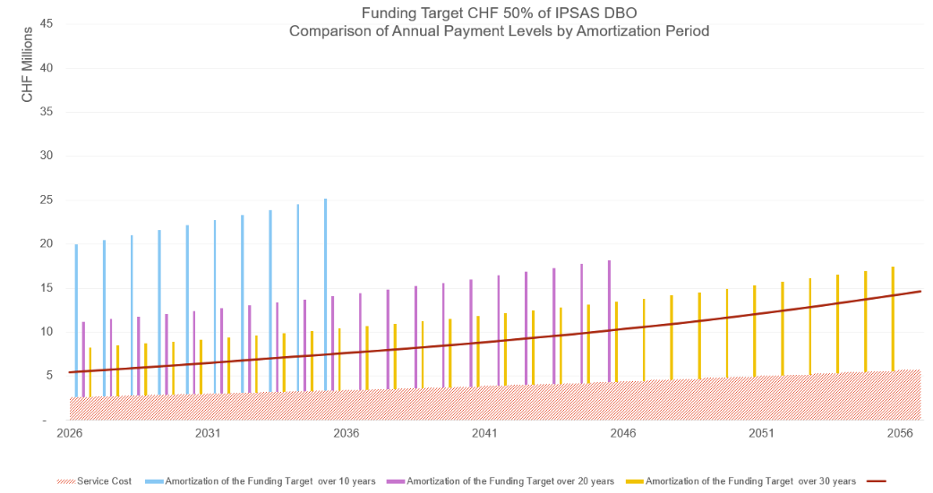
5.4 These scenarios demonstrate the trade-off between the speed at which funding objectives are achieved and the level of annual contributions required. Faster funding results in higher short-term contributions, whereas longer amortization periods reduce annual funding requirements but extend the period during which the Organization remains not covered.
5.5 Given current financing mechanisms are not sufficient, additional funding measures would therefore be required to place the Organization on a sustainable path toward achieving its funding objectives.
5.6 These scenarios are intended solely to illustrate the range of potential funding approaches available. The purpose is not to prescribe a specific level of contribution, but rather to demonstrate that the funding challenge can be addressed progressively over time through a structured and predictable funding strategy. The eventual funding objective and associated contribution levels would remain subject to the risk appetite, financial capacity and desired timeframe for improving the funded status of the ASHI obligation.
5.7 The precise targets would be subject to periodic actuarial and financial review and analysis. The key objective is to establish a clear and transparent long-term direction.

Review existing personnel-related reserves
5.8 A comprehensive review should be undertaken of legacy personnel-related reserves and funds that have limited ongoing activity or reduced beneficiary populations.
5.9 The External Auditor has previously highlighted the existence of such balances, including the Staff Superannuation and Benevolent Funds for approximately CHF 7.2 million. Subject to legal, governance and operational considerations, any surplus amounts could be redesignated by Council to support the funding of ASHI obligations.
5.10 This represents a potentially significant opportunity to increase funding levels without creating an immediate burden on Member States.

Additional annual contributions
5.11 The Organization should consider raising above the current level approved for the biennial contributions to supplement existing funding streams.
5.12 These contributions could take various forms, including:
– fixed annual appropriations;
– allocations from future budget surpluses;
– targeted funding approved through the budget process.
5.13 Regular contributions would accelerate progress toward the approved funding objectives and provide greater predictability.

Review the payroll-based funding mechanism
5.14 The recently introduced payroll-based funding measure should be maintained and periodically reviewed to consider:
– whether the current percentage shall be increased;
– whether broader application of the mechanism should be considered.
5.15 Payroll-based funding has the advantage of aligning benefit funding with the period during which benefits are earned, and it is the widely-adopted mechanism that all other UN Organizations have implemented in their funding strategies.

Establish a dedicated ASHI investment strategy
5.16 As assets dedicated to ASHI funding progressively increase, it will be important to ensure that these resources are managed within an investment framework specifically designed to support the long-term nature of the obligation.
5.17 The ASHI liability extends over several decades and exhibits characteristics that differ from the Organization's short-term operating cash requirements. Consequently, funding assets should be managed through a dedicated investment strategy aimed at preserving capital, generating long-term investment returns and supporting the gradual achievement of the approved funding objectives.
5.18 Investment returns can play a significant role in reducing the level of future further fundings. A structured investment approach would therefore constitute an essential component of any sustainable funding framework and would allow funding assets to contribute directly to the reduction of the unfunded liability.
5.19 Accordingly, Member States may wish to consider the adoption of a dedicated ASHI investment framework addressing, inter alia:
– investment objectives and risk tolerance;
– strategic asset allocation;
– liquidity requirements for future benefit payments;
– governance and oversight arrangements;
– performance monitoring and reporting;
– alignment between investment strategy and long-term funding targets.

Adopt a combined approach
5.20 No single measure is likely to generate sufficient progress on its own. A balanced strategy should therefore combine:
– reallocation of available personnel-related reserves;
– dedicated annual contributions;
– payroll-based funding;
– investment returns generated by accumulated assets.
5.21 Such an approach would diversify funding sources, reduce pressure on any single mechanism and enhance the likelihood of achieving long-term objectives.

Governance and monitoring
5.22 To ensure accountability and transparency, progress should be reviewed every two years. Such reviews should include:
– progress against approved funding targets;
– evolution of the funding ratio;
– performance of dedicated ASHI assets;
– status of reserve reviews and transfers;
– updated actuarial projections;
– recommendations for adjustments where necessary.
5.23 Regular monitoring will allow Member States to adapt the strategy as circumstances evolve while maintaining focus on the long-term objective.

Conclusion
The Plenipotentiary is requested to take note of this report.

______________

