
PLENARY MEETING | Document 71-E
 | 5 October 2026
 | Original: English
General Secretariat
Draft Financial plan for 2028-2031

Summary
This document presents the draft financial plan of the Union for 2028-2031. It also gives a preliminary analysis of the variances versus the 2024-2027 financial plan and the 2024-2025 and 2026-2027 budgets. This draft financial plan for 2028-2031 is balanced (revenue = expenses) and amounts to CHF 646.4 million.
A proposed revision of Decision 5 (Rev. Bucharest, 2022) is presented in the Appendix to this document.

Action required
The Plenipotentiary Conference is invited to consider this document and to approve the revisions to Decision 5 as presented in the Appendix.
Financial implications
This document provides the financial limits that will be applied to the implementation of the Strategic Plan 2028-2031.
______________

References
Decision 5 (Rev. Bucharest, 2022) of the Plenipotentiary Conference; Article 8, No. 51 of the Constitution

1. Introduction
1.1 The purpose of the draft financial plan for 2028-2031 is to provide a tool for the 2026 Plenipotentiary Conference to establish the basis for preparing the 2028-2029 and 2030-2031 budgets of the Union. By setting the amount of the contributory unit for the 2028-2031 timeframe and considering all relevant aspects of the work of the Union in the period concerned (Article 8, No. 51 of the Constitution), it determines related financial limits, until the next plenipotentiary conference.
1.2 The financial plan provides a framework which identifies for Member States their financial commitments to the Union for the 2028-2031 period, based on the approved amount of the contributory unit, and the way in which their financial contribution to the Union will be allocated across membership’s priorities for the Union which have been expressed through the strategic plan.
1.3 According to Article 28, No. 161B of the Constitution, and following the Secretary-General’s proposal, the Council has fixed the provisional amount of the contributory unit at CHF 318 000.
1.4 By revised Decision 5, on revenue and expenses for the Union for the period 2028-2031, the 2026 Plenipotentiary Conference will establish, through the Strategic and Financial Plan 2028-2031, the framework and the directives under which the two biennial budgets for 2028-2029 and 2030-2031 shall be developed. The financial plan 2028-2031, as revised and approved by the Plenipotentiary Conference 2026, shall be contained in Annex 1 to Decision 5.
2. Strategic Plan
2.2 The development of the strategic plan is undertaken in accordance with Article 11, No. 74A of the ITU Constitution and Article 4, No. 62A of the ITU Convention, which mandate the Secretary-General, with the assistance of the Coordination Committee, to provide Member States and Sector Members with the information required for preparing the Union’s policies and strategic plan, while the Council initiates the preparation of the draft plan before the Plenipotentiary Conference. Through Council Resolution 1428 (C24), the Council delegated the development of the draft Strategic and Financial Plans to the Council Working Group on strategic and financial plans (CWG-SFP), where Member States and Sector Members participate on an equal footing. This draft financial plan is aligned with the priorities set out in the present draft of the strategic plan and will be revised as needed to ensure full alignment with the final approved strategic plan 2028-2031.
2.3 The financial plan implements a results-based approach and allocates funds from expected regular-budget revenues available to the secretariat in 2028-2031 to priorities set out in the strategic plan.
2.4 The financial plan and the strategic plan will be translated into specific financial allocations to the Bureaux and the General Secretariat through the Operational Plan process and biennial budgets thereby providing funding for their work to achieve the expected outcomes, based on their respective contributions to achieving each priority. This will ensure a clear correspondence between planned activities and the resources required to deliver them.
2.5 The draft financial plan is therefore guided by several key parameters and determinants, including:
- the strategic goals and priorities defined in the strategic plan;
- the level of the contributory unit approved by Member States;
- the projected level of revenue available to the Union during the planning period, which establishes the overall ceiling for planned expenses; and
- the previous approved budgets and fiscal performance of the Sectors, Bureaux and the General Secretariat.
2.7 Within this framework, the financial plan establishes the overall resource envelope available to the Union for the period 2028-2031. Consequently, the implementation of the strategic plan will need to be achieved within these financial parameters, requiring prioritization of activities and efficient use of resources to ensure that the Union’s priorities are delivered in a financially sustainable manner.
3 Bases and assumptions
3.1 For assessed contributions (Member States, Sector Members, Associates and Academia), the revenue level is based on the information available as of 1 September 2026. Assessed contributions represent more than three-quarters of the Union’s revenue. Any change in the number of contributory units paid by Member States will impact on the 2028-2031 revenue forecast, and thus the expenses forecast in the financial plan will have to be adjusted accordingly.
3.2 The amount of the contributory unit has remained unchanged since 2006 at CHF 318 000 per unit, which corresponds to zero-nominal growth. During the period January 2006 until January 2026 the Geneva Consumer Price Index (CPI) increased by 10.5 per cent. If the contributory unit had been indexed to the Geneva CPI, the amount of the contributory unit would now amount to CHF 351 400, an increase of CHF 33 400 (zero-real growth). Such an increase in assessed contributions would have amounted to CHF 54.6 million for the 4-year period, which would have adequately funded the strategic priorities. Following the decision to retain the contributory unit at its current level, the draft financial plan would not be able to accommodate full funding at the levels proposed by the Bureaux and General Secretariat in pursuit of the strategic priorities. This is necessary to ensure that planned spending is limited to anticipated revenues. Section 5 provides information related to some funding constraints that the ITU will face in implementing this financial plan.
3.3 For cost recovery and other revenues, projections in the draft financial plan for 2028-2031 are broadly aligned with the actual revenue earned by ITU during the 2024-2025 biennium and the budgeted projected revenues for the 2026-2027 biennium. It is worth noting that predictions for Satellite Network Filing (SNF) revenue include a moderate increase. While SNF revenue is projected to be at higher levels than 2024-2025 (CHF 16.2 million) in 2028-2029 (CHF 21 million), an additional moderate uptick in revenues is anticipated in 2030-2031 (CHF 25 million) reflecting larger processing volumes which will be achieved through planned system investments and operational adjustments. However, this recovery is not expected to result in a return to the higher budgeted revenue levels observed in previous strategic plan cycles.
3.4 Based on the foregoing the estimated revenues for the 2028-2031 present a static picture. It is expected (as reflected in Table 1 below) that ITU’s revenues will remain at similar levels to those observed during the 2024-2025 biennium, with little or no growth, and a moderate risk of small to moderate decreases in specific years, depending on market volatility for cost recovery items. Table 1 below provides the breakdown of all revenue together with the comparison to 2026-2027 approved budget and 2024-2025 actual results.
Table 1 – Revenue by Source of funds (2024 to 2031) 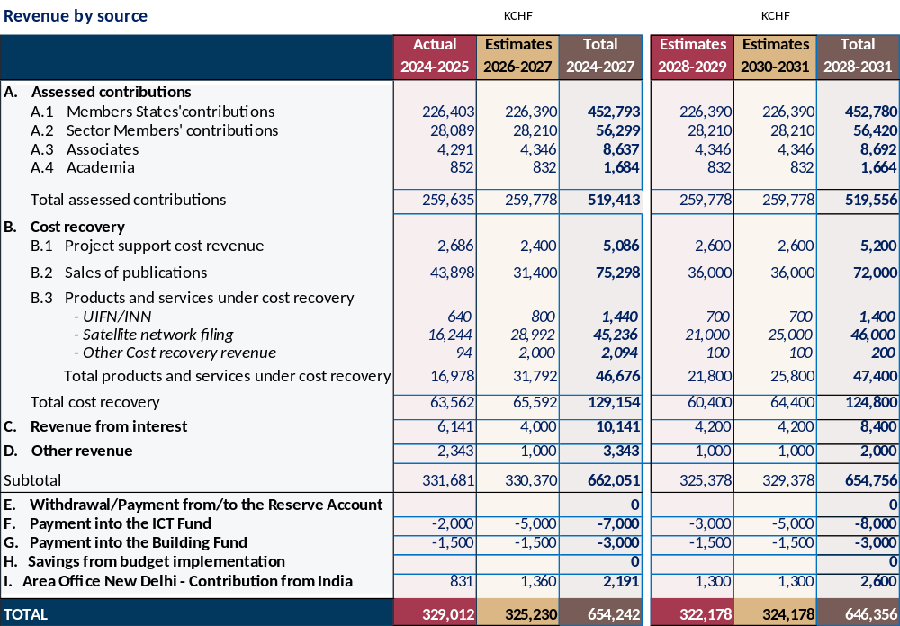
4 Use of Financial Resources
4.1 On the expense side, it is anticipated that ITU will be subject to increased costs, due to inflation, salary increases, rising health care costs and other inflationary factors. Accordingly, implementation of the financial plan through budgets in 2028-2029 and 2030-2031 will require careful prioritization to ensure continuity of core mandates and statutory functions, at increasing costs, within static revenues.
4.2 The implementation of efficiency measures will be needed to ensure balanced biennial budgets for 2028-2029 and 2030-2031, within the overall limits in the draft financial plan for 2028-2031. To ensure budget discipline and long-term financial sustainability, a set of structural efficiency measures will be required during the 2028-2031 period, including the following:
- Workforce costs must remain aligned with the available financial envelope and current projections indicate that a moderate reduction in overall staffing levels will be necessary to maintain expenses within the anticipated revenues in the context of zero nominal revenue growth and increasing costs. The secretariat will employ various methods including strategic vacancy management, agreed separation programmes, natural attrition and targeted redeployment.
- The ongoing modernization of core enterprise systems — including SAP S/4HANA, Microsoft Dynamics (CRM), Cvent and related digital platforms — must translate into measurable operational efficiencies. These investments are expected to reduce manual processes, eliminate parallel tracking systems, strengthen data integrity and standardize end-to-end workflows across finance, HR, procurement and project management. Over time, this digital transformation should enable leaner administrative structures and improved cost control.
- Expenditure on travel, meetings and other events will require continued discipline. Expanded use of virtual and hybrid ITU meetings and events, increased virtual participation by ITU staff in global meetings and events, strengthened mission prioritization, and tighter oversight of discretionary travel will be necessary to ensure that mission expenditure remains aligned with strategic objectives. The modernization of event management and conference systems should also support more efficient use of resources and improved planning of meetings.
- Finally, procurement rationalization and cross-sector synergies will be further pursued, including consolidation of contracts, reduction of duplicative services and enhanced coordination of support functions across the secretariat.
These measures are not temporary adjustments but must form part of a broader effort to align the Union’s cost structure with a more constrained revenue trajectory for 2028-2031. Maintaining financial balance under these conditions will require sustained management discipline and full realization of the efficiency gains associated with current transformation initiatives.
4.3 As discussed in section 2.2 above, this draft financial plan 2028-2031 is presented in alignment with the development of the strategic plan 2028-2031. The financial resources available during the 2028-2031 period, as set out in this document, will be applied to achieve the strategic goals and priorities as identified in the strategic plan 2028-2031. The draft Strategic Plan 2028–2031, as submitted by Council 2026 to the Plenipotentiary Conference, establishes the proposed priorities and outcomes for the Union. The secretariat has mapped, based on the 2026 workplans, the current products and services and related workstreams against these priorities and outcomes. This mapping provides the basis for the resource allocations presented in this Financial Plan and for strengthening the linkage between strategic, operational and financial planning. Based on this alignment, the secretariat has proposed an allocation of the financial resources to these draft priorities. The proposed allocations are presented in Table 2 below. The costs required to deliver on the enablers identified in the draft strategic plan are included in the costs to deliver the priorities.
4.4 While the secretariat has proposed allocations, it is recognised that the priorities in the current draft are subject to change by membership. Also, membership may wish to adjust the level of importance attributed to the specific priorities by adjustment of the proportion of ITU’s resources which is allocated to each priority. The allocations proposed in the draft financial plan 2028-2031 may therefore be adjusted as determined by membership at the Plenipotentiary Conference 2026, prior to finalisation and approval of the document.

Table 2 – Summary of Priorities by biennium
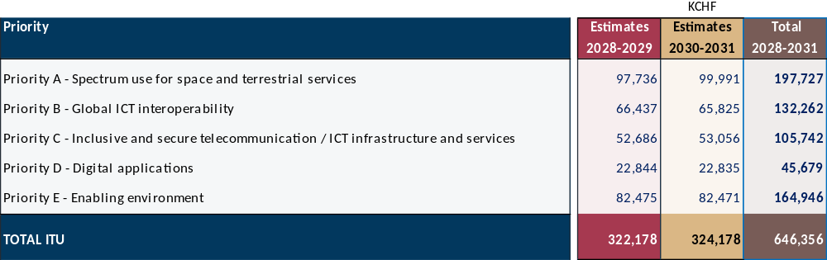
4.5 The Sector-level allocations shown in Annex 1 for 2028-2031 are based largely on the existing resource structure of the General Secretariat and the three Bureaux, adjusted to reflect the financial parameters set out in this Plan. During the 2028-2031 period, the Union will progressively strengthen the linkage between the Strategic Plan, Operational Plans and biennial budgets, in line with its results-based management framework. This will enable resources to be increasingly associated with the outputs and workstreams through which the General Secretariat and the Bureaux contribute to the priorities and expected outcomes of the Strategic Plan.
4.6 This transition will be implemented progressively through the Operational Plan and budget processes, with particular emphasis on:
- Results mapping: ensuring that the outputs and workstreams of the General Secretariat and each Bureau are clearly mapped to the relevant priorities and expected outcomes of the Strategic Plan, making their respective contributions explicit;
- Resource mapping and costing: progressively strengthening the association of financial and human resources with outputs and workstreams, using consistent methodologies, including an appropriate attribution of enabling and support costs;
- Planning and prioritization: using this improved results and resource information to support the preparation of biennial budgets and management decisions on the prioritization and allocation of resources within the overall financial envelope approved by the Plenipotentiary Conference; and
- Monitoring and reporting: progressively strengthening reporting on the use of resources and the delivery of results, thereby providing Member States with greater transparency on the relationship between resources allocated and results achieved.
This approach will be developed progressively during the 2028-2031 period as the Union’s planning, costing and information systems mature. It does not modify the overall financial envelope established by this Financial Plan or the respective authority of the Plenipotentiary Conference and Council in approving the Financial Plan and biennial budgets.
- 4.7 To add a further layer of transparency, Table 3 below cross-references the allocations of the General Secretariat and the three Bureaux shown in Annex 1 with the priorities of the Strategic Plan presented in Table 2. It provides an indicative view of how the resources each organizational component is expected to contribute to the Union’s strategic priorities. The mapping is based on the information and methodologies currently available and will be progressively refined through the Operational Plan and biennial budget processes as the results and resource-mapping framework matures.

Table 3 – Sector allocations by priority (indicative)

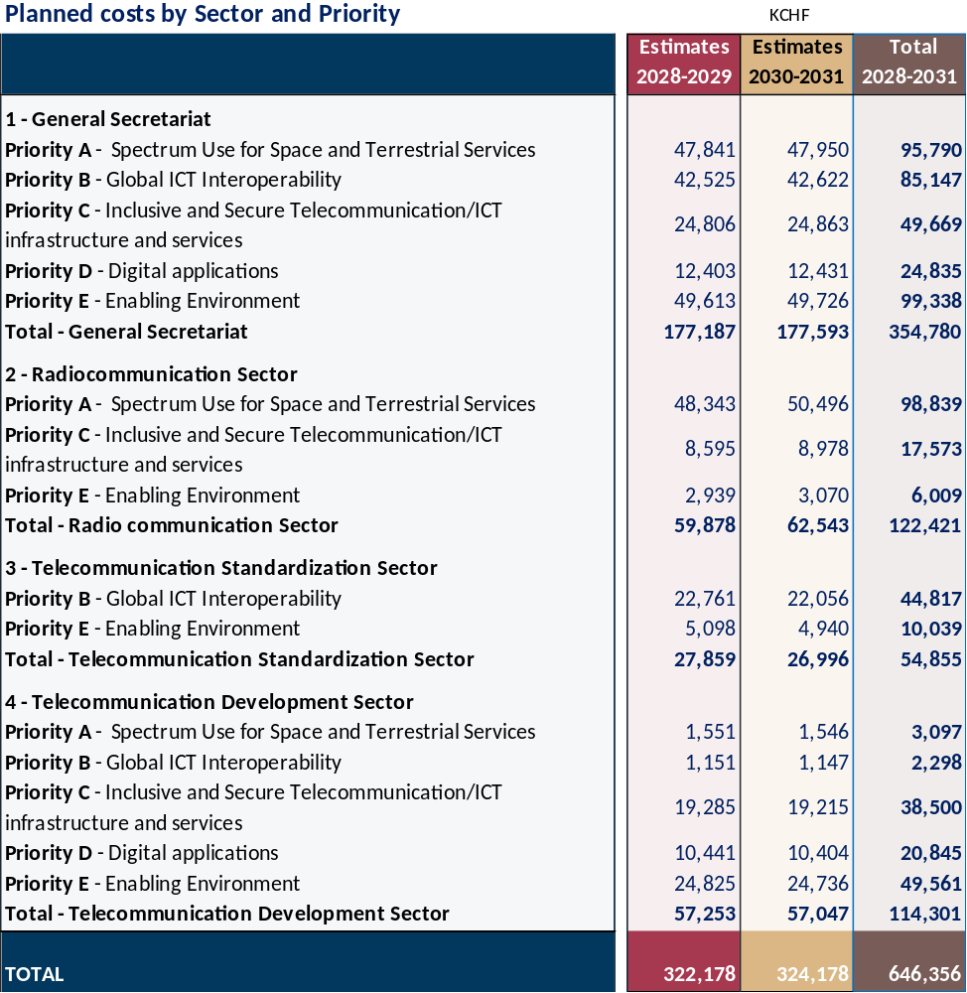

5 Financial Constraints
5.1 Having regard to the lack of growth in revenues anticipated for the 2028-2031 period, and anticipated increasing expenses of the Union, certain initiatives that would improve ITU’s effectiveness and possibly impact achievement of the strategic goals will not be able to be funded within the financial plan. Furthermore, funding required to support the financial implications of future World Conferences is not considered. During the four-year period leading up to the present Council, three world conferences have produced new or amended resolutions which those conferences have assessed would require additional funding for implementation. These have totaled more than CHF 15 million, all of which was outside the budgetary envelope set out in the relevant financial plans (2020-2023, and 2024-2027).

Appendix
MOD GS/71/1
DECISION 5 (REV. DOHA, 2026)
Revenue and expenses for the Union for the period 2028-2031
The Plenipotentiary Conference of the International Telecommunication Union (Doha, 2026),
considering
a) the strategic plan of the Union for 2028-2031, including goals, thematic priorities and product and service offerings of the Union, in compliance with Resolution 71 (Rev. Doha, 2026) of this conference;
b) Resolution 91 (Rev. Doha, 2026) of the Plenipotentiary Conference, on general principles for cost recovery
,
considering further

the need to link strategic, financial and operational planning in ITU,
noting
Resolution 151 (Rev. Doha, 2026) of this conference, on improvement of results-based management in ITU, an important component of which relates to planning, programming, budgeting, monitoring and evaluation, and the implementation of which should facilitate further strengthening of the management system of the Union, including financial management,
noting further
that Resolution 48 (Rev. Doha, 2026) of this conference stresses the importance of management and development of the human resources of the Union for the fulfilment of its goals, thematic priorities and product and service offerings,
decides
1 that the ITU Council is authorized to draw up the two biennial budgets of the Union in such a way that the total expenses of the General Secretariat and the three Sectors of the Union are balanced by the anticipated revenue, on the basis of Annex 1 to this decision, taking into account the following:
1.1 that the amount of the contributory unit of Member States for the years 2028-2031 shall remain unchanged at CHF 318 000;
1.2 that expenses for interpretation, translation and text processing in respect of the official languages of the Union shall not exceed CHF 85 million for the years 2028-2031;
1.3 that, when adopting the biennial budgets of the Union, the Council may decide to give the Secretary-General the possibility, in order to meet unanticipated demand, to increase the budget for products or services which are subject to cost recovery, within the limit of the revenue from cost recovery for that activity;

1.4 that the Council shall each year review the revenue and expenses in the budget, the different activities and the related expenses, as well as key financial indicators relevant for the Union;

2 that, if no plenipotentiary conference is held in 2030, the Council shall establish the biennial budgets of the Union for 2032-2033 and 2034-2035 and thereafter, having first obtained approval for the budgeted annual values of the contributory unit from a majority of the Member States of the Union;
3 that the Council may authorize expenses exceeding the budget for conferences, meetings and seminars if such expenses can be compensated by savings from previous years or charged to the following year;
4 that the Council shall, during each budgetary period, assess the changes that have taken place and the changes likely to take place in the current and coming budgetary periods under the following items:
4.1 salary scales, pension contributions and allowances, including post adjustments, established by the United Nations common system and applicable to the staff employed by the Union;
4.2 the exchange rate between the Swiss franc and the United States dollar insofar as this affects the staff costs for those staff members on United Nations scales;
4.3 the purchasing power of the Swiss franc in respect of non-staff items of expenses;

5 that the Council shall have the task of effecting every possible economy, in particular taking into account the measures for reducing expenses contained in Annex 2 to this decision, and considering the possible funding gaps, and, to this end, that it shall establish the lowest possible budgets commensurate with the needs of the Union, within the limits established by decides 1 above;
6 that the following minimum guidelines should be applied in relation to any reductions in expenses:
a. the oversight function of the Union should continue to be maintained at a strong and effective level;
b. there should be no reductions in expenses which would affect cost-recovery revenue;
c. fixed costs related to the reimbursement of loans shall not be reduced;
d. fixed costs related to after-service health insurance (ASHI) should be maintained at a level consistent with decisions taken by other organizations in the United Nations common system of salaries and benefits;
e. expenses in regular maintenance costs for ITU buildings which would be required to ensure the security and health of staff should be optimized;
f. the information services function in the Union should be maintained at an effective level;
7 that the Council shall aim in all circumstances to keep the Reserve Account at a level above 6 per cent of total annual expenses,
instructs the Secretary-General, with the assistance of the Coordination Committee
1 to prepare draft balanced biennial budgets for the years 2028-2029, as well as 2030-2031, on the basis of the associated guidelines in decides above, the annexes to this decision and all relevant documents submitted to the Plenipotentiary Conference;
2 to draw up and implement a programme of appropriate revenue increases, cost efficiencies and reductions across all ITU operations so as to ensure a balanced budget;
3 to implement the aforementioned programme as soon as possible,
instructs the Secretary-General
1 to provide to the Council, no less than seven weeks before its 2027 and 2029 ordinary sessions, complete and accurate data as needed for the development, consideration and establishment of the biennial budget;
2 to implement, monitor and propose improvements to the risk-management policy established in Resolution 71 (Rev. Doha, 2026), comprising all elements of a systematic and comprehensive risk-management framework, and to report annually to the Council;
3 to make every effort to achieve balanced biennial budgets, and to bring to the attention of the membership, through the Council Working Group on financial and human resources (CWG-FHR), any of its decisions that may have a financial impact likely to affect the achievement of such a balance, and to report annually to the Council

,
instructs the Secretary-General and the Directors of the Bureaux
1 to provide to the Council, on an annual basis, a report outlining expenses relating to each item in Annex 2 to this decision, and on ITU budget implementation for the previous year and anticipated implementation of the ITU budget for the current year;
2 to make every effort to achieve reductions through a culture of efficiency and economy and to include the savings actually achieved within the overall approved budgets in the above report to the Council;
3 to include in the above report to the Council a report on extrabudgetary activities and related expenses,
instructs the ITU Council
1
to authorize the Secretary-General, in accordance with the current Financial Regulations and Financial Rules, in the event that a surplus is achieved during the budget implementation, to prioritize allocating an appropriate amount to the ASHI Fund, with a view to keeping the ASHI Fund at a sustainable level;
2 to authorize the Secretary-General, in the event that a surplus is achieved during the budget implementation, to allocate an appropriate amount to the New Building Project Fund to finance the costs that cannot legally be financed by the loan from the host country;
3 to review and approve the balanced biennial budgets for 2028-2029 and 2030-2031, giving due consideration to the associated guidelines in decides above, the annexes to this decision and all relevant documents submitted to the Plenipotentiary Conference;
4 to consider further appropriations in the event that additional sources of revenue are identified or savings achieved;
5 to examine the cost-efficiency and cost-reduction programme drawn up by the Secretary-General;
6 to take account of the impact of any cost-reduction programme on the staff of the Union, and to implement without delay and preferably as from early 2028 funding that would be used in the following manner:
– fund separation where it is required, in the best interests of the Union, to address changes in skills and competencies aligned with reorganization;
– any unused balance would remain in the reserve to support future restructuring needs, recognising that organizational adjustments extend beyond a single financial year; and
– the secretariat shall report to Council annually on the use of the funds;
this would be funded to the extent possible by budgetary surplus, but also through a withdrawal from the Reserve Account, for an amount up to but not exceeding CHF 6 million;
7 in considering measures that could be adopted to strengthen control of the finances of the Union, to take into account the financial impact of such issues as ASHI funding and the medium- to long-term maintenance and/or replacement of buildings at the premises of the Union;
8 to invite the external auditor, the Independent Management Advisory Committee and CWG-FHR to continue to develop recommendations to ensure greater financial control of the finances of the Union, taking into account, inter alia, the issues identified in instructs the ITU Council 7 above;
9 to consider the reports relating to the matter, and report to the next plenipotentiary conference, as appropriate,
invites the ITU Council
to fix, to the extent practicable, the preliminary amount of the contributory unit for the period 2032-2035 at its 2029 ordinary session,
invites Member States
to announce their provisional class of contribution for the period 2032-2035 before the end of the calendar year 2029.
ANNEX 1 TO DECISION 5 (REV. DOHA, 2026)
Table 1
2028-2031 financial plan revenue and expenses
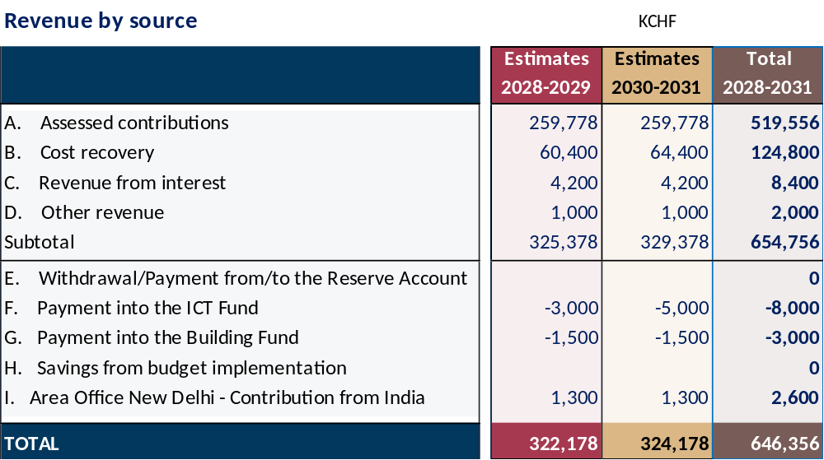

Expenses by Priority
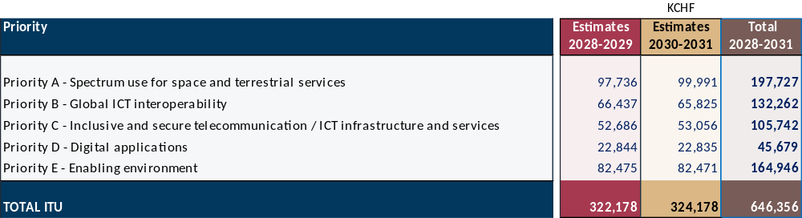
Table 2 – Indicative Expenses by Sector
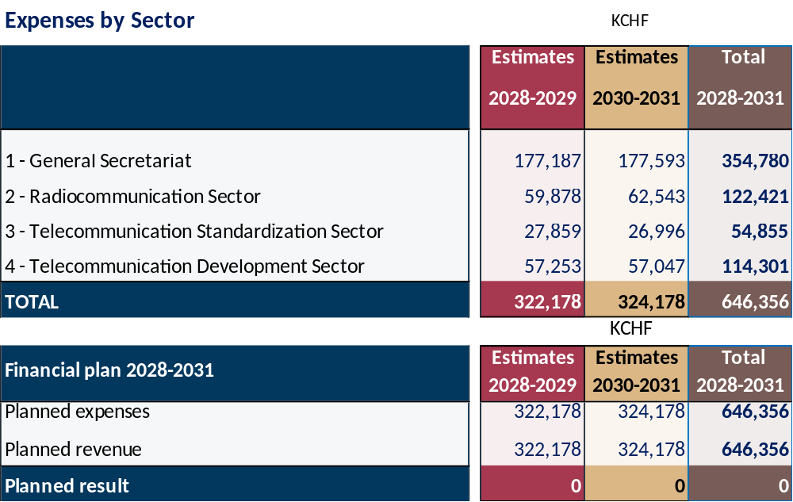

ANNEX 2 TO DECISION 5 (REV. DOHA, 2026)
Measures for improving ITU's efficiency and reducing its expenses
1)

Identification and elimination of all forms and instances of duplication of functions and activities between all ITU structural bodies and measures. Coordination, harmonization and closer cooperation among the Sectors, including optimization of management methods, logistics, coordination and support by the secretariat as well as centralization of finance and administrative tasks.
2) Coordination and harmonization of all seminars, workshops and cross-Sector activities by the secretariat's Inter-Sectoral Coordination Task Force (ISC-TF) in order to avoid duplication of topics, to optimize management, logistics, coordination and secretariat support and to benefit from synergy between the Sectors and a holistic approach to the subjects covered.
3) Enhanced efficiency in respect of regional offices, in implementing the goals and objectives of ITU as a whole, as well as in the use of local experts and local networks of contacts and resources. Maximum coordination of activities with regional organizations and rational use of existing financial and human resources, including savings on travel costs and costs associated with the planning and organization of events held outside Geneva.
4) Savings from attrition, redeployment of staff and review and possible reduction of grades of vacant posts, in particular in non-sensitive parts of the General Secretariat and the three Bureaux, in order to reach optimal levels of productivity, efficiency and effectiveness.
5) Prioritizing staff redeployment for the implementation of new or additional activities. New hiring should be the last option, while taking into account gender balance, geographical distribution and new skill requirements.
6) The use of consultants should only occur when the relevant skills or experience cannot be found among existing staff and after confirmation of this requirement in writing by senior management.
7) Upgrading the capacity-building policy to qualify the staff, including staff in regional offices, for multi-Sector proficiency, in order to improve staff mobility and their flexibility for redeployment to new or additional activities.
8) Reduction by the General Secretariat and the three Sectors of the Union of the cost of documentation by, among other measures, conducting paperless conferences and meetings of all kinds and at all levels; encouraging staff to avoid printing of e-mails and documents; reducing the archiving of additional paper documentation; pursuing initiatives aimed at making ITU a fully paperless organization; and fostering the adoption of innovative information and communication technology (ICT) solutions as viable and sustainable substitutes for paper, without any significant decrease in the quality of the information provided to event participants or to ITU staff in the course of their day-to-day work.
9) Reducing to the absolute minimum necessary the printing and distribution of ITU promotional/non-revenue-generating publications.
10) Implementation of practicable measures for making savings in the provision of interpretation and the translation of ITU documents, including minimizing the length of documents, and in the preparation of publications for events of all kinds and at all levels, without prejudice to the goals of Resolution 154 (Rev. Doha, 2026) of the Plenipotentiary Conference, as well as through optimization of resource usage in the language services, including the use of alternative translation procedures, while maintaining translation quality and the accuracy of telecommunication/ICT terminology.
11) Increasing the efficiency of World Summit on the Information Society (WSIS) programme activities and activities aimed at achievement of the Sustainable Development Goals, consistent with the financial plan and the biennial budget and, as appropriate, through cost recovery and voluntary contributions. Participation by the regional offices, in collaboration with other United Nations agencies, in WSIS activities being carried out at the regional level.
12) Optimization of the number and duration of meetings, and holding such meetings with the aid of ICT capabilities. Reduction of the number of groups to the minimum necessary through their restructuring and/or termination of their work in the absence of any outcomes and/or where there is duplication of activities, while avoiding any risk, in particular, of failure to fulfil the strategic and operational goals and objectives of the Union.
13) Regular assessment of the level of achievement of the strategic goals, objectives and outputs with a view to increasing efficiency through budget reallocation, when necessary.
14) For new activities or those having additional financial resource implications, a "value-added" assessment shall be made and implemented in order to improve efficiency and to avoid overlap and duplication.
15) Sound consideration of the size of, location of and resources allocated to regional initiatives, outputs and assistance to members, the regional presence both in the regions and at headquarters, as well as those actions resulting from the outcome of the World Telecommunication Development Conference and the Baku Action Plan, and financed directly as activities from the Sector budget.
16) Reduction of the cost of travel on duty, by developing and implementing criteria in order to reduce travel costs. The criteria should consider and aim at minimizing business travel, as far as possible, by prioritizing the allocation of staff from the regional and area offices, by limiting time on mission, through joint representation in meetings, and by rationalizing the number of staff sent on mission from various departments/divisions of the General Secretariat and the three Bureaux.
17) Appeals to Member States to reduce to the minimum necessary the number of issues raised and the time devoted to their consideration at all conferences, assemblies and other meetings.
18) Continued implementation by the Union of the comprehensive plan to improve the stability and predictability of the financial base of the Union, mobilizing the necessary resources and, inter alia, improving the management of internal corporate projects requiring significant long-term investments.
19) Member States, Sector Members and other ITU members taking all possible measures to settle/eliminate arrears to the Union.
20) Optimization of expenses related to maintenance, routine repair and renovation/reconstruction of the ITU buildings and facilities and to the provision of safety in accordance with applicable United Nations system standards.
21) Increased use of virtual meetings and remote participation in physical meetings in order to reduce and/or eliminate travel to meetings the proceedings of which are webcast and, preferably, captioned, including remote presentation of documents and contributions.
22) Introduction of innovative cross-cutting means and working methods for improving the Union’s productivity.

23) Continuing the efforts to simplify, harmonize or eliminate, as appropriate, internal administrative processes, for subsequent digitization and automation.
24) Consideration of further sharing of some common services with other United Nations organizations, and implementation of such sharing where beneficial.
25) Appeals to Member States, to the extent possible, with the support of the secretariat, to include in their proposals to ITU conferences an annex with relevant information in order to allow the Secretary-General/Directors of the Bureaux to identify the probable financial implications of such proposals.
26) Any additional measures adopted by the Council and the ITU management, including measures to increase the efficiency of the oversight function, assess and minimize the risk of fraud and other risks, implement external auditor, Independent Management Advisory Committee and Joint Inspection Unit recommendations in a timely manner, and implement the information technology and information management strategy.

___________________

Schedule of processing charges used are as per Document C25/125 – Decision 482 (01, last amended C25)

