
PLENARY MEETING | Document 46-E
 | 5 October 2026
 | Original: English
Report by the Secretary General
EXAMINATION OF THE FINANCIAL MANAGEMENT OF THE UNION BY THE PLENIPOTENTIARY CONFERENCE (YEARS 2022-2025)

Summary
The financial operating reports of the Union for the years 2022 to 2025 as approved by the respective Councils are submitted to the Plenipotentiary Conference for examination and approval.

Action required
The Plenipotentiary Conference is invited to approve this report.
Financial implications
N/A
______________

References
CV Art. 5, No. 101, CV Art. 4, No. 74, CS Art. 8, No. 53

1 The Constitution and Convention of the International Telecommunication Union stipulate as follows with regard to the examination of the financial management of the Union:

CV/Art. 5, No. 101
The Secretary-General shall:
r) with the assistance of the Coordination Committee, prepare an annual financial operating report in accordance with the Financial Regulations of the Union and submit it to the Council. A recapitulative financial operating report and accounts shall be prepared and submitted to the next plenipotentiary conference for examination and final approval;

CV/Art. 4, No. 74
The Council shall:
8) arrange for the annual audit of the accounts of the Union prepared by the Secretary-General and approve them, if appropriate, for submission to the next plenipotentiary conference;

CS/Art. 8, No. 53
The Plenipotentiary Conference shall:
e) examine the accounts of the Union and finally approve them, if appropriate;
2 Annexed hereto are the statements of the accounts of the Union for the years 2022 to 2025, as published in the financial operating reports and approved by the Council.

Annexes
Annex A – Statements of financial position, Statement of financial performance, Statement of changes in net assets, Cash Flow Statement and Comparison of Budgeted and actual amounts of the International Telecommunication Union for the 2022 financial period
Annex B – Statements of financial position, Statement of financial performance, Statement of changes in net assets, Cash Flow Statement and Comparison of Budgeted and actual amounts of the International Telecommunication Union for the 2023 financial period
ANNEX C – Statements of financial position, Statement of financial performance, Statement of changes in net assets, Cash Flow Statement and Comparison of Budgeted and actual amounts of the International Telecommunication Union for the 2024 financial period
ANNEX D – Statements of financial position, Statement of financial performance, Statement of changes in net assets, Cash Flow Statement and Comparison of Budgeted and actual amounts of the International Telecommunication Union for the 2025 financial period
ANNEX E – Financial management of the Union
ANNEX F – Draft resolution

ANNEX A
Statements of financial position, Statement of financial performance, Statement of changes in net assets, Cash Flow Statement and Comparison of Budgeted and actual amounts of the International Telecommunication Union
for the 2022 financial period
The financial statements are published in the financial operating report of the Union for the 2022 financial period and approved by the Council.
(Council Resolution 1426 relating to the approval of the financial operating reports audited by the External Auditor of the ITU accounts for the period from 1 January 2022 to 31 December 2022.)

I – Statement of financial position – Balance sheet at 31 December 2022 with comparative figures as at 31 December 2021
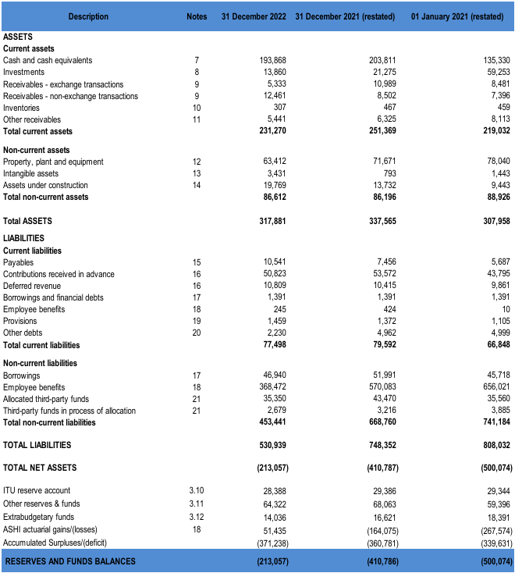

II – Statement of financial performance for the period which closed on
31 December 2022 with comparative figures as at 31 December 2021
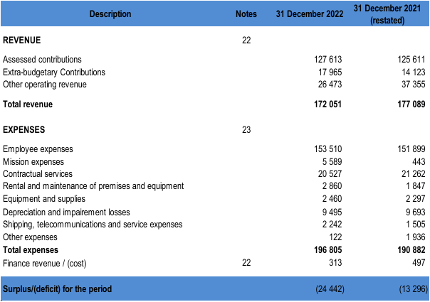

III – Statement of changes in net assets for the period which closed
on 31 December 2022
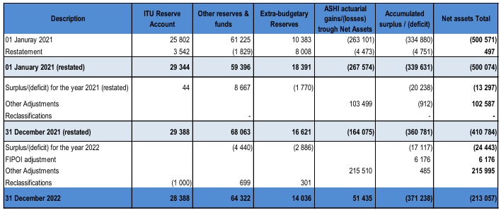

IV – Table of cash flows for the period closed on 31 December 2022 with comparative figures as at 31 December 2021
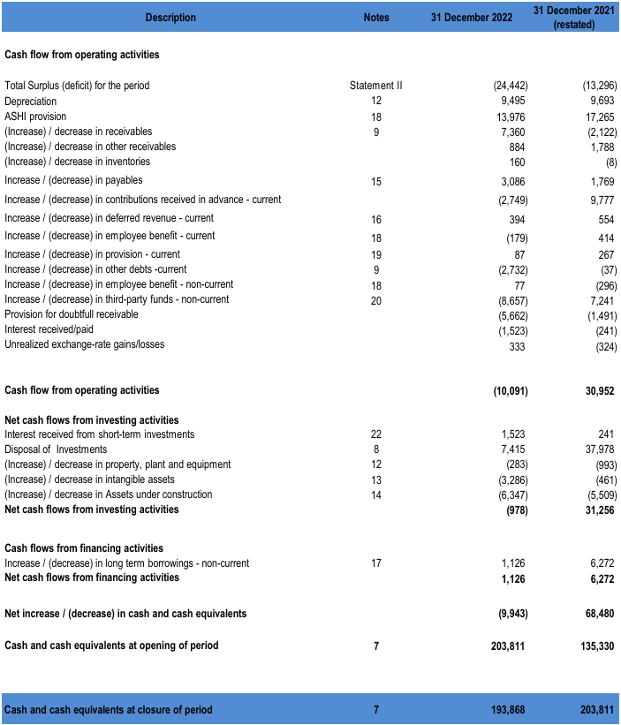

V – Comparison of budgeted amounts and actual amounts for
the 2022 financial period
(in thousands of CHF)
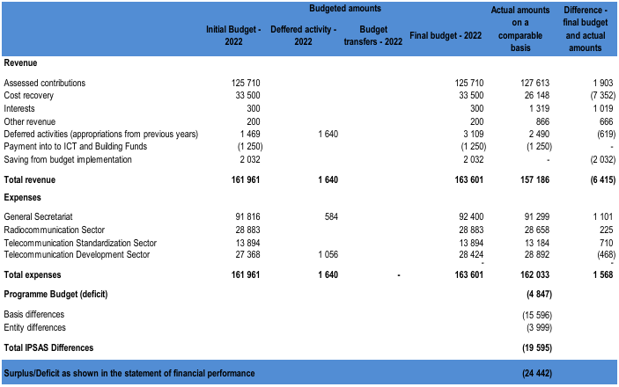

ANNEX B
Statements of financial position, Statement of financial performance, Statement of changes in net assets, Cash Flow Statement and Comparison of Budgeted and actual amounts of the International Telecommunication Union
for the 2023 financial period
The financial statements are published in the financial operating report of the Union for the 2023 financial period and approved by the First virtual consultation of councillors.
(Council Resolution 1430 relating to the approval of the financial operating reports audited by the External Auditor of the ITU accounts for the period 1 January 2023 to 31 December 2023.)

I – Statement of financial position – Balance sheet at 31 December 2023 with comparative figures as at 31 December 2022
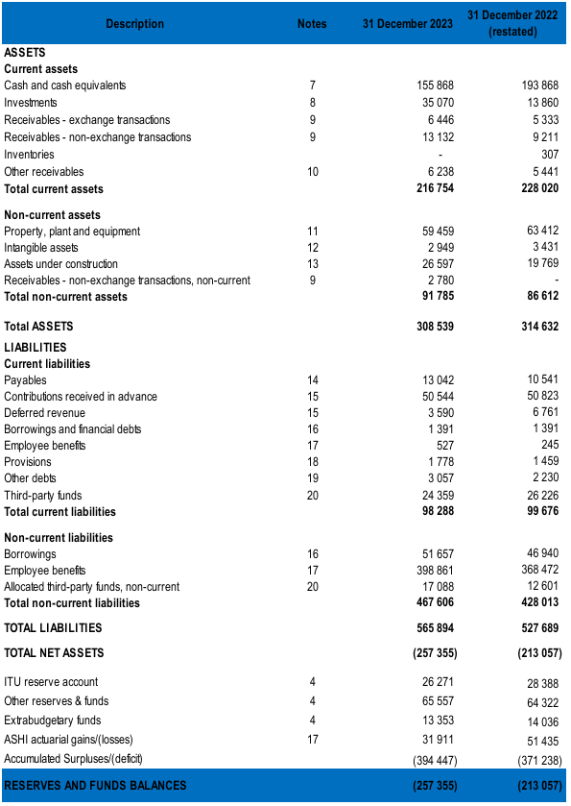

II – Statement of financial performance for the period which closed on
31 December 2023 with comparative figures as at 31 December 2022
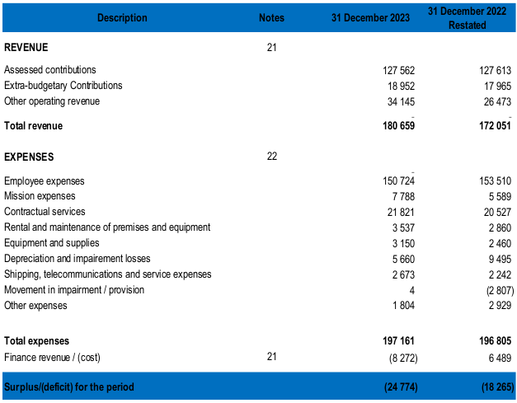

III – Statement of changes in net assets for the period which closed
on 31 December 2023
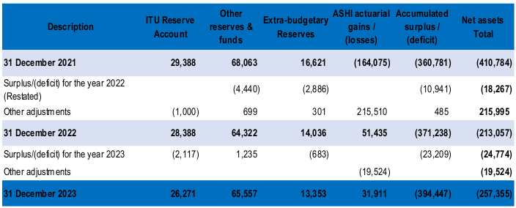
IV – Statement of cash flows for the period closed on 31 December 2023 with comparative figures as at 31 December 2022
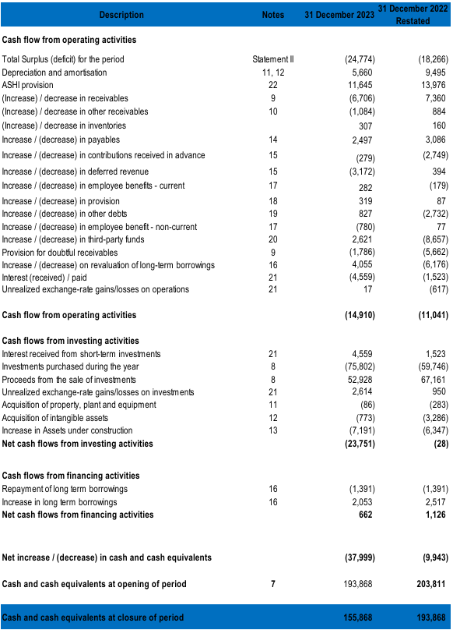

V – Comparison of budgeted amounts and actual amounts
for the 2023 financial period
(in thousands of CHF)
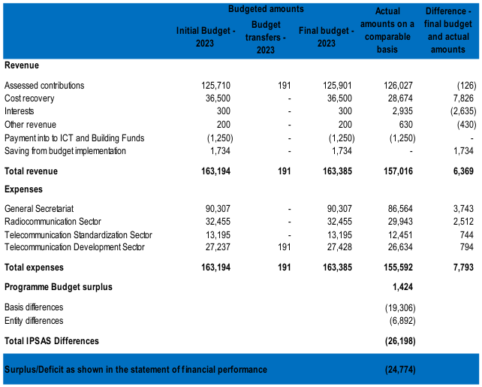

ANNEX C
Statements of financial position, Statement of financial performance, Statement of changes in net assets, Cash Flow Statement and Comparison of Budgeted and actual amounts of the International Telecommunication Union
for the 2024 financial period
The financial statements are published in the financial operating report of the Union for the 2024 financial period and approved by the Council.
(Council Resolution 1432 relating to the approval of the financial operating reports audited by the External Auditor of the ITU accounts for the period 1 January 2024 to 31 December 2024.)

I – Statement of financial position – Balance sheet at 31 December 2024 with comparative figures as at 31 December 2023
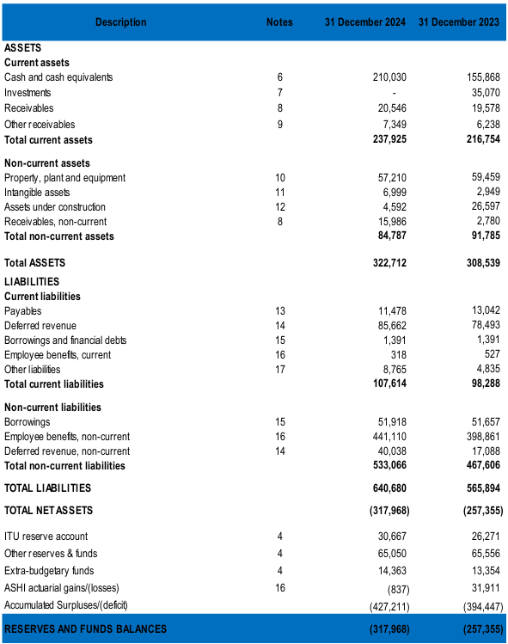

II – Statement of financial performance for the period which closed on
31 December 2024 with comparative figures as at 31 December 2023
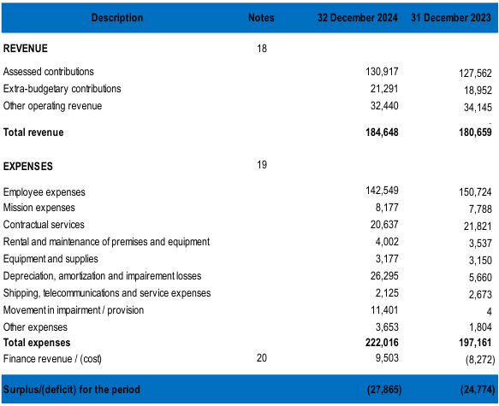

III – Statement of changes in net assets for the period which closed
on 31 December 2024
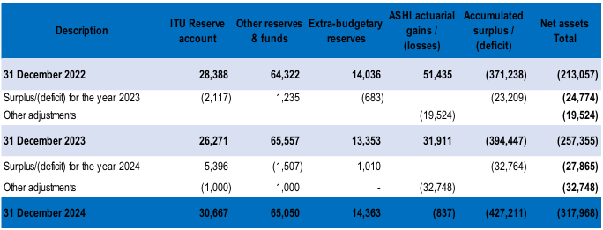
IV – Statement of cash flows for the period closed on 31 December 2024 with comparative figures as at 31 December 2023
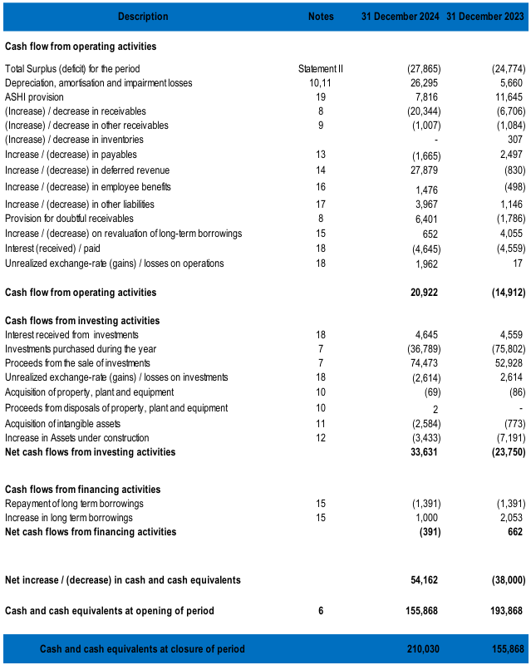
V – Statement of comparison of budgeted and actual amounts
for the 2024 financial period
(in thousands of CHF)
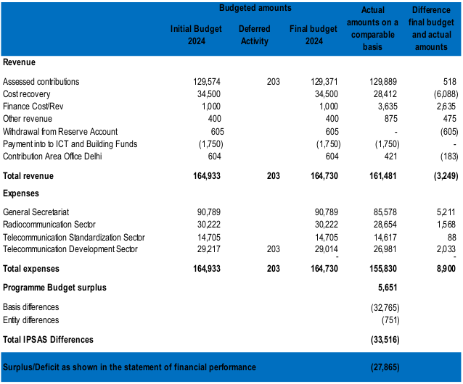

ANNEX D
Statements of financial position, Statement of financial performance, Statement of changes in net assets, Cash Flow Statement and Comparison of Budgeted and actual amounts of the International Telecommunication Union
for the 2025 financial period
The financial statements are published in the financial operating report of the Union for the 2025 financial period to be approved by the Council 2026 at its final session on 7 November 2026.
(Resolution 14XX relating to the approval of the financial operating reports audited by the External Auditor of the ITU accounts for the period 1 January 2025 to 31 December 2025.)

I – Statement of financial position – Balance sheet at 31 December 2025 with comparative figures as at 31 December 2024
(in thousands of CHF)
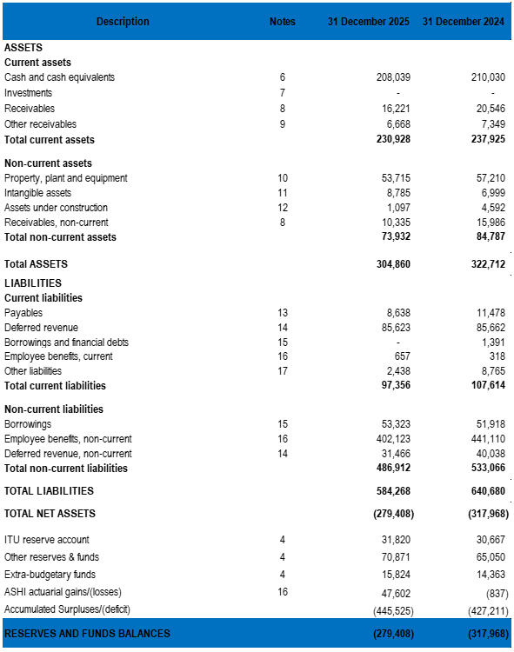

II – Statement of financial performance for the period which closed on
31 December 2025 with comparative figures as at 31 December 2024
(in thousands of CHF)
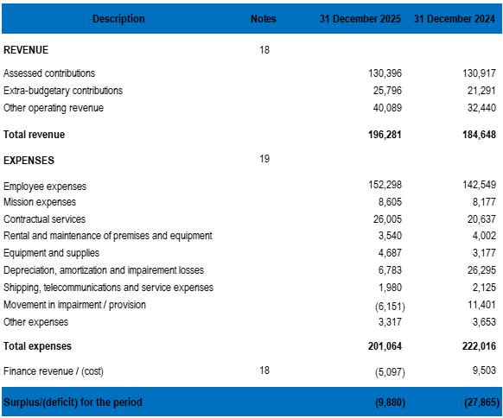
III – Statement of changes in net assets for the period which closed
on 31 December 2025
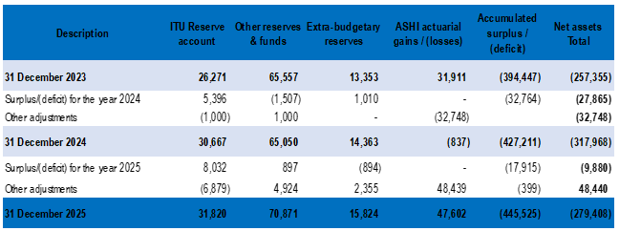

IV – Table of cash flows for the period closed on 31 December 2025 with comparative figures as at 31 December 2024
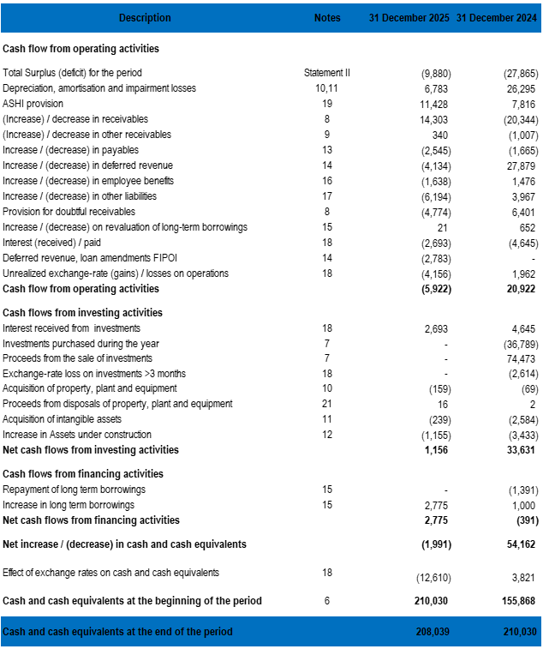

V – Comparison of budgeted amounts and actual amounts
for the 2025 financial period
(in thousands of CHF)
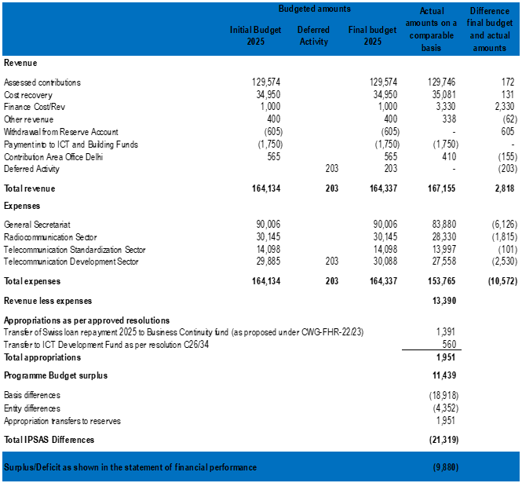

ANNEX E
Financial management of the Union
Table of contents
1 Implementation of the decisions and resolutions of the Plenipotentiary Conference (Guadalajara, 2010) concerning the finances of the Union (CS/Article 28, Decision 5, Resolutions 38 (Kyoto, 1994), 45 (Rev. Minneapolis, 1998), 91 (Rev. Guadalajara, 2010),
and 94 Bucharest (2022).
2 Budget of the Union
3 Assets, liabilities and net assets at 31 December 2025
4 Reserve Account and net assets
5 Cash and cash equivalent
6 Receivables
7 Fixed Assets
8 Employee benefits
9 Special accounts
10 Extra-budgetary contributions
11 Information and Communication Technology Development Fund (ICTDF)
12 Other financial management questions

FINANCIAL MANAGEMENT OF THE UNION
The finances of the Union are governed by the relevant provisions of the Constitution and the Convention of the International Telecommunication Union (Geneva, 1992), as amended in Kyoto in 1994, Minneapolis in 1998, Marrakesh in 2002, Antalya in 2006, Guadalajara in 2010, Busan in 2014, Dubai in 2018 and Bucharest 2022, the Financial Regulations and Financial Rules adopted by the Council and the decisions and resolutions adopted by the Council in accordance with such provisions.

1 Implementation of the decisions and resolutions of the Plenipotentiary Conference (Guadalajara, 2010) concerning the finances of the Union (CS/Article 28, Decision 5, Resolutions 38 (Kyoto, 1994), 45 (Rev. Minneapolis, 1998), 91 (Rev. Guadalajara, 2010), and 94 Bucharest (2022)

CS/Article 28: Finances of the Union: Procedure for choosing classes of contribution
1.1 Pursuant to Article 28 of the Constitution, Member States, upon invitation by the Secretary-General, shall announce their definitive choice of class of contribution by the date set by the plenipotentiary conference, which shall be a date within the penultimate week of the conference. Member States which have failed to notify the Secretary-General of their decision by the date set by the plenipotentiary conference shall retain the class of contribution previously chosen. The Secretary-General shall inform the Sector Members of the definitive upper limit of the amount of the contributory unit and invite them to notify, within three months from the closing date of the plenipotentiary conference, the class of contribution they have chosen. Sector Members which have failed to notify the Secretary-General of their decision within this three-month period shall retain the class of contribution previously chosen. Details of the evolution of the number of contributory units are given in §§ 2.7 and 2.8, Regular budget – Revenue.

Article 28, No. 165B
1.2 In 2023 the following changes occurred:
• Brazil increased its class of contribution from 3 to 8 units,
• Cambodia increased its class of contribution from 1/16 to 1/8 of a unit,
• Chile decreased its class of contribution from 1 to 1/2 unit,
• The United States increased its class of contribution from 30 to 35 units,
• Guinea increased its class of contribution from 1/8 to 1 unit,
• Equatorial Guinea increased its class of contribution from 1/8 to 1/4 of a unit,
• Libia increased its class of contribution from 1 to 1/4 of a unit,
• Papua New Guinea increased its class of contribution from 1/4 to 1/2 unit,
• Sri Lanka decreased its class of contribution from 1/2 to 1/4 of a unit,
• Venezuela decreased its class of contribution from 1 to 1/2 unit,
• Yemen decreased its class of contribution from 1/8 to 1/16 of a unit.

Decision 5 (Rev. Bucharest, 2022): Revenues and expenses of the Union for the period 2022-2025
1.3 Pursuant to this decision, the Plenipotentiary Conference (Bucharest, 2022) set the upper limit of the amount of the Member States’ contributory unit at Swiss Francs 318 000 for the years 2022-2025.

Resolution 38 (Kyoto, 1994): Contributory shares in Union expenses
1.4 Resolution 38 (Kyoto, 1994) instructs the Council to review, on request, the situation of countries not included in the United Nations list of the least developed countries in order to decide which of them may be considered as being entitled to contribute to defraying Union expenses in the 1/8 or 1/16 unit class.

Resolution 45 (Rev. Minneapolis, 1998): Assistance given by the Government of the Swiss Confederation in connection with the finances of the Union
1.5 By this resolution, the Plenipotentiary Conference expressed its appreciation to the Government of the Swiss Confederation for its generous assistance in financial matters and also expressed the hope that these arrangements might be renewed. The resolution was brought to the notice of the Government of the Swiss Confederation.

Resolution 91 (Rev. Guadalajara, 2010): Cost recovery for some ITU products and services
1.6 The implementation of this resolution is examined by the Secretary-General from an administrative and accounting standpoint in Document PP-20/20.

Resolution 94 (Rev. Bucharest, 2022): Auditing of the accounts of the Union
1.7 By this resolution, the Plenipotentiary Conference expressed its warmest thanks and deepest gratitude to the Italian Supreme Court of Audit for the auditing of the Union's accounts for the years 2012, 2013, 2014, 2015, 2016, 2017, 2018, 2019, 2020 and 2021 in the most careful, competent and accurate manner.
1.8 Following an open, fair and transparent selection and appointment process, the National Audit Office of the United Kingdom was appointed by the ITU Council as per Decision 621, at its 2020 session, as the external auditor of the ITU for auditing its 2022, 2023, 2024 and 2025 financial statements. The mandate of the National Audit Office of the United Kingdom was further renewed as per Decision 644 in 2025 for a period of two years for auditing the 2026 and 2027 financial statements.

2 Budget of the Union
2.1 The budget of the Union covered a budgetary period of two consecutive calendar years beginning on 1 January of an even-numbered year. Since the implementation of IPSAS in 2010, the budget of the Union has been allocated on an annual basis in order to enable the presentation of budget information in financial statements according to IPSAS 24. The ordinary budget comprises appropriations and expenses for the:
– General Secretariat;
– Radiocommunication Sector;
– Telecommunication Standardization Sector;
– Telecommunication Development Sector.
2.2 The plenipotentiary conferences authorized the Council to draw up the budgets for the General Secretariat and the three Sectors for the 2020-2023 period by Decision 5 (Rev. Dubai, 2018) and for the 2024-2027 period by Decision 5 (Rev. Bucharest, 2022).
2.3 In accordance with Resolution 1405, adopted by the Council at its 2021 session, the Secretary-General was authorized to adjust the appropriations in relation to the items of expenses in a) and b) below in accordance with the incurred changes through the use of the Reserve Account, and provided that the Reserve Account is kept at the level prescribed in Decision 5 (Rev. Dubai, 2018):
a) increases in salary scales, pension contributions and allowances, including post adjustments, applicable to Geneva, as adopted by the United Nations common system;
b) fluctuations in the exchange rate between the US dollar and the Swiss franc in so far as this affects the staff costs for those staff members on United Nations scales.
With this Resolution, the Secretary-General was instructed to withdraw CHF 1 000 000 from the Reserve Account on 1 January 2022 to the ASHI fund in order to address the unfunded long-term liabilities.
2.4 In accordance with Resolution 1417, adopted by the Council at its 2023 session, the Secretary-General was authorized to adjust the appropriations in relation to the items of expenses in a) and b) below in accordance with the incurred changes through the use of the Reserve Account, and provided that the Reserve Account is kept at the level prescribed in Decision 5 (Rev. Bucharest, 2022):
a) increases in salary scales, pension contributions and allowances, including post adjustments, applicable to Geneva, as adopted by the United Nations common system;
b) fluctuations in the exchange rate between the US dollar and the Swiss franc in so far as this affects the staff costs for those staff members on United Nations scales;
c) to authorize to balance the 2024-2025 accounts, should the need arise, from surplus in revenue;
d) to instruct the Secretary-General to transfer CHF 1 000 000 from the Reserve Account in January 2024 to the ASHI fund in order to address the unfunded long-term liabilities.

Regular budget

Expenses
2.5 Pursuant to its terms of reference as laid down by the plenipotentiary conference, the Council approved the following ordinary biennium budgets for the years 2022-2023 by Resolution 1405 and, 2024-2025 by Resolution 1417:
Year | General Secretariat | Radiocommunication Sector | Telecommunication Standardization Sector | Telecommunication Development Sector | Covid | TOTAL
Year | Thousands of CHF
2022 | 91 396 | 28 883 | 13 894 | 27 368 | 420 | 161 961
2023 | 89 887 | 32 455 | 13 195 | 27 237 | 420 | 163 194
2024 | 90 789 | 30 222 | 14 705 | 29 217 |  | 164 933
2025 | 90 006 | 31 145 | 14 098 | 29 885 |  | 165 134

2.6 The table below compares the expenses approved by the Council including adjustments including deferred activities as approved by Council, with actual expenses on a comparable basis for the 2022, 2023, 2024, and 2025 financial periods.

Period | 2022 | 2023 | 2024 | 2025 | Total 2022-2025
Regular budget (final) | 163 601 | 163 385 | 164 730 | 164 337 | 656 053
Regular budget – revenue | 157 186 | 157 016 | 161 481 | 167 155 | 642 838
Actual expenses & appropriations | 162 033 | 155 592 | 155 830 | 155 716 | 629 171
Unused appropriations (revenue to expense & appropriations) | −4 847 | 1 424 | 5 651 | 11 439 | 13 667
% | −3.08% | 0.907% | 3.44% | 6.8% | 4.3%

Revenue
2.7 Regular budget revenue was calculated to balance expenses by means of the contributions by Member States, Sector Members and Associates, cost recovery, withdrawals from the Reserve Account and savings from budget implementation. Details of regular budget revenue are given below.

Contributions by Member States
Year | Number of Member States* | Number of contributory units* | Amount of contributory unit | Revenue entered in the budget | Revenue posted to account**
Year | Number of Member States* | Number of contributory units* | Thousands of CHF | Thousands of CHF | Thousands of CHF
2022 | 193 | 343 11/16 | 318 | 109 293 | 109 293
2023 | 193 | 343 11/16 | 318 | 109 293 | 109 293
2024 | 193* | 356 | 318 | 113 188 | 113 195
2025 | 194 | 356 | 318 | 113 188 | 113 208
* At the time of establishment of the budget. NB: Palau became a new Member from 1 September 2024.
** These amounts include invoiced contributions and unpaid contributions at 31 December.

Contributions by Sector Members

Year | Radiocommunication  Sector* | Telecommunication Standardization Sector* | Telecommunication Development Sector* | Total units* | Amount of contributory unit | Revenue entered in the budget | Revenue posted to account**
Year | Units | Units | Units | Units | Thousands of CHF | Thousands of CHF | Thousands of CHF
2022 | 98 13/16 | 94 14/16 | 20 10/16 | 214 5/16 | 63.6 | 13 823 | 13 797
2023 | 98 13/16 | 94 14/16 | 20 10/16 | 214 5/16 | 63.6 | 13 823 | 13 967
2024 | 101 11/16 | 93 5/16 | 22 | 217 | 63.6 | 13 798 | 14 105
2025 | 101 11/16 | 93 5/16 | 22 | 217 | 63.6 | 13 798 | 13 984
* At the time of establishment of the budget.
** These amounts include invoiced contributions and unpaid contributions at 31 December.

Contributions by Associates
2.8 The annual contribution for Associates amounts to CHF 10 600 for Radio communication and Telecommunication Standardization Sectors and CHF 3 975 for Telecommunication Development Sector. The contribution for Associates from Developing countries amounts to CHF 1 987.50.

Year | Radiocommunication  Sector* | Telecommunication Standardization Sector* | Telecommunication Development Sector* | Total units* | Revenue entered in the budget | Revenue posted to account**
Year | Units | Units | Units | Units | Thousands of CHF | Thousands of CHF
2022 | 19 5/16 | 166 10/16 | 10/16 | 186 9/16 | 2 196 | 2 180
2023 | 19 5/16 | 166 10/16 | 10/16 | 186 9/16 | 2 196 | 2 164
2024 | 21 2/16 | 156 1/16 | 9/16 | 177 12/16 | 2 180 | 2 173
2025 | 21 2/16 | 156 1/16 | 9/16 | 177 12/16 | 2 180 | 2 118
* At the time of establishment of the budget.
** These amounts include invoiced contributions and unpaid contributions at 31 December.

Contributions by Academia
2.9 As per Resolution 169 (Rev. Dubai, 2018) of the Plenipotentiary Conference, Academia, Universities, and their related research establishments (designated as Academia) have been admitted as a new member category to participate in the work of the three Sectors of ITU. Resolution 169 (Rev. Dubai, 2018) allows academia to participate in all three sectors of ITU at one single fee.

Year | Total number of Organizations* | Revenue entered in the budget | Revenue posted to account**
 |  | Thousands of CHF | Thousands of CHF
2022 | 145 | 398 | 408
2023 | 145 | 398 | 413
2024 | 158 | 408 | 416
2025 | 158 | 408 | 436
* At the time of establishment of the budget.
** These amounts include invoiced contributions and unpaid contributions at 31 December.

3 Assets, liabilities and net assets at 31 December 2025
3.1 In order to assess the financial state of the Union, the Plenipotentiary Conference may wish to take note of the position of the assets and liabilities of the Union at 31 December 2025. The Statements of financial situation for the four financial periods are included in Annexes A, B, C and D. The statements of financial situation are presenting a comprehensive view of ITU activities.
3.2 IPSAS mandatory information related to each Statement of financial situation and statement of financial performance position are included in the financial operating reports presented to Council (Documents C24/40, C24/43, C25/40 and C26/40). This Document focuses on specific significant positions of ITU financial operating reports.

4 Reserve Account and net assets
4.1 Unlike other United Nations specialized agencies, ITU does not have a working capital fund to ensure the financing of its activities. In accordance with No. 485 of the Convention and Article 27 of the Financial Regulations, the Reserve Account is maintained mainly from unused appropriations. Variations in the Reserve Account are detailed in the statement of changes in the net assets of the Union. It is made up of:
a) the positive or negative net balance from the regular budget implementation for each financial year;
b) transfers from other reserves/funds as decided by the Council;
c) any amounts to be credited to the Reserve Account as prescribed by the accounting standards common to the organizations of the United Nations system.
4.2 By its Decision 5 (Rev. Dubai, 2018), the Plenipotentiary Conference requested the Council to aim under normal circumstances at keeping the Reserve Account (after integration of unused appropriations) at a level above six per cent of the total budget.
4.3 The table below show the ratio of the Reserve Account over the budget for the years from 2022 to 2025:
 | 2022 | 2023 | 2024 | 2025
(In thousands of CHF)
Reserve account | 28 388 | 26 271 | 30 667 | 31 820
Budget | 161 961 | 163 194 | 164 933 | 165 134
% of annual budget | 18% | 16% | 19% | 19%

4.4 The table below shows the Union’s own funds allocated to the organization according to the statement of changes in ITU’s net assets and the Reserve Account at 31 December of the y-year period 2022-2025 after allocation of the surplus of the year:
In thousands CHF | 31.12.2022 | 31.12.2023 | 31.12.2024 | 31.12.2025
Reserve Account | 28 388 | 26 271 | 30 667 | 31 820
Other allocated reserves | 64 322 | 65 557 | 65 051 | 70 871
Balance of the savings from previous year | 3 224 | 2 771 | 2 098 | 6 374
Investment fund | 14 849 | 13 476 | 13 706 | 16 835
New Building Reserve | 20 427 | 23 278 | 21 905 | 20 197
Risk Register fund | 3 430 | 3 430 | 3 430 | 3 430
Welfare fund | 348 | 314 | 315 | 341
Centenary fund | 212 | 212 | 212 | 212
SS&B Reserve and Complement fund | 6 284 | 6 528 | 6 833 | 6 931
SS&B Assistance fund | 276 | 276 | 279 | 279
ASHI fund | 14 000 | 14 000 | 15 000 | 15 000
Health Insurance fund | 1 272 | 1 272 | 1 272 | 1 272
Own funds allocated to the organization according to the statement of changes in net assets | 92 710 | 91 828 | 95 718 | 102 691

4.5 In order to meet the requirements of certain functions or activities, the Union operates a number of special funds, which are described briefly below.
4.6 The ASHI fund was established in 2013 in order to constitute a reserve dedicated to the long-term funding of the ASHI liability. This fund will be monitored in order to take into account future variations of ITU obligations due to changes in actuarial assumptions.
4.7 The Health Insurance guaranty fund also established in 2013 will be dedicated to the financing of ITU’s new Health Insurance scheme on a pay-as-you-go basis and will be credited with surpluses of contributions over claims.
4.8 The total net assets of the Union presented in the statement of financial situation are including the positions disclosed here above as well as the effects of transition to IPSAS and the extra-budgetary reserves.

Other special funds

ITU Centenary Prize Fund
4.9 The Council decided in 1978 to institute an "ITU Centenary Prize Fund" intended to reward an individual or a group of individuals who have contributed to the development of international telecommunications. Centenary prizes were awarded in 1979 and 1983. In 1992, the Council resolved to use the Centenary Prize Fund for the modernization and upgrading of the ITU Central Library. At 31 December 2025, the balance of the fund stood at KCHF 212, unchanged since 2021.

Staff Welfare Fund
4.10 The Staff Welfare Fund is administered by the Secretary-General in consultation with the ITU Staff Council. The revenue of the fund is the Union's share of the caterer's profits and the expenses correspond to the sums used for the welfare of the staff. The balance of the fund stood at KCHF 348 at 31 December 2025.

Capital Budget Fund
4.11 Revenue in the Capital Budget Fund dedicated to buildings maintenance consists of the annual payments debited to the ordinary budget and annual payments by the caterer. Expenses consist of the costs of maintaining the Union's buildings. The balance of the Capital Budget Fund dedicated to buildings maintenance stood at KCHF 6 649 at 31 December 2021.
4.12 The Capital Budget Fund also serves to finance the purchase and development of the main computer systems and cover the new systems and the replacement and upgrading of existing ones. Budgetary allocations are decided by the Council. The balance of the Capital Budget Fund dedicated to purchase and development of computer systems amounted to KCHF 8 168 at 31 December 2021.

5 Cash and cash equivalent
5.1 The cash resources of the Union are drawn mainly from the assessed contributions of Member States, Sector Members and Associates. If these contributions, payable in advance by 1 January each year, are not sufficient to cover the Union's cash requirements, the Secretary-General may resort to advances from the Government of the Swiss Confederation under the prevailing arrangements. From 2022 to 2025, no funds had to be sought from this source. The Plenipotentiary Conference may wish to express its gratitude to the Government of the Swiss Confederation, and that the current arrangements will be maintained in the future.
5.2 In December 2025 the Fondation des Immeubles pour les Organisations Internationale (FIPOI) submitted to ITU a proposal for amendment of three existing loans in the context of the measure adopted by the Swiss Confederation to support the stability, resilience and operational continuity of international organisations headquartered in Switzerland during the current financial challenges. ITU has therefore obtained a two-year conditional waiver for the 2025 and 2026 instalments of the three loans for a total of CHF 2.8 million. Such conditions provide that ITU shall maintain its activities and essential jobs for “Geneva internationale” in Geneva for a minimum period of 10 years.
5.3 The satisfactory inflow of contributions has made it possible to invest available funds. As from 1 January 1998, interest revenue is entered as revenue in the budget of the Union (the interest account having been abolished by Council-97 in Resolution 1100).
5.4 Cash is managed separately for ordinary budget and special accounts activities, for telecommunication exhibitions, for technical cooperation projects funded by UNDP, for technical cooperation projects funded by trust funds and for voluntary contributions. Amounts due between these separate funds are settled regularly as far as possible.
5.5 Deposits in convertible currencies with Swiss and foreign banks are converted at the United Nations rate.

6 Receivables
6.1 Receivables represent as yet uncollected revenue that Member States, Sector Members and Associates have committed to pay to ITU in respect of annual contributions, purchase of publications, satellite network filings or other invoices. Amounts due on contributions bear interest from the beginning of the fourth month of each financial year of the Union at three per cent per annum during the following three months, and at six per cent per annum as from the beginning of the seventh month. Interest is credited to the Reserve for debtors’ accounts in accordance with Article 24 of the Financial Regulations.
6.2 Non-current, non-exchange receivables represent receivables from the debt repayment schedules applicable to members having undertaken to repay such debts under an agreement spanning several financial periods.
6.3 In accordance with IPSAS, a provision is constituted for Member States, Sector members, Associates and Academia having arrears of over two years. The provision is including interests on arrears.
6.4 Satellite Network Filings (SNF) invoices are payable within six months from invoice date. In accordance with IPSAS, a provision is constituted for SNF invoices at 31 December of each year.

In thousands of CHF | 31.12.2022 | 31.12.2023 | 31.12.2024 | 31.12.2025
Current receivables – exchange transactions | 6 437 | 7 687 | 9 774 | 8 530
Provision for losses on current receivables – exchange transactions | -1 104 | -1 241 | -1 272 | -1 226
Current receivables – exchange transactions: net value | 5 333 | 6 446 | 8 502 | 7 303
Current receivables – non-exchange transactions | 29 560 | 40 541 | 48 009 | 111 534
Provision for losses on current receivables – non-exchange transactions | -20 349 | -27 409 | -35 964 | -34 603
Current receivables – non-exchange transactions: net value | 9 211 | 13 132 | 12 044 | 76 931
Non-current receivables – exchange transactions | 0 | 0 | 0 | 0
Provision for losses on non-current receivables – exchange transactions | 0 | 0 | 0 | 0
Non-current receivables – exchange transactions: net value | 0 | 0 | 0 | 0
Non-current receivables – non-exchange transactions | 14 677 | 9 101 | 22 048 | 5 967
Provision for losses on non-current receivables – non-exchange transactions | -14 677 | -6 321 | -6 062 | -5 967
Non-current receivables – non-exchange transactions: net value | 0 | 2 780 | 15 985 | 0

6.5 The Member State, Sector Member and Associate contributions invoiced and representing revenue associated with the following financial period according to the budget adopted by Council, are included in the receivables of the financial period and the related revenues are deferred.

6.6 The table below gives the evolution of deferred revenue:
In thousands of CHF | 31.12.2022 | 31.12.2023 | 31.12.2024 | 31.12.2025
Contributions – Member States | 45 913 | 45 813 | 42 717 | 48 047
Contributions – Sector Members | 4 121 | 3 882 | 3 640 | 3 830
Contributions – Associates | 639 | 714 | 611 | 601
Contributions – Academia | 150 | 135 | 121 | 163
SNF | 5 096 | 3 590 | 5 385 | 4 148
Contributions – Extra-budgetary | 38 827 | 41 447 | 73 227 | 57 518
Deferred revenue, loan amendments FIPOI | - | - | - | 2 783
Deferred revenue | 94 746 | 95 581 | 125 700 | 117 089

Settlement of arrears
6.7 The evolution of arrears and the slow settlement of arrears and special arrears accounts continue to be of great concern to the Council. In addition to the regular reminders regarding outstanding amounts, each debtor has been requested to submit a repayment schedule and to settle the debt as soon as possible. Details on arrears, special arrears accounts and cancelled special arrears accounts as well as proposed measures to speed up the settlement of arrears are given in Document PP-26/47 – Arrears and special arrears.

7 Fixed Assets
7.1 Property, plant and equipment held by ITU are valued at historical cost less accumulated depreciation and accumulated impairment losses. Land is not taken into account when calculating the intrinsic value of the buildings. The land rights (right of superficies) concerning the land areas made available by the State of Geneva is without cost to the Union.
7.2 In-kind gifts are measured at fair value estimated at the date of receipt of the movable assets. Recognition of revenue associated with in-kind gifts intended for the creation or purchase of a specific asset is spread over a period equal to the depreciation time of the concerned asset as from the date of its bringing into use.
7.3 Goods with a value equal to or higher than CHF 5 000 are capitalized at the time of receipt and subsequently depreciated on a straight-line basis.
7.4 Goods with a cost lower than CHF 5 000 (low-value goods) are capitalized during the month of acquisition and fully recognized as expenses in the statement of financial performance at the monthly closure following acquisition.
7.5 Subsequent costs related to fixed assets are capitalized and depreciated when they bring about an increase in service potential associated with use of the fixed asset and do not concern maintenance or repair costs for the concerned fixed asset, these being recognized in the statement of financial performance.
7.6 Where a fixed asset comprises several significant components having different useful lives, each component is recognized separately. Depreciation is calculated on a straight-line basis according to the estimated useful life of each item, with a final residual period, if applicable. The residual values and useful lives of assets, as well as the depreciation methods, are reviewed, and adjusted if necessary, at each annual closure.
7.7 The net book value of fixed assets as of 1 January 2022 and as at 31 December 2022, 2023, 2024 and 2025 is shown in the table below:

Categories of asset  (in thousands of CHF) | Buildings | Mach. & equip. | Furniture & fixtures | Computer equipment | Vehicles | Under constr. | Total
Net carrying amount at 1 January 2022 | 70 227 | 123 | 32 | 1 229 | 60 | 13 732 | 85 403
Net carrying amount at 31 December 2022 | 62 423 | 126 | 22 | 800 | 41 | 19 769 | 83 181
Net carrying amount at 31 December 2023 | 58 968 | 106 | 12 | 351 | 21 | 26 597 | 86 055
Net carrying amount at 31 December 2024 | 57 014 | 84 | 6 | 104 | 2 | 4 592 | 61 802
Net carrying amount at 31 December 2025 | 53 601 | 47 | 9 | 88 | 0 | 1 097 | 54 842

7.8 Buildings constitute the most significant position in ITU fixed assets. A detailed table of fixed assets movements is included in each financial operating report.
7.9 At 31 December 2021, the balance still owed to FIPOI stood at CHF 53.6 million.
7.10 It should also be noted that, as from 1 January 1996, outstanding and new advances of loans bear no interest.
7.11 The table below displays the outstanding amounts of the FIPOI loans related to the buildings as of 31 December 2025:
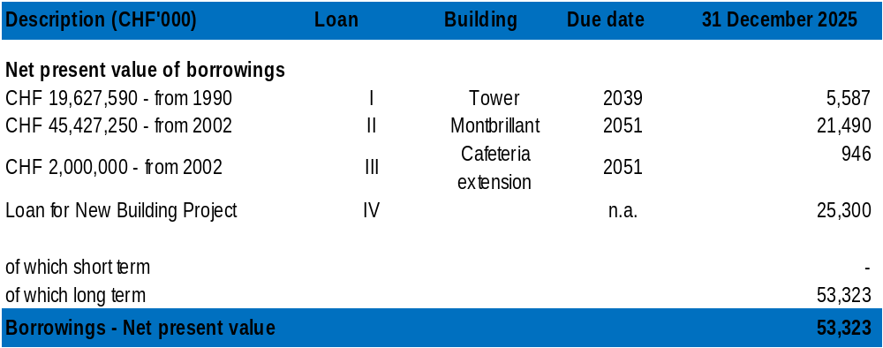

7.12 The Extension C consists in a building linking the Montbrillant and Varembé buildings.
7.13 Council 2016, through Decision 588, decided to replace the Varembé building by a new construction (herein called “Varembé-2”) that would also include the offices and facilities of the Tower building, and complement the Montbrillant building which would be retained and refurbished.
7.14 In 2017, a new interest-free loan amounting to CHF 150 million was granted for the ITU new building project. The loan amount drawn down by ITU on this fourth loan stands at CHF 25.3 million as at 31 December 2025 (CHF 22.5 million as at 31 December 2024).
7.15 Following revision of the new building project, ITU has recorded CHF 21 million impairment in the 2024 financial report and has received confirmation that the loan can be repurposed for the revised building project. The Swiss Federal Government has formally agreed to the reprogramming.
7.16 The reimbursement of the loan granted for the new ITU premises will start only after the successful delivery of the new building.
7.17 In December 2025 FIPOI submitted to ITU a proposal for amendment of the three loans in the context of the measure adopted by the Swiss Confederation to support the stability, resilience and operational continuity of international organisations headquartered in Switzerland during the current financial challenges. In such context, ITU has obtained a two-year conditional waiver for the 2025 and 2026 instalments of the three loans for a total of CHF 2.8 million.
7.18 Such funds are earmarked for the purpose of the support provided by the Host Country, to enable ITU to finance the uninterrupted conduct of meetings in Switzerland during the construction phase of the new building while the headquarters buildings and the CICG are partially or fully unavailable.

8 Employee benefits
8.1 The following employee benefits are recognized:
– Short-term benefits due to be settled within twelve months after the end of the accounting period in which employees render the related service;
– Long-term benefits resulting from the possible deferral of benefits acquired during the prior period or periods;
– Long-term post-employment benefits;
– Other long-term employee benefits.
8.2 Long-term benefits cover:
– Obligations associated with the possibility of accruing unused leave days and having them taken into account when establishing the date of retirement;
– Obligations associated with repatriation;
– Obligations associated with the pension plan of the United Nations Joint Staff Pension Fund;
– Obligations concerning the After-Service Health Insurance (ASHI), as specified under the United Nations ASHI programme;
– Obligations relating to the former pension plan in order to define ITU’s obligations at the date of closure of the period.
8.3 These last two benefits come under the heading of defined-benefit plans and, as is also the case for repatriation obligations, are the subjects of actuarial studies.
8.4 ITU is a member organization participating in the United Nations Joint Staff Pension Fund (UNJSPF), which was established by the United Nations General Assembly to provide retirement, death, disability and related benefits to employees. The Pension Fund is a funded, multi-employer defined benefit plan. As specified by Article 3(b) of the Regulations of the Fund, membership in the Fund shall be open to the specialized agencies and to any other international, intergovernmental organization which participates in the common system of salaries, allowances and other conditions of service of the United Nations and the specialized agencies.
8.5 The plan exposes participating organizations to actuarial risks associated with the current and former employees of other organizations participating in the Fund, with the result that there is no consistent and reliable basis for allocating the obligation, plan assets, and costs to individual organizations participating in the plan. ITU and the UNJSPF, in line with the other participating organizations in the Fund, are not in a position to identify ITU’s proportionate share of the defined benefit obligation, the plan assets and the costs associated with the plan with sufficient reliability for accounting purposes. Hence ITU has treated this plan as if it were a defined contribution plan in line with the requirements of IPSAS 39. ITU’s contributions to the plan during the financial period are recognized as expenses in the statement of financial performance.
8.6 Since January 2020, ITU is part of the United Nations Staff Mutual Insurance Society against sickness and accident (UNSMIS). It is a medical insurance fund for UN staff members. Established in 1947 and headquartered in Geneva. UNSMIS is designed to reimburse medical expenses for its members, which can include costs arising from sickness, accidents, and maternity. The society serves both active and retired UN employees and their families. UNSMIS operates on contributions from participating organizations and staff members, to ensure that its members receive medical care reimbursements under the society's rules and regulations. In addition to handling claims, UNSMIS is responsible for maintaining agreements with health providers and ensuring the financial stability of the insurance plan. The actuarial reserve for long-term risks within UNSMIS was established in 1995 to cover the continuous increase in health-care costs and the progressive increase in the average age of members. Investment income from this reserve for long-term risks should make it possible to limit the rise in premiums and absorb any unforeseen costs. The study by EY proposed that the total for this reserve be maintained at USD 58.8 million. As of 31 December 2022, this reserve is fully financed.
8.7 Joining this UN medical plan presents advantages for the staff as the contribution rate has been decreased and the deductible removed but also for ITU on a long-term approach due to the size of this plan. This plan brings together several organizations and specialized agencies of the United Nations based in Geneva. This health insurance plan includes the staff of the UN office in Geneva; UNHCR and WMO.
8.8 To join the UNSMIS medical plan in January 2020, ITU had to contribute to the reserve fund of this plan for an equalization. The level of the contribution had been agreed at the level of USD 19.5 million which was paid from the CMIP (Continuation Medical Insurance Plan) guarantee fund in early 2020. In addition, an extraordinary contribution was agreed to be paid yearly for 13 years starting 2020. This extra-contribution aims to regularize the impact of ITU joining this medical plan based on the staff and retiree age, demographics and other agree factors. This extra-contribution represents a total amount of USD 22.5 million split to be paid yearly over 13 years. In 2025 and 2024, additional contributions of USD 1.7 million (CHF 1.4 million and CHF 1.5 million, respectively) were paid to UNSMIS.
8.9 ASHI obligations are the subject of an actuarial study pursuant to IPSAS 39 in order to identify and recognize the amount of ITU’s future liability in relation to the corresponding benefits. An independent actuarial valuation was contracted by ITU to evaluate the ASHI obligation as of end of each year. Recognition of the actuarial gains and losses of this plan follows the Other Comprehensive Income (OCI) method, which calls for recognition of actuarial gains and losses during the period as net assets in the statement of financial position.
8.10 The actuarial assumptions are described in the Notes relating to employee benefits in each financial period reflected in the financial operating report.
8.11 The following table shows the balance of short- and long-term employee benefits at 31 December 2025.

In thousands of CHF | Employee benefits – Short-term
In thousands of CHF | Overtime | Accrued leave | Total employee benefits  (short-term)
Opening balance 1.1.2022 | 34 | 390 | 424
Closing balance 31.12.2022 | 24 | 221 | 245
Closing balance 31.12.2023 | 208 | 319 | 527
Closing balance 31.12.2024 | 34 | 284 | 318
Closing balance 31.12.2025 | 90 | 567 | 657

In thousands of CHF | Employee benefits – Long-term
In thousands of CHF | ASHI | Pensions | Repatriation | Accrued leave | Total employee benefits  (long-term)
Opening balance 1.1.2022 | 545 636 | 54 | 13 330 | 11 063 | 570 083
Closing balance 31.12.2022 | 344 102 | 54 | 12 571 | 11 745 | 368 472
Closing balance 31.12.2023 | 375 271 | 54 | 12 208 | 11 328 | 398 861
Closing balance 31.12.2024 | 415 835 | 54 | 13 795 | 11 426 | 441 110
Closing balance 31.12.2025 | 378 824 | 54 | 12 610 | 10 635 | 402 123

8.12 The ASHI related obligation constitutes the most significant liability for ITU. The table below shows the evolution of the obligation and its impact on ITU net assets since the IPSAS implementation.

In thousands of CHF | 31.12.2022 | 31.12.2023 | 31.12.2024 | 31.12.2025
Present value of unfunded obligation recognized as liability in the statement of financial position | 344 102 | 375 271 | 415 835 | 378 824
Actuarial gains/(losses) recognized in net assets | 215 510 | (19 524) | (32 748) | 48 439
Cumulated ASHI actuarial gains and losses in net asses | 51 435 | 31 911 | (837) | 47 602

8.13 The fluctuation of the discount rate (from 2.50 per cent in 2022 down to 1.80 per cent in 2025) used for the calculation of ITU’s obligation related to ASHI, resulted in significant fluctuations over the net assets and the ASHI liability.

9 Special accounts
9.1 By decision of the Council, the following special accounts were opened in 1996: "GMPCS Memorandum of Understanding (GMPCS-MoU)" and "Universal international freephone number (UIFN)". Further to Decision 600 of the Council 2017, parties requesting these services of UIFN must deposit upfront a sum of CHF 300 per number in the Union’s accounts. Non ITU-T and non ITU-R members are charged an annual maintenance fee of CHF 100 per number to be paid into the Union’s accounts. As the numbers are used, ITU invoices its services.

10 Extra-budgetary contributions
10.1 In accordance with No. 486 of the Convention and the Financial Regulations, the Secretary-General may accept voluntary contributions and trust funds, in cash or in kind, provided that the conditions attached to such contributions are consistent with the purposes and programmes of the Union.
10.2 Extrabudgetary contributions are received from Member States, Sector Members, international and regional organizations, private-sector entities and other partners to support specific activities, programmes, projects and events of the Union. Such contributions may include voluntary contributions, sponsorship contributions and other forms of earmarked funding. They are managed in accordance with the applicable Financial Regulations, Financial Rules and the terms and conditions of the relevant contribution agreements.
10.3 For financial management and accounting purposes, the Union maintains the distinctions established in the Financial Regulations and Financial Rules between the different categories of extrabudgetary contributions, including voluntary contributions and trust funds. Trust funds are generally established to finance specific programmes or projects and are subject to support costs in accordance with the applicable cost-recovery policy and the terms of the relevant contribution agreement.
10.4 The table below shows the evolution of the balances of extrabudgetary funds between 2022 and 2025.
Evolution of extrabudgetary fund balances
(in thousands of Swiss francs)
Extrabudgetary fund category | Balance at  1 January 2022 | Balance at  31 December 2022 | Balance at  31 December 2023 | Balance at  31 December 2024 | Balance at  31 December 2025
Funds in trust | 46 686 | 38 827 | 41 447 | 73 227 | 57 517

11 Information and Communication Technology Development Fund (ICTDF)
11.1 The ICT Development Fund (ICTDF) is a special-purpose fund administered by the Union to support activities financed through dedicated resources and Council-approved allocations. As at 31 December 2025, the balance of the Fund amounted to CHF 3.3 million.
11.2 The table below shows the evolution of the balances of ICTDF between 2022 and 2025.
Evolution of ICTDF balances
(in thousands of Swiss francs)
Extrabudgetary fund category | Balance at  1 January 2022 | Balance at  31 December 2022 | Balance at  31 December 2023 | Balance at  31 December 2024 | Balance at  31 December 2025
ICT Development Fund (ICTDF) | 2 992 | 2 690 | 5 699 | 3 672 | 3 300

12 Other financial management questions

Cost attribution and cost recovery
12.1 In accordance with Resolution 91 (Rev. Guadalajara, 2010), the Council has established the methodology for cost attribution in order to identify the costs of the various ITU activities and services provided. The Council has also identified possible areas of cost recovery in addition to those where the cost-recovery principle is already applied, for example universal international freephone number (UIFN). Currently, cost recovery applies to UIPRN/UISCN, GMPCS-MoU, publications and satellite network filings.

Approval of the accounts of the Union for the years 2022 to 2025
12.2 In accordance with No. 53 of Article 8 of the Constitution, the Plenipotentiary Conference gives final approval to the accounts of the Union.

ANNEX F
MOD GS/46/1
RESOLUTION 150 (REV. Doha, 2026)
Approval of the accounts of the Union for the years 2022-2025
The Plenipotentiary Conference of the International Telecommunication Union (Doha, 2026),
considering
a) No. 53 of the ITU Constitution;
b) the report of the ITU Council to the Plenipotentiary Conference in Document PP-26/46, relating to the financial management of the Union during the years 2022-2025, and the report of the Administration and Management Committee of this conference (Document PP-26/XX),
resolves
to give its final approval of the accounts of the Union for the years 2022-2025.

______________

