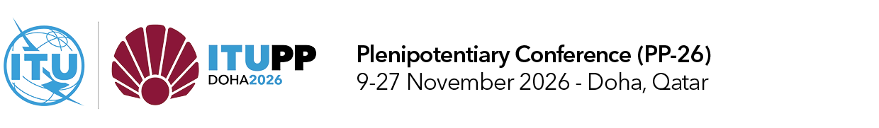
PLENARY MEETING | Document 20-E
 | 5 October 2026
 | Original: English
Note by the Secretary General
REPORT OF THE COUNCIL ON THE IMPLEMENTATION OF THE STRATEGIC PLAN AND THE ACTIVITIES OF THE UNION, MARCH 2022 – JULY 2026

Summary
This report reviews the implementation of strategic plans and activities of the International Telecommunication Union (ITU) over the period between October 2022 and July 2026. It reports on the implementation of the “Connect 2030 Agenda for global telecommunication/information and communication technology, including broadband, for sustainable development”, adopted by PP-22 (Resolution 200 (Rev. Bucharest, 2022)). It spans the final year and a half of implementation of the strategic plan for 2020-2023 and the first two and a half years of the current strategic plan for 2024-2027. It is aligned with the structure of strategic plan 2024-2027. It combines the annual activities report, as required by No. 102 of the Convention, and the report on the implementation of the strategic plan, as required by No. 61 of the Convention and Resolution 71 (Rev. Bucharest, 2022) of the ITU Plenipotentiary Conference. This document aims to present all relevant activity in a results-oriented, evidence-based and thematic manner, providing links to analytical figures assessing progress towards ITU’s strategic targets. In accordance with the request by the ITU Council session from 28 April to 8 May 2026, this report has been finalized under the supervision of the Chair of the Council with the assistance of the ITU secretariat.
Action required
The Plenipotentiary is invited to consider the report in the establishment of the strategic plan for the Union.
____________
References
Plenipotentiary Resolutions 71, 151 and 200; and CV102 and CV61

Foreword
The past four years have seen digital technologies move even more deeply into our economies, our societies and our daily lives.
Artificial intelligence (AI) has opened possibilities once confined to the realm of imagination. Space-based networks are helping close last-mile connectivity gaps. And the Internet has become indispensable to how we learn, work, access services and respond in times of crisis.
Yet this period has also brought conflict, displacement, environmental disasters and deepening inequality, reminding us that technological progress must never be its own end.
It must be a means to make a positive difference in people’s lives.
I saw that difference first-hand in 2023 and 2025, when I visited the Melkadida and Farchana refugee camps. For forcibly displaced people who have left behind their homes, livelihoods and, in many cases, families, connectivity is not a luxury; it is a lifeline.
Meeting them brought me back to the “why” of ITU’s work.
Behind every standard we develop and every frequency we coordinate are people seeking the opportunities that only meaningful connectivity provides.
That sense of purpose has guided ITU throughout the period covered by this report.
Today, about 6 billion people are online. Connectivity is more affordable in many parts of the world, digital skills programmes are reaching more learners, and countries are implementing the policies and infrastructure needed to make digital transformation safer, more inclusive and more sustainable.
However, this progress is not evenly shared.
Some 2.2 billion people remain offline. In low-income countries, fewer than one in four use the Internet. Too many women, rural communities, persons with disabilities, displaced people and others in vulnerable situations face not one but many digital divides.
As AI reshapes our world, those divides could widen further.
This is why ITU’s work goes beyond connecting communities. We help make connectivity affordable, reliable and secure, while strengthening the skills people need and the institutional capacity to drive digital transformation.
Our Partner2Connect Digital Coalition has shown what is possible when the international community rallies around that ambition. Together, governments, industry, development banks, international organizations, academia and civil society surpassed our collective goal of mobilizing USD 100 billion for meaningful connectivity and sustainable digital transformation by 2026, bringing the value of Partner2Connect pledges to more than USD 121 billion.
This milestone shows the world’s commitment to strengthening digital infrastructure, making services more affordable, building digital capacity for all, and redoubling efforts to reach those still waiting to be connected meaningfully.
Over these four years, ITU and its members have reinforced the foundations on which our shared digital future depends. We have secured international agreements that will keep communications moving safely across land, sea, air and space.
Our work has also helped prepare the technical and scientific ground for the next generation of mobile and satellite connectivity, while advancing standards for AI, quantum information technologies and other innovations that will shape the future digital landscape.
Through our Academic Advisory Body, we have strengthened our ability to anticipate emerging technologies. Our work has also helped enhance the resilience of submarine cables and the sustainability of space-based networks. And we have translated global development priorities into practical action through regional initiatives, technical assistance and capacity building.
Often, our achievements remain invisible to the people who rely on them. But they are present every time a signal reaches a mobile phone, a ship communicates at sea, a warning is delivered before disaster strikes, or different technologies work together across borders, free from harmful interference.
This is ITU at its best: building trust, cooperation, and shared technical foundations for digital innovation to serve everyone.
In parallel, we have helped expand the opportunities that connectivity creates. The ITU Academy has grown into a global learning community of 110 000 people. Our network of Digital Transformation Centres has provided digital skills training to more than 760 000 participants, over half of them women. And through Giga, our joint initiative with UNICEF, more than 2.3 million schools have been mapped as we support governments with the ambitious goal of connecting every school on Earth.
The momentum built over the past four years came together during Geneva Digital Week 2026, which brought three major global gatherings into one shared conversation about our digital future.
The inaugural United Nations Global Dialogue on AI Governance mandated by the General Assembly and co-coordinated by ITU and UNESCO, gave countries a new space to address shared AI challenges and opportunities, informed by the first findings from the International Scientific Panel on AI. It showed how international cooperation can connect scientific evidence with policy, and policy with action. The WSIS Forum carried forward the legacy of the World Summit on the Information Society following its 20-year review, reaffirming the foundations every country needs to participate in the digital future: connectivity, capacity, inclusion and cooperation. And at the AI for Good Global Summit, the focus was firmly on action, turning the promise of AI into practical solutions that improve people’s lives. That same week also saw the inaugural meeting of the AI for Good Global Commission, bringing together more than 40 leaders from government, industry, civil society, the technical community and international organizations to help expand access, strengthen trust and accelerate practical AI solutions.
Just as we have advanced our global mission, we have readied ITU to meet future challenges.
To help our members navigate accelerating technological change, we have made our organization more agile, transparent, innovative and results-driven, with stronger financial management, governance, oversight and accountability. We have invested in our people and modernized the systems that support our work.
ITU’s transformation is not separate from our mission. In fact, I believe it is precisely what will enable us to deliver even greater impact going forward.
The achievements documented in this report belong to the entire Union. They reflect the leadership of our Member States, the expertise of our Sector Members, Associates and Academia, the commitment of our partners, and the dedication of ITU staff around the world.
As we look ahead, let us remember that ITU’s success will not be measured by the number of standards adopted, agreements reached or resources mobilized, but by how many lives are improved by our collective efforts.
That is the promise of digital technology, and the responsibility we share.
Doreen Bogdan-Martin
Secretary-General
International Telecommunication Union

Table of contents
Page
i. Executive summary 7
ii. Insights and takeaways 12
1 Introduction 16
2 Global statutory conferences in 2022-2025 17
2.1 ITU Plenipotentiary Conference (PP-22) 17
2.1.1 ITU elections 17
2.2 WRC-23 and RA-23 17
2.2.1 World Radiocommunication Conference 2023 17
2.2.2 Radiocommunication Assembly 2023 18
2.3 World Telecommunication Standardization Assembly 2024 19
2.4 World Telecommunication Development Conference 2025 19
3 Impact of ITU’s work 21
3.1 Strategic Plan 2020-2023: Final results 21
3.2 Impact of ITU’s work from 2024 to 2025 (first two years of SP 2024-2027) 22
3.2.1 Universal connectivity 22
3.2.2 Sustainable Digital Transformation 29
4 Products and services 33
4.1 Development and application of ITU Administrative Regulations 33
4.1.1 Radio Regulations 33
4.2 Allocation and management of resources 34
4.2.1 Spectrum use for space and terrestrial services 34
4.2.2 Numbering, naming, addressing and identification resources 36
4.3 Development of international standards 37
4.3.2 ITU-R Recommendations 39
4.3.3 Bridging the standardization gap 39
4.4 Development of policy frameworks and knowledge products 41
4.4.1 Cybersecurity: Building confidence and security in ICTs 41
4.4.2 Emerging technologies: Shaping frameworks for transformation 43
4.5 Provision of data and statistics 46
4.6 Capacity development and digital skills 47
4.7 Provision of technical assistance 50
4.8 Convening platforms 52
4.8.1 WSIS process 52
4.8.2 AI for Good 55
4.8.3 Global Standards Symposium 56
4.8.4 Global Symposium for Regulators 56
4.8.5 Engaging academia in ITU’s work 58
5 Enablers 60
5.1 Membership-driven approach 60
5.2 Regional presence 61
5.3 Bringing everyone to the table 62
5.3.1 Gender equality 63
5.3.2 Youth empowerment 66
5.3.3 ICT/digital accessibility 68
5.3.4 Solutions for rural, remote and indigenous communities 71
5.3.5 Support for ageing populations 71
5.4 Commitment to environmental sustainability 72
5.5 Partnerships and international cooperation 76
5.5.1 Collaboration with the UN system and other international
intergovernmental processes 87
5.6 Resource mobilization 89
5.7 Transformation process: achieving organizational excellence 89
5.8 Human Resources 90
5.9 Status of Implementation of PP Resolutions 93

i. Executive summary
This report reviews the implementation of strategic plans and activities of the International Telecommunication Union (ITU) over the period between October 2022 and July 2026. It encompasses the completion of the organization’s four-year strategic plan for 2020-2023 (Resolution 71 (Rev. Dubai, 2018)) and progress over the first two years of 2024-2027 plan (Resolution 71 (Rev. Bucharest, 2022)).
During this reporting period, ITU advanced an ambitious agenda to connect everyone around the world and ensure that digital technologies deliver enduring benefits for all. The nearly four-year span was marked by accelerating technological evolution, expanding partnerships and deepening organizational transformation aimed at enhancing ITU’s effectiveness and impact for years to come.
In the world around us, Internet connectivity continued expanding, with usage rising from approximately 67 per cent of the global population in 2022 to nearly 74 per cent by 2025. Yet this growth masks deep and persistent inequalities. By 2025, only 23 per cent of people in low-income countries were online, compared with 94 per cent in high-income economies. Significant disparities also remain between urban populations (85 per cent online) and rural populations (58 per cent online).
Gender gaps persist in digital access and usage, especially in the world’s least developed countries. Globally, 77 per cent of men versus 71 per cent of women used the Internet in 2025. About 280 million more men than women were online worldwide in 2025, despite the nearly 45 per cent rise in Internet use among both women and men since 2019. Young users, meanwhile, remain at the forefront of digital adoption, with 82 per cent of youth aged 15–24 years being online in 2025, compared to 72 per cent of the rest of the population.
Digital affordability improved worldwide, with median mobile-broadband prices falling from 2 per cent to 1.4 per cent of gross national income (GNI) per capita and fixed broadband prices declining from 3.1 to 2.5 per cent in the 2022-2025 period. Yet despite these gains, billions of people still lack affordable services, basic digital skills, and access to devices and trust in online safety.

Global statutory conferences
Five ITU statutory conferences shaped policy and technology discussions over the period, aligning members and partners around shared spectrum coordination, technology standardization and digital development objectives.
The Plenipotentiary Conference (PP-22) in Bucharest, Romania, set ITU’s strategic direction through the 2024-2027 strategic plan. The conference modified 56 resolutions, adopted six new ones, and initiated major workstreams on artificial intelligence (AI), outer space sustainability, gender equality, climate action, pandemic-readiness and smart cities. It also achieved a historic milestone with the election of ITU’s first female Secretary-General.
Subsequent statutory conferences during the period up to 2025 reinforced and updated various sector-specific activities.
The World Radiocommunication Conference (WRC-23) in Dubai, United Arab Emirates, addressed over 30 agenda items spanning international mobile telecommunications (IMT), satellite, maritime and aeronautical services. The preceding Radiocommunication Assembly (RA-23) delivered the IMT-2030 framework (the basis for anticipated 6G telecom networks) and adopted new resolutions on gender equality, broadband, and spectrum sustainability. Together, these conferences strengthened the workings of ITU’s Radiocommunication Sector (ITU-R), safeguarded existing services, secured frequency allocations for next-generation systems, and confirmed the increasing importance of space and satellites for global communications.
The World Telecommunication Standardization Assembly (WTSA-24) in New Delhi, India, emphasized AI, emergency communications, and other fast-evolving digital priorities. The conference updated the structure of ITU’s Telecommunication Standardization Sector (ITU-T) and formed the new ITU-T Study Group 21 on multimedia, content delivery, and cable technologies. An accompanying “festival of standards” showcased innovation and cross-sector collaboration in line with United Nations digital cooperation goals.
The World Telecommunication Development Conference (WTDC-25) adopted the Baku Declaration and forward-looking Baku Action Plan that set out the priorities of ITU’s Telecommunication Development Sector (ITU-D) for 2026–2029. The conference also approved new regional initiatives for Africa, the Americas, the Arab States, Asia-Pacific, the Commonwealth of Independent States (CIS), and Europe, targeting each region’s most pressing digital development needs. Through these initiatives, ITU is positioned to mobilize resources and build partnerships that accelerate digital transformation, close persistent connectivity gaps, and support vulnerable communities – including the least developed countries (LDCs), landlocked developing countries (LLDCs) and small island developing states (SIDS), through concrete, impact-driven development projects.

Strategic plan results and impact
The 2020-2023 strategic plan helped countries around the world expand Internet access, improve affordability, strengthen cybersecurity, and promote innovation policies. The subsequent 2024-2027 plan has organized ITU’s wide-ranging work under two overarching goals: universal connectivity and sustainable digital transformation. Various workstreams aim to help countries boost connection quality, availability and affordability, as well as device access, skills, accessibility and security, all of which combine to make connectivity meaningful.
ITU has recorded significant global progress on affordability, device ownership and data systems over this reporting period. Collaboration with the United Nations Educational, Scientific and Cultural Organization (UNESCO) has improved the measurement of digital development and school connectivity across more than 200 economies. ITU also supports Giga (see more in section 5.5), a joint initiative with the United Nations Children’s Fund (UNICEF) to connect every school in the world to the Internet.
Cybersecurity capacity continued to expand, with the number of countries establishing national computer incident response teams (CIRTs) rising from 109 in 2020 to 132 by 2024, and those adopting national cybersecurity strategies increasing from 107 to 127 over the same period. Accessibility policies for persons with disabilities saw a significant rise, with the number of countries implementing national information and communication technology (ICT) accessibility frameworks reaching 127 by the end of 2024.
ITU helped six East African countries develop e-waste regulations and data systems between 2022 and 2025. Simultaneously, it advanced new international standards on extended producer responsibility and sustainable public procurement.
Across the same period, 28 countries benefited from ITU support with their national emergency telecommunications plans, strengthening global disaster preparedness. ITU delivered emergency telecommunications assistance during major disasters, providing equipment and technical support to afflicted communities in response to Hurricane Julia and Cyclone Freddy.
The organization took on a key role in the UN Secretary-General’s Early Warnings for All initiative (started at COP27 in 2022), which aims to ensure that everyone in the world is covered by timely disaster alerts by 2027. ITU also joined with the World Meteorological Organization (WMO), the United Nations Office for Disaster Risk Reduction (UNDRR) and the International Federation of Red Cross and Red Crescent Societies (IFRC) to form the initiative's AI subgroup, helping leverage AI technologies to enhance early warning systems.

Leadership in technology standards
ITU has strengthened its role as a leading standards organization with new work focused on challenges and opportunities presented by the latest technologies. ITU's input and expertise have helped shape quantum information technologies through initiatives such as the Quantum Standards Database, developed between 2023 and 2024, and the adoption of new recommendations by ITU standardization study groups on quantum security.
With the UN designating 2025 as the International Year of Quantum Science and Technology, ITU supported global awareness-raising and launched its own Quantum for Good initiative spotlighting potential benefits and the need to address risks related to these technologies.
An ITU-led focus group on virtual worlds and the metaverse, active until mid-2024, engaged over 17 000 participants and produced more than 50 technical outputs, setting the stage for the new Global Initiative on Virtual Worlds and AI. In addition, the Joint Coordination Activity on Metaverse Standardization (JCA-MV), established and activated in 2025, coordinates ITU’s metaverse standardization work and strengthens collaboration with external standards organizations. Parallel efforts advanced key frameworks for the Internet of Things, digital twins and smart cities.
ITU worked with other UN agencies to lay the groundwork for responsible AI across a range of applications. The ITU–FAO Focus Group on AI for Agriculture (led jointly with the UN Food and Agriculture Organization – FAO), for example, provided guidance on precision farming and climate-resilient food systems.
The ITU–WHO–WIPO Global Initiative on AI for Health has produced robust assessment frameworks to support the safe, evidence-based adoption of AI in clinical settings, complemented by reference implementations that demonstrate how these standards can be put into real-world practice and adapted as needed by national medical regulators. Targeted support has enabled greater participation from low and middle-income countries.

Products and services driving digital development
ITU remains a trusted global source of ICT statistics and analytics, producing flagship publications such as Facts & Figures and the Global Connectivity Report. The organization has strengthened statistical standards, expanded big data methodologies and reinforced international cooperation through platforms such as the Partnership on Measuring ICT for Development. These activities underpin evidence-based policymaking and enable countries to track progress towards connectivity and digital inclusion goals.
ITU Academy Capacity development grew significantly during the reporting period. Participation in ITU Academy programmes increased from approximately 26 000 learners in 2022 to over 110 000 in 2026, with women accounting for 44 per cent of those learners. Around 150 courses were delivered each year, more than 21 000 certifications awarded since 2023.
The ITU-Cisco Digital Transformation Centres (DTC) Initiative has provided training to over 764 000 course participants (52 per cent female) since its launch in 2019, including more than 653 000 course participants, of whom half were women, during the reporting period. Meanwhile, ITU's Digital Skills Forum and new Digital Skills Toolkit further strengthened national capabilities, enhanced workforce readiness and strengthened institutional capacity in developing economies.
In 2025 alone, ITU implemented or helped implement 106 projects valued at CHF 79.7 million, including 26 new projects, through its Telecommunication Development Bureau (BDT). Most new funding originated from external partners, reflecting growing confidence in ITU’s delivery capacity. All projects were in alignment with the 2023-2025 Kigali Action Plan and addressed national and regional priorities related to connectivity, policy frameworks and digital transformation, among other issues.

Global platforms and partnerships
ITU supported wider engagement and promoted public-private partnerships through multi-stakeholder platforms and initiatives focused on specific issues, challenges and opportunities, strengthening global cooperation to build a better digital future.
The World Summit on the Information Society (WSIS) remains a central basis for UN-led digital cooperation, facilitated by ITU’s annual WSIS Forum and related activities. The WSIS stocktaking database lists over 21 000 initiatives involving over 2.2 million stakeholders dedicated to responsible digital development for the good of all.
The AI for Good project continued growing throughout 2022–2026, with its AI-powered Neural Network community surpassing 35 000 members and extending to more than 137 000 online participants. ITU’s annual AI for Good Global Summit has become the UN system’s primary venue for showcasing responsible AI solutions, with the 2026 edition – back-to-back with the WSIS Forum and the UN's Global Dialogue on AI Governance – receiving over 12 000 on-site visitors at Geneva’s biggest conference venue.
Building on this momentum, ITU introduced new AI for Good initiatives, such as the AI Skills Coalition and regional AI for Good Impact accelerators. The 2024 and 2025 summit editions featured dedicated AI governance days, with high-level sessions exploring the shift from principles to practice as different markets and societies aim to scale up ethical, responsible AI.
World Standards Cooperation partners – ITU together with the International Organization for Standardization (ISO) and the International Electrotechnical Commission (IEC) – announced the new International AI Standards Summit during WTSA-24, unveiled the comprehensive AI Standards Exchange database at the AI for Good summit in 2025, and committed firmly to cooperation on responsible AI through their joint Seoul Statement, issued in December 2025 at the second International AI Standards Summit.
Flagship partnerships continued and driving action to connect everyone, everywhere. By July 2026, ITU's Partner2Connect Digital Coalition had mobilized 1 096 pledges worth more than USD 122 billion, surpassing ITU's ambitious target of USD 100 billion by 2026. Giga, the joint ITU–UNICEF initiative to connect every school, has catalysed partnerships across the UN system and beyond, including: the UNESCO-led Digital Transformation Collaboration; ITU's AI & Robotics Youth Training Programme with Google and the will.i.am Angel Foundation; and collaboration with multilateral development banks to boost digital infrastructure investment. Also, during the reporting period, the ITU-UNESCO Broadband Commission for Sustainable Development supported countries in expanding connectivity, while the EQUALS Global Partnership advanced equality for women through digital skills and empowerment initiatives.
ITU mobilized partners for Green Digital Action (see section 5.5), including through successive UN climate change conferences, starting at COP28 in Dubai in 2023. The new Green Digital Action Hub launched at COP30 in Brazil aims to support in-depth analysis of environmental impacts and help developing countries leverage AI and other new and emerging technologies for climate action. Other analytical work by ITU and partners highlights trends in greenhouse gas emissions by major digital companies, strengthening the evidence base for effective decarbonization across the industry.
In 2024, ITU and the International Cable Protection Committee formed the International Advisory Body on Submarine Cable Resilience as a global platform to share and promote best practices among governments and industry players to enhance cable resilience worldwide. The first International Submarine Cable Resilience Summit, held in Abuja, Nigeria, in 2025, launched three working groups to address risk management, connectivity and route diversity, and the timely deployment and repair of cables.
At the second International Submarine Cable Resilience Summit, held on 2-3 February 2026, in Porto, Portugal, the Advisory Body approved the Working Group Recommendations and endorsed the Porto Declaration, reinforcing international efforts to strengthen submarine cable infrastructure.
The International Advisory Body concluded with the release of its Final Report at a final meeting held in Geneva as part of the WSIS Forum in July 2026. The report consolidates the work and recommendations of the three Working Groups, providing practical guidance for governments and industry to strengthen telecommunication submarine cable resilience.
The Digital Infrastructure Investment Initiative (DIII), led by ITU with multilateral development banks (MDBs), has estimated that connecting everyone meaningfully would cost USD 1.6 trillion by 2030 for physical infrastructure alone. The Connecting Humanity Action Blueprint (2025), produced in partnership with the Kingdom of Saudi Arabia, estimates the total cost at USD 2.6-2.8 trillion when demand, skills, affordability and policy are included. DII Catalyser, a joint ITU-UNCTAD initiative with MDBs, is mobilizing partners to accelerate bankable digital infrastructure investment globally.

Preparing for the future
Since 2023, ITU has undertaken a comprehensive internal transformation to strengthen institutional governance, accountability and operational effectiveness.
Financial turnaround included transforming persistent budgetary deficits into consistent surpluses, fixing the financial management and bringing back on track the external audit process, as well as redesigning the new headquarters building project to ensure that it fits into the budget envelope while meeting ITU's future needs.
Key achievements also include the establishment of an Oversight Unit and Ombudsman function, redesigned operational planning processes, full compliance with international public sector accounting standards, and progress in treasury and human resource reforms.
Human resources modernization emphasized learning, performance management, leadership development, gender parity, mental health and flexible working arrangements. ITU also adopted organizational guidelines on the responsible use of generative AI and welcomed a new Chief Information Officer to accelerate digital modernization.
A new resource mobilization strategy adopted in 2024 focused on strengthening member engagement, enhancing products and services, and increasing voluntary contributions.
Notable priorities included modernizing satellite filings, expanding digital products, improving event revenue models, and developing a new partnership strategy to maximize ITU’s impact while safeguarding institutional integrity.
Now past the midpoint of the current strategic plan, the organization has attained a stronger position to face current and emerging global challenges. Moving forward, ITU continues evolving with technologies and supporting countries and communities as an international platform for technical cooperation to ensure real and lasting impact for all.

ii. Insights and takeaways

Key findings and takeaways

Connectivity, affordability and digital trends
– Global Internet use rose from 67 per cent in 2022 to 74 per cent in 2025 (from 5.4 to 6 billion users), yet still leaving 2.2 billion offline.
– Connectivity gaps persisted with 94 per cent of people online in high income countries versus 23 per cent in low-income ones.
– Mobile broadband median prices fell from 2.0 per cent to 1.4 per cent of gross national income (GNI) per capita, and fixed broadband from 3.1 per cent to 2.5 per cent (2022-2025).
– 5G coverage reached 55 per cent of the world’s population in 2025, up from 39 per cent globally in 2022; yet 5G coverage was still only 4 per cent in low-income countries in 2025.
– 82 per cent of individuals aged 15-24 used the Internet in 2025, versus 72 per cent of the rest of the population.
– The urban–rural usage gap narrowed slightly from 1.6 to 1.5, with 85 per cent of urban and 58 per cent of rural residents online in 2025.

Collecting data and policy evidence
– ITU collected information and communication technology (ICT) statistics from 200+ economies, strengthening big-data methods and publishing annual editions of Facts & Figures and the Global Connectivity Report.
– Countries with national ICT accessibility frameworks increased from 61 in2018- to 101 in 2025.
– Countries with computer incident response teams (CIRTs) rose from 109 in 2020 to 132 in 2024, while national cybersecurity strategies increased from 107 in 2020 to 148 in 2024.
– International bandwidth per Internet user more than doubled (2020-2024) to 322.8 kilobits per second (kbit/s), with total global bandwidth reaching 1.78 terabits per second (Tbit/s).

ITU’s global statutory conferences (2022-2025)
– The Plenipotentiary Conference (PP-22) modified 56 resolutions, adopted six new ones, and initiated major workstreams on artificial intelligence (AI), outer-space sustainability, gender equality, climate action, pandemic-readiness, and smart cities.
– PP-22 elected Doreen Bogdan-Martin as ITU’s first female Secretary-General.
– The World Radiocommunication Conference (WRC-23) gathered 3 982 participants from 163 Member States, with women’s participation rising to 22 per cent, and resolved 30+ agenda items across International Mobile Telecommunications (IMT), satellite, maritime, aeronautical and science services.
– The Radiocommunication Assembly (RA-23) adopted the IMT-2030 framework for 6G telecommunication networks, revised 26 resolutions in the ITU Radiocommunication Sector (ITU-R), and approved new resolutions on gender equality, broadband, spectrum sustainability, and inter-sectoral coordination.
– The World Telecommunication Standardization Assembly (WTSA-24) welcomed 3 700 delegates (27 per cent women), consolidated Study Groups 9 and 16 into Study Group 21 and adopted 8 new and 44 revised resolutions.
– The World Telecommunication Development Conference (WTDC-25) adopted the Baku Declaration, the Baku Action Plan and updated Regional Initiatives for 2026-2029 with delegates (including 34 per cent women) advancing ITU engagement on global sustainable development priorities.

Standards and technology leadership
– ITU’s Standardization and Radiocommunication Sectors (ITU-T and ITU-R) together approved 1 225 standards between 2022 and 2025.
– ITU-R Recommendations in force at the end of 2025 totalled 1 161.
– ITU’s Quantum Standards Database featured around 50 quantum technology standards and 30+ under development.
– The Focus Group on Metaverse (FG-MV) engaged 17 000+ participants and produced 52 deliverables before transferring work into Study Groups.
– The AI Standards Exchange Database, launched in 2025, brought together nearly 1,000 standards and related texts by the second half of 2026.
– ITU-R received the Engineering, Science & Technology Emmy Award in 2023 for the global high dynamic range television (HDR-TV) standard. With the 2023 recognition, ITU has now received a total of six Emmy Awards over the years.
Capacity development & digital skills
– ITU Academy expanded from 26 000 (end-2022) to 110 000 learners (July 2026), including 44 per cent women, and delivered around 150 courses per year with 21 000+ certifications since 2023.
– Accredited ITU Academy training centres delivered 159 courses to 4 243 participants (2023-2026), 89 per cent of them from developing countries.
– The ITU-Cisco Digital Transformation Centres (DTC) Initiative grew from 110 000 to 740 000+ course participants (52 per cent women) across four regions from 2022 to July 2026.

Technical assistance & implementation
– In the ITU Telecommunication Development Sector (ITU-D), 106 projects were under implementation in 2025, worth 79.7 million Swiss francs (CHF), with 90 per cent of overall project funding coming from external partners.
– New agreements in ITU-D in 2025 covered 26 projects worth CHF 4.3 million.

Global platforms & partnerships
– WSIS Stocktaking surpassed 21 000+ ICT for development (ICT4D) initiatives, and WSIS Prizes received 3 000+ submissions over three years.
– AI for Good’s Neural Network community grew to 35 000 members (137 000 online participants); the 2026 edition, as part of Geneva Digital Week, drew over 12 000 onsite visitors.
– The COP29 Declaration on Green Digital Action received endorsements from 80+ countries and nearly 1 800 companies and organizations, building momentum for the launch of the Green Digital Action Hub and the AI Climate Institute at the next UN climate change conference, COP30.
– Partner2Connect pledges reached an estimated USD 122 billion in July 2026, based on 1 096 pledges from over 508 entities in 149 countries, surpassing ITU's target of USD 100 billion in pledge value by 2026.
– ITU and the International Cable Protection Committee (ICPC) formed the International Advisory Body on Submarine Cable Resilience in 2024, bringing together over 42 government and industry experts to strengthen cooperation on subsea telecommunication cables and boost digital resilience globally. Following two years of international collaboration, the Advisory Body concluded its work in 2026 with a Final Report containing practical recommendations for governments and industry to strengthen submarine cable resilience worldwide.
– The Digital Infrastructure Investment Catalyser was launched by ITU and UNCTAD and is co-led with eight MDBs to address the USD 1.6 trillion digital infrastructure investment gap through a working group of 50+ organizations.

Ensuring everyone benefits
– 77 per cent of men and 71 per cent of women were online in 2025, leaving a global gender parity score of 0.92, unchanged since 2019.
– International Girls in ICT Day events (2023–2026) reached 80 000 girls across 500 events.
– The AI Skills Accelerator for Girls reached 820 young women in six regions.
– Youth Envoys grew to 180 envoys in 120 countries, and ITU’s Global Youth Summit (GYS-25) gathered 400 participants from 31 countries.
– Countries with ICT accessibility frameworks reached 101, and ITU-R approved updates to five accessibility-relevant publications.
– Indigenous community training programmes expanded to Latin America, Africa and the Caribbean, training hundreds of local network managers.

Environmental sustainability, climate action & circularity
– Global e-waste reached 62 billion kg in 2022, while recycling remained at 22.3 per cent, with e-waste generation expected to hit 82 billion kg by 2030.
– ITU supported 14 countries (2023-2025) on producer responsibility regulation and circular economy policies.
– ITU’s Greening Digital Dashboard and annual Greening Digital Companies reports have established regular coverage of 200 companies in the sector, with findings showing just 166 companies that reported operational (Scope 1 and Scope 2) emissions accounting for 297.3 million tonnes of CO₂-equivalent (tCO₂e) emissions in 2023 – or 0.8 per cent of global energy-related emissions.
– ITU’s Expert Group on Telecommunication/ICT Indicators (EGTI) established a subgroup on National Greenhouse Gas Emission Monitoring Indicators, with ITU supporting six countries in piloting the framework in 2025-2026 to collect national emissions and energy data.
– ITU-T Study Group 5 approved 110 Recommendations on environmental sustainability between 2022 and 2025.

Membership
– ITU reached 1072 member entities by September 2026, a net increase of more than 160 memberships since 2022.
– SME reduced-fee Associates reached 120 memberships, with +26 net new in 2025.

Organizational transformation
– ITU recovered from a series of qualified audit opinions, achieving full IPSAS compliance with improvements to treasury, extrabudgetary funds, and budget allocation systems.
– ITU through proactive and disciplined financial management achieved a 3 per cent budget surplus in 2024 and a 7 per cent budget surplus in 2025.
– ITU prioritized people and culture transformation, with the launch of the first Employee Engagement survey and follow-up action plans, the ongoing adaptive leadership programme ongoing, and the launch of the Rewards & Recognition programme.
– ITU significantly strengthened its governance and oversight, with the establishment of the Oversight Unit (fully staffed by January 2026), including the set-up of the Evaluation Function, as well as the formalization of the Ethics Charter, and establishment of the independent Ombudsman Function, and evaluation training conducted for staff to build community and expertise
– ITU realised significant efficiency gains by leveraging AI translation and editing tools to achieve a 20 per cent efficiency bump in terms of translation productivity.
– ITU recognized savings in Electricity Costs, including a 40 per cent reduction in 2024 vs 2023 (~CHF 650 000) and another 20 per cent reduction in 2025 (~CHF 200 000).
– ITU redesigned the New Building Project, with strengthened governance, with an iterative process involving key stakeholders, making sure that the project meets the ITU needs within the available funding.
– A new Digital Transformation strategy and AI Upskilling Programme for staff demonstrate system improvements that empower our people and bring tangible benefits to our membership.
– ITU operationalized an ISO14001-aligned environmental management system across all operations.

1 Introduction
The International Telecommunication Union (ITU) works to ensure that digital technologies result in meaningful and lasting benefits for everyone around the globe. In accordance with its mandate as a United Nations specialized agency, ITU advances radio spectrum coordination, technical standardization, and people-centred, technology-driven development to build a better digital future for all.
This report to PP 2026 on the implementation of the organization’s strategic plan and activities covers the period 2022-2026. The report is based on the results framework underpinning ITU's strategic plan.
While the first two years were covered by the previous Strategic Plan (2020-2023), this report takes into consideration the framework of the current Strategic Plan (2024-2027) with a careful mapping of activities between both periods.
That results framework links product and service delivery to key thematic priorities, strategic goals, the ITU mission and vision, and global development goals:
Figure 1
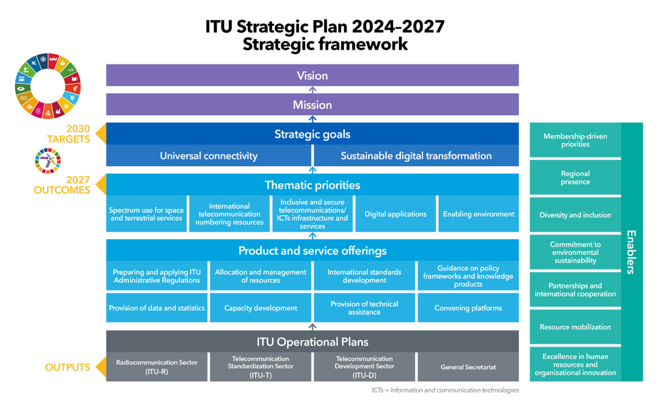
The figure above outlines the key components of the strategic framework. These include vision, mission, strategic goals and targets, thematic priorities and outcomes, product and service offerings, and enablers.
The sections that follow provide an overview of the ITU statutory conferences held during the reporting period, summarize the outcomes of the Strategic Plan 2020-2023 along with progress toward the goals of universal connectivity and sustainable digital transformation in the 2024-2027 period, highlight key achievements related to ITU’s products and services, and outline the organizational enablers that support the organization’s work and overall impact.

2 Global statutory conferences in 2022-2025

2.1 ITU Plenipotentiary Conference (PP-22)
The 21st ITU Plenipotentiary Conference (PP-22) took place from 26 September to 14 October 2022 at the Palace of Parliament in Bucharest, Romania, and was chaired by Mr Sabin Sărmaș, President of the Information Technology and Communications Committee of the House of Deputies of Romania. PP-22 set out the general policies and strategic direction of ITU for the coming period, adopting four-year strategic (Resolution 71) and financial plans (Resolution 71, Decision 5) and addressing key issues related to information and communication technologies (ICTs) in alignment with the requests of the ITU membership.
ITU’s four-year strategy highlights key priorities for radiocommunication, standardization and development work designed to connect the world, drive an inclusive global digital transformation, and help achieve the Sustainable Development Goals (SDGs) set out by the United Nations for 2030. The Final Acts of the Plenipotentiary Conference, Bucharest 2022, were signed by 159 Member States. In summary, the membership modified 56 resolutions and two decisions, introduced six new resolutions and suppressed one.
Key decisions agreed at the conference included resolutions on:
– Applying artificial intelligence (AI) technologies for good
– Confidence-building and sustainable development in outer space
– Empowering women and girls through digital transformation
– Frequency assignments by military radio installations for national defence services
– How new technologies can mitigate, rather than exacerbate, the climate crisis
– How technologies can protect against global pandemics
– The Internet of Things (IoT) for smart and sustainable cities and communities.

2.1.1 ITU elections
PP-22 also included elections for ITU’s senior leadership positions. Delegates made history with the election of Ms Doreen Bogdan-Martin (United States) as ITU's next Secretary-General. Ms Bogdan-Martin has become the first woman to lead the, at that time, 157-year-old organization. Mr Tomas Lamanauskas (Lithuania) was elected as ITU's Deputy Secretary-General; Mr Mario Maniewicz (Uruguay) was re-elected, for his second term, as Director of ITU's Radiocommunication Bureau (BR); Mr Seizo Onoe (Japan) was elected Director of ITU's Telecommunication Standardization Bureau (TSB); and Mr Cosmas Zavazava (Zimbabwe) was elected Director of ITU's Telecommunication Development Bureau (BDT). The 12-member Radio Regulations Board and the 48-member ITU Council were also elected (see the full PP-22 election results here).

2.2 WRC-23 and RA-23

2.2.1 World Radiocommunication Conference 2023
The World Radiocommunication Conference (WRC-23) was held in Dubai, United Arab Emirates, from 20 November to 15 December 2023. The Conference was chaired by H. E. Mr Mohammed Al Ramsi (UAE). It brought together the global radiocommunication community to update and strengthen the international regulatory framework governing work on the radio-frequency spectrum, with a view to achieving universal connectivity and sustainable digital transformation. The Conference gathered 3 982 participants from 163 ITU Member States. Notably, women accounted for 22 per cent of the delegates, reflecting a positive increase from 18 per cent at WRC-19.
WRC-23 addressed more than 30 agenda items concerning spectrum allocation and sharing, leading to several significant regulatory advances across mobile communications, satellite systems, maritime and aeronautical safety, and scientific services.
The Final Acts of WRC-23 consolidate the Conference’s key outcomes across all major agenda items, including:
– The identification of spectrum for International Mobile Telecommunications (IMT), which is crucial for expanding broadband connectivity and developing IMT mobile services. Identified spectrum for use by high-altitude platform stations as IMT base stations (HIBS) which offers the potential to provide mobile broadband with minimal infrastructure.
– Improved maritime safety by supporting the modernization of the global maritime distress and safety system (GMDSS).
– Digitalization of HF systems and new non-safety allocations for aeronautical services.
– Enhanced satellite services, including the adoption of regulatory actions for the provision of inter-satellite links. Enhanced earth station in motion (ESIM) operations to deliver high-speed broadband onboard aircraft, vessels, trains, and vehicles, and refined rules for non-GSO constellations.
– Science services (new and upgraded allocations supporting Earth observation, space research and space weather).
– Support for the State of Palestine in managing spectrum and deploying advanced telecommunications networks.
The 2024 Edition of the Radio Regulations is available here.

2.2.2 Radiocommunication Assembly 2023
The Radiocommunication Assembly (RA-23) took place from 13 to 17 November 2023, immediately preceding WRC-23. The Assembly brought together 566 participants from 95 Administrations, along with 41 Sector Members, 1 academic institution, and 2 UN specialized agencies. In line with its mandate charted future directions for radiocommunication systems and ICTs by establishing the future work programme of the Radiocommunication Sector (ITU-R) and approved a range of ITU-R recommendations and resolutions that will have a global impact on future radiocommunication technologies.
RA-23 delivered several key outcomes that shape the future work of ITU-R, including:
– The revision of 26 ITU-R resolutions notably updates to the working methods of ITU-R bodies (Resolution ITU-R 1-9).
– The confirmation of the existing Study Group structure, and the approval of the work programme and Questions of the Study Groups, along with four new ITU-R Recommendations (Resolution ITU-R 5-9).
– The Assembly also significantly updated the framework for the evolution of International Mobile Telecommunications, introducing the concept of IMT-2030 (Resolution ITU-R 56-3) and aligning future development principles accordingly (Resolution ITU-R 65-1).
– In addition, RA-23 adopted four new resolutions focused on promoting gender equality in ITU-R activities (Resolution ITU-R 72), supporting the use of IMT technologies for fixed wireless broadband (Resolution ITU-R 73), advancing the sustainable use of spectrum and orbital resources (Resolution ITU-R 74).
– Strengthening inter-sectoral coordination across ITU (Resolution ITU-R 75), consolidating earlier texts. The decisions relevant to WRC-23 were subsequently transmitted in Document WRC-23/217.

2.3 World Telecommunication Standardization Assembly 2024
The World Telecommunication Standardization Assembly (WTSA-24) took place from 15 to 24 October 2024 in New Delhi, India. This was the first WTSA held in Asia-Pacific region. It was preceded by the Global Standards Symposium (GSS-24) on 14 October 2024 and followed by leadership training, which was offered to newly appointed WTSA-24 drafting groups chairs and vice-chairs. The assembly welcomed H. E. Narendra Modi, Prime Minister of India, to its opening ceremony. The assembly was chaired by Mr Ritu Ranjan Mittar (India). Attended by 3 700 delegates from 164 countries, it achieved the 27 per cent female representation, the highest to date for ITU conferences held outside Geneva. It also showed the highest-level participation, with 37 Member States sending ministers. More than 20 side events were held during WTSA-24.
Key outcomes of WTSA-24 include:
– The consolidation in ITU’s Telecommunication Standardization Sector (ITU-T) of Study Group 9 and Study Group 16 into a new body, Study Group 21, covering technologies for multimedia, content delivery and cable television.
– The Assembly appointed new chairs and vice-chairs for 10 study groups, as well as for the Telecommunication Standardization Advisory Group and the Standardization Committee for Vocabulary.
– It also updated the mandate under Resolution 2, adopted new Questions for all 10 study groups in the sector and approved a substantial package of deliverables, including eight new resolutions, 44 revised resolutions, and a revised ITU-T Recommendation (A.25).

2.4 World Telecommunication Development Conference 2025
The 9th World Telecommunication Development Conference (WTDC-25), which took place from 17 to 28 November 2025 in Baku, Azerbaijan, marked a significant milestone for global connectivity and digital development. WTDC-25 was chaired by H.E. Mr Samaddin Asadov, Deputy Minister of Digital Development and Transport, Republic of Azerbaijan. The conference focused on a key theme: “Universal, meaningful, and affordable connectivity for an inclusive and sustainable digital future.”
WTDC-25 brought together around 2 000 participants comprising Member States, Sector Members, Associates, and Academia from more than 150 countries. Through collaborative dialogue and negotiation, the conference delivered several important outcomes.
These include:
– The Baku Declaration: The conference adopted the Baku Declaration, reaffirming the commitment of the membership of ITU’s Telecommunication Development Sector (ITU-D) to bridging the digital divide, enhancing connectivity, and empowering communities through ICTs. The Declaration serves as a guiding statement of values and priorities for ITU-D’s work.
– The Baku Action Plan: In line with the goals of the conference, WTDC-25 set priorities for ITU-D for the next four years (2026– 2029) and also approved a detailed Baku Action Plan, which will guide ITU’s digital development initiatives. These efforts will pay particular attention to the world’s most vulnerable areas, such as least developed countries (LDCs), landlocked developing countries (LLDCs), and small island developing States (SIDS). The Conference maintained ITU-D priorities that were already set in the last cycle:
• Affordable Connectivity
• Digital Transformation
• Enabling Policy and Regulatory Environment
• Resource Mobilization and International Cooperation
• Inclusive, Safe and Secure Telecommunications/ICTs for Sustainable Development.
– Regional Initiatives 2026-2029: WTDC-25 endorsed a renewed set of Regional Initiatives, tailored to address the specific needs and priorities of each of the six regions. These initiatives will drive targeted projects, foster partnerships, and ensure that ITU development work remains locally relevant and impactful.
– Resolutions: Apart from modification of 44 resolutions, WTDC-25 saw the addition of four new resolutions. These include:
• Artificial intelligence technologies in telecommunication development.
• Strengthening the role of ITU regional offices in accelerating digital transformation and leveraging partnerships.
• Provision of assistance and support to the Sudan to reconstruct damaged telecommunication/information and communication technology infrastructure and bridge the digital divide.
• Supporting digital transformation in Pacific Island countries pursuant to the Lagatoi Declaration.
– Study Group Questions 2026-2029: New and revised Study Groups Questions were agreed upon, reflecting the evolving landscape of digital technologies, regulatory challenges, and capacity-building needs. These Questions will guide the technical work of ITU-D and research efforts, supporting evidence-based policy development and best practice sharing. The publication of the 15 final reports approved for the previous study period (2022-2025) was also reported.
WTDC-25 also received with appreciation the report and presentation by the Secretariat on the implementation of the Kigali Action Plan. The detailed report and the presentation can be found in WTDC-25 website.

3 Impact of ITU’s work
The final assessment on the implementation of the Strategic Plan 2020–2023 and the current progress on the implementation of the SP 2024-2027 can be seen in the Dashboard here:
Figure 2
Connect 2030 Agenda
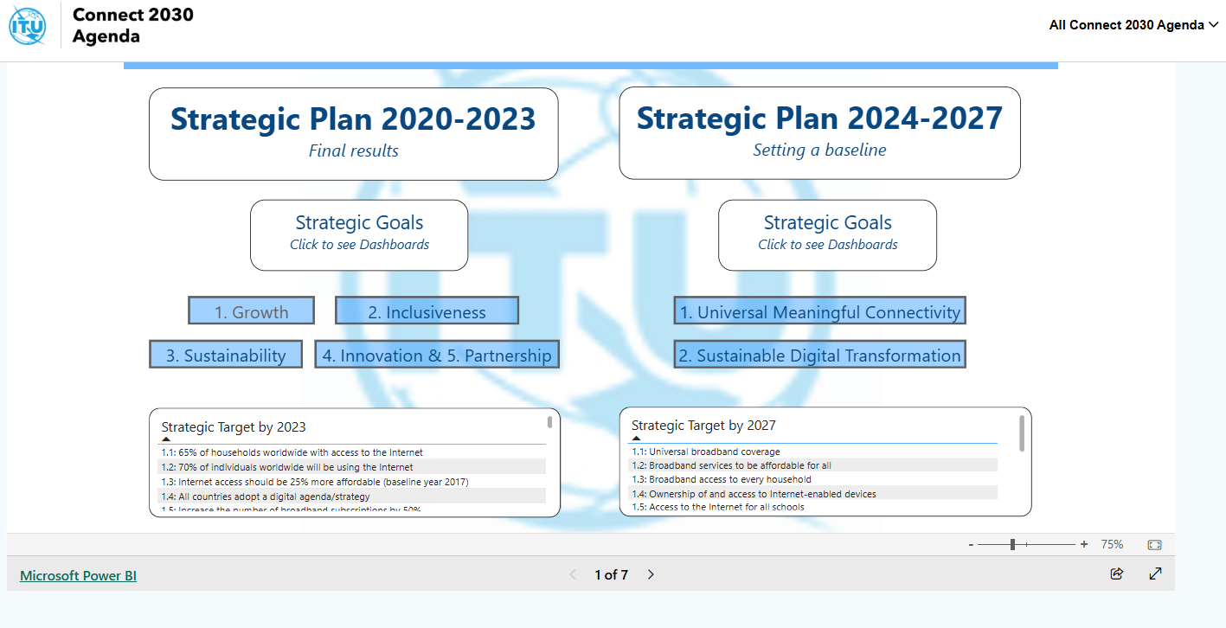

3.1 Strategic Plan 2020-2023: Final results
The final assessment of the Strategic Plan 2020–2023 shows steady progress toward the Connect 2030 Agenda (see Figure 2), with notable gains in access, affordability, inclusion, and enabling policy environment, while major gaps remain that will require sustained efforts in the years ahead. By the end of 2023, global Internet use reached 69 per cent of the world’s population (5.6 billion people), reducing the number of offline individuals to around 2.5 billion. High-income countries approached near-universal connectivity at 92 per cent, although the number of countries with broadband plans stagnated at 167, down from 170 in 2022. Affordability continued to improve, with the price of mobile data as a share of gross national income (GNI) per capita falling by 36 per cent between 2017 and 2023. Broadband subscriptions rose significantly —fixed broadband by 19.2 per cent and mobile broadband by 21.0 per cent— with the fastest growth occurring in low-income countries, even if the target of a 50 per cent increase was not fully met.
Despite advances, inclusiveness remains a challenge. Only 22 per cent of people in low-income countries used the Internet in 2023, though this represents a 25 per cent increase since 2020. Regional disparities persist, with Africa recording just 36 per cent usage and LDCs and LLDCs reaching 30 per cent and 35 per cent, respectively. Affordability remains a barrier for low-income economies, though the gap between high-income and lower-middle-income countries has narrowed by 42 per cent since 2017. Gender inequalities continue: 72 per cent of men and 66 per cent of women were online in 2023, leaving more than 260 million more men connected, and women remain 10 per cent less likely to own a mobile phone. Accessibility frameworks for persons with disabilities, however, expanded significantly, rising from 61 countries in 2018 to 117 by end-2022 and 127 by end-2024.
The global e-waste recycling rate increased from 20 per cent in 2017 to 22.3 per cent in 2022, still far below the 30 per cent target, while e-waste generation continues to grow rapidly and is expected to reach 82 megatonnes (Mt) by 2030. Countries with e-waste legislation rose to 81 in 2023, moving closer to the target of 97. Work on climate impact advanced through ITU’s development of global standards for net-zero ICT emissions, while sector emissions remained stable at around 133 megatonnes of carbon dioxide (MtCO₂) in 2023. Cybersecurity readiness improved: the share of countries with national CIRTs/CERTs grew from about 55 per cent in 2018 to 65 per cent in 2023, and 127 countries now have national cybersecurity strategies. Emergency telecommunications planning also advanced, with 83 per cent of countries adopting national plans by 2023.
Innovation and partnership continued to strengthen the ecosystem. Ninety-seven countries reported national innovation policies in 2023, up from 66 in 2016, though still far from universal adoption. Member surveys show increasing recognition of the importance of collaboration, with 61 per cent affirming its significance and around 70 per cent reporting benefits from working with partners. In the new Strategic Plan 2024-2027, innovation and partnership are positioned as cross-cutting enablers rather than standalone goals.

3.2 Impact of ITU’s work from 2024 to 2025 (first two years of SP 2024-2027)
This section assesses the latest state of progress on the target indicators under the two goals of the Strategic Plan 2024-2027: Universal connectivity (section 3.2.1) and Sustainable digital transformation (section 3.2.2). Where data allow, the analysis assesses progress over the period since 2022. The assessment draws primarily on ITU’s Measuring digital development: Facts and Figures 2025, which provides the most recent estimates for several core connectivity indicators, as well as on ITU datasets covering e-waste, greenhouse gas emissions, regulation and cybersecurity. Additional data are drawn from other United Nations agencies, where relevant.
The assessment remains partial, as for several targets and indicators defined in the Strategic Plan, data coverage is still insufficient to produce robust global or regional aggregates. While the progress observed reflects, in part, ITU’s efforts, outcomes are also shaped by a wide range of external factors and actions by governments, the private sector and other stakeholders. As such, ITU cannot be viewed as the sole driver of the results presented.

3.2.1 Universal connectivity
This sub-section covers the main dimensions of universal connectivity, including broadband coverage, affordability, access to devices, Internet use, and related enabling conditions.

Target 1.1: Universal broadband coverage
5G coverage has expanded rapidly in recent years and now covers 55 per cent of the world’s population in 2025, up from 39 per cent in 2022. Eighty-four per cent of the population in high-income countries is covered by 5G, but only 4 per cent of people in low-income countries.
While 5G deployment is still underway in many regions, 4G remains a reliable connectivity solution, currently available to 93 per cent of the world’s population. As of 2025, 96 per cent of the world’s population is covered by 3G or higher technology (see Figure 3). Yet extending networks to the remaining 4 per cent —approximately 312 million people— has proven elusive, due to poor infrastructure, limited affordability, and lower device ownership. Since 2018, when coverage first surpassed 90 per cent, the global gain has amounted to just six percentage points. Almost half of the population that remain without access to a mobile broadband network are in Africa (see Figure 4).
Figure 3
Population coverage by type of mobile network, 2015-2025
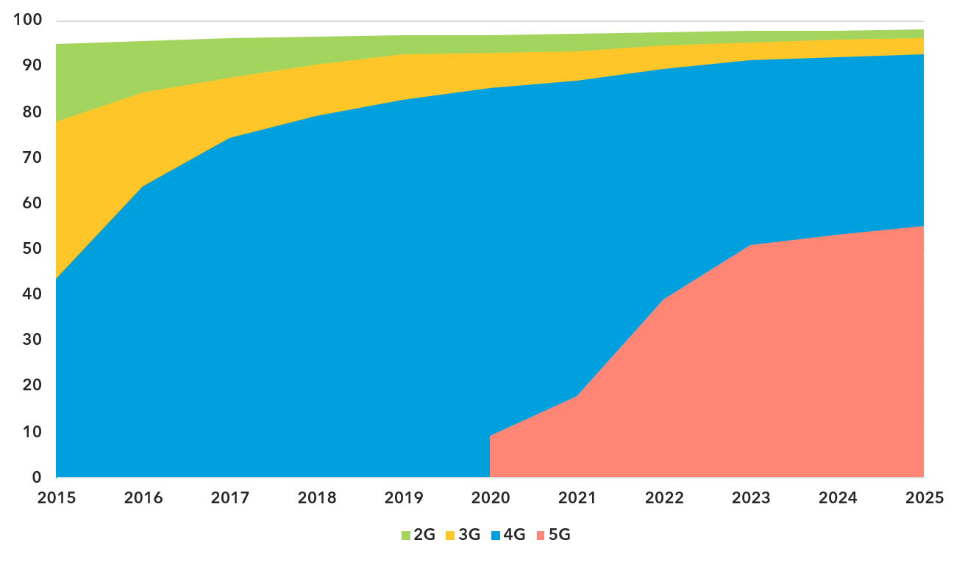
ITU Facts and Figures 2025 (p. 9) – The values for 2G, 3G and 4G networks show the incremental percentage of the population that is not covered by a more advanced technology network (e.g. in 2025, 96 per cent of the world's population is covered by at least a 3G or above network, with 3.6 per cent having only 3G, 37.6 per cent having 4G, and 55.1 per cent having 5G). There are insufficient data to produce estimates for 5G coverage prior to 2020. Interactive chart.
Figure 4
Population coverage by type of mobile network, 2025
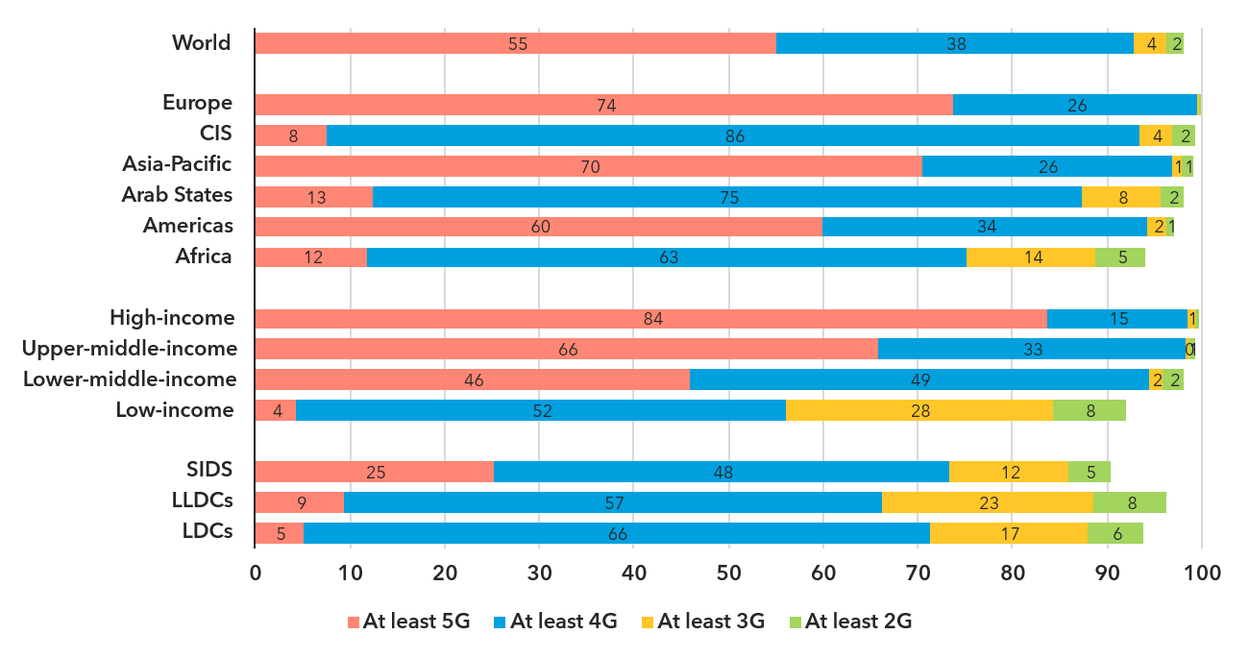
ITU Facts and Figures 2025 (p. 10) – The values for 2G, 3G and 4G networks show the incremental percentage of the population that is not covered by a more advanced technology network (e.g. in 2025, 96 per cent of the world's population is covered by at least a 3G or above network, with 3.6 per cent having only 3G, 37.6 per cent having 4G, and 55.1 per cent having 5G). Interactive chart.

Target 1.2: Broadband services to be affordable for all
Between 2022 and 2025, both the data-only mobile broadband and fixed broadband baskets became more affordable across all regions and income groups. Globally, the median price of the mobile broadband basket, measured as a percentage of GNI per capita using the data-only mobile broadband basket with 5 GB monthly allowance (allowing 5 gigabytes of data use per month; see Figure 5), the most recent reference measure, decreased from 2.0 per cent to 1.4 per cent. Similarly, the median price of the fixed broadband basket fell from 3. per cent to 2.5 per cent (see Figure 6). A record number of economies now meet the Broadband Commission target of keeping broadband costs below 2 per cent of GNI per capita.
While mobile broadband is increasingly affordable, fixed broadband remains unaffordable for many, especially in low-income economies. Subscribers in lower-middle-income economies pay approximately eight times more of their income for mobile broadband compared to those in high-income economies, while low-income subscribers pay 24 times more. Additionally, in low-income countries where fixed broadband is available, the subscription cost can consume nearly one third of the average person's income. Even where services are affordable on average, significant gaps persist within countries. Affordability continues to be a central obstacle to universal and meaningful connectivity, closely linked to weaker infrastructure, lower investment, and low-income levels.
Figure 5
Price of the data-only mobile broadband (5 GB) basket as
per cent of gross national income per capita, 2022-2025
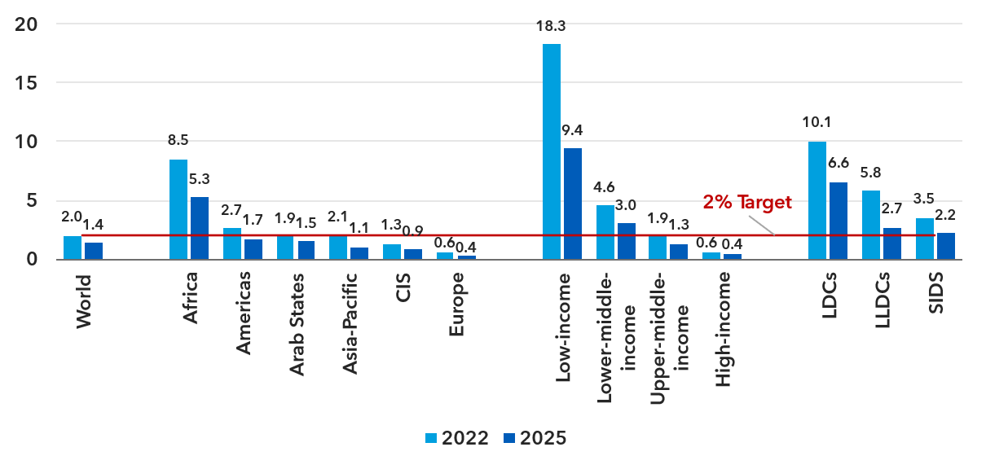
ITU Facts and Figures 2025 (p. 20) – As of 2025, mobile broadband price statistics refer to the data-only mobile broadband basket with at least 5 GB monthly allowance, reflecting the methodology adopted by the Expert Group on Telecommunication/ICT Indicators (EGTI) in 2024. For comparability, 2024 statistics presented here are based on ITU's experimental data collection for the same data-only mobile broadband basket. Interactive chart.
Figure 6
Price of the data-only mobile broadband (5GB) basket as
per cent of gross national income per capita, 2022-2025
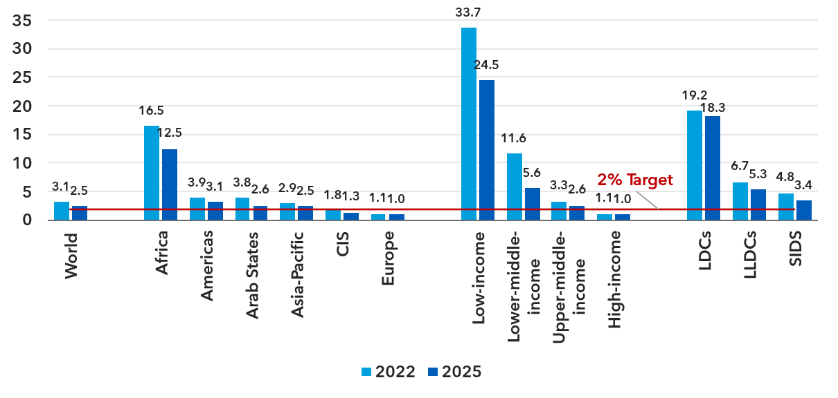
ITU Facts and Figures 2025 (p. 21) – Interactive chart.
Affordability is a key enabler of meaningful connectivity. The current indicator is based on the established ITU methodology (‘price baskets’) but needs to be revised in the ongoing process of drafting the ITU Strategic Plan 2028-2031. The reference to “developing countries” should be removed, as this classification is no longer used and affordability should be monitored globally. In addition, affordability should be measured separately for fixed and mobile broadband services, given their different cost structures. Both should continue to be expressed as a percentage of GNI per capita.

Target 1.3: Broadband access to every household
Household Internet access remains an important dimension of connectivity but has become increasingly difficult to measure accurately. The distinction between individual and household access is becoming less meaningful due to widespread mobile access and shared devices. Respondents often interpret “household Internet access” inconsistently, leading to growing measurement challenges and a decrease in data availability. In addition, there are no internationally comparable data for the number of households, necessary for computing the indicator. As a result, ITU no longer produces global or regional aggregates for this indicator.
In 2024, 167 countries had established broadband plans or digital strategies, a figure that has stagnated since 2019 and declined from 170 in 2022. To advance global connectivity, further efforts are needed to encourage the remaining 20 to 30 countries to develop and adopt their national broadband plans.

Target 1.4: Ownership of and access to Internet-enabled devices
Globally, 82 per cent of individuals 10 years or older own a mobile phone. Ownership is considered universal when penetration rate reaches 95 per cent. This threshold has been reached in high-income economies, while upper-middle-income economies have already surpassed the 90 per cent mark. In low-income economies, only 53 per cent of the population aged 10 years and over own a mobile phone (see Figure 7).
Figure 7
Percentage of individuals owning a mobile phone and using the Internet, 2025
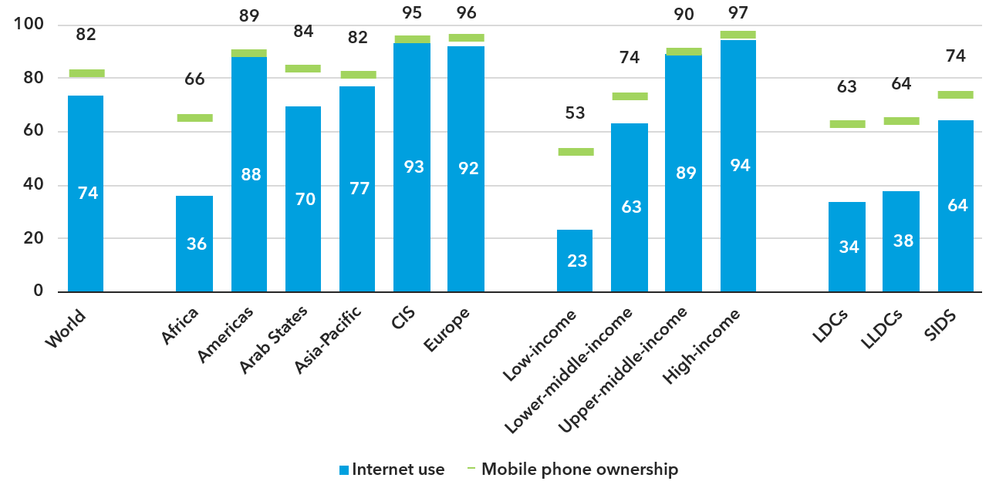
ITU Facts and Figures 2025 (p. 26) – Mobile phone ownership refers to individuals aged 10 or older. Interactive chart.
Access to Internet-enabled devices is essential for meaningful connectivity, but the current indicators (percentage of individuals using a smart telephone and percentage of individuals who own a smart telephone) present several challenges. They partly overlap, and data availability is low. Many countries do not regularly collect data on smartphone ownership or use, and no global or regional aggregates are available. A simpler and more widely available indicator should be used in the SP 2028-2031. The SDG indicator on mobile phone ownership provides a suitable alternative: it is methodologically sound, collected by more countries and allows disaggregation by gender and other characteristics.

Target 1.5: Access to the Internet for all schools
This data is gathered by the UNESCO Institute for Statistics (UIS), and the following indicators are available in this dashboard (under Indicator 4a, Target 4a.1):
– Percentage of schools with access to the Internet for pedagogical purposes.
– Percentage of schools with access to computers for pedagogical purposes.
Data are available by country and disaggregated by level (i.e. primary, lower secondary, upper secondary). Latest year available is 2024. Regional and global estimates are also available.
Figure 8
Proportion of schools with access to computers or
the Internet for pedagogical purposes (per cent), 2024
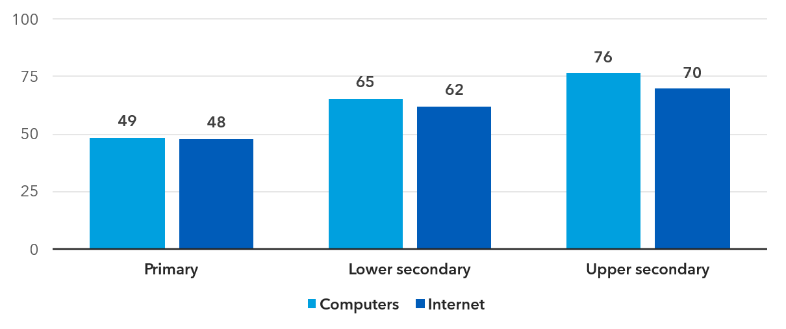
UNESCO Institute for Statistics. Find more here.
In 2024, about half of primary schools had access to computers and the Internet. More than 60 per cent of lower secondary schools and more than 70 per cent of upper secondary schools had access to these facilities (see Figure 8).
The existing data does not allow yet for drawing conclusions on the evolution of world averages. School connectivity may be a relevant target. However, the current indicator is inadequate. A threshold of 500 MB per month is far below what is required for educational use. Additionally, ITU is not the main data source for this indicator. The United Nations Educational, Scientific and Cultural Organization (UNESCO) collects data on schools with Internet access.

Target 1.6: Improved cybersecurity preparedness of countries
In terms of enhancing cybersecurity preparedness among countries, notable progress has been observed. By 2024, 132 countries had established Computer Incident Response Teams (CIRTs), an increase from 109 in 2020. Additionally, 127 countries had implemented National Cybersecurity Strategies and Action Plans, up from 107 in 2020.

Target 1.7: Universal access to the Internet by all individuals
In 2025, 74 per cent of the world’s population were online, compared with 71 per cent a year earlier. In absolute numbers, this corresponds to 6 billion people, up from 5.4 billion in 2022, representing an increase of 13 per cent over the period (see Figure 9). While progress continues toward universal connectivity more than a quarter of the global population remained offline.
Figure 9
Individuals using the Internet
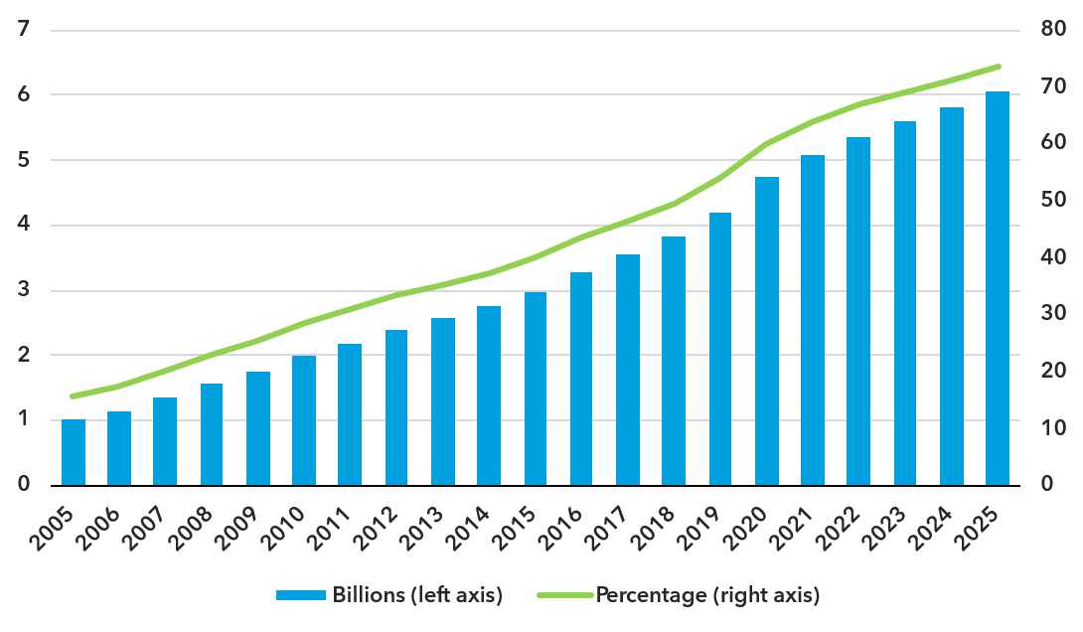
ITU Facts and Figures 2025 (p. 1) – Interactive chart.
Internet use is closely linked to levels of development. High-income countries are nearing universal Internet use with 94 per cent of the population using the Internet. In contrast, only 23 per cent of the population of low-income countries used the Internet.
Within the Commonwealth of Independent States (CIS), Europe and the Americas, between 88 and 93 per cent of the population used the Internet. In Asia-Pacific and the Arab States regions, Internet use stood at 77 and 70 per cent, respectively, which is in line with the global average. By contrast, the average figure for Internet use for the Africa region was just 36 per cent.
Universal connectivity also remains a distant prospect in the least developed countries (LDCs) and landlocked developing countries (LLDCs), where only 34 and 38 per cent of the population were online, respectively. While the annual growth rate in 2025 in these economies averaged 7.4 and 5.5 per cent, respectively, which is higher than in most of the other groups or regions, the connectivity gap is not expected to close anytime soon (see Figure 10).
Figure 10
Percentage of individuals using the Internet by region and special groups, 2022 and 2025
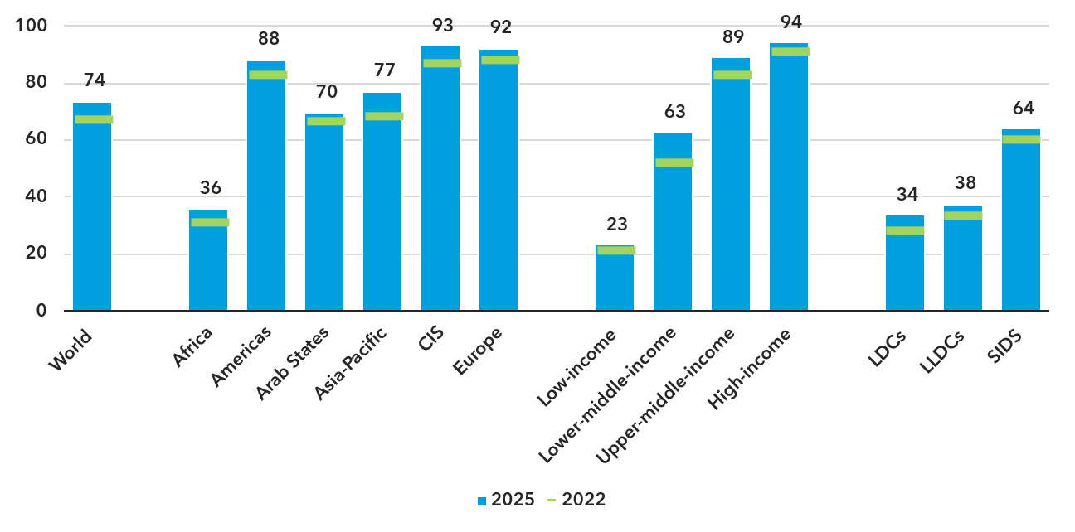
ITU Facts and Figures 2025 (p. 3) – Interactive chart.

3.2.2 Sustainable Digital Transformation
This sub-section covers key dimensions of sustainable digital transformation, including digital inclusion gaps, digital skills, use of digital services, cybersecurity preparedness, and environmental sustainability.

Target 2.1: All digital gaps to be bridged (particularly gender, age and urban/rural)
This target shows uneven progress depending on the disaggregation, such as gender, age, and location (rural and urban). This indicates that advancements in digital access are not uniform, highlighting the need for targeted strategies to address specific gaps.
Figure 11
Percentage of women and men using the Internet, 2025
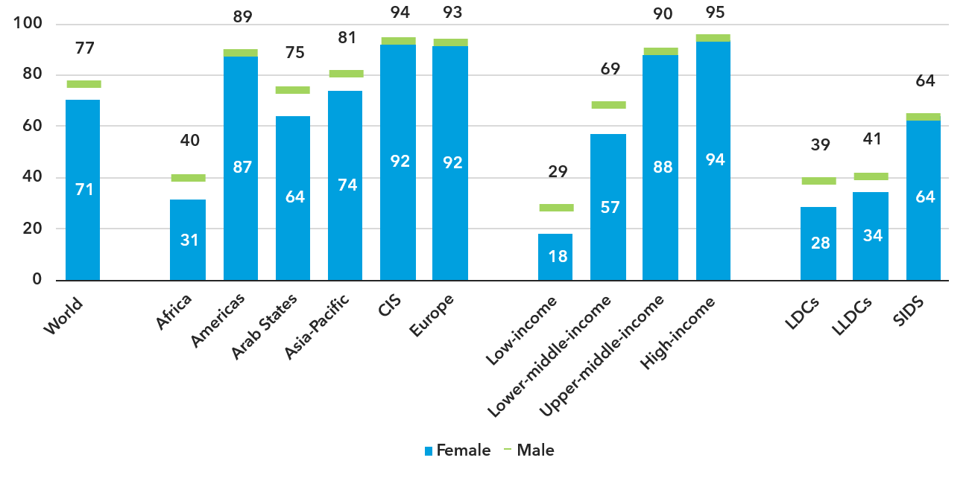
ITU Facts and Figures 2025 (p. 5) – Interactive chart.
Globally, 77 per cent of men used the Internet, compared with 71 per cent of women (see Figure 11). Internet penetration rate among women and men have both grown by 10 per cent between 2022 and 2025, but there are still about 280 million more men than women using the Internet in 2025.
Gender parity is deemed to be achieved when the gender parity score, defined as the female percentage divided by the male percentage, is between 0.98 and 1.02. As is the case for overall Internet use, gender parity is closely correlated with the level of development. Between 2022 and 2025, the global gender parity score has remained at 0.92, indicating a lack of progress towards global gender parity.
Among ITU regions, gender parity has been achieved in Europe, in the Americas and the CIS regions. In the Small Island Developing States (SIDS) group, the gender parity score remained at or even above 1 between 2022 and 2025, indicating gender parity. The SIDS are also a notable, positive exception to the strong correlation between gender parity and overall Internet use as they have achieved gender parity even though less than two-thirds of the population use the Internet.
Figure 12
Percentage of individuals using the Internet by age group, 2025
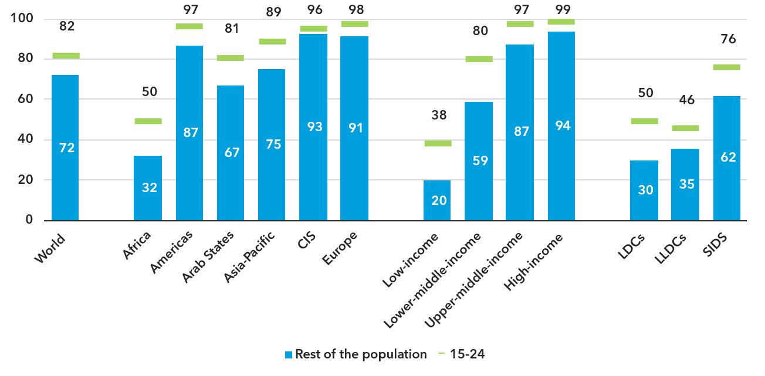
ITU Facts and Figures 2025 (p. 6) – “Youth” refers to 15 to 24-year-olds. Interactive chart.
In terms of Internet usage by age, Globally, 82 per cent of people aged 15 to 24 use the Internet, ten percentage points more than among the rest of the population (72 per cent) (see Figure 12). This generational gap, observed in every region, has been slowly shrinking over the last four years. In this age group, “universality,” meaning when the penetration rate is at least 95 per cent, has already been achieved in Europe, the CIS region and the Americas region.
In relative terms, 15- to 24-year-olds in low-income countries are 1.9 times more likely to use the Internet than the rest of the population. This is the largest generational gap of any income group, with 15- to 24-year-olds in high-income countries only five percent more likely to use the Internet than the rest of the population.
Figure 13
Percentage of individuals using the Internet in urban and rural areas, 2025
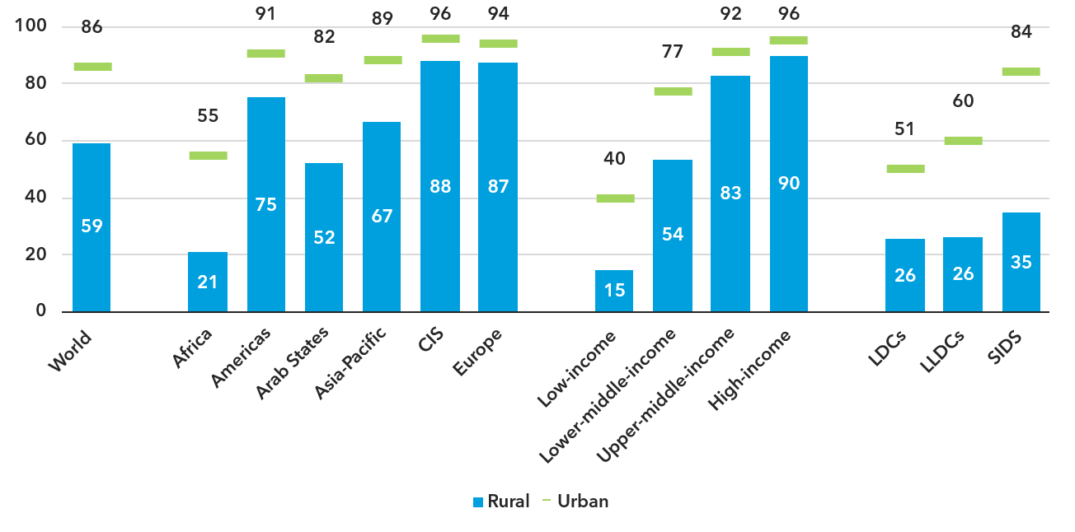
ITU Facts and Figures 2025 (p. 7) – Interactive chart.
Significant disparities in Internet usage persist between urban and rural areas. Globally, 85 per cent of urban dwellers use the Internet in 2025, compared to just over half of the rural population (58 per cent).
The urban-rural gap, measured as the ratio of the two percentages, has slowly decreased from 1.6 to 1.5 over the last four years. Unsurprisingly, the urban-rural gap is smallest in regions with high Internet use penetration, including in Europe, where the ratio is just 1.1, compared with 2.6 in Africa. In all regions, progress has been modest over the last four years.
In high-income countries, where 94 per cent of the population uses the Internet, the urban-rural gap has almost been bridged, with an average ratio of 1.1. In low-income countries, by contrast, the urban-rural gap remains wide with only one in seven rural dwellers (14 per cent) online, which is little more than one-third the share of urban residents (see Figure 13).
This target is very broadly formulated and overlaps with Target 1.7 on universal Internet use and other targets. No single indicator can possibly measure all the digital gaps. The indicator is identical to the one already proposed under that target. The recommended approach, therefore, is to not use this target in the SP 2028-2031 and instead to consolidate all monitoring of usage gaps under Target 1.7, where disaggregation by gender, age and location is already proposed.

Target 2.2: Majority of individuals to have digital skills
Because self-reporting of individuals’ ICT skills may be subjective, ICT skills are measured based on whether an individual has recently performed certain activities that presuppose a degree of proficiency in the relevant skills. These ICT skills are grouped into five areas: communication and collaboration; problem solving; safety; digital content creation; and information and data literacy.
While the importance of digital skills in leveraging ICTs for economic prosperity and social well-being is well-documented, data remain very scant. Only 88 countries have submitted data since 2020, and rarely for all skill areas. Of these just 48 countries provide comparable data on ICT skill levels and only eight provided data on overall skill levels.
Despite these gaps, certain trends and patterns in ICT skills are emerging. Internet users consistently show strong communication skills. In all countries reporting data on communication and collaboration, at least three-quarters of Internet users possess at least basic skills in this area, regardless of national Internet usage levels.
Skill levels in other areas are more diverse. In the countries providing data, the share of Internet users with at least basic skills in information and data literacy tends to be higher than in other areas, except communication and collaboration. However, substantial variation persists across all skill areas, even among countries with similar levels of Internet use. For the eight countries reporting overall skill levels, the share of Internet users with at least basic skills ranges from 16 to 74 per cent, a gap of almost 60 percentage points.
Digital skills are a critical enabler of meaningful connectivity and digital transformation. The current indicator is no longer collected and was replaced with an indicator using a refined methodology introduced in 2025 by ITU. Data availability remains limited, although it is expected to improve as more countries adopt the refined methodology when collecting data.

Target 2.3: Universal usage of Internet services by businesses
Business Internet use is an important dimension of digital transformation. However, ITU is not the primary source of this data. UN Trade and Development (UNCTAD) and Eurostat compile data on the use of ICTs by businesses. Data availability varies greatly across countries. However, world averages are currently unavailable due to insufficient data.

Target 2.4: Majority of individuals accessing government services online
ITU oversees this indicator, but world averages are not available as there is insufficient data. The use of online government services is an important dimension of digital inclusion, but this target focuses on one specific application of the Internet while excluding others such as e-commerce, digital payments or health services. Data availability is low, and no global aggregates are produced.

Target 2.5: Climate and environment action
Of the 81 countries covered by a national e-waste policy, legislation, or regulation, 67 contained provisions promoting the Extended Producer Responsibility (EPR) principle, 48 had enshrined national e-waste collection targets in their regulations, and 37 had done so for e-waste recycling targets at the national level.
Meanwhile, the fifth edition of the Greening Digital Companies report shows that the 166 digital companies disclosing their operational emissions (accounting for 94 per cent of the revenue of the 200 leading digital companies) reported 297.3 million tCO₂e in 2023, or 0.8 per cent of the world total energy-related emissions, marking a 1.4 per cent increase from 2022. (For information on climate and environment see Section 5.4section 5.4.)
The environmental impact of ICTs is increasing rapidly, driven by the growing number of connected devices, the expansion of data centres, and the scaling of AI applications. These trends are accelerating demand for energy and raw materials and contributing to higher emissions, pollution, and e-waste generation. The target should therefore be reframed in the SP 2028-2031 to explicitly include the reduction of the negative environmental impacts of ICTs.
Additional information for all these targets can be found in the latest edition of ITU’s flagship reports Measuring digital development: Facts and Figures 2024, Measuring digital development: Facts and Figures: Focus on Landlocked Developing Countries July 2025, as well as the Global Connectivity Report 2025.
Figure 14
Projection of e-waste generation worldwide, 2010-2030
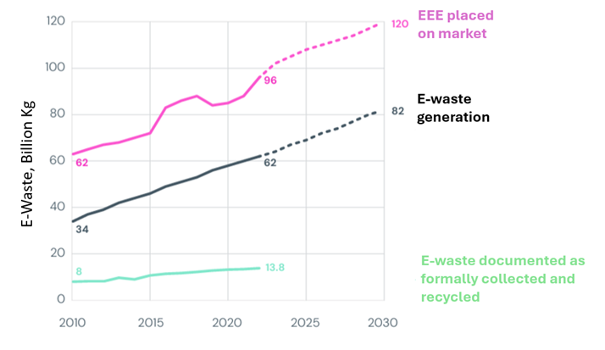
Global e-waste Monitor 2024 (p. 28) – Figure adapted, see more here. EEE: Electric and Electronic Equipment

4 Products and services

4.1 Development and application of ITU Administrative Regulations

4.1.1 Radio Regulations
ITU maintains the Radio Regulations – the international treaty governing the use of the radiofrequency spectrum and satellite orbits for all kinds of wireless communications. In upholding the regulations and facilitating related international cooperation, the organization supports equitable access to and rational use of spectrum and orbits as finite natural resources.
Through ITU, administrations agree on the allocation of radio frequencies and management, along with the procedures for coordination to avoid harmful radio interference. ITU and its Radiocommunication Bureau enable these activities, supporting Member States worldwide with expertise on communications on land, at sea, in the air, and in space.
The Radiocommunication Bureau implemented the results of WRC-23 and is working on the preparations for WRC-27.
Notably:
– The new edition of the Radio Regulations, containing the final acts adopted by WRC-23, was published in 2024 and is available for free download from the ITU website.
– The Radiocommunication Bureau continues to update and maintain software tools for the implementation, use and analysis of the Radio Regulations.
– The RR5 Table of Frequency Allocations tool and the Radio Regulations Navigation Tool have been updated in line with the 2024 Edition.
– More information on ITU-R software tools can be found in the section on Software Improvements and Developments (2022-2025).
– The Manual for Use by the Maritime Mobile and Maritime Mobile-Satellite Services (Maritime Manual), published in December 2024, provides a comprehensive overview of maritime communications.
– The Council adopted the agenda and decided on the dates and location of the World Radiocommunication Conference 2027 (WRC-27).
– WRC-27 and the Radiocommunication Assembly 2027 (RA-27) will be held in Shanghai, China, from 11 October to 12 November 2027.
– The responsible and contributing groups for each WRC-27 agenda item, which were identified by CPM27-1, are conducting the preparatory studies for WRC-27.
– The Radiocommunication Bureau is working on the processing of space and terrestrial notices.
– More information on the results of this work can be found in the next section on Spectrum use for space and terrestrial services.

4.2 Allocation and management of resources

4.2.1 Spectrum use for space and terrestrial services
Table 1
Results of the processing of space notices and other related activities, 2022-2025.
Results of the processing of space notices and other related activities | 2022 | 2023 | 2024 | 2025 | Total  2022-2025
Coordination and notification requests | 1 518 | 1 349 | 1 384 | 1 198 | 5 459
Requests for broadcasting-satellite and associated feeder links Plans | 134 | 130* | 204** | 90 | 558
Requests for fixed-satellite service Plan | 134 | 92 | 87*** | 53 | 366
* Including 90 entries in the List of Regions 1 and 3 in application of Resolution 559 (WRC-19) by 45 countries.
** Including 82 entries into the Plans of Regions 1 and 3 following the successful completion of Resolution 559 (WRC-19) by 41 countries.
*** Including seven new entries in the Plan for ITU Member States not yet having an allotment.

Table 2
Terrestrial notices 2022-2025
Terrestrial notices | 2022 | 2023 | 2024 | 2025 | Total  2022-2025
Notices recorded in the MIFR/Plans | 63 893/  16 250 | 71 083 /  28 076 | 71 072/  16 878 | 45 109/  21 998 | 251 157/  83 202
Review of findings for terrestrial stations recorded in the MIFR | 1 562 | 11 | - | 6 490 | 8 063
Notifications of coast and ship stations for recording in the ITU maritime database | 1 854 | 1 818 | 683 | 1 957 | 7 312
High-frequency broadcasting requirements | 11 311 | 7 969 | 10 195 | 10 470 | 39 945
Monitoring observations concerning the monitoring programme at 2 850-28 000 kHz/ and 406-406.1 MHz | 25 530/  407 | 29 909/  612 | 27 854/  920 | 33 406/  1 114 | 116 699/  3 053
Reports of harmful interference | 1 007 | 1 110 | 1 100 | 1 140 | 4 357

ITU-R Software Improvements and Developments (2022-2025)
There have been substantial advancements in software applications and tools from 2022 to 2025, focusing on enhancing user access to ITU-R outputs and improving the overall efficiency of radiocommunication services.
In 2022, BR concentrated on updating key software applications that enable users to query and analyse the Table of Frequency Allocations (TFA) and related regulatory texts. Major enhancements included the development of tools for processing coordination requests and High-Altitude Platform Station (HAPS) notifications. The migration of the TerRaSys database to the SQL (Structured Query Language) server and the integration of eTerrestrial web tools for various terrestrial services were also significant achievements. Additionally, online tools for GE84 compatibility were enhanced, and High Frequency Broadcasting software was re-engineered to improve user experience. A new online Harmful Interference Tracking System (HITS) was established to handle reports of harmful interference, while efforts were made to modernize space information systems and implement electronic communication systems for satellite network filings.
Continuing into 2023, there has been progress with software developments centred on the BR Space Information System. Key achievements included nearing user acceptance testing for modernized PXT software and maintaining the advancement of the e-submission system, ensuring compliance with recent resolutions from the World Radiocommunication Conference (WRC-23). A notable introduction was an online examination tool designed to assist administrations in verifying compliance with satellite filings. Moreover, the BR International Frequency Information Circular (BR-IFIC) for Space Services transitioned from a DVD format to a more accessible web-based application, improving user engagement with essential space service information.
In 2024, BR officially launched the BR IFIC (Space Services) online application, providing 24/7 access to crucial frequency information. Significant initiatives for the year included the rollout of the ITU Space Explorer web application to enhance satellite network submissions and the introduction of advancements in the e-Submission system, enabling uploads in the new SNS v10 format and facilitating better correspondence management through integration with the e-Communications system.
Furthermore, BR made considerable progress on terrestrial applications by updating software for processing notices and notifications under RR No. 9.21. New tools were developed, and existing ones were integrated into a single portal, significantly enhancing the overall user experience.
In 2025, BR delivered software implementing most of the changes mandated by WRC-23, allowing for processing of terrestrial and space frequency notifications in accordance with the 2024 edition of the ITU Radio Regulations. BR web applications were also improved, making it easier for administrations and satellite operators to submit and exchange information related to satellite network filings. Software implementing Council Decision 482 (Mod. 2025) was made available in advance of the entry into force of the latest revision. The Satellite Interference Reporting and Resolution System (SIRRS) has been enhanced to enable UN Organizations such as ICAO to report and communicate cases of harmful interference to ITU.
In 2025, BR finalized and released the updated version of the Radio Regulations Navigation Tool, to incorporate the Radio Regulations 2024 Edition (WRC-23) and the most recent versions of the ITU’s Basic Texts (Constitution and Convention). The RR5 TFA software was also updated accordingly. Moreover, BR officially launched the BR IFIC (Terrestrial Services) online application, ensuring 24/7 access to frequency information pertaining to terrestrial services and providing for the online validation of the terrestrial frequency assignments notifications, prior to their submission to BR. In addition, BR completed the Maritime Service Publications enhancement. It included the development of digital maritime publications, a sales platform and anticounterfeits measures.
In 2025, the ITU-R Geospatial Catalogue was released, comprising Geographical, Geopolitical, and Radio-Meteorological Data supporting the development and application of radio wave propagation prediction methods, and enabling the BR to conduct precise technical analyses, ensuring interference-free operation of radiocommunication systems.
Overall, the improvements spanning 2022 to 2025 have streamlined processes, provided easier access to vital information, and fostered a more efficient interface for members and stakeholders involved in radiocommunication, establishing a robust foundation for future technological advancements.

4.2.2 Numbering, naming, addressing and identification resources

Enhancing global connectivity: Evolution of NNAI resource management
Numbering, naming, addressing and identification (NNAI) resources governed by relevant ITU-T Recommendations play an indispensable role in enabling global connectivity across fixed, mobile and satellite telecommunication networks. The mandates contained in the ITU Constitution and Convention, the International Telecommunication Regulations, and relevant ITU-T Recommendations have been implemented by disseminating information approved by national Administrations. Updates to assignments, changes and reclamations of NNAI resources administered by national Administrators are notified to ITU, published in the ITU Operational Bulletin (two issues per month), posted on the ITU website and reflected in ITU databases. In addition, for certain international resources, ITU assigns resources directly to Member States and eligible entities (e.g. operators) in accordance with established procedures in the relevant ITU-T Recommendations, and in consultation with the competent ITU-T Study Group, its Chair and/or designated advisers.
During the period of 2022 to 2025, the demand for international telecommunication NNAI resources increased significantly, largely due to the rise of machine-to-machine (M2M) and Internet of Things (IoT) services, as well as the expansion of services via Low Earth Orbit (LEO) satellites. This growth necessitated enhanced flexibility in resource management, particularly with the emergence of embedded SIM cards (eSIMs). At the WTSA-24 held in October 2024, key Resolutions (60, 61, and 20) related to international telecommunication numbering were revised to adapt to these challenges. Throughout the period, ITU-T Study Group 2 played a crucial role in addressing numbering complexities by updating recommendations and introducing new procedures to improve transparency in the application process. In addition, relevant Recommendations were advanced to support emerging connectivity models, including a new ITU-T Recommendation on international NNAI resources for IoT/M2M services/applications, and work on a new category of E.164 resource for global satellite services, in coordination with relevant ITU-R Working Parties.
For international telecommunication NNAI resources assigned directly under the authority of the Director of ITU’s Telecommunication Standardization Bureau (TSB), the specification of clearer assignment procedures (Recommendation ITU-T E.1120) strengthened governance, transparency and operational handling, tightening lifecycle controls (including annual certification and reclamation) and complementing the ecosystem by adding an auditing framework (Recommendation ITU-T E.1121) to help verify that assignments remain valid and properly administered and used. User-facing numbering webpages and applicant guidance were also improved to reduce delays associated with incomplete applications. Expectations regarding annual certification and consequences for non-payment were reinforced, and efforts progressed from policy discussion to concrete reclamation actions, supporting accurate databases and reducing the accumulation of unused or orphaned resources. Efforts to combat misuse of numbering resources led to the revision of WTSA Resolution 61, expanding its scope to cover NNAI resources, while promoting public awareness and best practices among Member States. Additionally, WTSA Resolution 65 was modified to address emerging issues such as spoofing and voice cloning technologies, ensuring telecommunications networks remain responsive to these threats. Relevant ITU-T recommendation was clarified and improved to provide clearer provisions on the handling of misuse cases through ITU-T processes. In addition, the Wangiri Fraud Mitigation Technical Report (TR.MMWF) was agreed, providing analysis and methodologies to address a widespread telephone-based fraud scheme. The newly introduced auditing framework is also a complementary mechanism to reporting of misuse.
Moreover, the ITU Operational Bulletin (OB), which disseminates official updates on NNAI resources, was modernized to enhance readability and efficiency in alignment with digital transformation efforts, with further digitalization initiatives ongoing. In response to WTSA Resolution 91, a repository for national numbering plans was established, encouraging active participation from various stakeholders to further refine the repository based on their feedback. This ongoing evolution ensures that the management of NNAI resources remains robust and aligned with technological advancements in the telecommunications landscape.

4.3 Development of international standards

Standardization: Foundations to shape technologies of today and tomorrow
Technologies built to universal standards can benefit everyone. ITU standards promote interoperability, accessibility, security, affordability and resilience, enabling seamless connectivity, access to information and more sustainable digital development. ITU standards are developed in ITU-T and also in ITU’s Radiocommunication Sector (ITU-R), being issued, respectively, as ITU-T Recommendations and ITU-R Recommendations.

4.3.1 ITU-T Recommendations and related publications
ITU-T Recommendations are the technical standards developed by ITU-T. They are complemented by other publications, such as Supplements, Technical Papers, Technical Reports, and augmented by pre-standardization deliverables prepared by ITU-T Focus Groups. There are currently 10 study groups in the sector, after the consolidation of ITU-T Study Groups 9 and 16 into Study Group 21 by WTSA-24. As of December 2025, only one active Focus Group was active, out of the 11 that were active in the reporting period (see the ITU-T focus group homepage for further detail):
Table 3
ITU-T Focus Groups 2025
Focus Group | Topic | Start | End | Deliverables produced
FG-AINN | Artificial Intelligence Native for Telecommunication Networks (FG-AINN) | 2024-07 | – | –
FG-CD | Cost Models for Affordable Data Services | 2023-03 | 2025-10 | 6
FG-MV | Metaverse | 2022-12 | 2024-06 | 52
FG-AI4A | AI and IoT for Digital Agriculture | 2021-10 | 2024-06 | 5
FG-TBFxG | Testbeds Federations for IMT-2020 and beyond | 2021-12 | 2024-04 | 8
FG-AI4NDM | AI for Natural Disaster Management | 2020-12 | 2024-03 | 5
FG-AN | Autonomous Networks | 2020-12 | 2024-03 | 9
FG-AI4H | Artificial Intelligence for Health | 2018-07 | 2023-09 | 36
FG-AI4EE | Environmental Efficiency for AI and Emerging Technologies | 2019-05 | 2022-12 | 20
FG-AI4AD | AI for Autonomous and Assisted Driving | 2019-10 | 2022-09 | 3
FG-VM | Vehicular Multimedia | 2018-07 | 2022-09 | 3

The following table summarizes the number of normative and non-normative publications approved during the reporting period (see https://itu.int/tdata/pubs/ for additional publication statistics).
Table 4
ITU-T publications, 2022-2025
Publication type | 2022 | 2023 | 2024 | 2025
Recommendations (new and revised) | 255 | 286 | 412 | 272
Supplements (new and revised) | 33 | 27 | 23 | 24
Technical Papers and Technical Reports | 14 | 26 | 22 | 18
Other study group publications | 13 | 3 | 3 | 2
Focus group deliverables | 26 | 36 | 79 | 6

Conformance and interoperability
In 2026, ITU conducted a survey on the use of ITU-T Recommendations in national conformity assessment frameworks, confirming strong interest in the ITU Conformity and Interoperability (C&I) Programme (SG11-TD909/GEN). In line with Resolution 177 (Rev. Bucharest, 2022), TSB developed criteria for assessing Pillar 1 of the C&I Programme and prepared a draft concept for an “ITU Mark,” drawing on existing international conformity programmes, including the ITU Mark (ITU GMPCS). A report on these developments, prepared in collaboration with ITU-T SG11, is available as Document SG11-TD939 R1/GEN.

AI Standards Exchange Database
The AI Standards Exchange Database responds to a call to the Global Digital Compact (Articles 58, 59 and 60) which proposed the establishment of an AI Standards Exchange to facilitate sharing of information about AI standards. The AI Standards Exchange Database was established in 2025 based on the ITU-T Standards Landscape data for ITU-T standards. It was developed under the World Standards Cooperation —which brings ITU together the International Organization for Standardization (ISO) and the International Electrotechnical Commission (IEC)— in partnership with the Institute of Electrical and Electronics Engineers (IEEE), the Internet Engineering Task Force (IETF) and the AI Standards Hub of Alan Turing Institute. Launched at the AI for Good Global Summit 2025 on 11 July 2025, the database expanded to include nearly 1000 AI standards and related publications from ITU, ISO, IEC, IEEE and IETF by the second half of 2026. By early 2026, ITU had are some 200 AI-related standards published and 200 under development.

4.3.2 ITU-R Recommendations
During the reporting period 2022-2025, ITU Member States approved 164 new or revised ITU-R Recommendations. All ITU-R recommendations are available at: https://www.itu.int/pub/R-REC. There are 1 161 ITU-R Recommendations currently in force.
In 2023, the work of ITU-R was recognized with the Engineering, Science & Technology Emmy Award for developing the radiocommunication standard for high dynamic range television (HDR-TV). Presented by the Television Academy, the award acknowledges the pioneering efforts of engineers and specialists within ITU-R Study Group 6 in creating a global HDR-TV standard that enhances viewers' visual experience. This marks the third Emmy Award granted to ITU-R study groups – and the sixth Emmy for ITU as a whole.

4.3.3 Bridging the standardization gap
WTSA Resolution 44 on bridging the standardization gap between developing and developed countries was first adopted in Florianopolis (2004) and has adapted over time to keep pace with evolving needs and to align with Resolution 123 (Rev. Bucharest, 2022) of the Plenipotentiary Conference. Resolution 44 was most recently updated at WTSA-24 to reaffirm and clarify the four-point action plan (see Figure 15) for the next four years.
Figure 15
Bridging the Standardization Gap action plan
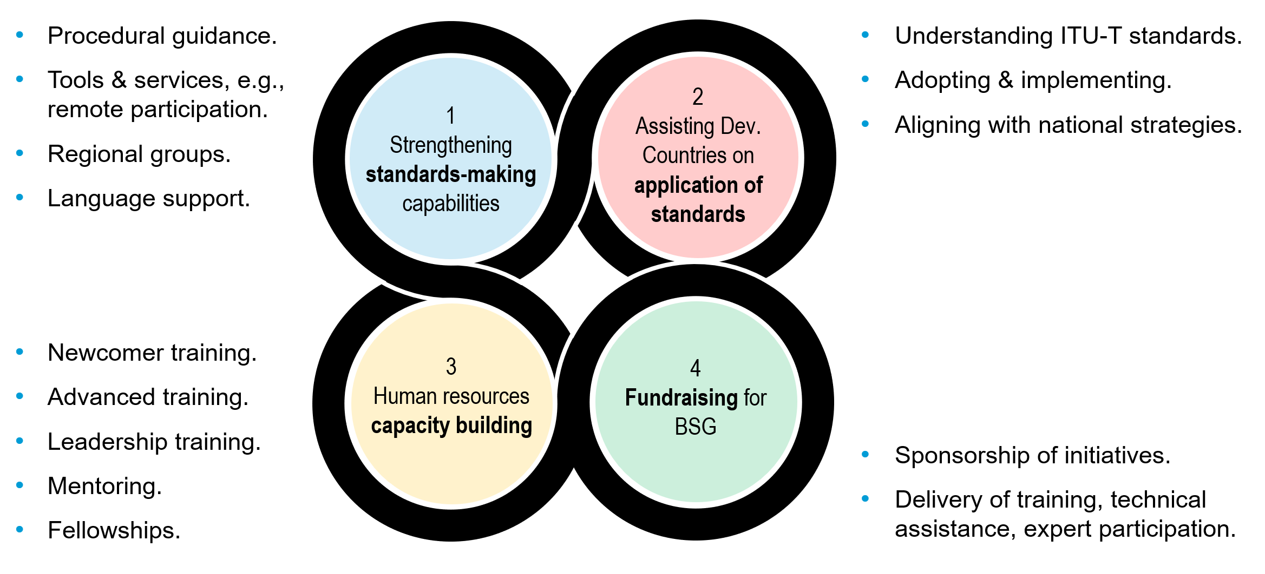
Accordingly, ITU’s implementation of the Bridging the Standardization Gap (BSG) programme aims to enhance the ability of all countries, in particular developing countries, to participate in the development and implementation of ITU-T standards.
During the 2022-2025 reporting period, the Telecommunication Standardization Bureau (TSB) has continued building on previous work, concentrating on:
1 Organizing 62 regional group meetings across the 27 current regional groups of ITU-T study groups. The most recent of these groups is ITU-T Study Group 15 Regional Group for Africa (SG15RG-AFR), created at the request of Members in October 2025. Regional groups are effective mechanisms to address local issues, encourage contributions to ITU, and increase the number and quality of technical inputs from developing countries.
2 Providing Fellowships to encourage engagement and continuity of active participation by ITU-T delegates from eligible developing countries. 713 fellowships were awarded during the reporting period, taking into account each candidate's suitability and prioritizing equitable distribution in terms of region, gender, delegates with specific needs in accordance with Service Order 21/02, "Policy for awarding fellowships for events and activities funded through the ITU regular budget".
3 Expanding the content and delivery of training to more fully meet the needs of newcomers and experienced delegates from developing countries, including those who serve or wish to serve in leadership positions. Updated training is provided via online training modules, stand-alone e-meetings and face-to-face events, frequently collocated with study group or regional group meetings, with an increased emphasis on practical skills and interactive learning. This training is closely integrated with the capacity building requirements of WTSA Resolutions 55 (gender equality) and 107 (next-generation experts). Sixty-two capacity building events were held during the reporting period, in person and online, reaching over 1 000 participants in 2025 alone.
4 Enhancing Electronic Working Methods to facilitate the participation of delegates from developing countries, primarily through the MyWorkspace platform and the enhancement of language services, such as on-demand machine translation of official meeting documents via ITU’s Document Management System. Such enhancements reinforce ITU’s implementation of WTSA Resolutions 32 (strengthening electronic working methods) and 67 (use of all official languages on an equal footing).
5 Collaborating with partners, including sponsors and hosts, as well as with ITU’s Telecommunication Development Bureau (BDT) and ITU regional/area offices, to raise awareness and build regional capacity. WTSA Resolution 44 invites voluntary contributions from all stakeholders to facilitate ITU-T’s efforts to bridge the standardization gap. For example, Japan's Ministry of Internal Affairs and Communications has supported activities since 2023, most recently via the project “Artificial Intelligence Technology and Standards Capacity Building in Asia Pacific”, which by December 2025 had delivered four capacity building workshops across the Asia region, reaching over 200 BSG participants.
6 Streamlining and harmonizing internal data analysis, working methods and delegate on-boarding to help delegates, particularly those from developing countries, to contribute effectively at ITU-T events, and to report progress on implementation of WTSA Resolution 44 to Council, WTSA and the Telecommunication Standardization Advisory Group.
7 Promoting the Guidelines for National Standardization Secretariats, which set out practical mechanisms to develop national structures and procedures to support effective participation in ITU-T activities in alignment with national standardization priorities.
8 Engaging in a range of initiatives that promote the implementation of ITU-T Recommendations, including: e-waste, the Digital Financial Services Security Lab, United for Smart Sustainable Cities (U4SSC), Conformity and Interoperability (C&I), and Safe listening.

4.4 Development of policy frameworks and knowledge products
ITU develops handbooks, technical reports and papers, inter alia through its study groups to assist its membership on telecommunication/ ICT matters (see, for example, section 4.3 above). Best practices from Member States, the private sector, research and academia are collected and shared back with Member States.
ITU provides knowledge-exchange products and tools to enable dialogue and enhance cooperation, helping countries maximize digital benefits for everyone, and providing key insights to understand and navigate the challenges and opportunities that come with promoting connectivity and digital transformation.
With the aim of strengthening the capacity of Member States to advance their ICT policy, legal, and regulatory frameworks, ITU-D provides guidance, knowledge products, capacity development, and technical assistance. This helps equip national decision-makers with the evidence and tools needed to navigate increasingly complex ICT and digital markets and ecosystems. The coordinated efforts of ITU-D also ensure that the support provided to countries incorporate key dimensions such as affordability, inclusion, competition, and investment with a whole-of-government approach to unleash overarching digital strategies. ITU-D also advances global advocacy on the role of regulation in enabling sustainable digital transformation through high-level flagship events in accordance with WTDC Resolution 48 (Rev. Baku, 2025) on Strengthening cooperation among telecommunication regulators.
ITU-D continues to develop services and products to support affordable connectivity and digital transformation, including an updated version of the Spectrum Management System for Developing Countries (SMS4DC), the Harmonized Calculation Method for Africa (HCM4A), updated Broadband Maps, the Connectivity Planning Platform (CPP), and initiatives promoting the use of emerging technologies, including AI, for development.

4.4.1 Cybersecurity: Building confidence and security in ICTs
Within the development sector, ITU supported Member States in strengthening their institutional readiness by assisting in the development of National Cybersecurity Strategies, helping to establish and operationalize National Computer Incident Response Teams (CIRTs), and through national, regional and global cyberdrills. As of July 2026, ITU has assisted 90 countries by evaluating their cybersecurity readiness, leading to the establishment or improvement of National CIRTs. As of May 2026, ITU has organized over 60 international, regional, or national CyberDrills (including 4 Global CyberDrills), involving more than 160 countries across all six ITU regions.
The fifth edition of the ITU Global Cybersecurity Index (GCI) was launched in September 2024. ITU provided targeted capacity building, technical assistance, and policy guidance to enhance cyber preparedness and operational response capabilities through programmes for Cyber for Good, Her CyberTracks and ITU Academy and the ITU Centres of Excellence and Academy Training Centres. These activities complemented broader efforts to strengthen resilience, improve cyber governance, and ensure secure and inclusive access to digital technologies. ITU continued to engage with stakeholders in the Open-ended Working Group on security of and in the use of ICTs (OEWG), and is prepared to continue engaging with the new permanent mechanism and its thematic group on capacity building.
ITU also advanced Child Online Protection through awareness-raising materials, knowledge management, and targeted programmes, alongside policy support and collaboration with national stakeholders to strengthen digital safety frameworks for children. As of May 2026, ITU has supported the development of national COP frameworks or related assessments in 16 countries. This work was further reinforced through the Protection through Online Participation (PoP) initiative, which combined intersectoral collaboration, preparatory research, and multi-stakeholder consultations, culminating in the launch of the PoP Guiding Principles. In parallel, ITU strengthened industry engagement through the 2025 Industry Connect event series, fostering dialogue with digital service providers on emerging risks and shared responsibilities for child online safety. ITU-T SG17 established a Correspondence Group on Child Online Protection (CG-COP) in March 2024 to identify the scope and gap for COP standardization.
In collaboration with the Committee on the Rights of the Child, UNICEF, and over ten co-signatory UN agencies, ITU developed and launched the Joint Statement on Artificial Intelligence and the Rights of the Child. Technical standardization and radiocommunication activities supported this work through security-focused recommendations, studies, and updates that addressed evolving threats and the protection of critical ICT infrastructure.
ITU-T Study Group 17 advanced work on security of Artificial Intelligence, International Mobile Telecommunication systems, cloud, Internet of Things, Intelligent Transport Systems, digital twin systems, quantum key distribution, access control, digital financial, privacy preserving and other smart services. ITU-T Study Groups 5, 13, 15 and 21 also approved recommendations across a wide range of issues from trustworthiness of IMT-2020 and beyond, infrastructure (e.g. power grid, passive optical network), fixed, mobile and satellite convergence, digital rights management for video/audio content distribution, and multimedia authenticity. SG11 continues its activities on signalling security to combat counterfeit and stolen ICT mobile devices and attacks on telephone networks (e.g. telephone spam, robocalls, spoofing numbers, etc. SG20 continues its work on security, privacy, trustworthiness, and identification for the Internet of Things (IoT) and smart sustainable cities and communities (SSC&C). ITU-R has established clear security principles for International Mobile Telecommunication (IMT) (3G, 4G and 5G) networks. The United for Smart Sustainable Cities (U4SSC) initiative, supported by 20 UN entities, is advancing work on security and privacy aspects related to digital public infrastructure in cities. The Global Initiative on Virtual Worlds and AI – Discovering the Citiverse, supported by more than 70 partners, is also advancing work under its Security and Trust track in the development of the citiverse and virtual worlds.
ITU and the International Cable Protection Committee established the International Advisory Body on Submarine Cable Resilience in 2024, bringing together government and industry experts to strengthen this critical infrastructure. Following the Abuja Summit in 2025, three Working Groups developed recommendations on risk identification, monitoring and mitigation; connectivity and geographic diversity of cable landing points and routes; and timely cable deployment and repair. The recommendations were approved at the Second International Submarine Cable Resilience Summit, held in Porto, Portugal, on 2–3 February 2026, where the Porto Declaration was also endorsed.
The Advisory Body completed its two-year work programme at the WSIS Forum 2026, approving its final report on 10 July. Consolidating the contributions of more than 160 Working Group members, the report provides practical guidance for governments, regulators and industry to reduce risks, improve deployment and repair, and diversify connectivity, strengthening submarine cable resilience worldwide.
For further information visit ITU Cybersecurity Activities.

4.4.2 Emerging technologies: Shaping frameworks for transformation
ITU continues to shape global frameworks for fast-evolving technologies, with a particular focus on AI, quantum information technology, the metaverse and virtual worlds, and the Internet of Things (IoT). This work supports inclusive and sustainable digital transformation worldwide and is achieved through standards, UN system coordination, dedicated initiatives, and practical projects on the ground.

Artificial intelligence
ITU has remained at the leading edge of international Artificial Intelligence cooperation since 2017, ensuring that AI contributes to social and economic development and advances progress across the UN Sustainable Development Goals. Guided by Plenipotentiary Resolution 214 (Bucharest, 2022), ITU’s AI work covers standardization capacity building UN system-wide coordination, and multistakeholder platforms.
ITU advanced the standardization work through relevant study groups, focus groups and several pre-standardization initiatives. These include study groups in the standardization sector as well as some in the radio communication sector, the focus groups on AI-Native Networks, AI for Agriculture, AI for Natural Disaster Management, AI for Health, and global initiatives on Resilience to Natural Hazards through AI Solutions, AI for Food Systems, AI for Health, AI and Data Commons, Virtual Worlds and AI. This work was complemented by ITU’s collaboration on AI standards with other Standards Development Organizations under the World Standards Cooperation (see section 4.3.1) to promote consensus-based international standards. Annual International AI Standards Summits have started to answer the call from the global community for comprehensive and impactful AI standards. ITU’s standardization role in AI was formally reinforced through the adoption of World Telecommunication Standardization Assembly Resolution 101 (New Delhi, 2024), underscoring ITU’s recognized mandate to develop trusted, international AI standards.
ITU is working to help with equipping countries around the world with the knowledge and tools necessary to take advantage of AI, with the aim of ensuring that its benefits are globally accessible and equitable. The AI for Good Impact initiative includes flagship programmes such as the AI Skills Coalition, Young AI Leaders Community, Global AI Challenges, and the Innovation Factory and Startup Acceleration Programme. The initiative also launched a series of regional Impact events, including AI for Good Impact India, and AI for Good Impact Africa. These programmes, alongside AI Landscape Survey, Early Warnings for All AI Sub-Group, the ITU Academy AI courses, and project like AI Technology and Standards Capacity Building in Asia-Pacific, underscore ITU’s commitment to bridging the AI divide, fostering international partnerships, and supporting sustainable development goals through AI capacity building. The adoption of World Telecommunication Development Conference Resolution 91 (Baku, 2025) further strengthens ITU’s commitment to supporting AI technologies in telecommunications development.
UN system-wide policy coherence and programmatic coordination on AI continued through the Inter-Agency Working Group on AI (IAWG-AI), co-led by ITU and UNESCO. The group has developed key initiatives like the UN System-wide Ethical Principles for AI, and the UN System White Paper on AI Governance, both endorsed by the UN Chief Executives Board for Coordination. The group also launched the UN AI Resource Hub, which is a dynamic, searchable public platform showcasing over 1000 documented AI initiatives, building on the ITU-compiled UN Activities on AI Report. Entering its sixth year, the IAWG-AI has transitioned into a stable institutional coordination mechanism. Several resolutions, including United Nations General Assembly Resolution A/RES/79/325 and A/RES/80/173, recognize the work of the IAWG-AI.
At the multistakeholder platform level, AI for Good has continued serving as the UN’s primary, action-oriented platform promoting AI solutions in health, education, infrastructure and other development priorities, co-convened by ITU with more than 50 UN partners and the Government of Switzerland. The global conversation on governance was elevated further during the AI Governance Day at the AI for Good Global Summit. The annual WSIS Forum serves as a multistakeholder platform for the broader ICT for Development community to discuss the challenges and opportunities for emerging technologies such as AI in the context of development. In 2026, these platforms gained further momentum through Geneva Digital Week, which brought together the AI for Good Global Summit, the WSIS Forum and the inaugural Global Dialogue on AI Governance, expanding opportunities for inclusive exchange and international cooperation. For information on ITU’s work on AI and the environment, see section 4.4.2 above.

Quantum information technology
Quantum information technology remains a major area of growth within ITU’s work, reflecting its increasing impact on future communication networks. ITU-T Study Group 11, Study Group 13 and Study Group 17 continued developing quantum-related Recommendations, with over thirty new standards adopted since 2022, including X.1715 and the Y.3809 – Y.3814 series. Following WTSA-24, these groups updated and expanded their mandates: Study Group 11 continued studies on signalling and control architectures for quantum key distribution networks (QKDN); Study Group 13 advanced work on quantum network technologies; Study Group 15 introduced studies on transport-network requirements for quantum information technology; and Study Group 17 continued leading work on quantum key distribution (QKD) and post-quantum cryptography. An action adopted at WTSA-24 reinforced the urgency of migration to post-quantum cryptography (PQC) in telecommunication networks.
ITU-T now hosts approximately 50 quantum standards, with more than 30 additional deliverables under development. Coordination across this fast-moving domain continued through the Joint Coordination Activity on Quantum Key Distribution Networks (JCA-QKDN), established by ITU’s Telecommunication Standardization Advisory Group in January 2023. The JCA-QKDN held its first meeting in March 2023 and continued work through a collaborative session in Singapore in May 2024, which advanced a comprehensive Quantum Standards Database
At the global level, the United Nations General Assembly adopted Resolution 78/287 in June 2024, proclaiming 2025 as the International Year of Quantum Science and Technology (IYQ). ITU played a central role in the IYQ Steering Committee, supporting implementation, awareness-raising and global events. In this context, Quantum for Good was launched a global initiative for inclusive and sustainable quantum impact, dedicated to aligning quantum innovation with the UN Sustainable Development Goals. It is structured around three core pillars: bridging the quantum divide; industry leadership and standards and strengthening global cooperation on quantum technologies. Quantum for Good is integrated into the annual AI for Good Summit alongside additional IYQ-related activities since 2025, including the Quantum World Tour webinar series that showcases quantum ecosystems globally and the Quantum for Everyone online course developed in partnership with the UN International Computing Centre (UNICC) and Quantum Delta NL to build capacity. Youth engagement has also been a key priority throughout these activities, including through hackathons such as the Future Leaders in Quantum Hackathon 2025 which empower young innovators to apply quantum technologies to real-world challenges.

Metaverse and citiverse
Rapid growth in virtual worlds and metaverse-related technologies led ITU to explore the foundational requirements for future international standards. The Focus Group on Metaverse (FG-MV), established by ITU’s Telecommunication Standardization Advisory Group in December 2022, undertook extensive analysis of technical requirements and enabling technologies, with its first meeting in March 2023 attracting over 650 participants. The group also benefited from five ITU Forums on the Metaverse, which brought together more than 14 500 participants to explore challenges and opportunities.
FG-MV Workplan concluded in June 2024, producing 52 deliverables. These included a definition of the metaverse, a standardization roadmap, and studies on generative AI in virtual worlds, citiverse concepts, cross-platform interoperability, trust and security, accessibility, energy efficiency, policy considerations, digital twins, and metaverse use cases for cities and industrial contexts.
The work of the Focus Group has been successfully transferred to ITU-T Study Groups including ITU-T Study Group 20, which has successfully developed standards on digital twins for metaverse.
Following the closing of the Focus Group a new initiative on Virtual Worlds and AI has been launched, to provide a platform to develop interoperable and safe citiverse.
Building on this work, ITU co-organized the Metaverse Think-a-Thon 2024 with UNICC, FAO and the International Atomic Energy Agency (IAEA), challenging students and graduates to develop virtual-simulation solutions for global problems in education, disaster preparedness, conflict resolution and sustainable urban development. The initiative culminated in recognition of the winning teams during UN Virtual Worlds Day. ITU also coordinated the preparation and launch of the first UN Citiverse Challenge, launched in February 2025 with 15 partners. The challenge concluded with the development and recognition of innovative citiverse-based solutions addressing public service delivery, sustainability and tourism, highlighting practical pathways for cities to leverage virtual worlds as digital public infrastructure, and recognizing Team DataLab, winner of the Student Category, for their outstanding contribution, and Team WEO, winner of the Startup Category, for their innovative and scalable solution.
In parallel, ITU and 16 UN agencies published the first UN Executive Briefing on Unlocking the Potential of Virtual Worlds and the Metaverse for the SDGs in June 2024, highlighting their potential transformative impact and emphasizing the need for international standards and responsible development.

Internet of Things (IoT), Digital Twins and Smart Sustainable Cities
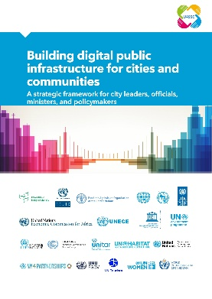
Work on IoT, Digital Twins and smart sustainable cities remained a key strand of ITU’s emerging-technology agenda. ITU-T Study Group 20 continued developing global standards for interoperable IoT technologies, big-data ecosystems and digital transformation for smart and sustainable cities and communities. These efforts support city-scale innovation, secure data flows and urban-systems efficiency.
See also the ITU-T Study Group 20 homepage and List of Recommendations.
The U4SSC Initiative complements this work by supporting digital public infrastructure, city platforms, and broader digital transformation in people-centred cities. Through its tools, frameworks and thematic working groups, U4SSC provides practical guidance to help cities implement standards-based, interoperable and inclusive digital solutions that advance sustainability, resilience and citizen-focused urban services.
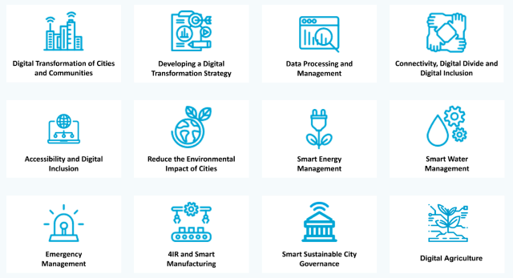
In support of people-centred digital transformation, ITU together with 11 UN entities, developed a Toolkit on Digital Transformation for People-Oriented Cities and Communities to assist cities and local authorities in navigating digital change. The Toolkit brings together international standards and guidance, the latest research and projections, and cutting-edge reports on a range of timely topics relevant to the digital transformation of cities and communities.
ITU, together with other organizations and United Nations agencies, held the Digital Transformation Dialogues (DTD) series - a platform to deepen understanding of how emerging technologies can reshape traditional processes, improve operational efficiency and unlock new opportunities for innovation and standardization. The Dialogues address evolving digital transformation themes, foster cooperation among city stakeholders, and examine the role of international standards in this domain. Through webinars, fireside chats and “ask-the-expert” sessions, DTD highlights the latest work and outcomes of ITU-T Focus Groups, initiatives and ITU-T Study Groups.
Knowledge dissemination in this area is further reinforced through the regular publication of the Digital Transformation and Cities Digest, which compiles insights, trends and developments related to digital transformation and smart cities and is made publicly available through a dedicated online platform.

4.5 Provision of data and statistics
ITU leads the global ICT statistics agenda, providing the evidence base needed for universal and meaningful connectivity and sustained digital transformation. Its statistical activities span the entire data lifecycle, with the ICT Data and Analytics Division, within BDT’s Digital Knowledge Society Department, carrying out most of this work.
– Statistical standards: ITU defines and updates international statistical standards for ICT indicators through the Expert Group on Telecom/ICT Indicators (EGTI) and the Expert Group on ICT Household Indicators (EGH).
– Data collection and dissemination: ITU compiles statistics for hundreds of ICT indicators, based on data collected from over 200 economies; it computes global, regional and country group estimates. All data is available for free on the ITU DataHub.
– Analysis and research: Publications in the Measuring Digital Development series assess the state of global connectivity, tackle specific themes, and identify solutions.
– Data science for official statistics: ITU’s data science practice leverages big data and new methods to enhance the accuracy, timeliness, and granularity of ICT statistics.
– Capacity development and technical assistance: ITU supports the statistical community and other stakeholders, including policymakers, by developing technical documentation, training materials, online courses, workshops, and providing technical assistance.
– Global cooperation and engagement: ITU’s ICT Data and Analytics Division organizes events, including the World Telecommunication/ICT Indicators Symposium (WTIS), a key global event on ICT statistics, and cooperates with various organizations, to mobilize resources, advance the statistics agenda, leverage synergies, scale up initiatives, and maximize impact.

4.6 Capacity development and digital skills
Capacity development is the flagship programme of ITU’s Telecommunication Development Sector (ITU-D), aimed at achieving a digitally competent society where all people can improve their livelihoods through digital skills and tech knowledge. This is realized by developing capacities of ICT and telecommunication professionals, boosting digital literacy and skills of citizens, and developing knowledge resources.
The ITU Academy portal is the main gateway to ITU capacity development and training activities. It offers ICT professionals and policy-makers access to capacity development opportunities using various methodologies and tailored to different learning styles, such as online instructor-led, self-paced, or face-to-face courses. Its comprehensive training catalogue covers a large array of topics relevant to the ITU membership, such as artificial intelligence, cybersecurity, e-waste, spectrum management, digital transformation, satellite communications, emergency telecommunication, data governance, ICT measurement, policy and regulation, wireless and fixed broadband and others.
Over the past years, the ITU Academy has experienced strong growth. Between March 2022 and May 2026, the ITU Academy quadrupled its community, expanding from 26 000 to 110 000 users. Today, over 90 per cent of participants come from developing countries, and the share of women among new users has risen to 44 per cent, almost twice the level recorded in 2019. Around 150 courses are delivered every year, with over 70 per cent online, enabling scale and accessibility, and the remainder face-to-face courses, enabling intensive exchange among participants. Completion rates have consistently exceeded industry benchmarks, rising from 68 per cent for face-to-face courses and 28 per cent for online courses in 2023, to nearly 90 per cent and 55 per cent, respectively, by the end of 2025. These gains reflect sustained efforts to enhance the quality of courses and strengthen engagement with learners. In total, more than 17 500 certifications were issued since 2023, recognizing participant achievements and providing them with credentials to advance their careers.
Figure 16
ITU Academy registrations, 2012-2024
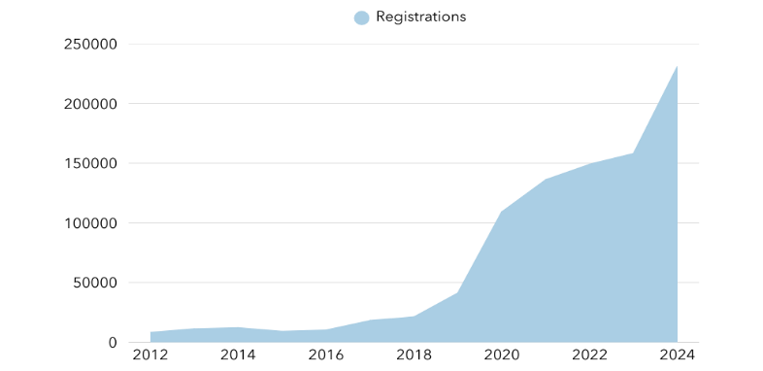
One of ITU’s key training delivery mechanisms is the network of ITU Academy Training Centres (ATCs), which was launched in 2023, following the outcomes of WTDC in 2022 (see Figure 17).
Figure 17
ITU Academy training centres course participants, by region
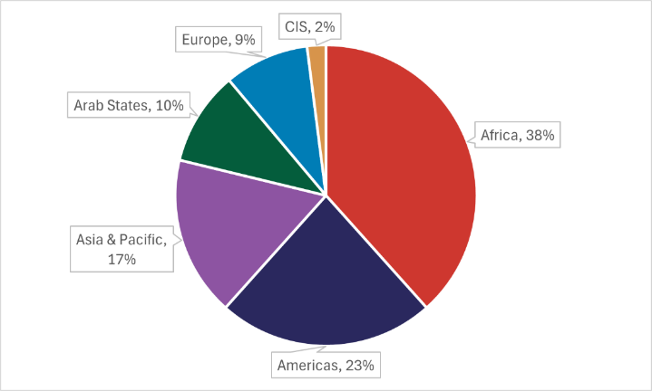
The Digital Transformation Centres (DTC) Initiative, which was launched in September 2019 by ITU in partnership with Cisco, has the objective of supporting countries to strengthen the digital capacities of citizens, particularly those in rural and the underserved communities. The Initiative operates through a global network of national institutions, the Digital Transformation Centres (DTCs), which are nationally anchored institutions mandated to deliver digital skills training programmes in their countries. The DTCs operate nationally and demonstrate proven capacity, infrastructure and experience to implement basic and intermediate level training. Between 2021 and June 2026, the Initiative received strong financial support from the Government of Norway, complemented by ITU ICT-DF support.
The number of DTCs has grown to 16 in total, covering the Africa, Americas, Arab States, and Asia-Pacific regions. Since the start of the DTC initiative in 2020 until April 2026, over 764 000 (52 per cent female) participants have been provided with basic and intermediate digital skills training.
Beyond achieving gender parity in overall reach, training delivered through the initiative has grown in underserved and rural communities served by the DTCs. This includes students, persons with disabilities (particularly those with visual impairments), youth, as well as micro, small and medium enterprises. Additionally, trainers and teachers received capacity-building support to ensure the delivery of high-quality training within these communities.
Under the Initiative, ITU and Cisco facilitate networking opportunities for DTCs by organizing face-to-face workshops and virtual meetings every year. These meetings contribute to strengthening the global DTC network and provide a platform to discuss implementation, review progress and achievements made, and explore new ideas to support the work of the DTCs. In 2023, 2024 and 2025, Global DTC Workshops were hosted by the Department of Information and Communication Technology (the DTC in the Republic of the Philippines); the ICT Training and Development Center under the Ministry of Communications and Digital Affairs (the DTC in Indonesia) in collaboration with Indosat Ooredoo Hutchison; and the Community Technology Centres (Centros Tecnológicos Comunitarios – the DTC in the Dominican Republic) in collaboration with the Instituto Dominicano de las Telecomunicaciones (INDOTEL). These meetings serve as an opportunity for DTCs to regularly engage with each other and to further strengthen the DTC community.
In 2026, the Global DTC Workshop was hosted by ITU and held in Geneva from 21 to 24 April 2026, in conjunction with the annual meeting of the ITU Academy Training Centres. These meetings serve as an opportunity for DTCs to regularly engage with each other and to further strengthen the DTC community.
In 2024, the project “Capacity development to accelerate school connectivity in collaboration with the Giga Initiative” was launched to support the ITU-UNICEF Giga Initiative to connect every school in the world to the Internet. Through the project, tailored training courses are provided to government officials, policymakers, and regulators in countries engaged in Giga (54 as of 1 June 2026) to support them on their school connectivity journeys. The courses, which are delivered both online and in-person, have all been tailored for school connectivity and cover topics such as business planning for school connectivity, ICT infrastructure mapping and modelling for school connectivity, cybersecurity for schools, collaborative policy and regulation for school connectivity, and financing school connectivity. The first training course was held in February 2025, and between then and June 2026, five in-person and seven online courses have been developed and delivered.
The ITU Digital Skills Forum is a core global event for the ITU membership and other stakeholders where the most pressing needs are discussed with the aim of achieving universal digital skills and close the global digital skills gap. The ITU Digital Skills Forum 2024 took place in Manama, Bahrain, from 17 to 19 September 2024. It was organized by ITU and hosted by the Telecommunications Regulatory Authority (TRA) of the Kingdom of Bahrain. Under the theme “Developing skills for digital transformation” the Forum brought together over 700 participants from 66 countries, comprising physical and remote participation, from public and private organizations, universities and research institutions, and other regional and international organizations.
The ITU Digital Skills Toolkit 2024 was launched at the Digital Skills Forum 2024. The toolkit offers a comprehensive, step-by-step guide to support the ITU membership to create effective national digital skills strategies and policies. This practical resource offers actionable insights and examples, making it a valuable tool for countries at all stages of digital development. An accompanying eLearning course, based on the Toolkit, was launched in March 2026, as a complementary resource for governments. The course, entitled “Road to digital skills strategy”, is available on the ITU Academy under this link.
The capacity building component of Bridging the Standardization Gap: the initiative provides training materials provided for on-demand access via ITU-T resources, in all six languages wherever possible. Collaboration is ongoing between ITU’s standardization and development bureaux (TSB and BDT) and ITU regional offices to raise awareness and build capacity at regional level.
Another example of ongoing capacity building programmes and initiatives can be found in section 4.8.2 (AI Skills Coalition). A final example can be found in section 5.5, which shows how the Giga school connectivity initiative is underpinned by capacity development programmes with governments and stakeholders, leveraging the ITU Academy platform.

4.7 Provision of technical assistance
Along with providing extensive technical expertise and coordination as a UN specialized agency, ITU serves as an executing agency for digital development projects aimed at ensuring connectivity benefits everyone, everywhere.
ITU-D has the key function of implementing projects under arrangements established with funding partners. Such projects aim to facilitate and enhance telecommunication development by offering, organizing, and coordinating technical cooperation and assistance activities.
During 2025 alone, ITU (through BDT) implemented or helped implement 106 projects in total, valued at CHF 79.7 million. 32 of these projects completed their activities during the year, while the remaining 74 projects will continue their implementation as per the respective project documents. The table below presents the overall distribution of this portfolio by region and the overview of (1) the funds mobilized to support the implementation of these projects, (2) the seed funding allocated by ITU from the ICT Development Fund (ICT-DF).

Overview of ITU-D projects with activities in 2025 by region (figures in k CHF)
Region | Number of projects | Funding from partners | ITU funds | Total project funding
Africa | 20 | 26 917.7 | 1 505.4 | 28 423.2
Americas | 16 | 6 241.1 | 236.8 | 6 477.9
Arab States | 6 | 2 568.9 | 696.8 | 3 265.7
Asia-Pacific | 15 | 6 374.1 | 851.8 | 7 225.9
CIS | 3 | 344.1 | 509.5 | 853.6
Europe | 3 | 411.1 | 45.6 | 456.7
Multi-regional* | 43 | 25 164.9 | 7 880.7 | 33 045.5
Total | 106 | 68 022.0 | 11 726.5 | 79 748.5
* Multi-regional or projects benefiting all regions.

In 2025, BDT signed a total of 26 new projects valued at CHF 4.3 million. With these figures, BDT closed the preceding WTDC cycle (2023-2025) with a total of 91 new projects signed valued at CHF 51 million. Despite being a shorter implementation period of 3 years, the total number of projects signed during the cycle represents a positive trend in terms of resource mobilization, continuing the upward trend already achieved during the WTDC-17 cycle (2018-2022) (see Figures 18 and 19). These new projects are multi-regional, regional, and national in nature, and cover the full range of ITU-D priorities defined in the WTDC Kigali Action Plan.
Figure 18
New projects signed by ITU per year of signature (2015-2025)

Figure 19
Funding mobilized in new projects signed by WTDC cycles

With regards to source of funds, 90 per cent of the funds for the new projects signed during the WTDC cycle for 2023-2025 came from the extrabudgetary funds mobilized by BDT from third parties, while the remaining 10 per cent results from the allocation of seed-funds from ITU’s ICT Development Fund (ICT-DF). Notably, since ITU is not a funding institution, the feasibility of signing new projects depends greatly on the availability of funding partners willing to support ITU’s work. However, the ICT-DF has provided an instrumental resource to enable the set-up of new ITU-D projects, since a growing number of donors now request that agencies receiving funds provide a certain level of co-funding to ensure the feasibility of new projects. This shows the instrumental importance of the ICT Development Fund (ICT-DF) as a key mechanism to enhance the resource mobilization work conducted by BDT in support of ITU Member States.
During 2025 ITU has also continued to strengthen project management practices across all ITU projects. This included strengthening reporting to partners, continuing with the operation of the Projects Board and strengthening the project monitoring function.
Further details and data can be found in the ITU-D projects portal and the new dashboard for ITU membership on status of projects.

4.8 Convening platforms

4.8.1 WSIS process
The World Summit on the Information Society (WSIS) continues to provide a key global framework for inclusive, people-centred digital development and for advancing the 2030 Sustainable Development Agenda. As lead facilitator, ITU leads WSIS Action Line implementation, strengthens multistakeholder engagement, and supports coordinated digital transformation efforts.
Guided by the Plenipotentiary Resolution 140 (Rev. Bucharest, 2022), Council Resolutions: 1332 (Mod. 2024), 1334 (Mod. 2023), Sector Resolutions: WTDC Resolution 30 (Rev. Baku, 2025), WTSA Resolution 75 (Rev. Geneva, 2022), and RA Resolution ITU-R 61-3 (Rev. Dubai, 2023), since PP-22, ITU has hosted four WSIS Forum events, with the 2024 and 2025 editions held as WSIS+20 High-level Events, contributing towards the overall review, providing a global platform for dialogue and cooperation. The WSIS Stocktaking platform now contains more than 21 000 ICT for development projects, and the WSIS Prizes continue to highlight impactful digital initiatives, with more than 3 000 submissions received in the past three years.
Full details on ITU’s implementation of the WSIS process and the 2030 Agenda for Sustainable Development (through the WSIS architecture) since PP-22 are listed in the Final and Comprehensive Report on the ITU Activities for WSIS Implementation and the 2030 Sustainable Development Agenda Together with Proposals for Further Activities. Finally, the Annual reports on ITU’s contribution to the implementation of the WSIS outcomes focus on key WSIS-related initiatives and activities across ITU’s three sectors —Standardization, Radiocommunication, and Development— as well as the General Secretariat, outlining operational and policy-level progress in fulfilling ITU’s WSIS-related mandates.

WSIS Forum
The WSIS Forum hosted by ITU (co-hosted with Switzerland in 2024, 2025 and 2026) and co-organized with UNESCO, UNDP, and UNCTAD in collaboration with over 50 UN partners, is a leading global platform for advancing inclusive digital development and reviewing progress on WSIS Action Lines. Through capacity-building, partnerships, and knowledge exchange, it has engaged over 50 000 stakeholders from 160+ countries, shaping a shared vision and actionable roadmap for digital development and emerging technologies. The WSIS Forum 2023 focused on “WSIS Action Lines for building back better and accelerating the achievement of the SDGs”, WSIS+20 Forum High-Level Event 2024 reviewed two decades of progress, and WSIS+20 High-Level Event 2025 reaffirmed WSIS’s role in shaping global digital cooperation and laid the groundwork for the UN General Assembly’s WSIS+20 review.
The WSIS Forum 2026 was a key component of Geneva Digital Week, alongside the AI for Good Global Summit 2026 and the inaugural UN Global Dialogue on AI Governance, creating a unique convergence of global discussions on digital transformation, AI, and emerging technologies. Together, the events welcomed 12 000 onsite participants, with more than 250 ministers and deputies, regulators, UN heads and other high-level representatives, as well as industry leaders, policy experts, researchers, innovators, civil society and youth representatives.
WSIS Forum 2026 underscored the importance of advancing digital inclusion beyond connectivity by strengthening access, digital skills, relevant content, and meaningful use of technology. Participants emphasized the need to harness emerging tech, in particular, AI, as a driver for development, while addressing emerging challenges such as the AI divide, capacity gaps, and the importance of trusted, responsible, and sustainable approaches to AI.
The Forum further highlighted the role of digital finance, youth engagement, and efforts to close the gender digital divide as essential components of equitable digital transformation. A strong emphasis was placed on measuring impact and ensuring that progress is assessed not only through technological deployment, but through the tangible benefits delivered to people and communities.
Discussions across high-level sessions reinforced the importance of moving from dialogue to implementation through strengthened partnerships, improved coordination, and measurable outcomes. The WSIS Action Line Facilitators advanced work on updated roadmaps and indicators in line with the WSIS+20 Outcome Document, supporting a shared vision for the continued evolution of the WSIS process.
The United Nations Group on the Information Society (UNGIS) High-Level Meeting brought together heads and senior representatives of more than 40 UN entities to reaffirm the UN system's commitment to implementing the WSIS+20 Outcome Document. Members recognized UNGIS as the UN's principal coordination mechanism for digital cooperation, underscoring its role in strengthening policy coherence, reducing duplication, mobilising shared expertise, and supporting Member States. The meeting also marked the transition of the UNGIS Chair from UNCTAD to ITU for the 2026–2027 term and set priorities for the forthcoming UNGIS Work Plan, with ITU serving as the permanent secretariat of UNGIS.
The Ministerial Roundtable brought ministers together around AI strategy and policy, digital transformation, and infrastructure and inclusion. A common thread ran through the room: readiness, trust, and cooperation. Ministers called not for identical systems but interoperable ones that respect national circumstances, with ITU as a trusted platform translating shared principles into practical cooperation. AI must remain people-centred, ethical, and accountable, with growing momentum behind sovereign AI models and local-language datasets. Ministers warned of a structural divide as AI infrastructure funding concentrates in a few large private firms and stressed that success should be measured not by technology deployed but by lives improved, calling for blended finance, compute sharing, and investment that reaches underserved communities.
The Regulators Roundtable focused on putting governance essentials into practice, introducing the Actionable Core Toolkit to help regulators move from assessment to action across the seven governance essentials of the GSR-26 best practice guidelines, with concrete approaches shared from Nigeria's network intelligence ecosystems to Singapore's regulatory sandboxes and Ukraine's adaptive regulation sustaining resilience.
WSIS Prizes 2026 celebrated outstanding digital development initiatives from around the world, recognizing innovative projects that demonstrate the impact of ICTs in advancing sustainable development and implementing the WSIS Action Lines.
WSIS Stocktaking continues to serve as the global repository for collecting and sharing ICT-enabled initiatives supporting the WSIS Action Lines and the Sustainable Development Goals, highlighting good practices, innovative solutions, and collaborative efforts from around the world.

ITU’s contribution to the WSIS+20 review process
As the UN agency for digital technologies and a founding institution of the WSIS process, ITU played a central role throughout the WSIS+20 Review process. ITU actively contributed to and supported the preparatory process led by the UN General Assembly (UNGA), including engagement with the WSIS+20 co-facilitators, participation in consultative meetings, and the provision of substantive input to the WSIS+20 outcome document, as documented here on the WSIS+20 Secretariat dedicated page. ITU was guided by the ITU Secretary-General’s WSIS+20 Roadmap, which elaborates the strategic direction for ITU’s role in the WSIS+20 Review process and its preparatory activities. The Secretary-General prepared and submitted to UNGA-led WSIS+20 Review, the WSIS+20 Report: “Building a Digital Future for All”, documenting two decades of WSIS implementation and ITU’s contributions across policy, technical assistance, capacity development, data, and partnerships.
The summary of ITU’s Call for Inputs on the WSIS+20 Review, coordinated through the Council Working Group on WSIS and SDGs (CWG-WSIS&SDG), was transmitted by the CWG-WSIS&SDG Chair to the UNGA-led WSIS+20 Review, ensuring that diverse perspectives from governments and stakeholders were reflected and contributed to the overall process. For more detailed information on the outcome of the WSIS+20 review by UNGA and ITU’s contribution to the review process and its follow-up outcomes, read the Report on the United Nations General Assembly on the overall review of the implementation of the outcomes of the World Summit on the Information Society.

United Nations Group on the Information Society
ITU, as permanent Secretariat for the United Nations Group on the Information Society (UNGIS) with a rotational role of Chair and Vice-Chair, drives coordination, leadership, and strategic direction for digital cooperation across the UN system. UNGIS, the UN system’s inter-agency mechanism for advancing policy coherence and programme coordination on digital matters, comprises 31 UN entities and 17 observers. Since the adoption of the Global Digital Compact (GDC) in 2024, the group has led implementation via the WSIS Process and 2030 Agenda – GDC Matrix while contributing to major digital and development events, including the WSIS+20 review, the High-Level Political Forum (HLPF), IGF, and others.

Ongoing activities
ITU maintains and enhances the WSIS Stocktaking database, a global repository of over 21 000 ICT-related initiatives aligned with WSIS Action Lines, the SDGs, and the Global Digital Compact, serving as a critical tool for transparency, knowledge sharing, evidence-based policy, and innovation, while encouraging stakeholders to contribute, update, and support the development of analytical tools that generate strategic insights. Its role, including the WSIS Prizes, is outlined in the ECOSOC Resolution E/RES/2025/18.
Since 2012, ITU has organized the WSIS Prizes, celebrating best practices in digital-for-development, recognizing excellence and innovation in over 9 000 projects, with 270 winners and 792 champions to date, engaging hundreds of thousands of stakeholders and reaching millions; the 2023-2026 winners are available online.
Since 2011, ITU has coordinated the WSIS Fund in Trust, established by PP Resolution 140, to support WSIS implementation. In line with Council Resolutions 1332 and 1334, all members and stakeholders are encouraged to contribute voluntarily, with partners of the WSIS Forum 2023 and WSIS+20 High-Level Events 2024-2025 acknowledged for their support.
ITU serves in the Steering Committee Partnership on Measuring ICT for Development, with UNCTAD and UN DESA. The Partnership improves ICT data quality and availability for sustainable development, mapping core indicators against WSIS Action Lines, the Global Digital Compact, and the UN Meaningful Connectivity framework, identifying gaps, and supporting the 20-year WSIS+20 review, with ITU hosting all core data in the ITU DataHub.

4.8.2 AI for Good
AI for Good has continued to expand as the leading action-oriented UN platform for artificial intelligence, dedicated to identifying practical AI solutions to solve global challenges. Led by ITU and supported by over 50 UN agencies, the initiative advances AI skills, standards and solutions and maintains a year-round digital programme with open, online webinars, challenges, and collaborative activities.

AI for Good Global Summit
The annual AI for Good Global Summit remains the initiative’s flagship event. More than 12 000 participants from over 170 countries gathered during this year’s AI for Good Global Summit, alongside the UN Global Dialogue on AI Governance and WSIS Forum, underscoring the global momentum behind ITU’s AI for Good movement.
– The AI for Good Lab initiative was launched, building on AI for Good Sandboxes to help countries advance AI readiness and policy, skills development, and public AI infrastructure.
– Three new partners announced in the AI Skills Coalition: Coursera, TikTok, and the Government of Chile.
– The Agentic AI Security Focus Group (see Section 4.8.1) was launched to advance trusted agent behaviour and agent-to-agent authentication, with participation open to technical, policy, legal, and regulatory experts.
– ITU and WHO announced next year’s Robotics for Good Youth Challenge theme: AI and robotics for health emergencies.
– Team Venezuela won this year’s Robotics Challenge on Food Security with FAO.
– The AI for Good Global Commission held its first meeting, bringing together more than 40 leaders from government, industry, civil society, the technical community, and international organizations, co-chaired by President Paul Kagame of Rwanda and Salesforce CEO Marc Benioff.
– AI for Good Impact Europe was announced for 17 May 2027 during Serbia World Expo 2027.
– The Geneva AI Summit – next in the series that began at Bletchley Park – will be held in Geneva, Switzerland, on 21-22 June 2027, alongside ITU's annual AI for Good Global Summit, which is set for the week of 21-25 June 2027.
AI for Good events continue to serve as the UN system’s primary showcase for cutting-edge AI technologies, demonstrating pioneering applications, and connecting innovators with policymakers, researchers, and industry leaders to scale up AI solutions globally.
Central to this ecosystem is the AI for Good Neural Network, an AI-powered matchmaking community, which grew from 15 000 members in 2023 to more than 35 000 in 2024 and now has 60,000 active members as of 2026. Together with an extended online community exceeds 137 000. The platform’s smart-matching mechanisms support global cooperation and innovation, fostering impactful partnerships across sectors and regions.

AI for Good further strengthened its global impact through the development of the AI Skills Coalition, aimed at expanding AI education and capacity building worldwide. Since it’s launch in 2025, the AI Skills Coalition lists 83 partners and 245 courses in more than 18 languages. Coalition-linked activities reached over 20,000 learners in 2025 and named AI Skills Goodwill Ambassador, Will.i.am.
AI for Good also continues to develop practical solutions and young talent through Innovate for Impact, the Innovation Factory the UN-backed start-up pitching competition, and the Robotics for Good Youth Challenge.

4.8.3 Global Standards Symposium
The Fifth Global Standards Symposium (GSS-24) was held on 14 October 2024, in New Delhi, providing a vibrant platform for thought leaders, innovators, and decision-makers globally. This inclusive event welcomed both ITU members and non-members, serving as a precursor to the World Telecommunication Standardization Assembly (WTSA-24) that followed.
GSS-24 focused on the theme “Charting the Next Digital Wave: Emerging Technologies, Innovation, and International Standards,” highlighting the pivotal role of cutting-edge technologies and international standards in shaping the digital landscape. A notable highlight of the symposium was the High-Level Segment, where ministers and industry leaders gathered to discuss and influence the future of innovation, aiming to drive transformative change on a global scale.
Building on this momentum, GSS-24 concluded with a series of actionable recommendations emphasizing the importance of international standards in supporting innovation, emerging technologies, and sustainable development. The GSS-24 conclusions reaffirmed ITU’s role as a central platform for fostering collaboration among governments, industry, academia, and civil society, and underscored the need for coordinated efforts to leverage standards for the digital transformation of societies worldwide.

4.8.4 Global Symposium for Regulators
During the 2022-2026 period, the Global Symposium for Regulators (GSR) served as the premier global platform for evolving the regulatory mandate in response to rapid technological change and focused on innovative regulatory approaches essential for fostering digital transformation and inclusivity across the globe. Across the 2023–2026 cycle, participation in the GSR rose steadily —from around 750 delegates at GSR-23 to roughly 1 200 at GSR-26— reflecting growing global engagement in regulatory innovation. Over these three years, the GSR process delivered successive Best Practice Guidelines that strengthened the role of regulators as digital ecosystem builders and set clear strategies for inclusive, human-centred, and sustainable digital development worldwide.
GSR-23, held in Sharm El-Sheikh, Egypt, from 5 to 8 June 2023, under the theme of digital connectivity, participants discussed such topics as child safety online, affordable technology access, and sustainability in digital transformation. The event culminated in the endorsement of Best Practice Guidelines aimed at promoting an inclusive digital future, which provide strategies for enhancing connectivity and regulatory practices.
Following GSR-23, GSR-24 took place in Kampala, Uganda from 1 to 4 July 2024. The focus was on creating impactful regulations for cutting-edge infrastructure and transformative technologies, resulting in new Best Practice Guidelines designed to help ICT regulators support sustainable digital economies.
The GSR-25, occurred in Riyadh, Saudi Arabia, from 31 August to 3 September 2025. Under the theme of “Regulation for sustainable digital development.” Key discussions emphasized collaboration, innovation, and cross-border cooperation among regulators. The GSR-25 Best Practice Guidelines endorsed the role of regulators as digital ecosystem builders, stressing the need for innovation in regulatory practices and a human-centric approach to ensure digital transformation benefits all individuals.
The latest Global Symposium for Regulators (GSR-26) took place from 12 to 15 May 2026 in Ankara, Türkiye under the theme “Navigating the digital frontier” and was chaired by Mr Ömer Abdullah Karagözoğlu, President of the Information and Communication Technologies Authority (BTK).
Telecommunications regulators from around the world endorsed a comprehensive set of guidelines to navigate digital challenges and opportunities at GSR-26.
The new GSR-26 Best Practice Guidelines: Regulatory Governance Essentials are the new core kit regulators need to make digital markets deliver and provide an essential core toolkit to ensure digital markets deliver public-interest outcomes consistently, credibly, and at scale.

A blueprint for digital transformation
The regulatory guidelines endorsed at GSR-26 outline innovative approaches to advance evidence-based regulation, stronger cross-sector coordination, responsible experimentation, and regional and international cooperation.
In support of the guidelines, ITU also presented new tools to support sustainable digital development for all:
– Launched the Connectivity Planning Platform (CPP) – for governments to visualise, plan, map, and prioritize and accelerate the deployment of connectivity and digital infrastructure.
– Global Economic Model and Study Tool – to help regulators assess the socio-economic impact of connectivity investments.
– Digital Readiness Framework – to evaluate the maturity of legal, policy and governance frameworks for digital transformation.
– “Regulatory perspectives for satellite communications to connect underserved communities" – a report identifying mechanisms to leverage satellite technology for universal and meaningful connectivity, particularly for vulnerable populations and public facilities.

Enhancing Public-Private Dialogue
The IAGDI-CRO Platform. Established pursuant to WTDC Resolution 71 (Rev. Kigali, 2022), the Industry Advisory Group on Development Issues and Chief Regulatory Officers (IAGDI-CRO) has grown from a gathering of 50 executives into a dynamic and inclusive platform of over 200 participants, fostering meaningful and synergistic dialogue between industry leaders, regulators, and Member States. The IAGDI-CRO convenes back-to-back with the Global Symposium for Regulators (GSR), or through standalone meetings. This platform continues to engage a growing number of ITU-D Sector Members. Since ITU PP-22, eight virtual and physical meetings have been organized, primarily in conjunction with GSRs.
During GSR-26, the IAGDI-CRO set out private-sector perspectives on the regulatory and policy priorities shaping the next phase of the digital economy. Discussions were structured around four interconnected themes:
1 Sustainable digital infrastructure investment and environmental sustainability.
2 Strategic digital infrastructure, artificial intelligence (AI), cybersecurity, and digital sovereignty.
3 Convergence of connectivity architectures, space, sustainability, and network governance.
4 Moving from coverage to meaningful connectivity, closing the usage gap, and strengthening digital trust.
Throughout the period, core thematic priorities remained consistent and were progressively deepened, including child online safety, universal and meaningful connectivity, environmental sustainability (Green Digital), and trustworthy digital infrastructure. The series solidified the necessity of "whole-of-government" and cross-sectoral collaboration to achieve the strategic goals of ITU.

4.8.5 Engaging academia in ITU’s work
Around 180 universities and research institutions participate as academic members of ITU and contribute on a regular basis to ITU’s work. The number of academic institutions participating in ITU’s activities is constantly growing.
ITU Academia membership, the ITU Journal, ITU Kaleidoscope conferences, the Academic Advisory Board on Emerging Technologies, capstone projects serve as key platforms for academic engagement in ITU’s work. These initiatives foster collaboration between academia and industry, driving research and development while accelerating the transition of cutting-edge innovations from the lab to the market. Among the initiatives highlighted above, there are additional opportunities, including science and technology research, training, publications, events, and many others across ITU, to engage academia.

The Academic Advisory Board on Emerging Technologies
The Academic Advisory Body on Emerging Technologies was launched in September 2025 to produce informative policy briefs and forward-looking analyses on the evolving role and impact of innovation. The Academic Advisory Body brings together 26 leading experts from different world regions to examine how emerging technologies can best serve society.

Capstone Projects
There is also an opportunity to collaborate on capstone projects that serve as a bridge between academic learning and real-world challenges. These projects provide students with hands-on experience by working on pressing global issues. ITU proposes real-world challenges, enabling students to apply their knowledge, develop innovative solutions, and gain practical experience.

ITU Journal
The ITU Journal on Future and Evolving Technologies (ITU J-FET) continues to serve as an inclusive, high-quality platform for research on communications, networking, and emerging technologies. Published online on a quarterly basis and accepting submissions year-round, the journal provides comprehensive scientific coverage across all areas emerging relevant to ITU’s work like the metaverse and advances in AI, edge computing, and low-Earth orbit satellite networking, among others. ITU Journal is free of charge for both, readers and authors.
In addition to peer-reviewed research, the ITU Journal offers the ITU Journal Webinars Series, recorded webinar discussions featuring leading minds in academia and chief technology officers (CTOs). Since launching its special webinar series in 2022, the journal has hosted high-level talks with organizations such as NTT DOCOMO, the O-RAN Alliance, GSMA, Nokia, and China Mobile, as well as with prestigious universities worldwide. These webinars complement the journal’s mission by fostering dialogue between researchers and industry leaders, promoting knowledge exchange, and supporting the global research community in exploring future and evolving technologies.
Along with research articles, the journal includes recorded webinar discussions with top-level researchers and industry leaders.

Kaleidoscope academic conference
The ITU Kaleidoscope academic conference series, technically co-sponsored by IEEE and the IEEE Communications Society, continued to showcase emerging research trends and their relevance for international standardization across the last few years. Kaleidoscope 2022, held in Accra, Ghana, explored innovation for the metaverse through keynote sessions, paper presentations, demos, and student exhibits. Building on this, Kaleidoscope 2024, organized in New Delhi alongside WTSA-24, focused on innovation and digital transformation for a sustainable world, featuring a special session on engaging youth in standards development and supporting the next generation of consensus builders, emphasizing the role of digital technologies in tackling global challenges and the urgent need to connect the remaining one-third of the world’s population still offline, reinforcing Kaleidoscope as a key platform linking academic research with global standardization priorities. In 2025 the 16th edition of the conference, AI and frontier technologies for good, was launched. Kaleidoscope 2026 was hosted by the AI for Good Global Summit 2026 in July and will feature multidisciplinary research exploring how frontier technologies —such as artificial intelligence, brain– computer interfaces, embodied AI, autonomous driving, geospatial and space computing, and quantum information —interface with telecommunications. Participants exchanged ideas on these innovations, their socioeconomic impacts, the policies needed for sustainable development, and the ethical considerations guiding their use.

Seminars and workshops: Diving deeper
In-depth seminars and workshops are vital to ITU’s engagement across the radiocommunication, standardization and development sectors

ITU-R

Seminars
ITU-R delivered a robust programme of world and regional radiocommunication seminars to strengthen global understanding of the Radio Regulations and the management of radio-frequency spectrum and satellite orbits. Activities included the World Radiocommunication Seminar (WRS-22) and the Regional Radiocommunication Seminars for the Arab States, Europe and Asia-Pacific, and later for the Americas, Africa and the CIS region. These seminars offered hands-on training on ITU notification procedures, software tools, trends in radiocommunication services and databases, and provided regional forums addressing evolving radiocommunication trends. The latest World Radiocommunication Seminar, WRS-24, convened in Geneva, complemented by outreach events to support regional capacity building.

Workshops
ITU-R also expanded its thematic workshop programme, organizing Inter-regional Information Sessions on WRC-27 Preparation, “ITU in Service of Space”, “Broadcasting in Times of Crisis,”, “ITU Workshop on the Future of Television for Europe together with “Demonstrations on the Future of Broadcasting”, “ITU-R Workshop on Fixed Wireless Access Systems” alongside specialized workshops on National Table of Frequency Allocation across all three ITU regions. Additional technical assistance in the years 2023 to 2025 notably included support to the 16 Southern African Development Community (SADC) administrations for the SADC Shared Satellite Network initiative, through in-person workshops and virtual meetings. Further scientific sessions, such as the WMO-ITU Seminar on Earth Observation for SDGs and the ITU Workshop on Radioastronomy, reinforced the Radiocommunication Bureau’s role in advancing radiocommunication knowledge and global spectrum coordination.

ITU-T
ITU-T maintained a high level of engagement through increasingly diverse seminars, workshops, symposiums, and webinars. It organized many non-statutory events, virtual, hybrid, and in-person, highlighted by strong participation in the DC3 Conference on digital currencies. Activity expanded further, with more than 100 workshops in 2022, 2023, 2024 and in 2025, complementing the weekly year-round programming of the AI for Good platform. These events strengthened collaboration with external partners, increased visibility of ITU-T’s standardization work, supported peer learning, and attracted new members. Collectively, they addressed emerging trends in global standardization and contributed to the development and implementation of international standards.

ITU-D
ITU-D seminars and workshops continued to serve as essential mechanisms for capacity building and development support. In 2022, ITU’s Telecommunication Development Bureau (BDT) organized 57 events aligned with the Buenos Aires Action Plan and in 2023 this number has reached to 143 with the implementation of projects and the Kigali Action Plan. By 2024, ITU-D had significantly expanded its engagement, delivering 211 events, including seminars, workshops, webinars, and forums, focused on advancing sustainable digital transformation. In 2025, the number of events peaked at 220 events which were structured as capacity-building sessions addressing cybersecurity, digital access, gender inclusion, youth empowerment, policy and regulation, environmental sustainability, and institutional strengthening. Highlights included Cyber Drills across multiple regions, the Mainstreaming Gender in ICTs series, Girls in ICT Day regional events, training on digital regulation, broadband and 5G stakeholder workshops, e-waste management seminars, and GovStack and ITU Academy Training Centre (ATC) courses. These initiatives provided practical knowledge, fostered collaboration, and supported Member States in building resilient, inclusive digital ecosystems.

5 Enablers
ITU's membership-driven approach, presence in regions worldwide, and commitment to bringing everyone to the table enables it to deliver on its goals and priorities effectively and efficiently.

5.1 Membership-driven approach
At end September 2026, ITU reached its highest level of membership, with 1 072 member entities accounting for 1 416 Sector Member, Associate, and Academia memberships, with 405 new memberships (+144 net new memberships) between 2023 and September 2026. Membership growth across sectors and regions reflects sustained engagement and commitment to ITU's objectives, despite challenges in retention and financial risks.
The loss of 261 memberships between 2023 and September 2026 underscores a constant risk to stability, both in the budget and in ongoing technical studies, as well as the need to maintain a membership-driven, responsive, service-oriented approach in ITU’s work. However, ITU’s membership has evolved and grown over time to reflect the global, changing digital ecosystem. With this evolution, ITU is continuously adapting its topics and working methods to remain a relevant global, neutral platform for its members.
At end of September 2026, ITU has reached 1 072 distinct member entities (+87 new/+34 net new entities year-to-date) including Sector Members, Associates and Academia.
In the period from 2023 to end September 2026:
– 1 416 memberships across all Sectors: +405 new and -261 either denounced or excluded.
– Sector Members accounted for 40 per cent of all new memberships, Associates for 44 per cent and Academia for 17 per cent.
– Positive trend across all sectors, with net new memberships of +39 in ITU-R, +29 in ITU-T, +62 in ITU-D, and +14 for Academia.
– Membership grew in all regions, though the overall increase was driven mainly by Asia and the Pacific (+69 net new memberships: +129/-60), and international and regional organizations (+24 net new memberships: +28/-4), followed by Americas (+17 net new memberships: +82/-65) and Europe (+12 net new memberships: +111/-99).
– Over the period from 2023 to end September 2026, forecasted contributions grew by just under CHF 250k but remain just under CHF 17 million, despite net growth in membership. This is due to the continued growth in low-fee categories and exempted entities.
– After a slow 2024, the community of small and medium-sized enterprises (SMEs) is growing again at rapid pace. Associates with SME reduced fees option, available from January 2020: 134 memberships (44 from ITU-R, 90 from ITU-T) have benefitted from the reduced fees. +13 net new entities year-to-date at end September 2026 (+25 net new entities in 2025).
Figure 20
Membership changes 2023- end September 2026
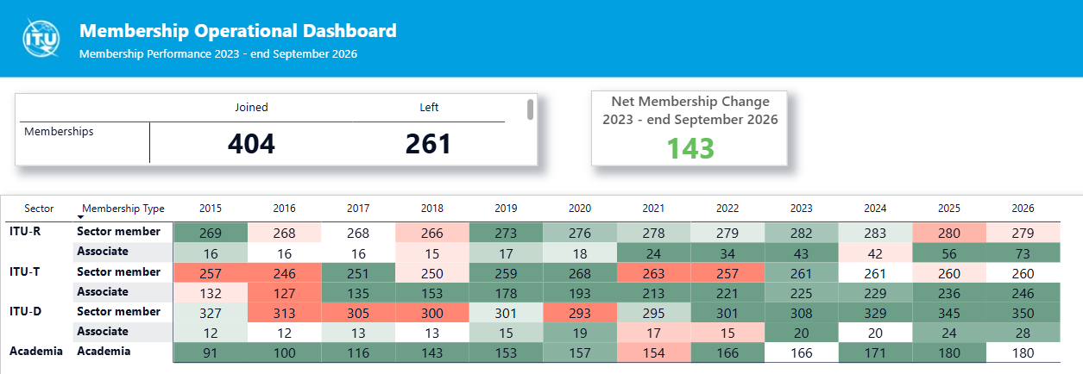

5.2 Regional presence
As an extension of ITU as a whole, the regional presence plays a vital role in the achievement of ITU’s mission, enhancing ITU’s understanding of local contexts and its ability to respond to countries’ needs effectively. The regional presence consolidates strategic planning at the level of each regional/area office, implementing programmes and initiatives that are consistent with and based on ITU’s strategic goals and thematic priorities. By applying the global targets and clarifying programme priorities at the regional level, ITU also seeks to enhance its overall global effectiveness and impact.
The regional presence strengthens ITU’s position as a shaper/doer and enhance United Nations cooperation, to build enhanced regional opportunities and thereby reach more countries and define clearer, more impactful priorities for country-level engagements. Efforts are also be made to strengthen capacity at the regional level to ensure the ability of the regional and area offices to implement the programmes and engagements determined based on ITU’s strategic goals and thematic priorities.
Per the recommendations of Council-25 (Report by the Chair of the Standing Committee on Administration and Management, Document C25/105, § 26, Annex H, Annex A and Annex 1), the Secretariat has conducted the review of the ITU Regional Presence since July 2025. These efforts have culminated in the final report on the review of the ITU Regional Presence (Document C26/24) that was presented at Council-26. The details of the review including the findings were made available in Document C26/INF/10. The updated report on the review taking into account the comments of membership will be presented at PP-26.

Regional Initiatives, 2026-2029
ITU’s latest World Telecommunication Development Conference (WTDC), held in Baku in November 2025, approved a new set of regional initiatives for the period 2026-2029. These initiatives, outlined in the Baku Action Plan, address specific needs for each major region of the world to advance and accelerate digital transformation. See the ITU-D webpage for further details on the regional initiatives.

5.3 Bringing everyone to the table

Ensuring equal access to and use of ICTs for all
ITU work on digital inclusion is guided by a holistic and intersectional approach that addresses the diverse needs of people across age, ability, gender, educational background, socio-economic status, and geographical location.

Intersectional work
Figure 21
Digital Inclusive Society
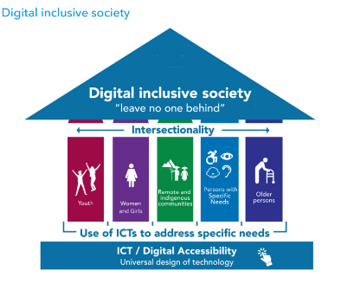

Key achievements in ITU-D’s holistic and intersectional approach include:
– Strengthen capacity on digital inclusion topics to over 14 000 ITU members, stakeholders and policymakers from 120+ countries to support designing and implementation of national digital inclusion policies and strategies.
– Tailored and localized digital inclusion trainings to 13 000+ end-users in 40+ countries, including blind users in Pakistan, youth in Africa, and Indigenous communities in Latin America.
– Targeted support to 12 LDCs, LLDCs, and SIDS.
– In particular, the BDT work on digital inclusion brought tangible impact in the following areas:

Expert advice and capacity building to develop digital inclusion policies and strategies
ITU-D strengthened capacity on digital inclusion policies through expert support and tailored interventions, equipping more than 10 500 policymakers, decision-makers, and stakeholders from over 120 countries across Africa, Asia-Pacific, the CIS, the Arab States, the Americas, and Europe. This capacity-building enabled them to design, develop, and implement strategies, policies, and practices that advance digital inclusion and equity, ensuring that all people —including women and girls, older persons, persons with disabilities, and people from remote and Indigenous communities— can equitably use ICT products and services to communicate, participate, and thrive in the digital space.
This extensive knowledge transfer was achieved through tailored face-to-face executive trainings, workshops, and participation in regional, global, and UN platforms addressing inclusive digital policies, gender mainstreaming, ICT/digital accessibility, ageing, and youth engagement.
In addition, to above effort over 3 500 ITU members and stakeholders strengthened their capacity on digital inclusion topics by engaging through online self-paced training made available through platforms such as ITU Academy. These trainings are free of charge, delivered in digitally accessible formats (can be also used by blind and deaf persons), and in multiple languages (such as English, French, Spanish, Arabic, Russian, and Portuguese) with localized content, ensuring inclusivity and broader reach.

National strategy on digital inclusion – an evolving model
Subject matter expertise to support development of National Strategic Plans on Digital Inclusion —designed from a holistic and intersectional perspective to ensure that the needs and requirements of all citizens to use technology, communicate, and participate in the digital society are addressed— was also promoted and facilitated. A pilot plan was implemented by BDT in Burundi, with the intention of replicating and further developing this approach in other countries and regions. In addition, gender policy reports were developed for Burundi, Ethiopia, Haiti, the Dominican Republic, and Libya.

5.3.1 Gender equality
Data in shows that gender disparities in digital access persist 77 per cent of men online compared to and 71 per cent of women, using the Internet worldwide. Unchanged since 2019, the global gender parity score remains at 0.92, indicating no overall progress in recent years. The Americas, Europe, CIS and Small Island Developing States are around parity, but significant gaps remain in Asia-Pacific (0.91) and the Arab States (0.86), and are widest in Africa, despite progress from 0.70 to 0.78 since 2019. Notably, least developed countries and landlocked developing countries continue to experience substantial divides. Despite increased global connectivity, women continue to be disproportionately excluded from full participation in the digital world, especially in lower income (find more in section 3.2.2 above).
ITU uses a dual approach to address disparities: (1) targeted interventions to directly address gender gaps, and (2) mainstreaming gender perspectives across all policies, programmes, and decision-making processes. ITU’s commitment to integrating gender equality across all activities is anchored in Resolution 70.
Targeted interventions supporting girls and women in ICT include International Girls in ICT Day, EQUALS, Women in Cyber, Talking Tech, Her Digital Skills, Her CyberTracks, and the African and Americas Girls Can Code Initiatives. Initiatives offer training, mentoring, and opportunities to motivate girls and young women to pursue ICT careers. In 2024, for example, Her Digital Skills delivered 21 workshops benefiting over 1 700 participants, while Her CyberTracks trained approximately 300 women in cybersecurity.
EQUALS 2.0 reflects its new phase, with a refreshed governance structure and strategic vision and mission, reaffirming commitments to close the gender digital divide. The EQUALS Research Report 2025: Advancing Gender Empowerment in the Digital Age provides updated global evidence on gender gaps in access, skills, leadership, and emerging technologies. The 2025 EQUALS Gender Inclusivity Index outlines progress and remaining gaps in advancing gender equality across the mobile industry.
Expanded capacity-building efforts include structured courses and certifications accessible from ITU Academy There is a self-paced online training on gender analysis for digital inclusion and another based on ITU’s Handbook on mainstreaming gender in digital policies, which supports the integration of gender equality into national strategies. This remains essential given that 94 countries had developed national digital agendas by 2022, but only 21 explicitly included women and girls.
The Her Digital Skills project developed by ITU-D is enabled by contributions, including one from Qualcomm that supports the implementation of Her Digital Skills in Cameroon, Ethiopia, Ghana, Kenya, and Nigeria, and one from the Women’s World Wide Web, GSMA and Ernst & Young (EY) that supported content development and the delivery of the initiative in the Philippines, Kenya, Nepal, Uganda, and South Africa, as well as the Caribbean, reaching over 23 countries and benefiting around 5 600 young women in total.
Her Digital Skills: Towards a Gender Transformative Approach, a framework and practitioners' guide released in 2024, recommends gender-transformative approaches to the design of digital skills education programmes, inside and outside the classroom.
The ITU-D AI Skills Accelerator for Girls programme was born out of a need to address the underrepresentation of women in AI and leadership roles in tech. The programme is hands-on and will have two cohorts of young women benefiting of the activities. The first cohort started in October 2024 with in-person workshops running across 6 countries (one per each ITU region: Paraguay, Malta, Kenya, India, Kazakhstan, Jordan) and from August 2025 other countries would benefit under the second cohort (Uzbekistan, Guatemala, Egypt, Mozambique). More than 820 young women have benefited from the programme.
The yearly celebration of International Girls in ICT Day continued to grow as a means to mobilize skills and leadership globally. The 2023–2026 themes moved from “Digital Skills for Life” to “Leadership”, then to “Girls in ICT for inclusive digital transformation” and this year to “AI for Development: Girls shaping the digital future”. The initiative’s cumulative reach from 2023 to 2026 had surpassed 80 000 girls and young women through 500 events in all six ITU regions.
In April 2026, ITU celebrated 15 years of Girls in ICT Day, marking a major milestone in advancing gender equality and girls’ meaningful participation in the digital ecosystem. Since 2011, the initiative has mobilized global partners and inspired action through role models, mentorship, digital skills development and awareness-raising. With more than 12 000 events in 175 countries, reaching over half a million girls and young women, Girls in ICT Day has become a global platform to help bridge gender gaps in ICT access, skills, leadership and career pathways.
ITU’s Network of Women (NoW) communities operate across all three ITU sectors: ITU-R, ITU-T and ITU-D; to increase women’s representation, and leadership in ITU’s work. These networks offer mentoring, training, and support for women delegates, particularly in preparation for major conferences:
A new Network of Women Ministers and Leaders in ICT was convened during the WSIS+20 High-Level Event in July 2024 and subsequently in conjunction with the WSIS+20 High-Level Event and AI for Good Global Summit. A new coordination mechanism for all ITU Networks of Women has also been launched, bringing together the various NoW secretariats to share knowledge, best practices and common activities.
ITU-R: The NOW4WRC initiative, aimed at promoting gender equality and bridging participation gaps in ITU-R activities, contributed to an increase in the proportion of women delegates from 18 per cent at WRC-19 to 22 per cent at WRC-23. Mentoring is currently underway for WRC-27 through the NOW4WRC27 initiative.
ITU-T: Women represented 26 per cent of participants at WTSA-24. The NOW4WTSA24 campaign encouraged greater nomination of women for leadership roles, contributing to women holding around 25 per cent of ITU-T leadership posts — a 25 per cent increase — and representing approximately 28 per cent of standardization experts.
ITU-D: Women represented 36 per cent of participants at both WTDC-22 and WTDC-25. The Empowering Women Leaders Mentorship Programme engaged more than 150 participants, with male mentors accounting for 30 per cent, marking a milestone in ally engagement. A “Confidence Booster Masterclass”, held in August 2025 on the eve of GSR-25 in Saudi Arabia, brought together more than 60 participants from 40 countries to strengthen public-speaking confidence and communication skills. A pre-WTDC-25 training course, delivered virtually on 8 October, reached 143 delegates from 64 countries. In addition, the Super Women Series: Enhance your presence, influence, and impact, delivered through the ITU Academy between October and November, benefited more than 107 women delegates representing over 42 Member States.

A new NOW Inter-sectoral Coordination Group has been established in 2026 to strengthen collaboration among women's networks in ITU-R, ITU-T and ITU-D, increase the visibility of NOW activities, and enhance strategic engagement ahead of PP-26 and subsequent statutory conferences.
In 2024, the Handbook on mainstreaming gender in digital policies offered Member States good practices on how to mainstream gender into current and future digital policies.
ITU celebrated its 160th anniversary in 2025 with a high-profile campaign on how the organization has evolved with technologies and continues connecting people for a better future. It simultaneously marked World Telecommunication and Information Society Day (WTISD) with a thematic focus on Gender equality in digital transformation. ITU160 Gender Champions embody this vision by amplifying young women’s leadership in digital development and driving inclusive, equitable digital futures.
Gender is integrated across annual WSIS Forum activities. The WSIS+20 Outcome Document, adopted at the UN General Assembly in December 2025, calls for gender-responsive digital transformation and integrates gender into all WSIS Action Lines.
As part of the 2025 UN-wide 16 Days of Activism under the theme: “UNiTE to End Digital Violence against All Women and Girls'', ITU organized a social media video campaign, co-authored a blog article with Plan International, and held a Virtual Session on sexual harassment in the tech sector in partnership with UN Women. Additionally, ITU has been actively engaged in the work of the Human Rights Council President’s Advisory Board on Gender Equality.
ITU continues to report annually to the UN System-Wide Action Plan on Gender Equality and the Empowerment of Women (UN-SWAP). Network of Women Ministers and Leaders in ICT was convened. Institutional gender balance remains a challenge with women representation in senior leadership posts (P5-D1-D2) having only increased from 31 per cent (end 2022) to 33 per cent (end 2025). Efforts to address this include strengthened accountability frameworks, organizational culture, and improved talent attraction measures. A new parental leave policy introduced in 2023, extending 16 weeks to all parents regardless of gender, plus an additional 10 weeks for birthing mothers, aims to support work–life balance and retain diverse talent. ITU has also committed to the United Nations Gender Equality Acceleration Plan (GEAP), where senior management works towards effectively mainstreaming gender equality.
The ITU Gender Task Force is ITU’s internal coordination mechanism on gender equality and mainstreaming, established to support the mainstreaming of gender across all Sectors and the General Secretariat. A new internal coordination and accountability mechanism for the Gender Task Force has been developed.
A January 2024 staff capacity assessment informed new capacity development and gender parity needs, where trainings on inclusive leadership, microaggressions and harassment prevention where offered, as well as an ITU Gender Parity Plan was developed in 2025. ITU’s first staff engagement survey in January 2025 established an important monitoring role key to continuous improvement, including towards gender equality and gender mainstreaming in ITU.
ITU’s leadership milestone at PP-22, electing its first woman Secretary-General, who assumed office in January 2023, is a testament to the organization’s commitment to gender equality across all levels of governance. In PP-22, 33 per cent of the delegates were women.
In preparation of PP-26 and based on the mandate to encourage more women to participate in ITU statutory meetings, an advocacy campaign was launched, which included a NoW breakfast at Council-26, and a training program for women and young delegates, which is under development.
For further information see www.itu.int/gender and annual reports to the Council: Documents C25/6, C24/6 and C23/6.

5.3.2 Youth empowerment
The ITU Youth Strategy is the operational framework for strengthening ITU's capacities in engaging and empowering youth through ICTs. The strategy aims to be fit-for-purpose and to reduce the youth digital divide and is built on three pillars: creating a community of young leaders; bringing young people together to engage with ITU and members; and fostering participation in ITU activities.
From 2020 onward, ITU-D advanced youth engagement through Generation Connect, an initiative that aims to engage global youth and encourage their participation as equal partners. In 2023, Generation Connect expanded its activities through its Generation Connect Global Youth Summit in Kigali; participation of Youth Envoys in PP-22 in Bucharest; intergenerational dialogues in ITU-D Study Groups; and contributions to global events including ECOSOC Youth Forum, the World Food Forum, YOUNGA, the Misk Global Forum, LDC5 Youth Track in Doha, the World Mobile Congress in Barcelona, and at the Commission on the Status of Women (CSW-67) in New York.
The ITU Secretary-General's Youth Advisory Board is a dynamic and forward-thinking initiative that empowers young individuals to shape the future of global connectivity. 12 exceptional youths were appointed to the ITU Secretary-General's Youth Advisory Board.
The 2025 edition of the ITU Global Youth Summit (GYS-25) led by ITU-D, was held in Varadero, Cuba, from 11 to 13 March 2025 under the theme “Amplifying youth voices in ICT for an inclusive and connected future”. GYS-25 was the 17th youth event organized by ITU, continuing a journey that began with ITU’s first-ever youth forum, held in Johannesburg, South Africa, in 2001. Around 400 participants from 31 countries attended the event from all ITU regions with gender balance, and representation from Least Developed Countries, Landlocked Developing Countries and Small Island Developing States, among others. Governments, international and regional organizations, private sector, and academia also took part, along with representatives of other UN agencies and Generation Connect Youth Envoys. The programme benefited from the input by the Informal Coordination Group on the Youth Summit and the Global Youth Celebration (TDAG-ICG-GYS) and the structured youth consultations facilitated by BDT in a co-creation process engaging Generation Connect Youth Envoys from all six ITU regions. The process supported transparency, alignment, and coordination between youth inputs and ITU decision-making structures, contributing to a more systematic and consistent institutional approach to meaningful youth engagement. https://www.itu.int/itu-d/meetings/gyc-25/.
In 2022, the Generation Connect Digital Learning Certificate was launched through ITU Academy, new Generation Connect podcast episodes were released, and cooperation with the Kofi Annan Changemakers programme deepened. The six Youth Envoy regional groups grew to 180 envoys in 120 countries, with activities such as the GC-EUR Digital Jam and participation in Huawei’s Seeds for the Future in Bangkok.
In March 2023, the WSIS Forum and Geneva International Model United Nations (GIMUN) jointly launched the WSIS Generation Connect Youth Prize under the theme “Digital Future Through Meaningful Inclusion of Youth”.
In 2024, ITU intensified the implementation of PP Resolution 198 by integrating youth perspectives into programmes, management practices, and human resources development. A youth task force of staff from all sectors and the General Secretariat strengthened internal advocacy, while the Secretary-General’s Youth Advisory Board was established to provide youth-driven recommendations on topics such as AI, space, submarine cables, and environmental issues.
The ITU-D Generation Connect Young Leadership Programme (GCYLP) was developed jointly with Huawei to support thirty young fellows annually with mentorship, training, and funding to implement digital development initiatives in their communities. Up to now two (2) cohorts have been selected from over 10 000 applicants benefiting 60 young innovators from 39 countries from across all six (6) regions. Application for the 3rd cohort was open in March 2026 and about 6 500 applications were received. From 2023, ITU supported 184 Generation Connect Youth Envoys from 64 countries, ensuring that youth voices were represented across global digital development platforms. Following the World Telecommunication Development Conference 2025 (WTDC-25) a new call for Generation Connect Youth Envoys was launched on 9 March 2026,
ITU also continued publishing updates on youth-related initiatives through Council Documents C24/31, C24/32 and C25/32, while ITU-D youth activities were documented in BDT reports to ITU’s Telecommunication Development Advisory Group.
In 2024-2025, the first ITU Young Professionals Programme attracted more than 3 500 applicants, resulting in six P1 appointments across the organization.
The first ever ITU Youth Leadership training week was successfully held in Geneva, on 11-15 May 2026, with the participation of more than 70 ITU young staff, physically and remotely. The first ever ITU Reverse Mentorship Initiative was launched in early 2026, between senior and young staff, to model mutual learning and promote inter-generational dialogues across ITU in a tangible and innovative way.
In 2025, the ITU Gender and Youth Office (GYO) was established with functions including to ensure coordinated and meaningful youth engagement across ITU as a unified organization. The GYO also leads the Geneva-based UN Youth Focal Points network, currently comprising 15 organizations working together to enhance inter-agency collaboration on youth initiatives and promote professional development opportunities for young UN staff and interns. ITU actively participated the UN Task Force on Meaningful Youth Participation Core Principles in 2025, as part of the Pact for the Future’s Working Group on Youth led by the UN Youth office in New York.
ITU further engages with youth globally through social media and digital platforms, including Instagram, Facebook, LinkedIn, and dedicated podcasts. Between 2022 and 2025, 13 ITU youth podcast episodes were released, addressing themes such as digital skills, artificial intelligence, the metaverse, space, and climate. The ITU Digital Hubs initiative for students in ITU academia institutions was developed to officially launch in early 2026. These youth-led initiatives strengthen ITU’s outreach to young audiences and advance its mandate to foster inclusive participation in the digital future.
Youth engagement in emerging technologies, especially AI and robotics, grew significantly during this period. In 2024, the AI/ML in 5G Challenge featured thirteen youth-focused challenges and attracted more than 4 000 young participants, while the 2024-2025 Robotics for Good Youth Challenge engaged over 7 000 youth from more than forty countries in developing solutions for disaster response. A dedicated youth zone at the AI for Good Global Summit 2024 and 2025 further expanded learning and collaboration opportunities.
Youth engagement also extends to immersive and emerging digital environments. Building on initiatives such as the UN Metaverse Think-a-Thon and the UN Citiverse Challenge, youth was invited to develop innovative solutions using virtual worlds and citiverse-based digital infrastructure, fostering creativity, digital skills, and real-world applications.

5.3.3 ICT/digital accessibility
The ITU Council adopted an ITU Accessibility Policy in 2021 that addresses both external accessibility (making ICTs accessible) and internal accessibility (making ITU accessible). During the reporting period, ITU continued to advance digital accessibility for persons with disabilities by strengthening awareness, expanding training opportunities, and mainstreaming accessibility across all sectors of its work. ITU-D, ITU-T, and ITU-R worked jointly to ensure that persons with disabilities could fully benefit from digital technologies, supporting Member States through expert advice, capacity-building programmes, and technical resources such as executive trainings, regional events, speaking engagements, and the dissemination of good practices and tools. ITU’s global work also contributed to broader progress at country level, with the number of national regulatory frameworks on ICT accessibility rising to 127 in 2024, marking a significant increase after years of stagnation.
ICT/digital accessibility activities in the Telecommunication Development Sector (ITU-D) focused on strengthening Member States’ capacities and driving digital inclusion. ITU-D provided expert advice for policy makers, supported regional events on “Accessible ICT for All” (Americas, Europe and Arab States) and with related workshop and initiatives in Asia and the Pacific, CIS, and Africa regions. ITU-D regularly contributed with expertise to international fora to promote inclusive policies and strategies. Stakeholder demand for ITU-D’s online learning (ITU Academy) opportunities remained high, with thousands participating in self-paced training programmes on web accessibility, communications in emergency and crisis situations, ageing in the digital age, and inclusive connectivity for rural and Indigenous communities. The latest key resources included the Strategic mainstreaming of ICT accessibility for an inclusive digital transformation available in English, the ITU-WHO Implementation toolkit for accessible telehealth services, ITU-ILO toolkit on accessibility in job applications; the ITU-D toolkit for ICT accessibility implementation “Towards inclusive digital communities” (with a self-assessment in English, French and Spanish); video available in Arabic, Chinese, English, French, Russian and Spanish, specialized guidance for Smart Villages and Smart Islands programmes that complement over 100 tools and resources aimed at supporting global implementation of an inclusive digital transformation. All ITU-D resources, including thematic reports and online self-paced courses remained free of charge, available in accessible formats, and translated into multiple UN languages.
ITU-D has been instrumental in empowering ITU members to strengthen knowledge, exchange experiences, and design actionable policies strategies to advance digital accessibility at global, regional, and national levels. Moreover, ITU-D has created dynamic spaces for exchanging good practices to advance implementation through flagship regional events such as Accessible ICTs for All (held in Cuba, Mexico, Guatemala, Spain, Belgium, Morocco and Jordan), with participation of over 80 per cent of countries from each region and an average of 200 participants in every event, jointly with major Digital Inclusion and Accessibility platforms including the Conferences of States Parties to the UN Convention on the Rights of Persons with Disabilities (CRPD), Regional Digital Inclusion Forums (e.g. Asia-Pacific), the Global Forum on Ageing (Japan), and the Digital Accessibility Forum (UAE).
ITU-T’s advanced accessibility through work on mainstreaming inclusive design within standards development and improving user-facing digital platforms. ITU-T enhanced the "ITUSearch" system by aligning it with ITU design guidelines to make navigation clearer and more accessible. The sector also continued to support work linked to emerging technologies, including through collaboration with the World Health Organization (WHO) on Accessibility of telehealth services and safe listening in for music playing devices, personal sound amplifiers, venues, and video game playing / e-sports, as well as AI-related benchmarking frameworks for health applications developed within a joint ITU and WHO Focus Group (part of ITU-T Study Group 21, formerly Study Group 16). In addition, ITU-T Study Group 20 advanced standardization on human-centric digital services enabled by Internet of Things (IoT) and smart sustainable cities and communities, with particular focus on digital health, accessibility, and inclusion. Complementing these efforts, the Global Initiative on Virtual Worlds and AI – Discovering the Citiverse continues to address digital inclusion and accessibility in the citiverse and virtual worlds, recognizing that the creation of new digital environments raises accessibility considerations related to digital skills, visual impairment, and neurodivergence that must be proactively addressed. ITU-T maintained dedicated repositories and information channels to ensure that accessibility considerations remained central to standards-related activities and widely accessible to members and stakeholders.
The Radiocommunication Sector (ITU-R) reinforced accessibility by updating several key technical publications addressing the needs of persons with disabilities and persons with specific needs. Five ITU-R publications were revised and approved under Resolution ITU-R 67-2 on telecommunication/ICT accessibility, ensuring their continued relevance and alignment with emerging technological contexts. Updates included Report ITU-R BT.2207 on accessibility to broadcasting services and Report ITU-R SM.2153 on short-range radiocommunication devices. ITU-R also approved Recommendation ITU-R BT.1702-3, which provides guidance for reducing photosensitive epileptic seizures caused by television content. The Handbook on “Digital Terrestrial Television Broadcasting networks and systems implementation” also deals with accessibility issues and how those can help persons with disabilities and persons with specific needs. Through these revisions, ITU-R strengthened its commitment to ensuring that radiocommunication systems and broadcasting environments remain safe, inclusive, and accessible to all users.
On the internal component of the ITU Accessibility Policy, there is a significant ongoing work at each concerned component, e.g. new building design, Facilities, Communications, Procurement, Human Resources (HR) functions such as recruitment or staff wellness, information technology (IT) systems, Conferences and Publications, etc. ITU is progressing to meet UN standards and ITU Accessibility Policy, but some areas need strengthening and better coordination. In this order of ideas, ITU has continued reporting on the 15 UNDIS (UN Disability Inclusion Strategy) common system performance indicators (PIs). The UNDIS seeks to ensure the UN system fully integrates disability inclusion across all activities, providing a framework for sustainable, transformative progress across the organization.
The UNDIS PIs focus on four core areas: Leadership, strategic planning and management; Inclusiveness; Programming; and Organizational culture. The results of ITU’s self-assessment are:
Figure 22
ITU’s self-assessment under UNDIS
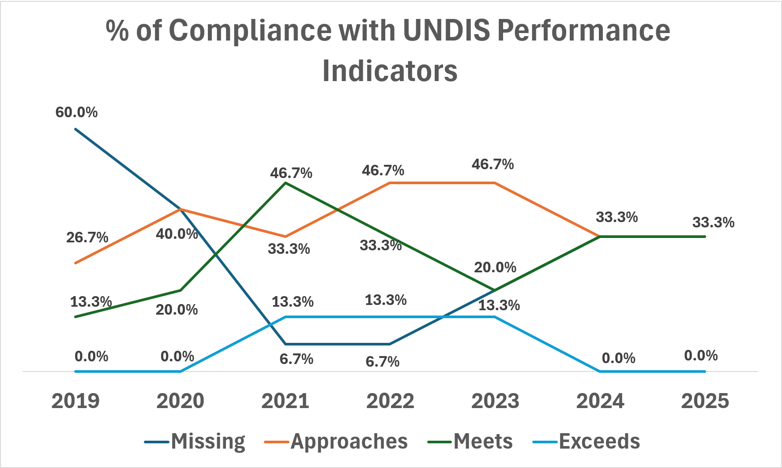

5.3.4 Solutions for rural, remote and indigenous communities
Since 2002, ITU members have sought to empower indigenous communities through technologies, as reflected in the resolutions adopted and reconducted systematically within the work of ITU’s World Telecommunication Development and Plenipotentiary Conferences.
In 2023, ITU delivered its first online training programme, Innovative communication tools to strengthen the capacities of Indigenous communities, which drew more than 200 participants (45 per cent women) from 16 Latin American countries. A second blended programme, Managers in ICT Networks in Indigenous and Rural Communities in Latin America, delivered through the ITU Academy and in person in Colombia, graduated 40 professionals with gender balance. The 2023 – 3rd edition of this managers’ programme was also launched to continuously adapt training to the evolving needs of Indigenous and rural communities. ITU further contributed its long-standing experience in a dedicated WSIS session on “Capacity Building and Enabling Environments for Meaningful Access in Indigenous and Rural Communities,” highlighting lessons learned from 18 years of work in this field. Work continued through 2024-2025 on ITU-D activities addressing the specific needs of Indigenous Peoples through targeted training, knowledge-sharing, and project support.
Since 2023, ITU’s digital inclusion work for rural, remote, and Indigenous communities has expanded significantly. In Latin America and the Caribbean, the 4th edition of the Managers in ICT Networks in Indigenous and Rural Communities Blended Training Programme graduated 28 network managers from 9 countries (2023/2024), while a new short course on Designing Community Connectivity Strategies certified 50 participants from 10 countries in 2024. the 5th generation of the Managers in ICT Networks in Indigenous and Rural Communities has already engaged 69 participants from 12 countries. In parallel, the programme was launched in Africa for the first time in 2025, with 65 participants from 18 countries currently enrolled. These efforts are strengthening local capacity and empowering communities to lead their own digital development.

5.3.5 Support for ageing populations
By 2050, the world’s population of people aged 60 years and older will double (2.1 billion). In the context of the two global mega trends, population ageing and the rise of technology, the socio-economic landscape will face significant change and challenges. ITU strengthened its commitment to supporting ageing populations in an increasingly digital world, in alignment with the UN Decade of Healthy Ageing (2021-2030). Throughout this period, ITU contributed expertise in 17 international events and workshops, such as the UN DESA Global Policy Dialogue on Ageing and the High-Level Forum on the Silver Economy, working alongside UN agencies and civil society partners to advance a rights-based, inclusive digital transformation for older persons.
A key achievement was the dissemination of ITU-D’s flagship resources, including the Guidelines Report: Ageing in the Digital World, From Vulnerable to Valuable, complemented by multilingual video tutorials and an online self-paced training programme on ICTs for better ageing and livelihoods. These tools enabled governments, practitioners, and stakeholders to strengthen their capacity to design inclusive technologies, support digital literacy among older persons, and convert demographic challenges into sustainable development opportunities. ITU-D also promoted evidence-based policymaking through the joint report by ITU and the Pan American Health Organization, The Role of Digital Technologies in Ageing and Health (2023), which highlighted how accessible, inclusive digital solutions can improve health services, facilitate independent living, and enhance social participation for older adults.
From 2024 to 2025, ITU-D continued advancing practical initiatives to support older persons, including digital skills development in Gran Chaco, ICT network management training in Latin America, and community-level training for indigenous and rural populations, all with an emphasis on connectivity, community media, and sustaining local digital ecosystems.

5.4 Commitment to environmental sustainability
Overall, the initiatives implemented by ITU from 2022 to 2025 reflect a robust commitment to environmental sustainability through climate action, responsible e-waste management, disaster risk reduction, and the promotion of smart, sustainable urban development. ITU’s comprehensive approach underscores the necessity of collaboration among various stakeholders to meet global sustainability goals effectively.
To that end, the Green Digital Action initiative, first launched at COP28, has catalysed industry commitments aimed at reducing emissions and building a monitoring framework for sustainability within the ICT sector.

E-Waste management and circular economies
E-waste management remains a cause for concern and requires immediate attention and action, as the amount of e-waste has grown five times faster than compliant collection and recycling since 2010. According to the 2024 Global e-waste Monitor, the world is projected to produce 82 billion kilograms of e-waste annually by 2030. Further on its partnership with UNITAR and Fondation Carmignac to deliver this flagship global publication, the Global E-waste Monitor, ITU also supported the preparation of two regional E-waste monitor reports and two national E-waste monitor reports.
ITU has also been actively supporting several countries across the Americas, Africa, and Asia-Pacific in developing and implementing producer responsibility regulations for e-waste. Between 2023 and 2025, ITU provided technical assistance on the circular economy in 14 countries alongside international funding partners that include UN Environment Programme and UN Institute for Training and Research (UNITAR), the German Agency for International Cooperation (GIZ), the United Kingdom Foreign, Commonwealth and Development Office (FCDO), the Government of the Kingdom of Saudi Arabia, the Government of Australia, and the Government of Colombia.
Noteworthy regional knowledge products on e-waste and the circular economy published between 2022 and 2025 include the “Management of waste electrical and electronic equipment in Latin America: current situation and outlook”, and the “Guidelines for the development of national systems for integral management of waste electrical and electronic equipment in Latin America”, both coordinated with the UN Industrial Development Organization (UNIDO).
ITU has also launched several initiatives to strengthen global capacity building and knowledge exchange on e-waste regulation, including study tours, webinars and the E-waste Challenge Massive Open Online Course (MOOC), designed and developed along with UN Environment Programme (UNEP), the Basel Convention Secretariat, EIT RawMaterials, KU Leuven, the World Health Organization (WHO), and the World Resources Forum.
To advance circularity, ITU has developed practical guides and tools for key stakeholders on circular and sustainable public procurement, including the “Policy practices for e-waste management: tools for a balanced and fair circular economy”, developed in collaboration with the Communications, Space & Technology Commission (CST) of Saudi Arabia, as well as a “Circular and sustainable public procurement-ICT equipment guide” produced under the GovStack initiative. The guide was developed alongside Recommendation ITU-T L.1061 on circular public procurement of information and communication technologies, which provides technical guidance to public-sector organizations on strengthening procurement practices and increasing the uptake of circular ICT goods and services.
Similarly, ITU has produced two national use cases to support the Implementation of the ITU-T International Standards for the Sustainable Management of Electrical and Electronic Equipment: On the road to a circular economy. In 2024, the standardization work on digital product passports and the development of environmental performance labelling further advanced approaches towards circular economies.
ITU-T Study Group 5, in turn, continued developing international standards to promote an environmentally sustainable, resilient and inclusive telecommunications/ICT sector. Between 2022 and 2025, 110 Recommendations were approved or consented by Study Group 5 in ITU-T, while 26 guidelines and supplements were agreed.
ITU standards have been especially instrumental in measuring and improving the environmental performance of ICTs, covering energy efficiency, emissions monitoring and material efficiency in technology products. Key activities for environmental efficiency ICT infrastructure include recommendations for networks, ICT services and products, as well as data centres. Two white papers on the safety of lithium-ion battery applications in data centres and on Lithium Batteries for Telecom Sites were published in collaboration with Huawei.
An international exchange initiative on regulating e-waste and engaging tech companies has been organized by ITU and the Government of Colombia. In March 2026 a webinar was organized to present the findings to a global audience of the India study tour of February. The final study tour took place (after Colombia in 2025 and India in 2026) in South Africa. A webinar to present the findings was organized in May.
At the country level, technical assistance was provided to the Government of Paraguay and to the Paraguayan electronics industry associations through two webinars in April. The webinars, part of ITU's project with the Government of the Kingdom of Saudi Arabia, developed government and industry capacity around the proposed e-waste management regulation and system in Paraguay. In Indonesia, through a project with the Government of the United Kingdom, focus groups were organized in May to support the consultation process on the development of extended producer responsibility regulations for electronics and the supporting financing mechanism for this. In May, ITU and the Government of Botswana released the national e-waste management strategy of Botswana. The strategy lays out a plan of action to tackle e-waste in the country.

Emergency telecommunications and crisis management
Emergency telecommunications remain a core ITU workstream for strengthening national climate resilience. By the end of 2025, at least 95 countries had national emergency telecommunications plans in place, up from 66 countries in 2021, reflecting improved disaster preparedness and resilience worldwide.
From 2022 to 2025, ITU-D strengthened national disaster preparedness and response by advancing the use of ICTs for emergency telecommunications in Member States. During this period, ITU-D supported more than 25 countries in the development and implementation of National Emergency Telecommunication Plans (NETPs), completing a total of 41 NETPs. These efforts enhanced national resilience and enabled faster and more effective emergency response. The organization also played a pivotal role in the implementation of the Early Warnings for All (EW4All) initiative, under which, ITU had supported 30 countries by 2025, including four pilot AI applications in countries under the AI subgroup of the EW4All to enhance early warning capabilities. ITU leads Pilar 3 on Warning Dissemination and Communication. Through this initiative, ITU-D facilitated technical, economic, and regulatory assessments to support the deployment of key public alerting technologies, including the Common Alerting Protocol (CAP), Cell Broadcast (CB), and Location-Based Short Message Service (LB-SMS). These technologies enable the effective use of digital networks, services, and mobile devices to disseminate timely alerts, contributing to the protection of lives and livelihoods. Since 2022, 28 countries have adopted Cell Broadcast, 10 countries rely on LB-SMS, and 6 countries have deployed both technologies for public alerting.
Direct disaster response efforts included the strategic pre-positioning of ITU's emergency telecommunications equipment in multiple geographical locations to reduce response times following disasters. Pre-positioning sites include Dubai (at the WFP warehouse), serving the Arab States, Africa, and Asia–Pacific regions; Zimbabwe, serving the SADC Member States; and Barbados, covering the Americas and the Caribbean. Since 2022, satellite communication equipment has been deployed to support emergency response operations in several countries, including Tonga following the eruption of the Hunga Tonga–Hunga Haʻapai volcano; Nicaragua after Hurricane Julia; Malawi and Mozambique in response to Cyclone Freddy and Cyclone Chido; Papua New Guinea following the eruption of Mount Bagana; and Grenada, Saint Vincent and the Grenadines, and Jamaica in the aftermath of Hurricanes Beryl and Melissa.
Training modules on emergency telecommunications were developed, with significant participation across various countries, helping ensure that disaster response is both structured and effective.
During COP28, ITU together with GSMA launched the call to action to deploy cell broadcast and location-based SMS. Many MNOs, including VEON, KDDI, Globe, Safaricom, Telefonica, MTN, and Axiata Group, have responded to the call and committed to utilizing digital connectivity to save lives.
ITU is also part of the Global Initiative on Resilience to Natural Hazards through AI Solutions, a collaborative effort led by various UN agencies, including ITU, UNEP, the UN Framework Convention on Climate Change (UNFCCC), the Universal Postal Union (UPU), and the World Meteorological Organization (WMO), to explore how AI can be effectively used in disaster management, providing expert guidance and support for research, innovation, and the development of standards.

Digital transformation enabling sustainable cities
ITU-T Study Group 20 made progress in smart city initiatives with the United for Smart Sustainable Cities (U4SSC) initiative, engaging over 250 cities in adopting performance indicators based on ITU standards. The focus has been on city governance and data integration to foster sustainable urban development.
ITU has produced several knowledge products through the initiative, including Guidelines for cities to achieve carbon Net Zero through digital transformation and a methodology to assess Net Zero progress in cities.

Climate change initiatives and collaboration
In response to climate change, ITU has made strides in studying energy consumption and greenhouse gas (GHG) emissions across the global tech sector. The annual "Greening Digital Companies" report series and the associated new Greening Digital Dashboard enable analysis based on the reported GHG emissions and energy use of 200 digital companies.
Complementing this flagship series, two knowledge products were published in 2025 on the environmental footprint of the ICT sector: a joint publication with the World Bank, “Measuring National ICT Sector Environmental Impact: ARCEP Case Study – France”, and an “ITU-Resilio White Paper on the Environmental impacts of the ICT sector in Switzerland”. These outputs build on earlier ITU work, including the report “Measuring the Emissions and Energy Footprint of the ICT Sector: Implications for Climate Action”, jointly produced with the World Bank in 2023 to present a comprehensive analysis of the energy and emissions landscape across 30 countries and examines connectivity networks, data centres, and consumer devices, offering insights into the environmental impact of the ICT sector.
ITU has also developed guidance and tools to support key stakeholders in enhancing ICT contributions to climate and environment action.
The “Scope 3 Guidance for Telecommunication Operators” developed by GSMA, GeSI and ITU aim to harmonize methods for assessing and reporting Scope 3 GHG emissions. Together with the World Bank, ITU produced a “Green data centres: Towards a sustainable digital transformation – A practitioner’s guide” with an accompanying “Green Data Centres for Policy Makers” e-learning course to make data centres more sustainable, climate resilient, and policy ready through practical strategies, frameworks, and real-world examples.
In November 2025, ITU published a new brief that took stock of digital technologies references in 53 NDCs and highlighted four national use cases demonstrating good practices for digital climate action.
ITU has actively engaged in climate resilience through partnerships with like the United Nations Office for Disaster Risk Reduction (UNDRR), the World Meteorological Organization (WMO) and the International Federation of Red Cross and Red Crescent Societies; as well as the WMO and the United Nations Environment Programme (UNEP) to leverage AI in disaster management. A comprehensive approach has been adopted whereby ITU collaborates with various international entities to ensure the allocation of radio spectrum for crucial meteorological services, enhancing communication during emergencies.
Within the Green Digital Action initiative, ITU is also leading a thematic pillar to reduce ICT Sector GHG emissions through collaboration, robust accountability and transparent reporting. For information on the Green Digital Action initiative see section 5.5 below.

Sustainable AI initiatives and collaboration
Under the Green Digital Action initiative’s thematic pillar on green computing, ITU has addressed the environmental implications of emerging technologies by reviewing existing approaches to assess their environmental impact. For artificial intelligence, this work is reflected in the 2025 report “Measuring what matters: How to assess AI’s environmental impact”. In parallel, ITU co created, in collaboration with GoCodeGreen, an open-access repository compiling sustainable software practices from around the world, supporting more environmentally responsible digital development.
On AI and environmental standards, the first international standard for Assessing the Environmental Impact of Artificial Intelligence systems was officially approved in February of 2026.
ITU also advances its work on responsible and sustainable artificial intelligence through various partnerships, including the Sustainable AI Coalition, convening a diverse network of governments, industry, academia and civil society to accelerate practical action. Through targeted dialogues and joint workstreams, the Coalition promoted shared approaches to assessing and reducing the environmental footprint of AI systems, while supporting transparency, measurement and good practices that can be adopted by stakeholders at different levels of capacity.

Circular economy initiatives and collaboration
ITU strengthened its circular economy engagement on standardization through the Digitalization for Circular Economy initiative (D4CE), working with UN partners such as the UNEP One Planet Network and UNIDO, as well as a broad coalition of stakeholders to advance digital solutions that enable more sustainable consumption and production. Among the key workstreams, D4CE supported collaboration on digital product passports, promoting interoperability, data governance and user-relevant information that can improve circular approaches, reduce e-waste and enable more resource-efficient value chains.

Internal sustainability initiatives
Between 2022 and 2025, ITU operationalized its Environmental Management System in line with ISO 14001 and UN Greening the Blue requirements, establishing formal governance, organization-wide objectives, mandatory staff training, systematic environmental data monitoring, internal audits, and annual management reviews. This period marked the transition from policy intent to embedded practice, with environmental considerations progressively integrated into facilities management, events, travel, procurement, and ICT operations, providing a structured foundation for measurable greenhouse-gas reduction and long-term operational efficiencies.

5.5 Partnerships and international cooperation
Cooperation, resource-sharing and win-win arrangements that benefit governments, industry and users, are helping drive towards technology as a basic enabling service that benefits all. ITU has strengthened a broad ecosystem of strategic partnerships and initiatives to accelerate sustainable digital transformation and advance progress on the UN Sustainable Development Goals. Working with UN agencies, governments, the private sector, academia and civil society, ITU has focused on expanding meaningful connectivity, promoting inclusive and gender-responsive digital development, supporting innovative uses of AI and emerging technologies, and embedding sustainability and resilience into standards, infrastructures and services worldwide.
This section summarizes key partnerships over the period of this report.

UN Global Dialogue on AI Governance
The inaugural UN Global Dialogue on AI Governance convened in Geneva on 6-7 July 2026, held back-to-back with the AI for Good Global Summit and during the WSIS Forum. The AI Dialogue was co-chaired by the Permanent Representatives of the Republic of El Salvador and the Republic of Estonia, to the United Nations in New York, USA, and guided by a Joint Secretariat comprised of the co-coordinators, ITU and UNESCO, and supported by the Office of Digital and Emerging Technologies (ODET) and the Executive Office of the United Nations Secretary General.
The AI Dialogue brought together 3 062 participants from 163 countries in Geneva, including Heads of State and Government, ministers, and representatives of over one thousand independent stakeholder entities across industry, civil society, academia, the technical community and international organizations. The programme was built to move in a deliberate arc: from high-level framing, into substantive exchange, and back to synthesis and the way forward, and spanned two days of comprehensive discussions with Member States and stakeholders, with a formal programme that comprised 12 official sessions on global AI governance and cooperation.
The programme opened with the preliminary report of the Independent International Scientific Panel on AI, followed by high-level plenary segments and four thematic breakout clusters: on AI opportunities and implications, bridging AI divides, safe and trustworthy AI, and human rights. Thematic breakout cluster discussions were facilitated by the UN Interagency Working Group on AI, co-chaired by ITU and UNESCO. The formal programme was complemented by 59 side events and the launch of an AI Dialogue Partnerships Hub, which by the event's close showcased more than 350 commitments, announcements and initiatives from across stakeholder groups.
Across the two days, several key messages were highlighted by participants: that AI's benefits will only reach people if capacity, not access alone, is built; that concentrated computing power and technical capability require sustained investment to close the resulting divide; that human rights and the protection of children must be embedded in AI's design and deployment; and that interoperability among diverse governance approaches offers a more realistic path forward than full harmonization. Participants also affirmed that no single government, company or institution can govern AI alone, underscoring the distinctive convening and coordinating role of the United Nations in bringing stakeholders together on an equal footing. The AI Dialogue closed with a shared sense that an important foundation had been laid for global AI governance cooperation, to be tested through tangible progress ahead of the second Global Dialogue on AI Governance, convening in New York in 2027.

Partner2Connect
The Partner2Connect Digital Coalition (P2C) has evolved into a flagship ITU multistakeholder alliance. Launched in 2021 in close cooperation with the Office of the Secretary-General’s Envoy on Technology, the United Nations Office of the High Representative for the Least Developed Countries (UN-OHRLLS), and the UN Secretary-General’s Roadmap for Digital Cooperation, the platform mobilizes resources, partnerships, and commitments for achieving universal meaningful connectivity and sustainable digital transformation.
Throughout the reporting period, Partner2Connect maintained a strong presence at major global, regional, and national events. P2C sessions took place at ITU Regional Development Forums, the WSIS Forum, AI for Good, Digital@UNGA, and the Third United Nations Conference on Landlocked Developing Countries (LLDC3), as well as through national Matchmaking Accelerators in countries including Ecuador, Guatemala, and Jamaica. Webinars, community engagement activities, and the Partner2Connect Annual Meeting continued to provide opportunities for announcing new commitments, sharing progress, and fostering partnerships.
As of June 2026, Partner2Connect had mobilized 1 074 pledges from 500 entities across 149 countries, with an estimated value of over USD 82 billion. These commitments include contributions from governments, the private sector, international organizations, development banks, academia, and civil society. Progress reporting has also continued to strengthen, with approximately 50 per cent of participating entities having submitted implementation updates, demonstrating that Partner2Connect serves not only as a platform for mobilizing commitments, but also as a mechanism for tracking progress and impact on the ground.
Annual meetings, targeted pledge mobilization campaigns, enhanced dashboards, and strengthened matchmaking services continue to support partners in announcing, implementing, and scaling commitments, particularly in LDCs, LLDCs, SIDS and other underserved communities. This work contributed to achieving the ambitious objective of mobilizing USD 100 billion in pledges ahead the end of 2026.
Partner2Connect is funded entirely through extrabudgetary resources. The initiative is supported by the Partner2Connect Champions programme, which is open to all ITU members As of December 2025, the P2C Champions include Amazon, Google, the Inter-American Development Bank, Microsoft, and ZTE.

Green Digital Action
The Green Digital Action initiative, launched at COP28 in 2023, as an ITU convened multistakeholder partnership with over 40 partners. Across COP28, COP29, and COP30, ITU worked with partners to convene and advance the Green Digital Action track with over 80 sessions uniting governments, industry, civil society, UN agencies, and multilateral banks to promote digital technologies as a means to achieve global climate objectives. Through these coordinated efforts, ITU positioned digital policy, connectivity, and innovation as central enablers of climate mitigation, circularity, and resilience, emphasizing the need for a whole-of-ecosystem response to the climate crisis.
At COP30 in Belém, Brazil, the Green Digital Action track marked its third edition, one year after the historic COP29 Declaration on Green Digital Action, which received endorsements from over 80 countries and about 1 800 companies, organizations and other stakeholders. A landmark outcome of the third edition was the creation of the Green Digital Action Hub (GDA Hub), announced as a legacy of COP30 and anchored in Brazil, which will serve as the nerve centre for coordinating digital climate solutions worldwide. Key objectives of the Hub include the operation of the newly launched AI Climate Institute, focused on building technological capabilities and fostering local innovation in developing countries so AI can effectively support climate mitigation and adaptation.
The Green Digital Action Summit 2025 co-hosted with the German Environment Agency, further intensified efforts by assessing progress since COP29 and driving collective action ahead of COP30. The summit gathered almost 50 speakers, 8 panels, 4 keynotes, 3 fireside chats and 1 digital art presentation.
The initiative continues to strengthen a global ecosystem of partners and commitments, with industry, governments, and organizations working together to promote sustainable digital transformation and accelerate progress toward net-zero. Community events, digital climate solution exchanges, and a growing body of ITU publications support knowledge-sharing and innovation across sectors. With partners spanning the tech industry, international organizations, policymakers, and civil society, Green Digital Action stands as a cornerstone for harnessing digital technologies to address climate change, laying the foundation for a sustainable and inclusive digital future for all.
For more information on the thematic pillar work under the Green Digital Action see section 5.4 above.

Digital@UNGA
To highlight digital solutions that can accelerate progress towards the 2030 Agenda, ITU and UNDP have convened major digital development events at UN Headquarters in New York under the themes of SDG Digital and Digital@UNGA. The 2023 edition, held as part of the SDG Action Weekend, and the 2024 edition, held ahead of the UN General Assembly and the Summit of the Future, showcased scalable digital initiatives and emphasized the essential role of digital in advancing the 2030 Agenda.
In 2025, to highlight the ever-increasing importance of digital on all areas of development, Digital@UNGA took this legacy forward by elevating, showcasing, and celebrating digital innovation during the United Nations General Assembly in September. In addition to an anchor event co-hosted by ITU and UNDP, the Digital@UNGA programme also featured 46 affiliate sessions led by more than 80 organizations, significantly expanding ITU’s each and impact during UN High-Level Week. A special edition of Digital@UNGA, called the Digital@UNGA WSIS edition, also took place in December ahead of the WSIS+20 High Level Review. By convening leaders from government, civil society, the private sector, youth, and academia, Digital@UNGA encourages the exploration of the trends, risks, and opportunities presented by digital and emerging technologies.

Broadband Commission – Impact over 15 years of putting broadband firmly on the international policy agenda
The Broadband Commission for Sustainable Development, was established in 2010 by ITU and UNESCO, under the leadership of H.E. President Paul Kagame of Rwanda and Mr Carlos Slim Helú, the Mexican industry leader of the Carlos Slim Foundation to advocate universal broadband connectivity to advance the UN 2030 Agenda and its 7 Global Advocacy Targets.
In 2025, the Commission marked its 15th anniversary, commemorating a notable achievement of tracking progress in broadband and digital inclusion. After fifteen years of advancing broadband connectivity through multistakeholder partnerships and advocacy, the Broadband Commission for Sustainable Development’s strategic framework, the Broadband Advocacy Targets, reached its expiration at the end of 2025. Over its lifetime, the Commission has published over 100 knowledge products, including 15 flagship annual State of Broadband reports, offering data, insight, and regional impact analysis, and proposing solutions to close connectivity gaps. Its 35+ Working Groups, supported by a community of over 500 international experts, have delivered pioneering research and actionable recommendations across priority areas such as digital health, education, gender, digital inclusion, financing, and more. In 2025, the working group on Data Governance, co-chaired by ITU, UNESCO, UNDP and the African Union completed key deliverables and presented the final report.
More than 70 concrete policy recommendations have been issued, spanning critical areas such as broadband infrastructure sharing, investment, and spectrum policy, to name a few. The Commission also established seven globally recognized Broadband Advocacy Targets, which served as a programmatic guide for regional and international action in broadband development and for achieving universal connectivity. Among these, the affordability target, first set at 5 per cent of monthly income and later revised to 2 per cent, has been adopted as a benchmark by governments and industry globally and is measured annually by ITU.
In its 15th anniversary year, the Commission issued a new four-part series of reports under the State of Broadband 2025. This expanded approach reflected the growing complexity of the broadband and digital ecosystem, offering focused insights into specific areas: progress toward achieving the Commission’s seven Advocacy Targets; regional developments with a spotlight on Africa; emerging satellite and non-terrestrial technologies; and the broader transformation of digital societies, including AI, data governance, and digital infrastructure. This special edition was also supported by the series of podcasts.
The Commission has helped catalyse global initiatives such as EQUALS, to bridge the gender digital divide; Giga, to connect every school to the Internet; and UNESCO’s e-Schools Initiative. It informed the launch of the Child Online Safety Universal Declaration and published an Agenda for Action to support digital response strategies during COVID-19 pandemic. The Commission set a valuable precedent for the importance of collaborative work to connect the unconnected and helped lay the foundations for the digital future. Several of the workstreams of the Commission continue to inform its joint work through other strategic initiatives, including the EQUALS Global Partnership, UNICEF-ITU Giga, Data Governance Toolkit and the ITU Partner2Connect Digital Coalition.
The Broadband Commission transitioned to a new chapter that will extend its experience and expertise into the AI and data-driven era. Its legacy of purposeful and sustained multistakeholder cooperation offers a strong platform for addressing the next generation of digital challenges.

EQUALS – Promoting access, skills, and ICT leadership for women and girls
As host and co-founding partner of the EQUALS Global Partnership for Gender Equality in the Digital Age, ITU has worked with more than 100 partners, from all sectors, to reduce the gender digital divide, supporting efforts in the Access, Skills, Leadership and Research Coalitions. The EQUALS Global Partnership for Gender Equality in the Digital Age is a committed group of corporate leaders, governments, businesses, not-for-profit organizations, academic institutions, NGOs and community groups around the world dedicated to promoting gender balance in the technology sector by championing equality of access, skills development and career opportunities for women and men alike.
EQUALS supports collaboration and scaling of successful initiatives across its Access, Skills, Leadership and Research coalitions to reverse the growing gender digital divide and accelerate progress toward Sustainable Development Goal 5, especially Target 5.B on enhancing women’s access to ICTs through workshops, e-mentoring with established tech professionals and a certification badge programme.
With partners, ITU promoted programmes such as EQUALS Her Digital Skills and the ITU-EIF EQUALS Joint Initiative “Tech as a Driver of Women’s Economic Opportunity” initiative have delivered workshops, mentoring and entrepreneurship support to women and girls across multiple countries and sectors. The EQUALS in Tech Awards, which reached its 10th anniversary, continues to recognize outstanding initiatives from around the world promoting women’s participation and leadership in the digital economy.
EQUALS 2.0 was relaunched in February 2025 at Mobile World Congress in Barcelona, and reflects its new phase, with a refreshed governance structure and strategic vision and mission, reaffirming commitments to close the gender digital divide, as well as three new workstreams. EQUALS new vision envisions a future where digital transformation for social change, education and business is driven by women and girls, bringing prosperity for all.

Giga – Working to connect every school to the Internet
The joint ITU–UNICEF Giga initiative, established in 2019, supports governments and other stakeholders towards connecting every school to the Internet and every learner to information, opportunity and choice by 2030. Since 2019, Giga has mapped more than 2.3 million schools and Infrastructure modelling in the context of connecting schools has been done for 15 countries with engagements underway to advance that work in 21 other countries.
Giga continued expand its engagement, reaching over 50 countries and with a growing pipeline of interest worldwide. Giga provides support governments with tools, advisory services and capacity building to realise to inclusive, affordable connectivity in thousands of schools, reaching millions of students across Africa, Asia and the Pacific region, Latin America, the Caribbean, Eastern Europe and the Commonwealth of Independent States. Its work is structured around four pillars school geolocation mapping, infrastructure mapping + modelling infrastructure, financing identification + mobilization, and procurement + contracting for connectivity. This is anchored on the provision of capacity development to governments via different learning formats including the Giga Learning Hub that delivers trainings through the ITU Academy. Nine training sessions (in person and online) since its inception in February 2025, attracting 210 participants from 52 countries to strengthen capacity in various aspects of delivering school connectivity. Giga also established an Acceleration Programme, a business development initiative designed to support early-stage innovators with skills development, mentorship, and grant financing to accelerate the development of solutions that foster global school connectivity. Nine teams from across the world were selected under the first cohort that started in November 2025 and ended in March 2026.
Leveraging the Giga and AI For Good platform, ITU has partnered with Google, and musician, tech founder and philanthropist will.i.am to bring artificial intelligence and robotics training to students across Africa, starting with aged 10-18 years 5 countries: Ghana, Ivory Coast, Kenya, Nigeria, and South Africa. This comprises of three tracks: National Robotics Youth Challenge, Training of Teachers and supporting the countries to establish AI school clubs in the schools connected. By June 2026, about 480 teachers and education stakeholders had received training across Ghana, Kenya and Nigeria.
Giga was recognized by the Global Digital Compact as a key initiative to connect schools and hospitals. This is also in alignment with the on ITU Strategic Plan Goal 1.5 and WSIS Action Line C2 “Information and Communication infrastructure”.
In March 2026, UNESCO, UNICEF and ITU released the Charter for Public Digital Learning Platforms, providing a shared normative reference for how public digital learning platforms should be designed, governed, and sustained. Building on Giga's school connectivity work, the Charter articulates principles for extending connectivity investments toward broader digital transformation of education systems, covering openness, interoperability, safety, accountability, and long-term public value.
In June 2026, the Technical Foundations for Education Digital Transformation workshop brought together representatives from approximately 12 countries to share experience with digital learning solutions across varying levels of maturity and exchange lessons on common implementation challenges. In parallel, the Giga Learning Hub delivered a four-day face-to-face training on Digital Governance for School Connectivity at the Giga Connectivity Centre in Geneva, attended by 29 government officials from 19 countries —drawn from ministries of ICT, education, and regulatory authorities— covering digital public infrastructure for education, institutional coordination, and change management for sustainable school connectivity.

Virtual Worlds and AI initiative
In June 2024, ITU, together with UNICC and Digital Dubai, has launched the Global Initiative on Virtual Worlds and AI “Discovering the Citiverse”, aim to harness the potential of immersive technologies and AI for development. Supported by more than 70 partners, this initiative serves as a global platform to foster open, interoperable and trusted AI-powered virtual worlds for people, businesses and public services. The UN Virtual Worlds Day, organized with 17 UN entities, explores how AI, spatial intelligence, and citiverse can support global priorities under the Pact for the Future and the Global Digital Compact. The inaugural edition in Geneva in 2024 and the event in Turin in 2025 highlighted how virtual worlds can contribute to digital public infrastructure and inclusive development. The UN Virtual Worlds Day took place on 11 May 2026 in Geneva.

Digital transformation for smart cities and communities
ITU-T Study Group 20 continues to advance digital transformation for smart cities and communities through the United for Smart Sustainable Cities (U4SSC) initiative, supporting cities in adopting ITU standards–based approaches to sustainable urban development. With a strong focus on city governance, data integration, and people-centred digital strategies, this work helps cities plan, implement, and scale up smart and sustainable solutions.
Supported by 20 UN entities, U4SSC contributes directly to Sustainable Development Goal 11 (“Make cities and human settlements inclusive, safe, resilient and sustainable”) and the Pact for the Future. The initiative has expanded to more than 250 cities worldwide, applying U4SSC Key Performance Indicators based on ITU standards. Results are shared through city snapshots, reports and case studies, providing evidence-based guidance for urban digital transformation.
U4SSC has broadened its thematic scope through seven areas of expert guidance, delivered via U4SSC Reports, covering city platforms and data spaces; AI in cities; digital transformation for people-centred cities; digital public infrastructure; urban energy and buildings; socio-cultural sustainability; and future foresight. Regular U4SSC meetings have strengthened governance structures, with new thematic groups supporting cities in designing sustainable, resilient, and inclusive digital strategies.
Complementing this work, ITU Digital Transformation Dialogues provided a dynamic platform for sharing knowledge and deepening the understanding of emerging technologies and technical standardization across various fields. Through engaging sessions, the DTD series fosters discussions on the rapidly evolving digital landscape and its impact on industries and society.
The ITU Digital Transformation and Cities Digest provides the latest updates on ITU’s activities on digital transformation, smart cities, virtual worlds and the metaverse. It also features information on upcoming events and new publications.
In addition, ITU continues to curate a wealth of knowledge through the Digital Transformation Resource Hub, offering high-quality publications on key digital transformation topics. These include, digital public infrastructure, AI, the Internet of Things, blockchain, digital twins, the metaverse and virtual worlds, and emerging digital transformation trends.

Intelligent transport systems
During WTSA-24, a new Resolution 104 was adopted on promoting and strengthening standardization activities for vehicular communications. In the framework of the new Resolution 104, ITU signed a memorandum of understanding with SAE International on 11 July 2025 to expand collaboration on vehicular communications and intelligent transport systems activities, which will facilitate global efforts to enhance road safety, support automated driving and contribute to related sustainable development goals.
The Collaboration on ITS Communication Standards (CITS) established itself as a recognized global platform bringing together experts from standards bodies, industry and government to share information and examine worldwide standards on Intelligent Transportation Systems (ITS). In the framework of the CITS, the Expert Group on Communications Technology for Automated Driving (EG-ComAD) has been established. The activities of EG-ComAD are conducted through three Working Groups: WG1 – “Vehicular communications for merging automatically into congested lanes”; WG2 – “Vehicular communications for advanced emergency braking, including to protect vulnerable road users (VRUs)”; and WG3 – “Technical and economic sustainability for vehicular communications”.
ITU also continues to advance intelligent transport systems (ITS) through its collaboration with the UN Economic Commission for Europe (UNECE) and the automotive ecosystem. The ITU–UNECE Future Networked Car Symposium (FNC) brings together industry, regulators and experts to examine the latest developments in vehicle automation, connectivity and regulation. ITU and UNECE have organized various editions of the FNC Symposium, one in 2022, two in 2023 (with a spin off in Qatar), one in 2024, two in 2025 under the framework of AI for Good Summit. See here for the various ITS-related events.

CTO and CxO meetings
The ITU's annual CxO roundtables from December 2023 to November 2025 served as crucial high-level forums for industry executives to discuss priorities and standardization activities across rapidly evolving telecommunications and emerging technologies. These events consistently highlighted the need for ITU leadership in shaping the future digital landscape.
The December 2023 roundtable in Dubai underscored ITU's role in developing standards for 6G transport networks, focusing on cost-effective optical solutions. Discussions emphasized AI and machine learning for network optimization, the potential of Non-Terrestrial Networks (NTN) for remote connectivity, and the importance of standardizing vehicle connectivity for smart mobility and disaster response. Emerging security concerns like voice traffic fraud and biometric SIM registration prompted calls for ITU guidance, alongside support for quantum information technologies standardization.
A year later, the December 2024 roundtable, also in Dubai, continued these themes by advocating for an ITU standardization roadmap towards 2030 for optical networks supporting IMT-2030 (also known as 6G). Various C-level executives (CxOs) highlighted network intelligence, environmental sustainability through Large Language Models (LLMs), and the development of open-source, multilingual AI. Key discussions included harmonizing standards for cross-border data flow, implementing global countermeasures against voice fraud (such as "do not originate" lists), and providing ITU guidance for NTN adoption to enhance connectivity and public safety. Reliable broadband networks for emergency services were also prioritized.
The November 2025 CxO roundtable in Munich further evolved these discussions, centring on key industry priorities where AI plays a pivotal role: performance, resilience, environmental sustainability, and security. It emphasized the need for responsible and trusted AI, calling for standards on ethics, data integrity, and zero trust architectures. Data centre innovations, driven by AI workloads and collaboration with power industries for renewable energy, were prominent topics. Non-terrestrial networks remained a focus for enhancing connectivity in rural and emergency areas, with a call for new performance indicators. Emerging technologies like distributed optical fibre sensing, quantum information technologies, and ultra-high-definition media were also identified for standardization efforts.
Collectively, these meetings showcased a consistent and evolving mandate for ITU's leadership in developing global standards for transformative technologies such as AI, 6G, NTN, and quantum computing, while simultaneously addressing cybersecurity threats and promoting environmental sustainability within the digital ecosystem.

World Standards Cooperation
The World Standards Cooperation is a partnership of ITU, the International Electrotechnical Commission (IEC), and the International Organization for Standardization (ISO) to advance the voluntary consensus-based international standardization system.
Joint activities include leading World Standards Day under the theme of how standards provide a shared framework that enables meaningful collaboration across industries, governments, and organizations to achieve common objectives of sustainable development (see past editions of World Standards Day).
The partners have also deepened collaboration on sustainability and AI, including joint statements at COP28 and COP29 on embedding sustainability into technical standards by design, aimed at achieving net-zero emissions and a resource-efficient, circular, and low-carbon economy in cooperation under the Green Digital Action track. The partnership also maintained a joint presence in the Standards Pavillion at COP29 and COP30, displaying a unified approach in advocating the role of international standards in climate action.
Other recent joint collaborative initiatives include the AI and Multimedia Authenticity Standards Collaboration (AMAS) to combat deepfakes, misinformation and disinformation. The AI and multimedia authenticity standards collaboration bring together standards development bodies, technology leaders, academic experts, policymakers, and civil society to build a future where we can trust digital content. The work of AMAS is focused on developing a mapping of the standards landscape for multimedia authenticity and an assessment of the legal and policies adopted by various governments, industry and civil society to address the challenges of deepfakes, misinformation and disinformation. On 11 July 2025, at the AI for Good Global Summit, the AMAS launched group released two reports – a technical paper on the standards mapping landscape for multimedia authenticity and a policy paper offering recommendations to guide the governance of AI globally and combat deepfakes, mis-and-disinformation. New reports from AMAS in 2026 were launched at the AI for Good Global Summit:
- Technical paper on AI and multimedia authenticity standards (second edition)
- Policy paper on the legal landscape for generative AI across different regions
The Technical Report on AI and Multimedia Authenticity Standards (Edition 2) and the Policy Paper on the Emerging Legal Landscape for Generative AI Across Different Regions provide a comprehensive assessment of the technical and policy foundations needed to build trust in AI-generated and digitally altered content. Together, the reports demonstrate that combating deepfakes, misinformation, and synthetic media requires both interoperable technical standards and effective regulatory frameworks.
The Young Research Associate Programme was launched in January 2026 and it is a one-year research-oriented initiative established to engage Master's, PhD, MBA students and early-career professionals in addressing the challenges of trust, authenticity, provenance, rights protection, and governance of AI-generated and AI-edited content. Three teams comprising of research students from different universities participated in the programme: Stop& Scan, Policy-as-code and System of Trust.
Stop & Scan addressed human decision-making; Amito/System of Trust orchestrated layered verification; and Policy-as-Code explored machine-readable compliance and content passports.
Policy-as-Code, Stop & Scan and System of Trust projects address three complementary layers of multimedia-authenticity standardization: translating policy into implementable controls, delivering authenticity information to users, and establishing an interoperable trust architecture. The projects were presented through the AMAS Young Research Associate Programme at the AI for Good workshop on 9 July 2026.
In addition, the partners convened the International AI Standards Summit, with key editions in New Delhi (2024) and Seoul (2025), and a dedicated International AI Standards Track during 2025 and 2026. These efforts were reinforced by the launch the AI Standards Exchange Database in 2025, which provides a one stop access with a search facility to 1000 AI-related standards and technical reports from the three partners and other participating standards development bodies such as IEEE and IETF which support coordinated standards development and the practical application of standards for trustworthy AI.

Leveraging AI as part of Early Warnings for All
ITU, together with World Meteorological Organization (WMO), the United Nations Office for Disaster Risk Reduction (UNDRR) and the International Federation of Red Cross and Red Crescent Societies (IFRC), formed the AI Sub-group of the Early Warnings for all Initiative to leverage AI to enhance early warning systems by uniting experts in AI, data science, and disaster risk management. The group bridges the gap between AI research and the practical needs of early warning practitioners and communities worldwide, where work is ongoing to facilitate pilot initiatives in countries. One such pilot is the work done using the Disaster Connectivity Map, where ITU has partnered with Microsoft AI for Good Lab, Planet and Institute of Health Metrics Evaluation to use AI to analyse satellite imagery and create high-resolution population density maps. This Early Warning Connectivity Map (EWCM) is used to highlight digital “coldspots”: areas where people do not have connectivity and cannot be reached or warned via digital networks. The EWCM has been showcased to demonstrate how identifying areas without connectivity can help protect people through early warning systems. Initially piloted in Fiji, Tonga, and Vanuatu, work has been expanded to 30+ countries under the Early Warnings for All initiative.

Advancing AI-driven disaster resilience
ITU works with WMO, UNEP and other partners to advance AI-driven disaster resilience and lay foundations for standards. The ITU/WMO/UNEP Focus Group on AI for Natural Disaster Management (FG-AI4NDM) developed technical reports, glossaries, roadmap on trends and standards and best practices on applying AI to data collection, modelling and communication across the disaster management cycle. FG-AI4NDM organized 12 meetings and 10 Workshops and Webinars in the last four years. Its outputs are already supporting initiatives such as the European Union-funded MedEWSa project. Building on this work, the Global Initiative on Resilience to Natural Hazards through AI Solutions, launched in 2024, brings together ITU, WMO, UNEP, UNESCO, UNFCCC and UPU to guide research, innovation and future standards that enhance resilience to natural hazards worldwide. Since 2022, nearly USD 20 000 in funding received from the International Union of Geodesy and Geophysics (IUGG) has supported experts’ participation in the FG-AI4NDM and Global Initiative meetings and workshops, enabling them to contribute their expertise to advancing standards and best practices in the field. Since its launch, the Global Initiative has already held three meetings, hosted respectively by the Barcelona Supercomputing Centre in Spain, the European Space Agency in Italy and the European Commission in Brussels. These focussed on reviewing the contributions, delivering sessions on leveraging AI tools for disaster management and advancing on refining the best practices and developing other deliverables.

AI and IoT for digital agriculture
In the agricultural domain, the ITU–FAO Focus Group on AI for Agriculture (FG-AI4A) explored how AI, IoT and emerging technologies can improve productivity, resilience and sustainability in food systems. Through a series of meetings, and more than 11 workshops and webinars, the group gathered experts from governments, industry, academia and international organizations to identify standardization gaps and best practices on precision farming, climate-resilient agriculture and resource optimization. Its findings, reflected in snapshot and technical reports, contribute to shaping future standards and guidance for digitally enabled agriculture that supports food security and sustainable rural development (outlined in the FG-AI4A snapshot report).
The deliverables have been transferred to ITU-T Study Group 20, which is now developing international standards on use cases, deployment, frameworks and architectural models for digital agriculture.
Building on the activities of the FG-AI4A, the Global Initiative on AI for Food Systems was launched during the AI for Good in July 2025, together with the World Food Programme (WFP), the UN Food and Agricultural Organization (FAO) and the International Fund for Agricultural Development (IFAD). This Initiative focusses on digital solutions integration, knowledge-sharing, synergistic partnerships, and proof-of-concept. On the occasion of World Food Day on 16 October 2025, the Session on AI for Food was organized as a part of the AI Discovery Series, with representatives of WFP, IFAD, ITU-T Study Group 20 and Rockefeller Foundation on the panel, elaborating on how AI standards can ethically, transparently, and interoperably enhance agricultural and food systems, address adoption challenges, and bring solutions to scale globally.

AI for Health
The Global Initiative on AI for Health (GI-AI4H), led jointly by ITU, the World Health Organization (WHO) and the World Intellectual Property Organization (WIPO), seeks to accelerate the safe and equitable integration of artificial intelligence into health systems worldwide. Building on the momentum of the ITU/WHO Focus Group on AI for Health (FG-AI4H), the initiative aims to develop technical standards, policy guidance, and mechanisms that enable responsible AI adoption. A core objective is to support evidence-based decision-making on the introduction of AI solutions while fostering global knowledge and data sharing to ensure that technological progress benefits all populations.
The FG-AI4H worked in partnership with WHO to establish a scalable benchmarking framework that evaluates AI-based methods for health, diagnosis, triage or treatment decisions. By 2025, the group finalized 36 deliverables. In addition to the standards that the Focus Group has produced, it has been using grants (approximately CHF 600K) from Fondation Botnar to build a modular (DevSecOps) open code reference implementation of the benchmarking framework, with a license permitting national health regulators and other to adapt according to their needs. Additionally, the grants were used to fund low- or middle-income country (LMIC) experts travel.

Digital Infrastructure Investment Initiative
Launched in 2024 as part of Brazil’s Presidency of the G20, the Digital Infrastructure Investment Initiative (DIII) was established to examine the full extent of the digital infrastructure investment gap, key barriers to investment, and the innovative financing approaches required to address them. Led by ITU and multilateral development banks —ADB, AIIB, AfDB, EIB, EBRD, IDB, IsDB and IFC— and supported by BCG as a knowledge partner, the DIII estimated that USD 1.6 trillion is needed to address the digital infrastructure investment gap and ensure universal, meaningful connectivity through 2030. Building on the DIII white paper published in January 2025 – which focused exclusively on infrastructure – ITU published Connecting Humanity Action Blueprint: Advancing sustainable, affordable and innovative solutions with the support of the Kingdom of Saudi Arabia to estimate the total funding required to close the global digital divide when demand side factors are also included. Connecting Humanity estimates that USD 2.6-2.8 trillion is needed to address gaps across not only digital infrastructure, but also affordability, digital skills, and policy and regulation.
As a follow-up to DIII, in July 2025 ITU together with UNCTAD launched the new Digital Infrastructure Investment (DII) Catalyser during the 4th International Conference on Financing for Development (FfD4) in Seville, Spain with the support of the governments of Brazil, Spain, and South Africa. The DII Catalyser was formally endorsed as part of the Seville Platform for Action to support implementation of the outcome document of FfD4 – Compromiso de Sevilla. The Catalyser is a multistakeholder platform that brings together the UN system and the MBDs —along with investors, private sector companies, governments, and civil society— to exchange knowledge and promote collaboration to accelerate investment in viable, bankable digital infrastructure models. It is focused on three pillars of work: 1) data, tools, and templates; 2) capacity building on investment policies and innovative finance; and 3) partnerships, investment, and funding opportunities.
The Catalyser was operational by September 2025 and is co-led by ITU, UNCTAD, and eight MDBs —ADB, AfDB, AIIB, EBRD, EIB, IDB, IsDB, and the World Bank Group— with a working group of over 50 organizations from across sectors. The DII Catalyser has thus far convened stakeholders alongside the United Nations General Assembly (UNGA, September 2025), the International Submarine Cable Resilience Summit (February 2026), and via two working group calls (November 2025 and February 2026). Looking ahead, the DII Catalyser will be developing a resource repository on existing tools and capacity building resources that can support investment planning for digital infrastructure, hosting investment matchmaking events, and producing a playbook on digital and AI infrastructure investments.

5.5.1 Collaboration with the UN system and other international intergovernmental processes
ITU, as the UN’s specialized agency for ICTs, drives global efforts to align digital technologies with the 2030 Agenda for Sustainable Development within and beyond the UN system. Following the UN Secretary-General’s Our Common Agenda, launched in September 2021, ITU has played a key leadership role in developing and implementing the Pact for the Future (A/RES/79/1), adopted at the Summit of the Future in September 2024, including its annexed Global Digital Compact (GDC). Through flagship initiatives and strengthened cooperation across UN processes and forums, ITU supports coherence on digital strategy and implementation across the UN system.

Implementing the Pact for the Future
As outlined in its Action Plan for implementing the Global Digital Compact, ITU has supported Member States and other stakeholders in advancing connectivity and sustainable digital transformation by aligning GDC objectives with existing or new initiatives. Under the UN Secretary-General’s Steering Committee for Pact Implementation, ITU co-leads the UN Working Group on Digital Technologies with the Office for Digital and Emerging Technologies (ODET), coordinating system-wide commitments and having developed the GDC Implementation Map.
Aligning with the GDC implementation, ITU’s core initiatives —Giga, Partner2Connect, Facts and Figures, EQUALS, Green Digital Action, and AI for Good (to name a few)— demonstrate leadership in bridging the digital divide, promoting digital skills, accelerating green-digital transitions, and embedding human-centric approaches in technology development. ITU also coordinates the High-Impact Initiative on Digital Public Infrastructure (DPI), co-organizing the annual Global DPI summit (Cairo, 2024; Cape Town, 2025) and the Citizen Stack Conference (India 2025) to strengthen global safeguards and interoperability.
Beyond the Global Digital Compact, ITU contributes to the implementation of the Pact for the Future through the UN Secretary-General’s Steering Committee Working Groups on Sustainable Development Goals, Peace and Security, International Financial Architecture Reform, UN Governance Reform, and Youth. In UN governance Reform, ITU advances space cooperation with and the United Nations Office for Outer Space Affairs (UNOOSA) and the Committee on the Peaceful Uses of Outer Space (COPUOS) through capacity-building on space law.

UN System-Wide Digital Cooperation
ITU maintains a strong presence across the UN system, fostering coherence in digital strategy and implementation. Within the Chief Executives Board and its High-Level Committees on Programmes (HLCP) and Management (HLCM), as well as the UN Sustainable Development Group, ITU provides leadership on advancing universal connectivity and guiding digital transformation, including the development of Artificial Intelligence.
Through its active engagement with Member States and other stakeholders at major UN conferences and forums, ITU strategically promotes the critical role of digital technologies for sustainable development. These platforms included, but were not limited to, ECOSOC and its functional commissions —such as the Commission for Social Development (CSocD) and the Commission on the Status of Women (CSW), the Multi-stakeholder Forum on Science, Technology and Innovation (STI Forum), the High-Level Political Forum (HLPF), UN General Assembly sessions (with Digital@UNGA), and other UN conferences, such as the Conferences of the Parties (COP) and the Conferences on SIDS, LDCs and LLDCs in New York and beyond. In particular, at the 2nd World Summit for Social Development (WSSD2) in Doha in November 2025, ITU contributed to the Doha Political Declaration (A/RES/80/5), emphasizing digital tools and AI for poverty eradication, decent work, social protection, and equitable access.
A 2022 UN survey identified over 500 digital initiatives across the UN system —with numbers likely growing— as digital themes increasingly feature in major conferences, reports, resolutions and outcome documents. ITU collaborates with sister UN agencies and other entities on digital ecosystems, data, AI, and public infrastructure, while strengthening system-wide resilience through standardization partnerships with IEC/ISO and coordination with the UN civil aviation and maritime agencies (ICAO and IMO). ITU also supports the UN Joint SDG Fund’s digital initiatives; serves as a leading agency for the UN AI Resource Hub, Inter-Agency Working Group on AI, UNGIS and the WSIS+20 Review; and raises awareness through International Girls in ICT Day, International Day of Women and Girls in Science, and International Day of Education, as well as other multistakeholder dialogues and regional briefings.

ITU’s leadership in the UN80 Initiatives
Under the UN80 Initiatives, ITU’s Secretary-General co-led the Specialized Agencies Cluster with the International Labour Organization (ILO), aligning digital transformation with UN reform proprieties. Following the UN Secretary-General’s September 2025 report Shifting Paradigms: United to Deliver and the subsequent UN80 Action Plan, the initiative has entered full implementation in 2026. ITU leads Work Package #8 (Expertise-on-Demand) with UNDP —connecting UN County Teams to specialized expertise— and co-lead #15 (Technology) with the Under-Secretary-General for Policy and the Chair of the UN Digital & Technology Network to consolidate digital infrastructure and launch the Technology Accelerator Platform (TAP). ITU also contributes to several other Work Packages, including #5 (UN Country Team Reconfiguration), #6 (Regional Reset), #7 (Joint Knowledge Hubs), #12 (Regional Integrated Platforms), #14 (United Services Roadmap), #16 (Data), #17 (Training and Research), #21 (System-Wide Results Management), and #29 (Mandate Registries & Tools).
ITU continues to collaborate with the UN system to enhance digital cooperation, linking policy, investment, and innovation to ensure that digital transformation accelerate global progress toward the 2030 Agenda while safeguarding human rights and trust in technological advancement.

5.6 Resource mobilization
The ITU Council, following instructions from the 2022 Plenipotentiary Conference (PP-22), adopted a resource mobilization strategy proposed by the Secretary-General at the Council’s 2024 session. The strategy has three main pillars, including strengthening member engagement and revenues, leveraging events, products, and services, and increasing voluntary contributions.
Member State unit contributions account for about 70 per cent of regular budget revenues. In the preparation of the strategy through the Council Working Group on Financial and Human Resources (CWG-FHR), delegates asked the ITU Secretariat for assistance in making the case for ITU within their own administrations for maintaining or increasing their unit contributions. The secretariat has developed an investment case for ITU, along with executive briefing materials and updated related web resources that can be used by delegations for internal consultations.
The secretariat is also undertaking a significant effort to modernize its operations, generating new efficiencies, and preparing more detailed, transparent reporting for Member States. Lastly, under the guidance of the Council Working Group for Strategic and Financial Plans (CWG-SFP), an ITU-wide effort is underway to improve the presentation of the ITU budget and make clearer links between the budget and operational and strategic plans, identifying funding gaps.
To strengthen Sector Member engagement and revenues, which account for about 10 per cent of regular budget revenues, the strategy calls for a review of Sector membership in consultation with the Sector Advisory Groups. This includes considering benefits that would encourage existing Sector Members to have memberships across multiple Sectors, and Associates to upgrade to full Sector membership. It also includes reviewing and modernizing key member services like study groups. Under-represented parts of the digital ecosystem and Member States having no Sector Member representation have been identified for targeted campaigns to ensure maximum diversity in ITU’s membership.
The resource mobilization strategy also calls for reviews of various events, products and services. Products and services account for about 20 per cent of the regular budget through cost recovery. About half of this comes from satellite filings. A working group in ITU-R is examining ways of modernizing satellite filings to reflect the changing market. Investments in new systems have been made to modernize delivery of maritime products, which account for the other half of cost recovery revenues, and further investments are planned to support the sale of digital products and modernization of ITU’s event experience, which would open the door to potential new revenue streams.
Regarding voluntary contributions, which are used to supplement the regular budget, Baku Action Plan adopted by the World Telecommunication Development Conference in 2025 provides a global framework, along with a set of regional initiatives, to guide the secretariat’s efforts towards raising funds for projects and initiatives. In addition, initiatives like Giga confirm the potential to boost funding and maximize impact by partnering with other UN agencies. The secretariat is also working to address key enablers of project implementation, including streamlined hiring and procurement processes, new information technology (IT) systems to support efficient ITU-wide coordination of outreach to members and partners, and a new partnership strategy to leverage partnerships for impact and provide greater transparency, while protecting the reputation of ITU.

5.7 Transformation process: achieving organizational excellence
ITU’s launched its transformation initiative in 2023 based on a comprehensive visioning process and changemakers programme involving staff from across the organization. This provided a foundation for change and engaged staff in a collective effort to prepare ITU for the future. While transformation is occurring across the General Secretariat and Bureaux, the focus of the transformation initiative has been on achieving operational excellence in the General Secretariat, as a service provider to the Bureaux and members.
As ITU’s transformation effort has matured, the secretariat has been transitioning from ideas to implementation. Business owners have been integrating recommendations where possible into their operational plans and budgets, prioritizing key initiatives. Transformation is being incorporated into strategic and financial planning as a performance enabler rather than as a separate undertaking, aligned with agreed strategic outcomes and KPIs. The evolution of this process has been covered in regular reporting to Council, including Documents C24/52, C25/55 and C26/55, as well as reports to CWG-FHR, the most recent being Document CWG-FHR-22/15.

Key achievements
By 2025, ITU had delivered several foundational transformation outcomes that strengthened governance, accountability, and operational effectiveness.
Key achievements include the establishment of an Oversight Unit incorporating an evaluation function, alongside the delivery of evaluation training for staff, and the formal establishment of the Ombudsman function. The operational planning process was redesigned to better align strategic priorities with operational plans and financial frameworks, improving coherence and execution discipline across the organization.
Significant progress was achieved in financial management and control, which included transforming budgetary deficits into consistent surpluses, bringing back on track the external audit process and full compliance with International Public Sector Accounting Standards (IPSAS), and improvements to treasury operations, extrabudgetary fund management, and post management. As well as redesigning the new headquarters building project to ensure that fits into the budget while meeting future needs. Human resources reforms advanced through a simplified ePMDS (electronic Performance Management and Development System) tool and targeted training, strengthen approaches to addressing underperformance, and the development of new policies to streamline recruitment. In support of culture and leadership development, a comprehensive Leadership Programme was delivered to staff and management. Responding to the Employee Engagement Survey results, the Secretary-General announced the introduction of a Rewards and Recognition Framework, as well as dedicated time for learning and innovation-related activities. In parallel, ITU developed its first organizational guidelines on the responsible use of generative AI, marking an important step toward structured adoption of emerging technologies.
In 2025, ITU also welcomed a new Chief Information Officer (CIO), who assumed a leading role in enabling and accelerating transformation. The CIO is spearheading ITU’s internal digital transformation and modernization agenda, focusing on updating systems, tools, and processes, and upskilling staff in collaboration with the Human Resources Department, while establishing a strong institutional foundation for data and AI as critical enablers of operational excellence, innovation, and impact. A new Innovation Hub was launched in early 2026 to give ITU staff a hybrid space to learn, experiment and collaborate with new digital and AI tools.

5.8 Human Resources
A central component of ITU’s wider institutional transformation has been the evolution of its Human Resources. This progress accelerated throughout 2024 and 2025, aimed at building an agile, capable, and people-centred workforce to respond to evolving priorities and deliver on ITU’s mandate.

a) People:
– Learning and development were strengthened through a comprehensive and cost-effective Learning Plan; visibility was enhanced through the “Let’s Learn” newsletter and a centralized SharePoint site, with the plan monitored and updated regularly in line with emerging needs.
– A new Mandatory Learning Policy was introduced in August 2024 to reinforce ITU’s organizational culture and promote a shared understanding of expected standards of conduct. Compliance has continued to improve significantly, with completion rates reaching 73 per cent across all ITU personnel and 86.2 per cent among all staff as of June 2026, supported by strengthened monitoring mechanisms and targeted follow-up with managers. Further measures are being developed to ensure compliance.
– Digital and AI-related learning initiatives have expanded in 2026, with structured training programmes on tools such as Copilot and other new platforms being rolled out to strengthen staff capabilities.
– Performance management was advanced through process streamlining and the introduction of the simplified ePMDS tool, allowing for more efficient performance discussions and feedback while reducing the time supervisors spend on performance evaluations by at least 50 per cent. Further modernization of the performance management framework is underway, including the development of a revised service order, more relevant competency framework, and targeted training to strengthen performance culture and accountability.
– A thorough recruitment review was initiated in early 2025, informed by UN system benchmarking. In 2026, this work is advancing through the development of recruitment policies and process maps, aligned with the transition to a new recruitment management system, supported by digital and AI-enabled solutions, further strengthening the efficiency, fairness and transparency of the selection process.
– Work is advancing on the development of a comprehensive workforce planning (WFP) framework, including the launch of a focused pilot (“WFP Light”), supported by staffing dashboards. WFP will incorporate workforce rationalization, succession planning and strategic skills alignment.
– Talent development and workforce agility were further strengthened through the Young Professionals Programme (YPP), the expansion of the Junior Professional Officer (JPO) scheme, and the agreement with United Nations Volunteers (UNV). The YPP targeted individuals from least-developed countries (LDCs), thereby contributing to ITU’s geographic diversity. Six young professionals were onboarded in 2025.
– ITU has continued its efforts to promote gender parity and geographic diversity across the workforce, with related metrics tracked throughout the recruitment process. Implementation of the Gender Parity Implementation Plan is underway, supporting UN gender parity objectives and advancing concrete actions to promote equality. The Voluntary Separation Programme (VSP) launched in March 2023, with a second tranche in November 2024, provided flexibility to support structural realignment in order to allow ITU to equip itself with additional skills and competencies and optimize resource allocation. As approved by the 2026 Council, the mutually agreed separations are under development.
– Transparency and evidence-based decision-making were reinforced through HR analytics, including the Workforce Analytics Dashboard, made available to Member States through the Council portal and is continuously updated and improved based on member state feedback.

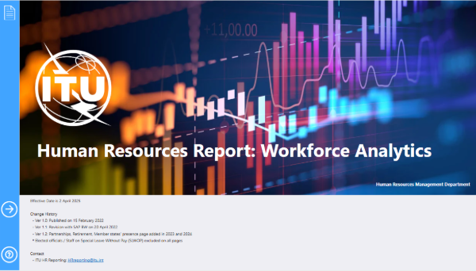

b) Culture:
– A comprehensive Leadership Development programme was launched in November 2024. It focused on Inclusive Leadership (P5 and above) with a dedicated gender module, as well as senior leadership training. Leadership capability was strengthened through Adaptive Leadership team workshops for P4 and above, and the Future ITU Leaders programme for ChangeMakers. Efforts have continued in 2026, including advanced adaptive leadership sessions. Peer consulting sessions have further reinforced leadership capacity across the organization.
– The first-ever Mental Health and Wellbeing Action Plan was developed in response to the outcomes of the 2023 UN-wide health survey and constitutes a cornerstone of the People and Culture agenda. The plan takes a holistic approach to well-being – encompassing physical, psychological, and social dimensions – with a strong focus on prevention, early intervention, and sustained support. Its implementation has progressed through expanded prevention initiatives, manager training, and strengthened support mechanisms, including counselling services, return-to-work programmes, as well as the development of a disability policy.
– ITU conducted its first Employee Engagement Survey in January 2025, achieving a 72 per cent participation rate. Findings were discussed through an all-staff townhall and workshop, leading to a comprehensive action plan. Implementation of the action plan is progressing across the organization in 2026, including initiatives such as Open-Door Sessions with Elected Officials, the Brown Bag Lunch Series, the Innovation and Learning Programme, and an ITU-wide Mentorship Programme, as well as departmental and bureau-level actions co-created at the grassroots level.
– Rewards and recognition are being strengthened through a comprehensive framework to celebrate service and performance, including the recognition of long-standing service in 2025. In 2026, the framework is being further operationalized with the launch of the Team Awards, recognizing collective achievements and reinforcing engagement, collaboration and a strong sense of purpose and belonging across ITU.
– Under the memoranda of understanding (MOUs) signed by ITU, in partnership with the World Intellectual Property Organization (WIPO), and the United Nations Ombudsman and Mediation Services (UNOMS), the new Ombudsman began her role at ITU on 5 January 2026. This has been complemented by a hybrid information session for all staff, including those in regional offices, and the launch of a Union-wide “Workplace Roadmap” session in February 2026, providing a clear “Where-to-Go Guide” to navigate support options. Follow-up sessions are being rolled out throughout 2026.

c) Services:
– Implementation of the HR Strategic Plan 2026–2027 is underway, supported by strengthened monitoring and reporting mechanisms.
– HRMD continued modernizing ITU’s regulatory framework by updating and introducing policies to better support its evolving workforce. The working hours and flexible working arrangements service order has been promulgated. Work is advancing across key areas, including staff rules amendments, fixed-term and short-term recruitment, consultant contracts, and entitlements and benefits such as rental subsidy, education grant and dependency benefits.
– The first phase of the HR Delegation of Authority (DoA) framework was introduced to streamline HR approval processes, enabling faster decision-making on key HR matters. Further work is ongoing to develop a comprehensive ITU DoA framework across the Union, aimed at strengthening accountability while enabling faster decision-making.
– A standard operating procedure (SOP) was developed for Special Service Agreement (SSA) payments to ensure the timely closure of contracts, including certification by managers that outputs have been successfully achieved. Additionally, a guideline on conflicts of interest for SSAs was introduced to facilitate the declaration and monitoring of actual or potential conflicts, ensuring compliance with ethical standards. An AI-enabled tool was developed to support the efficient and consistent preparation of job descriptions.
– HR digitalization has accelerated in 2026 through process automation, enhanced dashboards, and AI-enabled tools to support more efficient service delivery, improved user experience, and evidence-based decision-making. As part of this effort, a Contract History App has been developed to provide HR focal points with role-based access to essential HR data, replacing broader system access and enhancing compliance with data protection standards.
– HRMD has reinforced its commitment to accountability by systematically monitoring and addressing outstanding audit recommendations, using a structured approach aligned with ITU’s risk management priorities.
– SOPs for emergency situations for staff in Field Offices and on mission have been developed in close collaboration with the Staff Council, to enhance ITU’s emergency preparedness and staff security protocols.
– ITU actively engaged in a first UN system-wide inter-agency initiative on generative AI, taking a leading role in the development of an AI-powered chatbot for HR policy analysis and staff queries. The chatbot is currently being scaled for organization-wide deployment, providing staff with streamlined, user-friendly access to information on HR entitlements, policies, and related guidance.

5.9 Status of Implementation of PP Resolutions
The status of implementation of PP Resolutions can be found in the dedicated web-platform here.

______________

