 |  | Document ISCG/26-1/6-E
 |  | 28 January 2026
 |  | English only
Contribution by the secretariat
UPDATES ON SUSTAINABLE DIGITAL TRANSFORMATION ACTIVITIES
Purpose: Admin ( ) / Information (X) / Discussion ( ) / Proposal ( )
Contact: | Cristina Bueti  Focal Point on Digital Transformation  TSB |  | E-mail: | cristina.bueti@itu.int

- Telecommunication Standardization Sector (TSB)
Please see below updates on Sustainable Digital Transformation activities under TSB:
  - Digital Transformation Dialogues (DTD) and other events
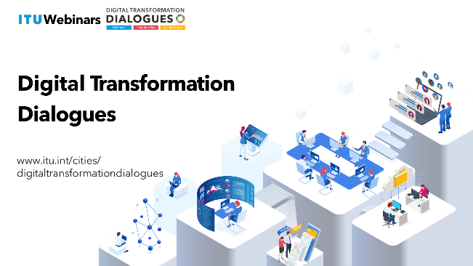
The International Telecommunication Union (ITU) has been organizing the Digital Transformation Dialogues (DTD). DTD offer a dynamic platform to facilitate a deeper understanding of emerging technologies to reshape traditional processes, improve operational efficiency and unlock new possibilities for innovation and standardization. The Digital Transformation Dialogues seeks to address evolving themes associated with digital transformation, foster cooperation among city stakeholders, and examine the role of standardization within this domain. The Digital Transformation Dialogues serve as a unique platform for highlighting the latest work and outcomes of the ITU-T Focus Groups, Initiatives and ITU-T Study Groups.
The following events have been held in 2025:
- ITU and UN-Habitat Webinar – Empowering lives through people-centred smart cities (31 October 2025)
- Digital inclusion and accessibility: Leaving no one behind in virtual worlds and the citiverse (15 May 2025)
- Artificial Intelligence & Virtual Worlds: Innovating the Future of Work and Economic Growth to advance the SDGs (6 May 2025)
- ITU and ATU Webinar – Shaping Africa’s Digital Future: Governance in the Metaverse and Virtual Worlds (25 February 2025)
More information on the Digital Transformation Dialogues is available at: https://www.itu.int/cities/digitaltransformationdialogues/
Regarding sustainable digital transformation ITU has held the following events:
- Side Event to 2025 BRS COPs: Towards a Global Framework for Digital Product Information Systems: Enhancing Sustainability and Traceability for the ICT sector, (Geneva, 30 April 2025)
- Forum on Sustainable Digital Transformation in Latin America,
(Santo Domingo, Dominican Republic, 8 May 2025)
- Digital solutions for sustainability: ICT’s role in GHG reduction and biodiversity protection (Geneva, 8 July 2025)
- From data to impact: Digital Product Information Systems and the importance of traceability for global environmental governance (Geneva, 8 July 2025)
- Navigating the Intersect of AI, Environment and Energy for a Sustainable Future (Geneva, 10 July 2025)
- ITU-UNIDO Workshop on "E-waste in Latin America: From Current Challenges to Future Solutions" EN | SP​ (Virtual, 17 October 2025)
- ITU Workshop on “Understanding and Reducing the Environmental Footprint of ICTs”
(Fully Virtual, 25 November 2025), from 1400–1530 CET.
- UNEA Side event on: Digital Product Information Systems for a resilient planet: Advancing circularity and transparency, (Nairobi, 10 December 2025)
- Second IEEE-ITU Symposium on Achieving Climate Resilience: Accelerating the Energy Transition and Digital Connectivity for Global Impact, (Geneva, 16 – 17 December 2025)

  - Digital Transformation Resource Hub
The Digital Transformation Resource Hub continues to collate a range of quality publications on various digital transformation topics such as smart sustainable cities, AI, IoT, blockchain, digital twin, metaverse & virtual worlds, digital public infrastructure and digital transformation trends.
  - Publications
Between May and December 2025, the ITU developed and distributed key publications focused on the topics of smart sustainable cities, metaverse, citiverse, AI-powered virtual worlds, environmental sustainability, e-waste and circular economy.
- Building digital public infrastructure for cities and communities
- A framework for enabling people-centred cities through digital transformation
- A guide to digital wellbeing
  - Case Study – Columbus, Ohio, United States of America
  - Case Study – The Cybersmile Foundation
  - Case Study – Dubai’s pursuit of digital wellbeing
  - Case Study – Jeddah, Saudi Arabia
  - Case Study – Shanghai, China (People’s Republic of)
  - Case Study – Spotify
  - Case Study – The End Now Foundation
- Guidelines for cities to achieve carbon Net Zero through digital transformation
- Methodology to Assess Net Zero Progress in Cities
- Future-Ready Cities and Communities
- Citiverse Use Cases Taxonomy Overview
- Citiverse Use Case Taxonomy: Global Insights and Implementation Pathways
  - Citiverse Use Case Taxonomy: City Administration, Services and Public Participation
  - Citiverse Use Case Taxonomy: Urban Planning, Placemaking and Infrastructure
  - Citiverse Use Case Taxonomy: Economic Development, Education and Tourism
  - Citiverse Use Case Taxonomy: Public Safety, Health and Disaster Resilience
  - Citiverse Use Case Taxonomy: Transport and Mobility
- No One Left Behind in the Citiverse: A Blueprint for Accessible AI-Powered Virtual Worlds
- Management of waste electrical and electronic equipment in Latin America: Current situation and outlook (available in English and Spanish)
- Measuring What Matters: How to Assess AI’s Environmental Impact
- White Paper on the Safety of lithium-ion battery applications in data centers
- White Paper on Lithium Batteries for Telecom Sites

  - Digital Transformation and Cities Digest
The ITU has consistently published the Digital Transformation and Cities Digest, with editions being released in March 2025, October 2025 and December 2025. Copies of the Digest are available for access on the Digital Transformation and Cities Digest webpage.

  - U4SSC Thematic Group on Enabling People-Centred Cities through Digital Transformation
As part of the United for Smart Sustainable Cities (U4SSC), which is a global UN initiative supported by 20 UN entities, a Thematic Group on Enabling People-Centred Cities through Digital Transformation is conducting its work through four working groups:
- Working Group 2: Policy Benchmarks for Digital Transformation of People-Centred Cities
- Working Group 3: Digital Transformation Assessment of People-Centred Cities
- Working Group 5: Intergenerational Procurement for People-Centred Cities
- Working Group 6: Digital Development Goals
More information is available at: https://u4ssc.itu.int/thematic-groups/.
______________

