Document CWG-SFP-5/3
9 February 2026
English only
Report by the Secretary-General
DRAFT ANNEX 2 TO RESOLUTION 71: SITUATIONAL ANALYSIS
Purpose
This document presents the proposed draft Annex 2 to Resolution 71 (Rev. Bucharest, 2022) containing the situational analysis, as agreed by the fourth meeting of the Council Working Group for strategic and financial plans 2028-2031.
Action required
The Council Working Group for strategic and financial plans 2028-2031 is invited to consider and to approve this document, with a view to submitting it to Council 2026 for endorsement.
_______________
References
CWG-SFP website; Resolution 1428 (C24)

ANNEX 2 TO RESOLUTION 71 (REV.DOHA,2026)
Situational analysis
To assess the internal and external factors that may influence the development and implementation of the ITU’s Strategic and Financial Plans for 2028–2031, a SWOT analysis is used. This tool examines:
- Strengths – Internal capabilities and assets that provide an advantage
- Weaknesses – Internal limitations that may hinder performance
- Opportunities – External trends or developments the ITU can leverage
- Threats – External risks or challenges that could affect the organization
This structured analysis supports alignment between the ITU’s strategic priorities, its core capabilities, and the evolving external environment.
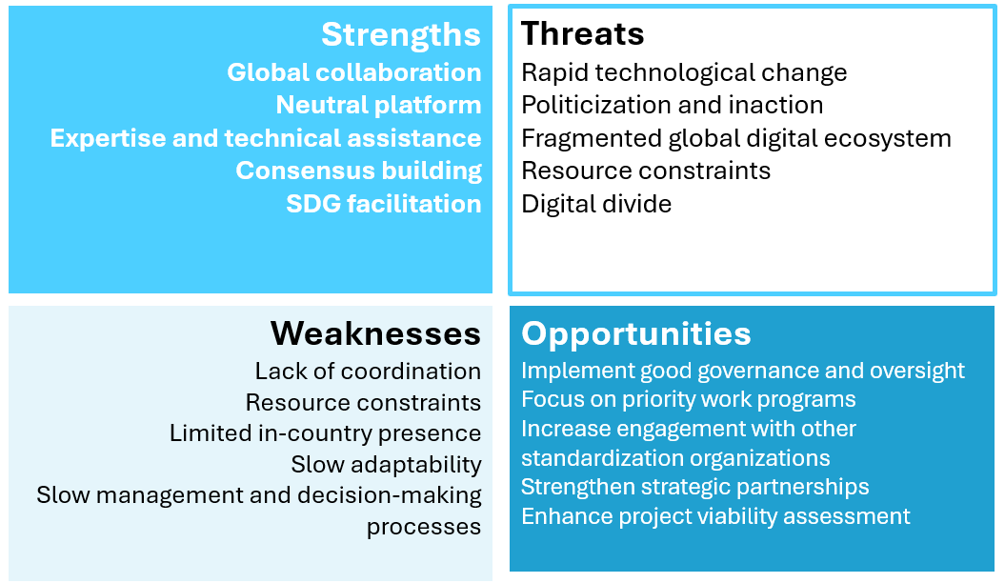
Additionally, two comments were received in relation to the SWOT analysis (see Document CWG-SFP-4/DT/1) for the consideration of the CWG-SFP:
- MEX (ADD): Weakness - regional presence
- RUS (ADD): Strength - the growing influence of States on technological development in the public interest.
Threat - the use of closed standards by big tech monopolists (technology privatization).
_____________

