Document CWG-SFP-4/INF/5
11 December 2025
English only
Note by the Secretary-General
SUMMARY OF THE STRATEGIC FORESIGHT WORKSHOPS
Purpose
This information document summarizes two workshops conducted in collaboration with the UN Futures Lab on strategic foresight.
Action required
This document is transmitted to the Council Working Group for strategic and financial plans 2028-2031 for information.
____________________________________
References
CWG-SFP website; Resolution 1428 (C24)

ITU Strategic Plan 2028-2031
Strategic Foresight Workshop with ITU Council Working Group
for Strategic and Financial Plans
(CWG-SFP)
Outcome Report
UN Futures Lab/Global Hub
Table of contents
Executive summary 2
1 About the Report 6
2 Strategic foresight for planning 7
3 Objectives and structure of the Strategic Foresight Workshops 8
3.1 Objectives of the Strategic Foresight Workshops 8
3.2 Structure of the Strategic Foresight Workshops 8
4 Key results from Workshop #1: ITU Strategic Plan 2028-2031:
Strategic Foresight Workshop with ITU Secretariat 9
4.1 Session One: Horizon Scanning Deep Dive Exercise 10
4.2 Session Two: Futures Triangle Exercise 11
4.3 Lessons Learned from Workshop #1: ITU Strategic Plan 2028-2031:
Strategic Foresight Workshop with ITU Secretariat 13
5 Overview: Key insights from Workshop #2: ITU Strategic Plan 2028-2031:
Strategic Foresight Workshop with ITU Council Working Group for Strategic
and Financial Plans (CWG-SFP) 14
5.1 Session one: What to introduce, scale, and set aside 14
6 Group work outcomes: Group 1 – Baseline scenario 16
7 Group work outcomes: Group 2 – Adaptation scenario 17
8 Group work outcomes: Group 3 – Radical change scenario 18
9 Group work outcomes: Group 4 – Marginal change scenario 19
10 Key lessons learned 20
11 Next steps 21
Annex 1 – Workshop #2: ITU Strategic Plan 2028-2031: Strategic Foresight Workshop
with ITU Council Working Group for Strategic and Financial Plan – Agenda 22
Annex 2 – All Group work outcomes: Raw results 23
Annex 3 – Strategic foresight methodology and scenarios 26
Annex 4 – Group work photos 28

Executive summary

Background
The International Telecommunication Union (ITU) - the United Nations specialized agency for digital technologies - partnered with the UN Futures Lab/Global Hub to embed strategic foresight into the development of the ITU Strategic Plan 2028–2031. This collaboration comes at a pivotal moment: ITU’s 160th anniversary and a global environment defined by accelerating technological change, geopolitical fragmentation, economic volatility, social transformation, and mounting environmental pressures. In line with the UN Secretary-General’s Our Common Agenda, which calls for long-term, anticipatory planning, ITU and the UN Futures Lab convened two strategic foresight workshops in 2025: (i) Workshop #1: ITU Strategic Plan 2028-2031: Strategic Foresight Workshop with ITU Secretariat on Tuesday, 26 August 2025; and (ii) Workshop #2: ITU Strategic Plan 2028-2031: Strategic Foresight Workshop with ITU Council Working Group for Strategic and Financial Plans (CWG-SFP) on Monday, 8 September 2025.
Strategic foresight is an approach for systematically thinking and acting in a long-term and anticipatory way under conditions of uncertainty. ITU’s engagement in this strategic foresight initiative represents a proactive step to updating and adapting its planning methods in response to the needs and uncertainties of the 21st century. By embedding foresight into its planning and decision-making, ITU enhances its ability to anticipate disruption, strengthens its value proposition to its members, and leverages UN 2.0 capabilities to remain future-ready.

Horizon scanning deep dive exercise
The workshops surfaced six key interlinked Signals, Trends, and Drivers of Change that may shape ITU and considered their implications for ITU’s Strategic Plan 2028-2031:
1) Geopolitics and the effect on consensus-building: Geopolitical rivalries, emergence of blocs, increasing polarization, transformation of national political frameworks, and eroding trust in international organizations.
2) Economic pressures and financial sustainability: Financial instability, rising debt, currency reevaluation, competing priorities and broader fiscal stress with a potential domino effect on ITU’s budget, staffing, and programmes.
3) The future of work and institutional adaptation: Automation and AI are reshaping work, while over-governance and administrative burden are risking diverting focus. At the same time, ITU’s relatively small size could become an advantage, enabling greater agility and adaptability.
4) Technology as a double-edged driver: Expanding AI literacy and democratized access to information offer opportunities for accessibility and inclusion, while AI weaponization, monopolization of AI and quantum infrastructure could deepen divides. An “AI bubble” could shift market dynamics, while an overemphasis on AI could divert attention from other ICT critical areas.
5) Social and human dimensions: Mental health, digital fatigue, impact on human intelligence and critical thinking, misinformation, and disinformation.
6) Environmental impact: Rapid digital infrastructure growth increases water, minerals, and energy demand and accelerates e-waste generation. A low-probability but high-impact Wild Card identified by participants was a solar flare capable of disrupting global digital infrastructure.
These dynamics interact across political, economic, technological, social, and environmental domains, creating reinforcing feedback loops that can either erode trust and widen inequalities or reinforce positive spillovers.

Futures triangle exercise
The discussion revealed some tension between a perceived current structural inertia of the organization and the need for transformation, as well as opportunities to leverage ITU’s strengths to shape a more agile and impactful future:
1) Weight of the Past - What is holding ITU back?: (i) The federal model; (ii) long decision cycles; (iii) over-governance; (iv) fragmented internal processes; (v) financial model; (vi) risk-averse culture; (vii) siloed working methods; (viii) the transition of national experts from delegations to ITU staff roles, and vice versa, that could potentially raise questions about neutrality and impartiality
2) Push of the Present - What is shaping ITU’s current focus?: (i) Geopolitical fragmentation; (ii) possible financial strain; (iii) technology disruptions; (iv) ITU’s engagement in multiple fast-moving domains; (v) and growing demands for accountability and impact
3) Pull of the Future - What is driving ITU forward?: (i) Agile governance and efficiency; (ii) empowered ITU staff and digital and AI literacy; (iii) diversified funding; (iv) reaffirmed ITU’s values and neutrality; (v) focus on areas where ITU provides unique added value; and (vi) technology for inclusive development
What to Introduce, Scale, and Set Aside
Participants discussed four scenarios developed exclusively for the exercise by the UN Futures Lab/Global Hub that drew on the findings of Workshop #1. Despite different assumptions, participants converged on a set of common themes:
1) Desired Future: (i) A trusted and neutral platform for global technical dialogue and cooperation; (ii) a future in which ITU is prioritizing activities, reducing duplication, and ensuring lean, effective financial management; and (iii) a future ITU that strengthens meaningful participation and strengthens global digital discussion building on ITU’s own strengths as a successful convenor and facilitator
2) Enablers, elements to scale or introduce: (i) Strong partnerships both externally across sectors (including with private industry), and internally within the UN; (ii) in-depth subject-matter expertise, open standards on clear radio regulation, and a strong value proposition; (iii) scaling training and skilling within ITU staff; (iv) upgraded internal systems, adoption of AI and digital tools; (v) and key performance indicators (KPIs) for performance measurement
3) Challenges, risks or mitigating points: (i) Lengthy processes and excessive documentation; (ii) financial pressures; (iii) fast emerging technologies, particularly AI; (iv) the risk of member fatigue; and (v) unequal engagement across regions and stakeholder groups
4) Prioritized actions: (i) Streamline and modernize internal processes and governance; (ii) strengthen collaboration and multi-stakeholder partnerships; (iii) improve financial management and transparency; (iv) focus on practical capacity building and measurable results; and (v) maintain leadership in radio regulation and standardization
While the retreat surfaced common elements for ITU’s future, it also revealed some divergences: (i) the question of ITU’s regional presence; (ii) ITU’s role in AI; (iii) on approaches to financing from strengthening transparency and efficiency within existing funding mechanisms to exploring diversified approaches.
The use of foresight methodologies enabled ITU to move beyond traditional strategic planning. By engaging with multiple plausible futures, the organization opened space for creative, non-linear thinking and was able to explore bold alternatives in a safe, structured way.

Lessons Learned
– Scenario development helps build resilience. Considering a spectrum of futures helped participants identify actions that hold value across different conditions, strengthening ITU’s ability to adapt regardless of the pace or direction of change.
– Common aspirations provide a strategic anchor. Across all groups, participants emphasized neutrality, efficiency, and inclusivity, offering clear signposts for the Strategic Plan.
– Collaboration and partnerships are essential. The exercise highlighted the need for stronger internal coordination and deeper engagement with external stakeholders, including other UN agencies and the private sector.
– Institutional agility requires cultural and procedural change. Modernizing internal processes, streamlining governance, and investing in staff skills to remain relevant amid rapid technological evolution.
– Constructive divergence sparks insight. Differences on regional presence, the scope of ITU’s work on AI, and financing approaches revealed strategic choices that merit further consultation and can guide targeted follow-up discussions.
Together, these lessons show that integrating strategic foresight into ITU’s planning cycle can sharpen priorities, reveal trade-offs, and foster a culture of continuous learning positioning ITU to navigate uncertainty while staying focus on its own mandate.

1 About the Report
The International Telecommunication Union (ITU) - the United Nations specialized agency for digital technologies - and the UN Futures Lab/Global Hub are partnering to integrate foresight practices and approaches into the development of ITU Strategic Plan 2028-2031. This collaboration comes at a time of profound uncertainty for the multilateral system, shaped by rapid technological change, environmental challenges, political shifts, economic volatility, and evolving social dynamics. It also coincides with ITU’s 160th anniversary, making a pivotal moment for reflection and forward-looking thinking.
The UN Secretary-General’s 2021 report, Our Common Agenda, underscored the need for the UN and multilateral system to be better prepared for major global risks while ensuring that policy decisions consider their impact on future generations. To this end, the UN Futures Lab (per Our Common Agenda proposal) was established by the Executive Office of the UN Secretary-General in 2023, to build and leverage strategic foresight efforts across the UN system and beyond to use futures thinking and strategic foresight in planning, policymaking, and decision-making.
As part of this effort, ITU and the UN Futures Lab/Global Hub designed a robust process that included (i) coordination and preparatory meetings; (ii) desk research and analysis; (iii) a Horizon Scanning Survey; and (iv) two strategic foresight workshops - “Workshop #1: ITU Strategic Plan 2028-2031: Strategic Foresight Workshop with ITU Secretariat” on Tuesday, 26 August 2025, and “Workshop #2: ITU Strategic Plan 2028-2031: Strategic Foresight Workshop with ITU Council Working Group for Strategic and Financial Plans (CWG-SFP)” on Monday, 8 September 2025. Participants’ key insights from the first discussion informed the design and discussions of the second. The outcomes from Workshop #2 were presented by the Chair at ITU CWG-SFP meeting for Council members’ consideration, a key step in the preparatory process for the 2026 Plenipotentiary Conference, where ITU’s Strategic and Financial Plans will be adopted.
This Outcome Report provides a comprehensive overview of Workshop #2 with ITU CWG-SFP, highlighting the key strategic insights generated by participants through facilitated, collaborative discussions. The report also reflects the various levels of analysis conducted throughout the process. To support clarity and usability, the report includes a series of annexes: Annex 1: Workshop #2: ITU Strategic Plan 2028-2031: Strategic Foresight Workshop with ITU Council Working Group for Strategic and Financial Plans - Agenda; Annex 2: All group work outcomes: raw results; Annex 3: Strategic foresight methodology and scenarios; Annex 4: Group work photos.

2 Strategic foresight for planning
Strategic foresight is an approach for systematically thinking and acting in a long-term and anticipatory way under conditions of uncertainty. It involves analyzing emerging issues and uncertainties to inform strategic planning and decision-making.
Strategic foresight is included in the Quintet of Change under UN 2.0 as part of the UN Secretary-General’s vision to reimagine a more inclusive, adaptive, and responsive United Nations, better prepared to navigate uncertainties and address the challenges and complexities of today’s world. As such, it enables organizations to better manage under conditions of uncertainty and better prepare for potential crises by looking into the future to look out for emerging signals and, ultimately, become more resilient.
In planning contexts, strategic foresight involves identifying priorities and the approaches needed to address them to be more anticipatory and adaptable. This can include the development of country-wide strategies, such as country programming frameworks, or thematic strategies.
To facilitate the practical application of these concepts to ITU’s work, this workshop encompassed the following well-established key strategic foresight tools and methods:
– Desired future: A foresight tool to identify characteristics of multiple and inclusive futures. It helps us to think about a range of outcomes rather than one scenario only.
– Adaptive scenario development: An approach to broaden our understanding of how the future may evolve. It helps us prepare not for one but multiple ways the future might unfold.
– Two methodologies in combination: In combination, both methodologies help us to develop a set of characteristics under specific environments with assigned variables and constraints for adaptive planning. The outcome of this approach is a menu of options with different actions, scope of change, enablers, and challenges, reflecting the diversity of futures ahead.
ITU’s engagement in this strategic foresight initiative represents a proactive step to updating and adapting its planning methods in response to the needs and uncertainties of the 21st century. By embedding foresight into its planning and decision-making, ITU enhances its ability to anticipate disruption, strengthens its value proposition to its members, and leverages UN 2.0 capabilities to remain future-ready.

3 Objectives and structure of the Strategic Foresight Workshops

3.1 Objectives of the Strategic Foresight Workshops
The strategic foresight workshops with ITU Secretariat and ITU Council Working Group for Strategic and Financial Plans aim to:
– Integrate foresight into ITU Strategic Plan development process to inform the development of ITU Strategic Plan 2028-2031.
– Establish a shared understanding of ITU’s future direction, fostering alignment and coherence.
– Support the articulation of ITU’s mission and vision to ensure they reflect emerging global trends, and future opportunities and challenges.

3.2 Structure of the Strategic Foresight Workshops
 | Workshop #1: ITU Strategic Plan 2028-2031: Strategic Foresight Workshop with ITU Secretariat | Workshop #2: ITU Strategic Plan 2028-2031: Strategic Foresight Workshop with ITU Council Working Group for Strategic and Financial Plans (CWG-SFP)
Date and time | Tuesday, 26 August 2025  (0930-1730 (CEST)) | Monday, 8 September 2025  (1430-1730 (CEST))
Participants | ITU Secretariat  (20-30 participants) | Council Working Group for Strategic and Financial Plans (35 participants)
Format and venue | In-person | In-person (and online for the plenary sessions)
 | Montbrillant Building, open space, ground floor | Montbrillant Building, open space, ground floor (and online platform for plenary sessions)
Methodology | Horizon Scanning Deep Dive and Futures Triangle | Desired Futures and Adaptive Scenario Development
Outputs | Workshop #1 report identifying emerging issues, categorized by their potential in supporting or hindering ITU’s future progress | Workshop #2 report presenting a range of preferred futures shaped by different future environments, noting variations in constraints and opportunities, and outlining elements to scale, adapt, or phase out
Outcomes | Shared understanding of emerging issues divided into those that will help the future of the organization | Strengthen agility in strategic planning through development of adaptable pathways and improved understanding of trade-offs informing ITU’s vision and mission
Facilitation | UN Futures Lab/Global Hub

4 Key results from Workshop #1: ITU Strategic Plan 2028-2031: Strategic Foresight Workshop with ITU secretariat
On Tuesday, 26 August 2025, ITU and the UN Futures Lab/Global Hub organized a full-day workshop with ITU Secretariat. The Workshop was opened by Mr Tomas Lamanauskas, ITU Deputy Secretary-General, emphasizing two realities shaping ITU’s planning horizon: (i) Heightened uncertainty and systemic shocks; and (ii) technology’s dual-use character, which simultaneously enables progress while also produces new risks across sectors (e.g. affordability, connectivity, sustainability).
After the opening remarks and an introduction by the UN Futures Lab/Global Hub, participants engaged in two exercises to make sense of change in the future: Horizon Scanning and Futures Triangle.

4.1 Session one: Horizon scanning deep dive exercise
Participants engaged in a Horizon Scanning Deep Dive exercise to identify and analyze key Signals, Trends, and Drivers of Change that may shape ITU and to consider their implications for ITU’s Strategic Plan 2028-2031. This resulted in the following key insights:
1) Geopolitics and the effect on consensus-building: Geopolitical rivalries among major powers, the emergence of blocs, increasing polarization, transformation of national political frameworks, and eroding trust in international organizations.
2) Economic pressures and financial sustainability: Financial instability, rising debt levels, currency reevaluation, competing priorities and broader fiscal stress with a potential domino effect on ITU’s budget, staffing, and programmes. Within this context, ITU faces a dual challenge: while revenues from traditional sources are diminishing, tech gains grow elsewhere.
3) The future of work and institutional adaptation: Automation and AI reshaping the nature of work, including ITU, and over-governance and administrative burden risking diverting focus from substantive work towards more administrative functions. At the same time, ITU’s relatively small size compared to other UN entities could become an advantage, enabling greater agility and adaptability.
4) Technology as a double-edged driver: Opportunities include expanding AI literacy, democratizing access to information, and leveraging ICTs to improve accessibility and bridge inequalities. At the same time, the weaponization of AI, its use in military applications, and the monopolization of AI and quantum infrastructure by a small group of actors could concentrate power and deepen global divides. Some participants raised the possibility of an “AI bubble”, which could shift market dynamics; while others cautioned about an overemphasis on AI crowding out attention to other ICT critical areas.
5) Social and human dimensions: Mental health concerns, digital fatigue, impact of AI on human intelligence and critical thinking, persistent inequalities and accessibility issues. While democratization of information expands participation and empowers users, it also amplifies risks related to misinformation, disinformation, and declining content quality.
6) Environmental impact: The rapid expansion of digital infrastructure is colliding with finite resources such as water, minerals, and energy and accelerating e-waste generation. Pressure is mounting to cap the energy consumption of data centres and AI models. In some contexts, this could force difficult trade-offs, with countries prioritizing data infrastructure over essential public services. A low-probability but high-impact Wild Card identified by participants was a solar flare capable of disrupting global digital infrastructure.

4.1.1 Signals, trends and drivers: interconnections
As part of the Horizon Scanning Deep Dive Exercise, participants identified interlinkages between Signals, Trends, and Drivers, which resulted in the following key interconnections:
– Trust, governance, and consensus: Rivalries and polarization erode trust, weakening consensus, ITU’s small size offers agility to rebuild credibility.
– Economic pressures and institutional capacity: Debt, currency volatility, and fiscal stress may reduce contributions, which could develop into downsizing and diminishing capacity to deliver on ITU’s mandate.
– Technology and inequality: Concentrated control of AI/quantum may widen divides, digital literacy and open access can mitigate these risks.
– Social resilience and technology: Digital fatigue, mental health concerns, and skills gaps reduce adaptability to rapid change.
– Security and governance: Cyber threats and weaponization heighten risks, sound governance can reinforce trust and legitimacy.
– Resources, environment, and inequality: Rising demand for energy, water, and minerals from ICT/AI strains resources and increases vulnerabilities.
These interconnections underscore that ITU’s strategic environment is shaped by complex, reinforcing dynamics requiring a systems change perspective, identifying leverage points where targeted interventions can break negative feedback loops and amplify positive spillovers.

4.2 Session two: Futures triangle exercise
Using the Futures Triangle methodology, participants conducted a deeper analysis of the Signals, Trends, and Drivers of Change previously identified. The discussion revealed some tension between a perceived current structural inertia of the organization and the need for transformation, as well as opportunities to leverage ITU’s strengths to shape a more agile and impactful future:

1) Weight of the past: What is holding ITU back?
– Governance structures: The federal model, long decision-making cycles, over-governance, proliferation and complex reporting requirements slow down responsiveness.
– Internal processes: Fragmented internal procedures (procurement, recruitment processes) reduce efficiency and make it harder to deliver results in a timely manner.
– Financial model: Currency fluctuations, possible uneven compliance to contribution rules by some Member States, and long-term budget cycles.
– Organizational culture: Risk-averse, “business-as-usual” mindset, and siloed working methods.
– Integrity and neutrality: The transition of national experts from delegations into ITU staff roles, and vice versa, raises questions about neutrality and impartiality.

2) Push of the present: What is shaping ITU’s current focus?
– Geopolitical fragmentation: Growing polarization, the emergence of competing blocs undermine consensus.
– Financial and operational pressures: Possible declining contributions, limited engagement from the private sector place increasing strain on ITU’s budget.
– Technology disruptions and risks: AI, cybersecurity, misinformation, child online protection, climate change, data governance, and demographic shifts.
– Mandate boundaries and coordination: ITU’s engagement in multiple fast-moving domains raises questions about mandate scope, potential duplication, and intersectoral coordination.
– Accountability and impact: Growing demand by Member States for clearer demonstration of results, with stronger indicators and measurable outcomes.

3) Pull of the future: What is driving ITU forward?
– Agile governance and efficiency: Streamlined resolutions, more focused meetings, simplified administrative and procurement processes; and greater use of digital tools.
– Empowered people and culture: Staff mobility, digital and AI literacy, and alignment of recruitment with organizational needs.
– Diversified and resilient funding: Expanded partnerships with the private sector, and exploring innovative financing models to reduce financial vulnerability.
– Reaffirming ITU’s values: Neutrality, one-country-one-vote, and ITU’s 160-year legacy of advancing a trusted platform to reach consensus on technical matters and driving innovation.
– Clarity of mandate and measurable impact: Focus on areas where ITU provides unique added value, while avoiding duplication, and demonstrating measurable results through clear indicators.
– Harnessing technology for inclusive development: Leveraging advances in AI, data, and space technologies, while addressing inequalities, fostering digital skills, and unlocking youth potential.

4.3 Lessons learned from Workshop #1: ITU Strategic Plan 2028-2031: Strategic Foresight Workshop with ITU secretariat
ITU’s strategic environment is not defined by single risks, but by the interplay of multiple Signals, Trends, and Drivers across (geo)political, economic, technological, social, and environmental domains. Several themes emerged repeatedly across both exercises, underlining their significance for ITU’s new Strategic Plan:
– Interdependencies amplify risk and opportunity: Geopolitical fragmentation, financial fragility, and technology concentration reinforce one another, creating feedback loops that can erode trust, widen inequalities, and strain resources. At the same time, fostering positive interconnections, such as the link between trust, security, digital literacy, and democratized access to information, can reduce inequalities and broaden participation. Addressing these dynamics requires a systems thinking approach and coordinated responses.
– Technology’s fast development requires ongoing monitoring: Rather than reacting to every new breakthrough, mechanisms for continuous scanning and structured prioritization will be helpful to ensure focus on areas where engagement delivers the greatest value.
– Institutional agility is a strategic asset: ITU’s relatively small size can enable faster adaptation, but only if governance, culture, and administrative and internal processes are streamlined, and if staff skills are rebalanced toward capabilities and work that are most impactful for members.
– People and inclusion matter: Digital fatigue, mental health concerns, and persistent gaps in participation (youth, gender, accessibility) underscore the importance of human-centred approaches.
– Sustainability and resilience are non-negotiable: Resource constraints, e-waste, and climate-related shocks demand that energy efficiency, circularity, and resilience planning are placed at the heart of digital and AI discussions.
These insights provided the foundation for Workshop #2 with ITU CWG-SFP to imagine what plausible futures could unfold for ITU in view of these emerging Signals, Trends, and Drivers and how ITU could deliver the best for its membership under those circumstances.

5 Overview: Key Insights from Workshop #2: ITU Strategic Plan 2028-2031: Strategic Foresight Workshop with ITU Council Working Group for Strategic and Financial Plans (CWG-SFP)
The Chair of ITU Council Working Group for Strategic and Financial Plans, Mr Mansour AlQurashi, and Mr Tomas Lamanauskas, ITU Deputy Secretary-General, opened the session by emphasizing the value of stepping back from day-to-day procedures to consider how the world may evolve and what that means for ITU. Participants were invited to take a broad, forward-looking view reflecting on ITU’s unique strengths and its role within both the UN system and the wider international ecosystem. The workshop then continued with: (i) Introduction to the workshop, strategic foresight, and overview of the key results from Workshop #1 by UN Futures Lab/Global Hub; (ii) session one: what to introduce, scale, and set aside; (iii) session two: key reflections and questions; and (iv) conclusion and next steps.

5.1 Session One: What to introduce, scale, and set aside
Building on the outcomes from Workshop #1, participants applied Desired Futures and Adaptive Scenario Development methodologies to identify the characteristics for ITU’s preferred future under different scenarios as well as enablers, challenges, and five prioritized actions. This approach produced a menu of options to guide decision-making under a range of different future conditions.
Key components of the session included:
– Introduction to Desired Future and Adaptive Scenario Development methodologies and overview of key insights from Workshop #1.
– Group exercise to articulate preferred futures, enablers, challenges, and prioritized actions.
– Plenary discussion to identify common themes across groups.

5.1.1 Desired futures and adaptive scenario development exercise
Participants discussed the four scenarios developed exclusively for the exercise by the UN Futures Lab/Global Hub which draw on the findings of Workshop #1. Each scenario incorporated (geo)political, economic, environmental, technological and organizational elements. The scenarios varied in the scale of change from a (i) baseline or “business-as-usual” future to pathways of (ii) marginal change, (iii) adaptation and (iv) radical transformation.
This scenario-based approach recognized that the pace and extent of change cannot be predetermined, and organizations, including ITU, must be prepared for a wide range of possible futures.
Despite the differing assumptions and degrees of change, participants identified a set of common themes across the Desired Future statements, enablers, challenges, and prioritized actions that emerged as fundamental to the Union’s strategic direction under any scenario:

1) Desired future
– Core mandate and neutrality: Every group envisioned an ITU that remains a trusted, neutral platform for global technical dialogue and cooperation
– Efficiency and focus: All groups called for prioritizing activities, reducing duplication, and ensuring lean, effective financial management
– Inclusive and connected: A future ITU that strengthens meaningful participation and strengthens global digital discussion building on ITU’s own strengths as a successful convenor and facilitator

2) Enablers, elements to scale or introduce
– Collaboration and coordination: Strong partnerships are seen as critical both externally across sectors (including with private industry), and internally within the UN
– Technical expertise: In-depth subject-matter expertise, open standards on clear radio regulation, and a strong value proposition
– Capacity building and knowledge sharing: Scaling training and skilling to ensure ITU keeps a pace with technology development and ITU members can fully engage
– Modernization and technology use: Upgrade internal systems, adoption of AI and digital tools, and use of key performance indicators (KPIs) for performance measurement

3) Challenges, risks or mitigating points
– Bureaucratic complexity: Lengthy processes and excessive documentation pose risks for efficient decision-making
– Financial pressures: Economic uncertainty, high staffing costs, and limited resources threaten sustainability in the future
– Rapid tech change: Emerging technologies, particularly AI, evolve faster than ITU’s current structures and skills can adapt
– Participation gaps and fatigue: Risk of member fatigue and unequal engagement across regions and stakeholder groups

4) Prioritized actions
– Streamline and modernize internal processes and governance
– Strengthen collaboration and multi-stakeholder partnerships
– Improve financial management and transparency
– Focus on practical capacity building and measurable results
– Maintain leadership in radio regulation and standardization.
While the retreat surfaced common elements for ITU’s future, it also revealed some divergences. Despite broad agreement on ITU’s core mandate and need for greater efficiency, three areas generated notably different views:
– First, the question of ITU’s regional presence received little attention overall and was raised substantively by one group only, suggesting either implicit agreement with the status quo or a need for deeper discussion on the value of expanding or restructuring field operations.
– Second, participants expressed mixed opinions on ITU’s role regarding AI: Some advocated for a more proactive standard-setting and coordination role, while others cautioned against extending beyond ITU’s established scope.
– Third, on financing, perspectives ranged from strengthening transparency and efficiency within existing funding mechanisms to exploring diversified approaches, including cost-sharing with other Geneva-based UN agencies and new partnership models. These differences highlight strategic choices for further discussion.

6 Group work outcomes: Group 1 – Baseline Scenario
Desired future statement
– By 2031, ITU is recognized as a neutral trusted platform for technical dialogue and cooperation. It prioritizes its activities and services in line with its core mandate and demonstrates flexibility and efficiency in its financial management.
Current enablers, scale, and introduce | Set aside, risks, and mitigation points
– Strengthening cooperation and intersectoral coordination to reduce duplication of projects, and as such, increase efficiency  – Diversified expertise among ITU members, especially private sector  – Strengthened consensus building within the membership  – Improved participation of members in discussions to ensure that outputs align with members’ needs  – Scaled ITU capacity building and knowledge-sharing initiatives to support greater member engagement | – Bureaucratic processes were perceived both as a risk as well as a positive factor that provides certainty about ITU’s decisions  – Economic challenges  – Duplication of activities between ITU sectors can waste resources  – Initiatives outside of ITU’s core mandate  – AI and emerging technologies present both risks and opportunities  – Documentation overload  – Geopolitical tensions
Five prioritized actions
1 Deliver practical and targeted capacity building initiatives to meet identified member needs
2 Strengthen collaboration and cooperation among ITU members
3 Emphasize effective financial management
4 Reform and modernize some ITU processes

7 Group work outcomes: Group 2 – Adaptation scenario
Desired future statement
– An interconnected and networked ITU that builds on its strengths, prioritizes effectively, and concentrates on the most pressing global ICT issues
Current enablers, scale, and introduce | Set aside, risks, and mitigation points
– A unique network of ICT ministers and private sector that facilitates connectivity  – Strong convening power, demonstrated by successful initiatives such as AI for Good, and effective collaboration with other organizations and stakeholders  – A clear value proposition that creates economic benefits associated with resolutions, such as for radio spectrum, etc.  – Deep technical expertise across critical ICT topics  – Use of KPIs to measure and track outcomes  – Strengthening coordination and cooperation with templates, guidance, explanations, etc. | – ITU Council meetings composed of the full membership can lead to extended discussions; more focused meetings with improved time management could enhance efficiency  – High number of resolutions can dilute efficiency; strengthening strategy and operational plans while streamlining resolutions could support efficiency, without forcing members to make multiple immediate changes  – Approximately 80% of ITU costs relate to staff, i.e. it is a services-oriented organization  – Continued investment to modernize internal systems and infrastructure
Five prioritized actions
1 Establish how resolutions are prioritized, aligning funding with priority projects
2 Focus on areas where ITU excels, such as AI for Good
3 Introduce measures, such as two-minute speaking limit to streamline discussions
4 Balance between core ICT functions and vertical sectors
5 Provide standardized templates that include sunset clause and clear explanations of funding sources

8 Group work outcomes: Group 3 – Radical change scenario
Desired future statement
– By 2031, building on its internal strengths, ITU will remain firmly anchored in its core mandate while staying ready to address emerging global challenges, including potential future needs for standards on AI use and AI-related connectivity. It will safeguard intergovernmental processes and uphold the value of multilateral cooperation, operating as an independent, neutral, and lean organization with efficient systems supported by AI. Underpinned by resilience, sustainability, and strong cooperation, ITU will be technology-centric and inclusive, fostering transparency and robust partnerships while enhancing the visibility and participation of developing states.
Current enablers, scale, and introduce | Set aside, risks, and mitigation points
– Clear prioritization  – Adoption of AI and other technologies within ITU  – Scale up regional offices  – Demonstrate ITU’s value through concrete projects and improved communications  – Restructure ITU’s management system  – Strong resources  – Current resolutions on new technologies that allows ITU to be agile in line with new technological developments  – Develop guiding AI standards | – Technology is evolving faster than ITU’s current processes  – A wide range of demands  – Membership fatigue  – Limited resources and funding  – Lack of the necessary skills within ITU
Five prioritized actions
1 Reimagine and rebrand an ITU that can stand still in the UN
2 Spread risks by investing in different technologies rather than selecting single “winners”
3 Increase efficiency and transparency for financing and partnerships
4 Foster organizational agility and cultivate multi-stakeholder partnerships
5 Clearly communicate ITU’s impact through defined metrics and consistent reporting on outcomes

9 Group work outcomes: Group 4 – Marginal change scenario
Desired future statement
– By 2031, a strengthened international rules-based order allows ITU to concentrate on its core mandate while fostering an inclusive, safe, and trusted digital world. Guided by the principles of “doing less with less, but better”, ITU prioritizes its resources to be able to deliver amid different demands. By promoting decentralization of technological innovation, ITU helps bridge digital divides.
Current enablers, scale, and introduce | Set aside, risks, and mitigation points
– Open standards for interoperability  – A platform for sharing best practices  – Share resources with other Geneva UN agencies providing cost-savings and operational efficiencies | – Coordination to be strengthened externally and internally through Inter-Sector Coordination Group (ISCG), and Inter-Sectoral Coordination Task Force (ISC-TF), with other UN agencies in New York, Geneva, as well as external coordination  – Coordination challenges that could be improved by replacing present intersectoral coordination mechanisms with a Digital Collaboration Platform for efficiency
Five prioritized actions
1 Advance standardization
2 Bridge the standardization gap
3 Strengthen regulatory work
4 Proposal to review ITU Constitution and Convention
5 More industry engagement to improve inclusiveness given their instrumental work on standards and radiocommunication bureau

10 Key lessons learned
The use of foresight methodologies enabled ITU to move beyond traditional strategic planning. By engaging with multiple plausible futures, the organization opened space for creative, non-linear thinking and was able to explore bold alternatives in a safe, structured way.
Strategic foresight proved to be a powerful enabler of institutional reflection. By surfacing multiple plausible desired futures, it allowed ITU to move beyond narrow planning assumptions. Despite varied scenarios (from baseline to radical transformation), there was consistency in the aspiration of ITU as a more agile, neutral, trusted institution that remains firmly anchored in its core mandate while adapting to rapid technological and geopolitical change.
Several key lessons emerged:
– Scenario development helps build resilience. Considering a spectrum of futures helped participants identify actions that hold value across different conditions, strengthening ITU’s ability to adapt regardless of the pace or direction of change.
– Common aspirations provide a strategic anchor. Across all groups, participants emphasized neutrality, efficiency, and inclusivity, offering clear guideposts for the Strategic Plan even when opinions diverged on tactics.
– Collaboration and partnerships are essential. The exercise highlighted the need for stronger internal coordination and deeper engagement with external stakeholders, including other UN agencies and the private sector, with very specific proposals in some instances: e.g. using a Digital Collaborative Platform.
– Institutional agility requires cultural and procedural change. Modernizing internal processes, streamlining governance, and investing in staff skills were repeatedly cited as prerequisites for ITU to remain relevant amid rapid technological evolution.
– Constructive divergence sparks insight. Differences on regional presence, the scope of ITU’s work on AI, and financing approaches revealed strategic choices that merit further consultation and can guide targeted follow-up discussions.
Together, these lessons show that integrating strategic foresight into ITU’s planning cycle can sharpen priorities, reveal trade-offs, and foster a culture of continuous learning positioning ITU to navigate uncertainty while staying focus on its own mandate.

11 Next steps
Moving forward, ITU will share the Outcome Report as an Information Document to be presented at the 4th CWG-SFP meeting for consideration as work continues on ITU Strategic Plan 2028-2031 ahead of the Plenipotentiary Conference in 2026 in Qatar. If deemed appropriate, the report may also be circulated ITU-wide, including to internal stakeholders who were not directly involved in the Strategic Foresight workshops, such as Elected Officials and Senior Management.
The UN Futures Lab/Global Hub stands ready to support ITU in the next steps of its Strategic Plan process and beyond, as needed. This support may include, but is not limited to:
– Support training for staff, delegates, and other members in futures thinking and foresight to create a sustained foresight capability within ITU and its membership.
– Support the establishment of an ongoing mechanism to scan and analyze emerging technologies to help the ITU Secretariat and Member States anticipate disruptive Signals, Trends, and Drivers and assess the possible impact on ITU’s work.
– Conduct in-depth explorations of specific topics identified by ITU as meriting deeper discussion.

Annex 1
Workshop #2: ITU Strategic Plan 2028-2031: Strategic Foresight Workshop with ITU Council Working Group for Strategic and Financial Plans - Agenda
Monday, 8 September 2025, 1430-1730 hours (CEST) at ITU Montbrillant Building

Time | Item
1430-1500 | Welcome and agenda overview  – Welcome remarks by Mr Mansour AlQurashi, Chair of ITU Council Working Group for Strategic and Financial Plans (7 min)  – Opening remarks by ITU Deputy Secretary-General (7 min)  – Summary of Workshop #1 and introduction to Workshop #2 context, objectives and agenda by the UN Futures Lab/Global Hub (16 min)
1500-1630 | Session one: What to introduce, scale, and set aside  – Plenary: Introduction to Adaptive Scenario Development (10 min)  • Introduction to Adaptive Scenario Development and Desired Futures methodologies  – Group work: Adaptive Scenario Development exercise (80 min)  • Envision a Desired Future for ITU under different limitations, constraints, and opportunities  • Identify enablers, processes, or behaviours to introduce or scale  • Determine legacy practices, processes, assumptions, or priorities to sunset
1630-1715 | Session two: Key reflections and questions  – Plenary: Groups sharing and discussion (45 min)  • One representative per group shares key insights  • Reflections, questions, and answers
1715-1730 | Conclusion and next steps  – Summary of key outcomes by the UN Futures Lab/Global Hub (5 min)  – Follow-up actions, including next steps for ITU Strategic Plan by ITU Strategy and Planning Division (10 min)

Annex 2
All group work outcomes: raw results

1 Group 1: baseline scenario
Desired future statement
– ITU is trusted as a neutral platform for technical discussions
– ITU prioritizes its services according to its core mandate
– ITU is agile and efficient in financial management
Current enablers, scale, and introduce | Set aside, risks, and mitigation points
– Strengthening cooperation and intersectoral coordination to reduce duplication of projects, and as such, increase efficiency  – Diversified expertise from ITU members, especially from the private sector  – Strengthening consensus building (from the membership)  – Improve participation of members in the discussion. This will help to ensure that outputs are assigned to the needs of the members  – ITU to scale up capacity building and knowledge sharing to increase participation of membership | – Bureaucratic processes are a risk, as well as a positive factor that brings certainty and reduces questions about ITU’s decision  – Economic challenges  – Duplication of activities between the different ITU sectors and waste of resources  – Initiatives that are not part of ITU’s core mandate  – AI and emerging technologies can be a risk or a benefit to Member States  – Too much documentation (documentation overload)
Five prioritized actions
1. Practical and targeted capacity building to achieve the desired need
2. Increased collaboration and cooperation especially among ITU members
3. Emphasize effective financial management
4. Reforming and modernizing some of ITU processes

2 Group 2: adaptation scenario
Desired future statement
– Interconnected, networked ITU, playing to its strengths – what it is already good at – with the ability to prioritize and to focus on the most pressing issues
Current enablers, scale, and introduce | Set aside, risks, and mitigation points
– Unique network of ICT ministers and private sector that enable connectivity  – Good convenor of events and with other organizations and stakeholders. AI for Good is a real success that ITU knows how to do very well  – ITU’s value proposition creating economic value associated with resolutions: radio spectrum, etc.  – Expertise in important topics  – KPIs to measure outcomes  – Strengthening coordination and cooperation with templates, guidance, explanations, etc. | – More focused and improved time management for government meetings and discussions  – ITU Council is composed on the full membership, any conversation can be long  – Bolster strategy and operational plans and dial back excessive number of resolutions without forcing members to make multiple immediate changes  – 80% of ITU costs is staff, i.e. it is a services-oriented organization  – Still modernizing infrastructure, etc.
Five prioritized actions
1 Prioritization how resolutions are prioritized, and connect funding with projects
2 Focus on what ITU does well, e.g. AI for Good
3 Limit speaking time to a maximum of two minutes
4 Balance between ICT and verticals
5 Provide templates with sunset clause and explain funding resources

3 Group 3: radical change scenario
Desired future statement
– Delivering on its core mandate, while works on other demands, such as developing standard rules for AI use and revisiting AI connectivity
– Defend intergovernmental processes
– A more agile organization, lean, independent and neutral
– ITU with few staff meet systems run by AI
– An organization underpinned by resilience, sustainability, strong cooperation, that is technology centric and inclusive
– Transparency and strong partnerships
– Improve visibility of developing states
– Building on internal strengths
Current enablers, scale, and introduce | Set aside, risks, and mitigation points
– Prioritization  – Using AI and other technologies at ITU  – Scale up regional offices  – Demonstrate ITU’s value  – Restructure management system  – Strong resources  – Current resolutions on new technologies  – Guiding AI standards | – ITU moves slower than technology  – A wide range of demands  – Fatigue is being felt by ITU membership  – Limited resources and funding  – Lack of the necessary skills within ITU
Five prioritized actions
1 Reimagine and rebrand an ITU that can stand still in the UN
2 Spread risks by investing in different tech not picking winners
3 Increase efficiency and transparency for financing and partnerships
4 Being agile and use different partnerships
5 Deliver value through the scope of work and metrics, communication

4 Group 4: marginal change scenario
Desired future statement
– The strengthening of an international rules-based, which allows ITU to focus on its core mandate
– An inclusive and safe digital world through a strengthened rules-based order
– Principle “doing less with less, but better”, more focused work to be able to deliver amid different demands and limited resources
– Decentralization of technological innovation to bridge the gaps
Current enablers, scale, and introduce | Set aside, risks, and mitigation points
– Open standards for interoperability  – Platform for sharing best practices  – Share resources with other Geneva UN agencies (cost-saving/shared economy) | – Strengthened external and internal coordination with the current structure Inter-Sector Coordination Group (ISCG), and Inter-Sectoral Coordination Task Force (ISC-TF), with other UN agencies in New York, Geneva, as well as external coordination  – Replace present intersectoral coordination mechanisms with a Digital Collaboration Platform for efficiency
Five prioritized actions
1 Standardization
2 Bridge the standardization gap
3 More regulatory work
4 Proposal to review ITU Constitution or Convention
5 More industry engagement to improve inclusiveness given their instrumental work on standards and radiocommunication bureau

Annex 3
Strategic foresight methodology and scenarios

1 Methodology
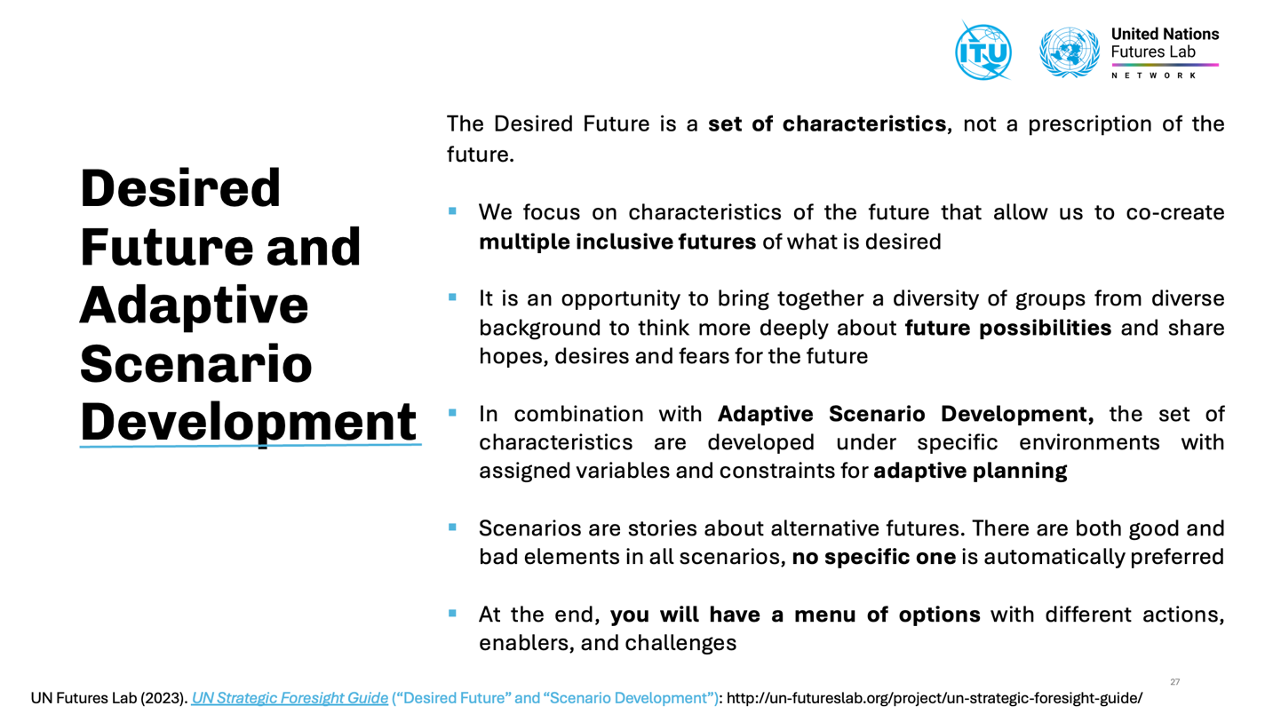
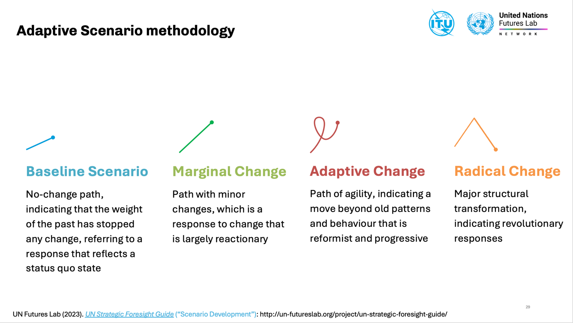
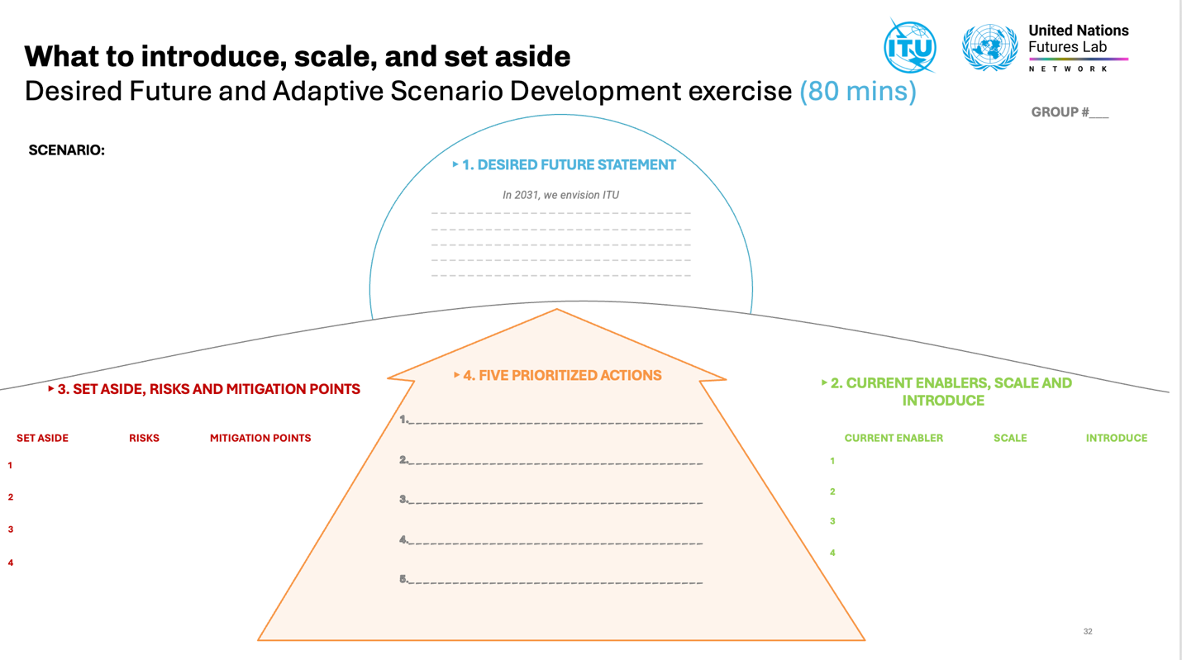

2 Scenarios developed by UN Futures Lab/Global Hub based on the insights from Workshop #1
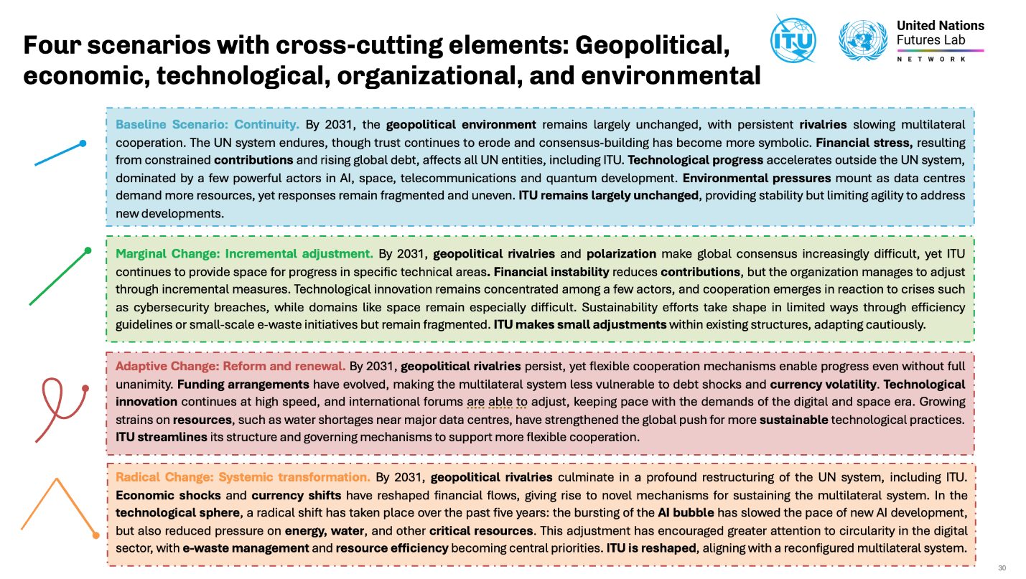
Annex 4
Group work photos

1 Group 1: Baseline Scenario
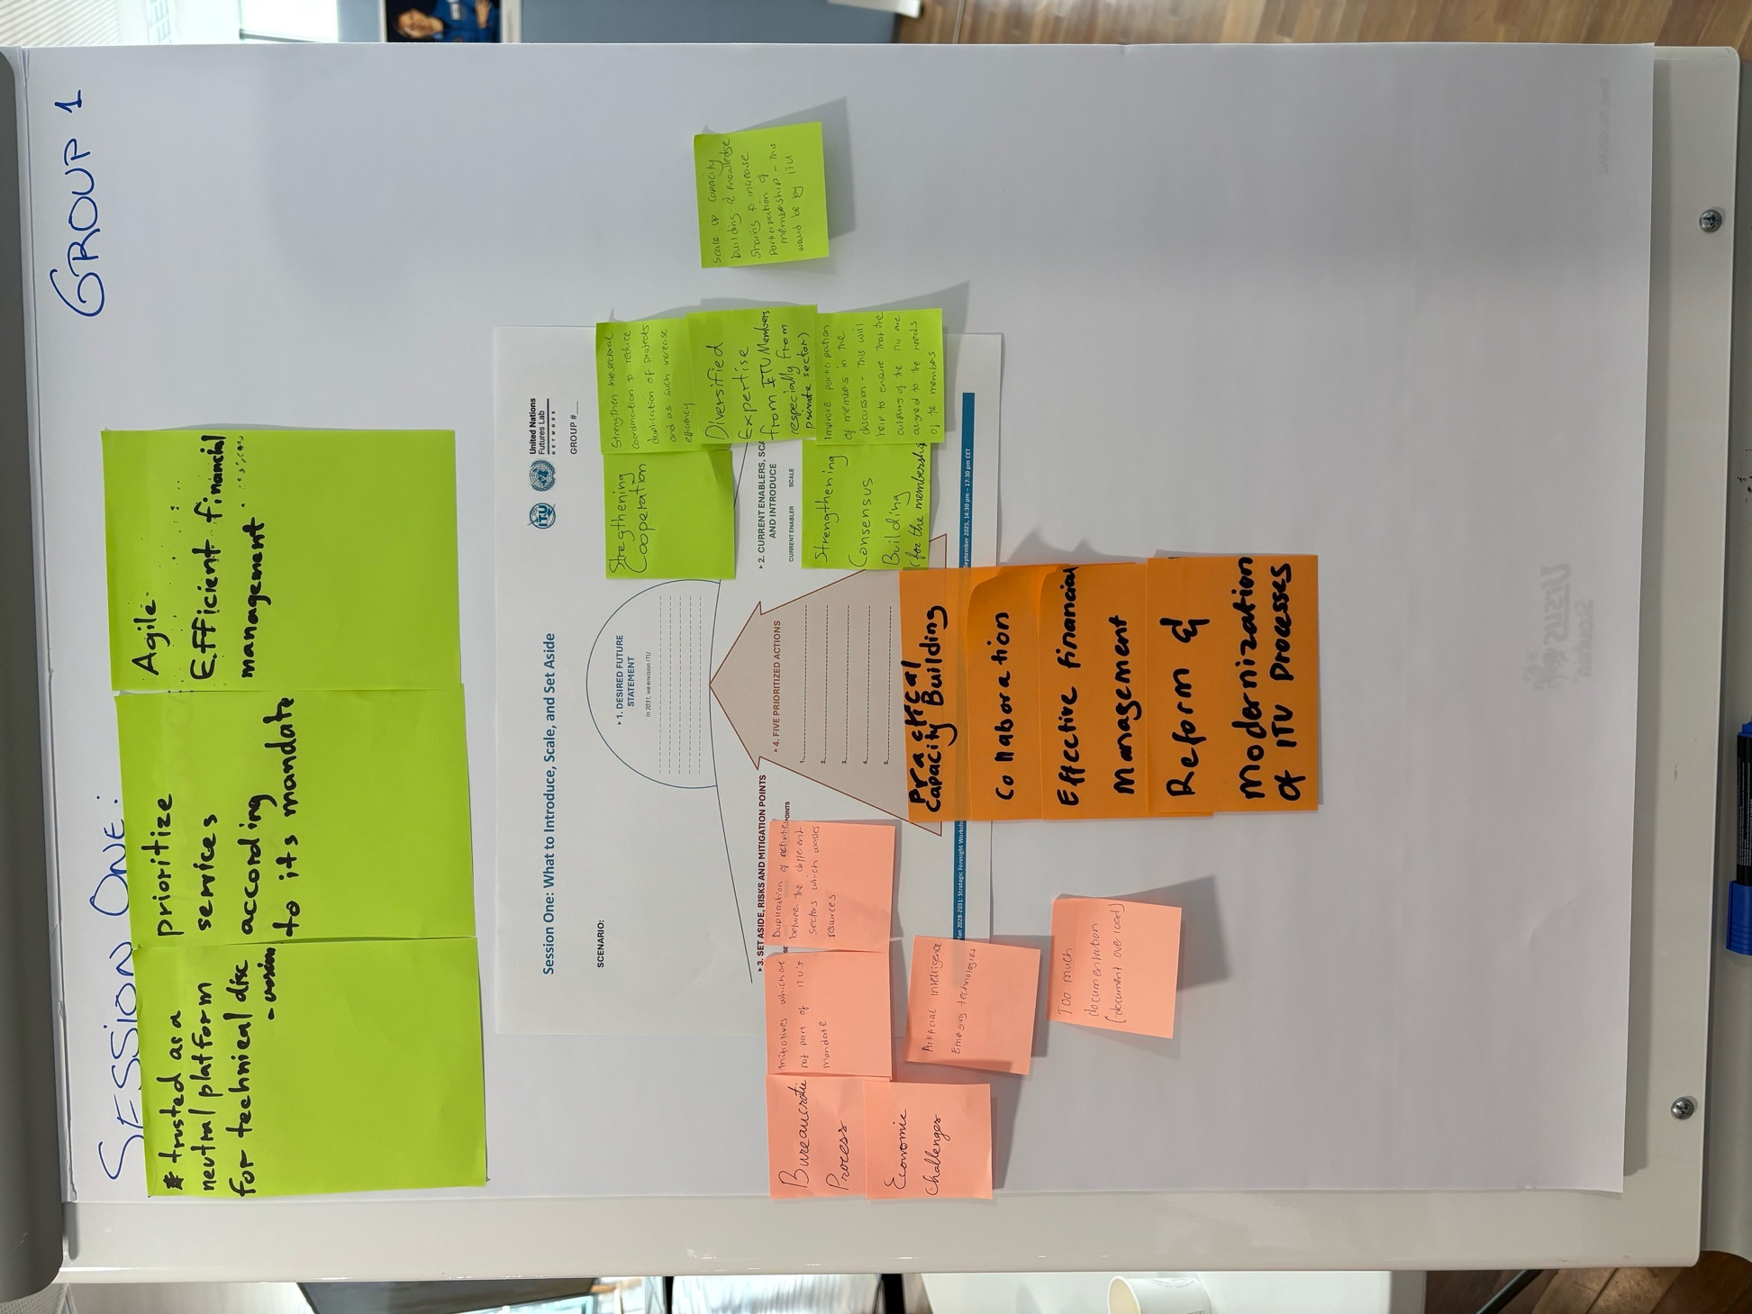

2 Group 2: adaptation scenario
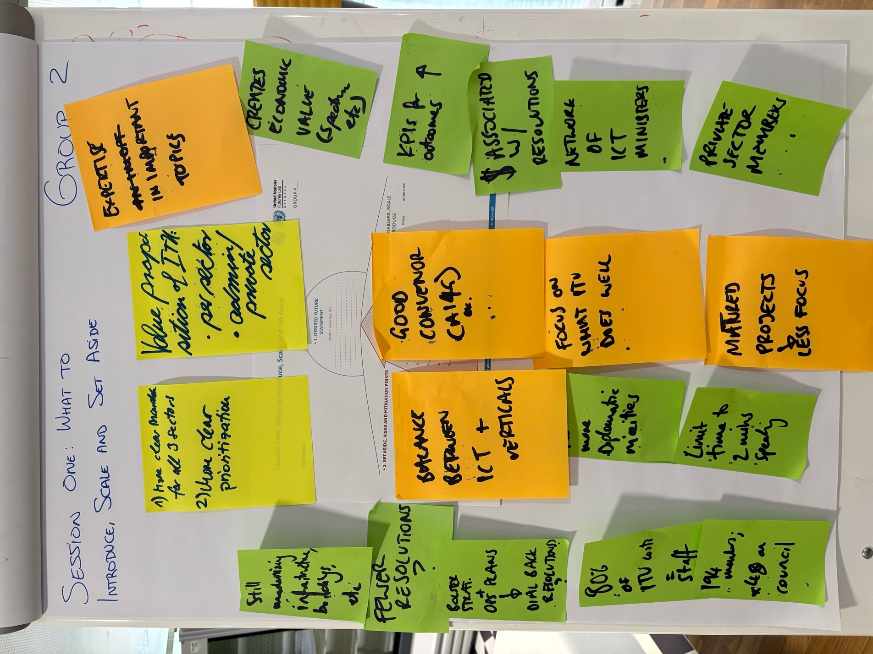

3 Group 3: radical change scenario
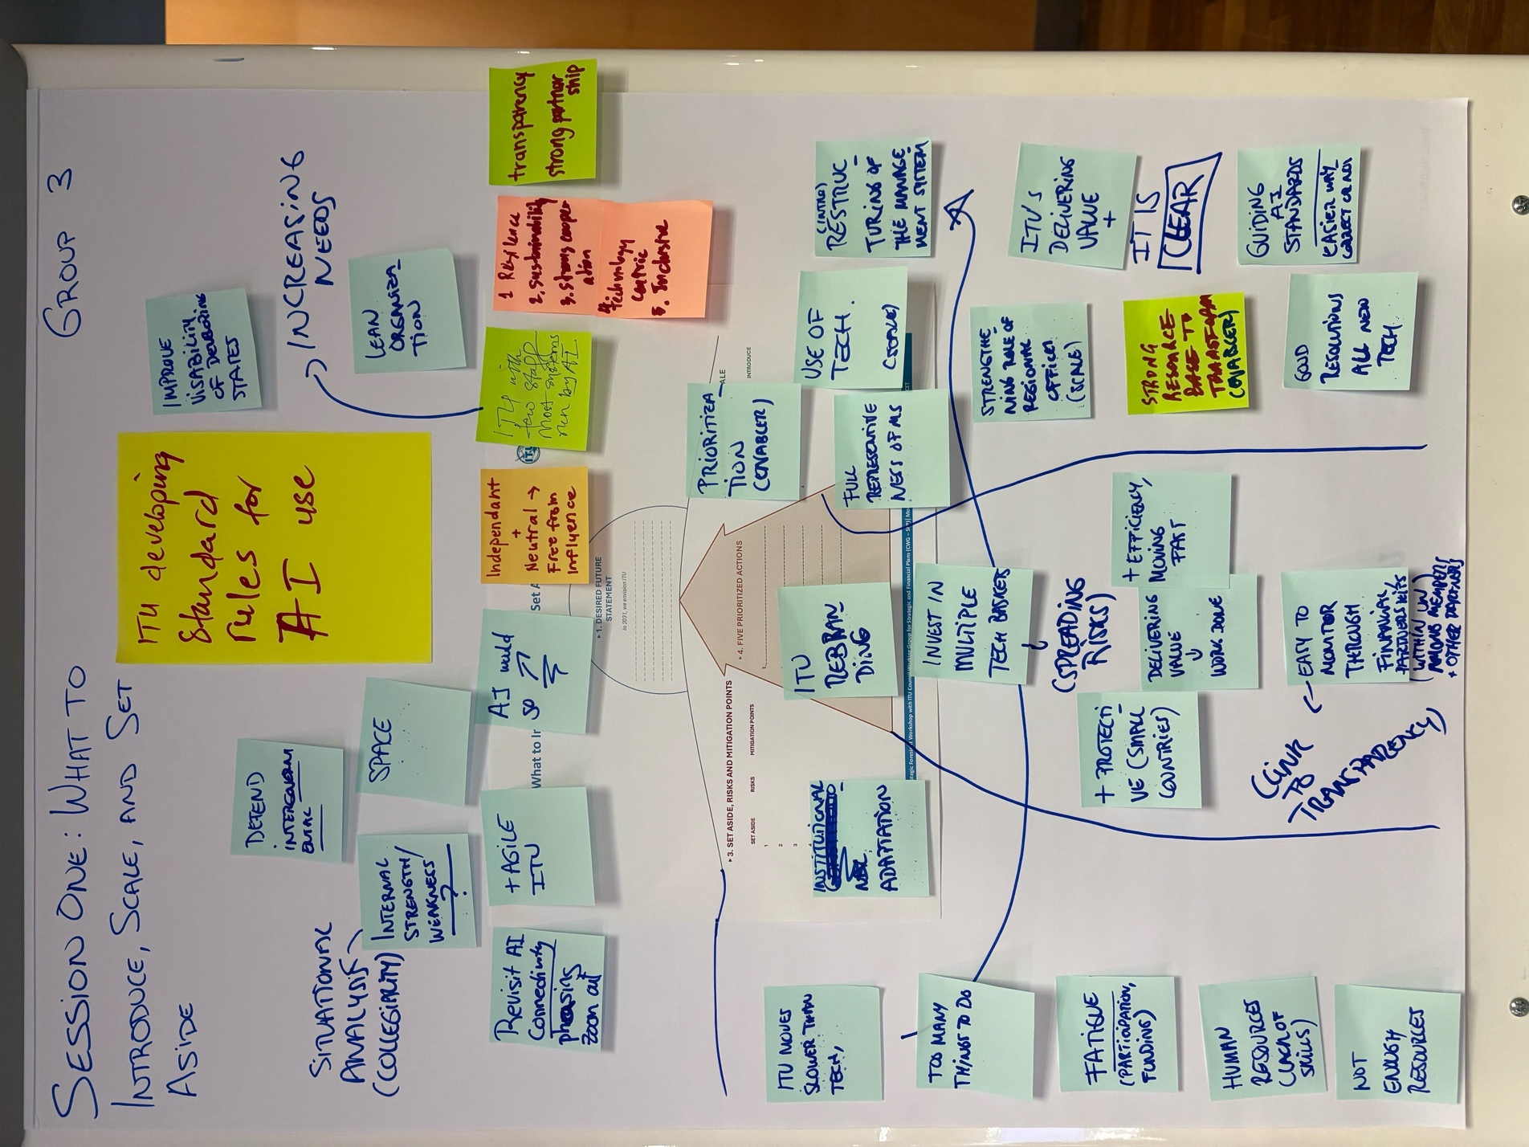

4 Group 4: Marginal Change Scenario
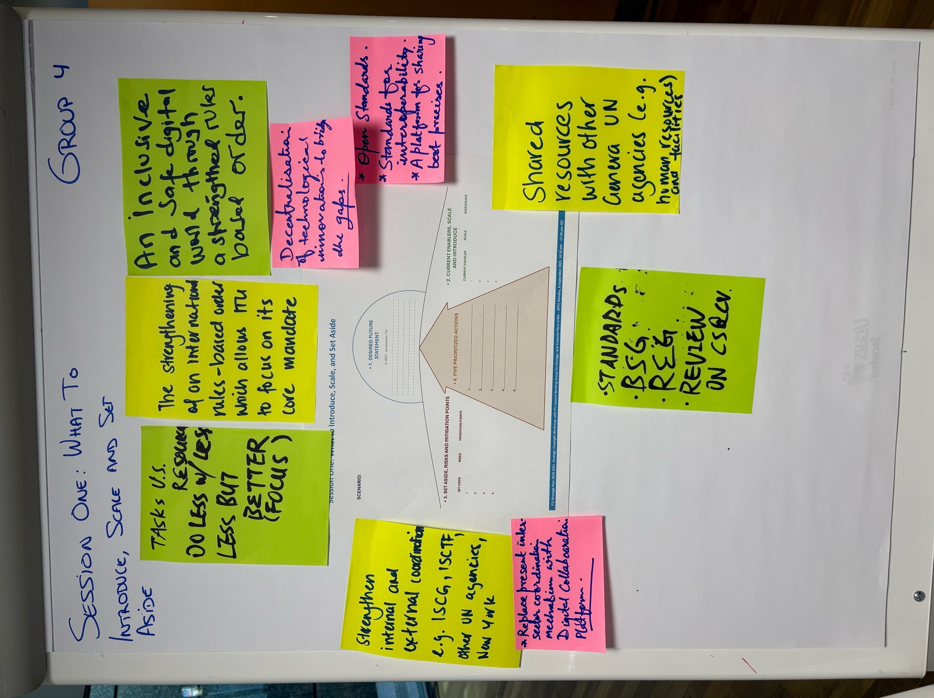

______________

The Outcome Report was produced by the UN Futures Lab/Global Hub and shared with ITU for feedback.
The UN Futures Lab (per Our Common Agenda proposal) was established by the Executive Office of the UN Secretary-General in 2023, to build and leverage strategic foresight efforts across the UN system and beyond to use futures thinking and strategic foresight in planning, policymaking, and decision-making.
UN Futures Lab (2023). UN Strategic Foresight Guide.
Horizon Scanning is a tool to identify emerging changes that could have a big impact on a country or a specific sector. UN Futures Lab (2023). UN Strategic Foresight Guide (“Horizon Scanning”).
A Signal is a first indicator of change, with the potential to scale. UN Futures Lab (2023). UN Strategic Foresight Guide (“Horizon Scanning”).
A Trend is an established general direction in which something is changing. Ibid.
A Driver of Change is a source of change. Ibid.
A Wild Card is a low-probability, high-impact event. UN Futures Lab (2023). UN Strategic Foresight Guide (“Horizon Scanning”).
Futures Triangle is a foresight tool for analyzing Signals, Trends, and Drivers that could shape ITU’s plausible futures, especially on topics that have been traditionally difficult to make progress on. UN Futures Lab (2023). UN Strategic Foresight Guide (“Futures Triangle”).
The detailed outcomes of Workshop #1 are presented in a separate Outcome Report. Key insights from Workshop #1 are outlined in this report under Section 4.
UN Futures Lab (2023). UN Strategic Foresight Guide.
UN Futures Lab (2023). UN Strategic Foresight Guide (“Desired Future”).
UN Futures Lab (2023). UN Strategic Foresight Guide (“Scenario Development”).
Participant handouts are provided for each workshop with detailed descriptions and step-by-step instructions for how to engage with the tools and methodology.
Horizon Scanning is a tool to identify emerging changes that could have a big impact on a country or a specific sector. UN Futures Lab (2023). UN Strategic Foresight Guide (“Horizon Scanning”).
Futures Triangle is an approach to engage people in conversation about broad forces that may shape the future. UN Futures Lab (2023). UN Strategic Foresight Guide (“Futures Triangle”).
All workshop reports include (i) key insights and analysis; (ii) raw data; (iii) methodology; and (iv) photos and screenshots from the group work.
Workshop #1 was informed by a pre-workshop Horizon Scanning survey. The survey drew on Signals, Trends, and Drivers from ITU publications, draft situation analyses, and academic sources across Political, Economic, Social, Technological, Legal, and Environmental (PESTLE). Participants assessed them by (i) relevance, (ii) time horizon, and (iii) implications, while also contributing new additions (19 in total).
A Signal is a first indicator of change, with the potential to scale. UN Futures Lab (2023). UN Strategic Foresight Guide (“Horizon Scanning”).
A Trend is an established general direction in which something is changing. Ibid.
A Driver of Change is a source of change. Ibid.
A Wild Card is a low-probability, high-impact event. UN Futures Lab (2023). UN Strategic Foresight Guide (“Horizon Scanning”).
Futures Triangle is a foresight tool for analyzing Signals, Trends, and Drivers that could shape ITU’s plausible futures, especially on topics that have been traditionally difficult to make progress on. UN Futures Lab (2023). UN Strategic Foresight Guide (“Futures Triangle”).
The scenarios, which draw on the insights from Workshop #1, were developed by the UN Futures Lab/Global Hub for the purposes of the exercise and are included in Annex 3: Strategic Foresight Methodology and Scenarios.

