Document CWG-SFP-4/INF/4
11 December 2025
English only
Note by the Secretary-General
LINKING ITU STRATEGIC AND FINANCIAL PLANS
Purpose
This document outlines the approach taken by the Secretariat to link ITU’s strategic and financial plans. The approach relies on the principles of results-based management to ensure that resources are applied to activities with significant impact. The document includes a timeline illustrating the process for developing and integrating the financial aspects into the draft Strategic and Financial Plans for 2028-2031.
Action required
This document is transmitted to the Council Working Group for strategic and financial plans 2028-2031 for information.
____________________________________
References
CWG-SFP website; Resolution 1428 (C24); Document CWG-SFP-3/6

Introduction
As presented to the third meeting of the Council Working Group for strategic and financial plans 2028-2031 (CWG-SFP), for the development of the draft Strategic and Financial Plans for 2028-2031, ITU will focus on strengthening its Results-Based Management (RBM) framework to ensure effective integration of strategic, financial and operational plans (see Document CWG-SFP-3/6). Specifically, this enhancement will apply a data-driven approach to more clearly distinguish between expected results (impact and outcome indicators at the level of the Strategic Plan) and the routine work plans (outputs, activities and their costs) at the level of the Operational Plans.
This structured results chain will help to improve the allocation of resources and workflows towards tangible and measurable results, as well as improve the clarity of future financial and operational reporting. Diagram 1 below visualizes how the Strategic and Operational Plans cover specific areas of the overall results chain, and the way in which the Financial Plan is integrated into the process.
DIAGRAM 1
Integration of Strategic, Financial and Operational Plans in overall results chain
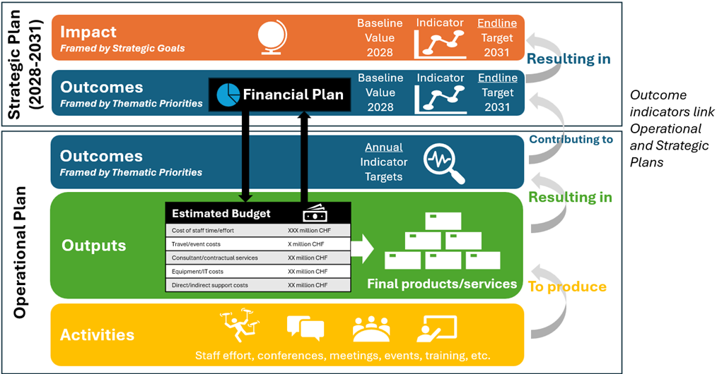

Integrating the Financial and Strategic Plans
The Financial Plan developed at the level of the Strategic Plan is an estimate of the expected revenues and the allocation of resources to each of the desired Priorities/Outcomes, based on their relative priority as defined in the Strategic Plan. The Financial Plan provides guidance for the budgeting and delivery of Outputs in Operational Plans during the period covered by the Strategic Plan.
It is envisaged that there will be several stages of development, as summarized below:

1 Validation of revenue streams for 2028-2031
As part of the preparatory work, the Secretariat is validating all major revenue streams to ensure the credibility of the baseline for the 2028-2031 period:
– Regular Budget (Contributory Units): Stability of CU commitments, membership trends, and scenario modelling for potential adjustments at ITU Plenipotentiary Conference in 2026 (PP-26).
– Satellite Network Filing (SNF) Revenues: Updated projections based on the 2026-2027 revenue patterns, implementation of the revised cost-recovery methodology, and expected filing volumes.
– Publications and Sales: Trends in digital distribution and anticipated revenue levels.
– Interest and Miscellaneous Income: Conservative estimates based on reserve utilisation, cash management, timing of receipts and global economic outlook on investment trends.
Based on the preliminary analysis of these validated streams, the initial indicative budget envelope for 2028-2031 is approximately CHF 650 million, subject to refinement following Council guidance.

2 Link to the 2026-2027 operational planning exercise
The ongoing operational planning exercise for 2026-2027 is providing essential data for refining the strategic and financial frameworks for the next period. This exercise:
– Clarifies the actual resource requirements for delivering outputs.
– Identifies opportunities for efficiency gains from digitalisation, process redesign, and RBM tools.
– Helps determine which outputs should be maintained, scaled up, or concluded.
– Enables refinement of sectoral priorities and thematic areas for the 2028-2031 Strategic Plan.
This operational insight is a critical input for aligning strategic objectives with realistic financial envelopes.

3 Path toward a full costing of the strategic plan
Once strategic priorities and expected results have been agreed by the CWG-SFP, the Secretariat will proceed with a complete review of the Strategic Plan, including:
– Resource envelopes required for each Priority.
– Estimated efficiencies and savings that offset expenditure growth.
– Alignment of RBM indicators with the financial framework.
– Clear articulation of how the Financial Plan supports the delivery of ITU’s mandate.
This ensures that the Financial Plan presented to PP-26 is evidence-based, transparent, and results-oriented. Annex 1 below visualizes the timeline for the development and approval of the financial plan.

ANNEX
Timeline for the development and approval of the financial plan
Presentation of the revised approach and initial revenue envelope | Jan. 26 | CWG-SFP
Guidance on structure, assumptions, and modelling scenarios | Jan. 26 | CWG-SFP
Review of the refined draft Financial Plan aligned with the updated Strategic Plan | TBD | CWG-SFP
Review and endorsement of the refined draft Financial Plan aligned with the updated Strategic Plan | Apr. 26 | Council 2026
Validation of revenue projections and sector-level expenditure envelopes | Apr. 26 | Council 2026
Direction on Decision 5 elements to be submitted to PP-26 | Apr. 26 | Council 2026
Approval of the ITU Strategic and Financial Plans 2028-2031 | Nov. 26 | PP-26
Decision on the Contributory Unit value, expenditure ceilings, and long-term sustainability measures | Nov. 26 | PP-26
Adoption of the revised Decision 5 | Nov. 26 | PP-26

______________

