Document CWG-FHR-22/20
12 December 2025
English only
Report by the Secretary-General
STRENGTHENING RISK MANAGEMENT AND THE INTERNAL CONTROL SYSTEM
Purpose
To inform the CWG-FHR on the establishment of the Risk Management and Internal Controls Task Force, the update of the Corporate Risk Register and initiatives to address control weaknesses identified through oversight recommendation in an effective and timely manner.
Action required
The Council Working Group on financial and human resources is invited to note this report.
_______________
References
CWG-FHR website; Council Documents C24/49, C25/49 and C25/61, and Document CWG-SFP-3/6

Background
The 2020 ITU Risk Management Policy aligned risk management activities at ITU with the 2017 Committee of Sponsoring Organizations of the Treadway Commission (COSO) Enterprise Risk Management Framework (ERM), which integrates the relationship between strategy, objectives, risks and controls as part of an organization performance framework.
The Policy assigned roles and responsibilities for risk management in accordance with the Institute of Internal Auditors Three Lines Model (TLM). The Policy also articulates risks and related controls into categories or perspectives (i.e. strategic, operational, financial, and fiduciary) and provides a multi-level risk appetite statement.
Further, at the 2025 Session of Council, the External Auditor, the National Audit Office (NAO) of the United Kingdom, made a series of recommendations that pertain to risk management and internal control, as presented in Document C25/41-E . In addition to guidance provided by the Independent Management Advisory Committee (IMAC), these recommendations guided the ITU’s actions in this area in Q3 and Q4 of 2025, and they are as follows:
• R6: Improve the Letter of Representation process, introducing validation procedures which can inform the assessment of control effectiveness.
• R9: review the effectiveness of the existing risk management arrangements and ensure that these support ITU in identifying and mitigating risks to the Union's objectives systematically.
• R11: establish a structured, risk-based second line of control to systematically monitor compliance, providing continuous assurance on the most significant and important internal controls.
• R17: establishes a systematic process for follow-up of open recommendations using existing tools.
As requested by Council 2025, a summary table listing of all the risks recorded in the Corporate Risk Register have been made available through the Council webpage. In addition, a dashboard view of all oversight recommendations in the Compliance Tracker is provided below.

1 Establishment of the Risk Management and Internal Controls Task Force
As reported to Council 2024, the Management Coordination Group (MCG) is overseeing risk management and internal control activities within the Organization. To further bolster the Senior Management role under the TLM, and to put in place a governance structure to ensure the effective consideration and implementation of oversight recommendations, a new Risk Management and Internal Controls Task Force (RMIC-TF), chaired by the Deputy Secretary-General, was established by the Secretary-General in 2025. The main objectives of the RMIC-TF are to:
1 Reinforce managerial ownership and accountability for risk and internal control activities across the organization to affect a more systematic management of risks and ensure the presence of an effective internal control system to provide greater assurance regarding the attainment of objectives.
2 Ensure that control weaknesses identified through oversight recommendations are implemented in a timely manner to mitigate the underlying risks, including more recent ones concerning to the existing risk management arrangement, second-line functions, the letter or representations and statement on internal controls.
To review and strengthen ITU enterprise risk management arrangements, in line with the recent external auditor’s recommendations, the RMIC-TF engaged an external consultant to provide an external independent assessment of the ITU’s Risk Management framework. This assessment aims to provide objective insights into the organization’s current risk management and internal controls maturity across key dimensions, including governance, risk management integration, capabilities, and business-level performance. This review will include a significant number of interviews (more than 20) with ITU stakeholders, including also IMAC and the External Auditor.
Specifically, a diagnostic review will assess ITU’s risk management practices, governance, and controls, benchmarking maturity against international standards through interviews, surveys, and document analysis. Findings will highlight strengths, gaps, and opportunities for improvement.
Based on these insights, a phased roadmap will outline actionable steps to enhance governance, compliance, and risk culture. A gap analysis will inform a structured action plan with clear responsibilities, milestones, and measurable outcomes. The assignment will conclude with a final report summarizing key findings and recommendations to build a resilient, future-ready risk management framework.

2 Update of the Corporate Risk Register
The Corporate Risk Register has been updated using the existing risk register template. As mentioned, all recorded risks are provided in a summary table made available through the Council Webpage, including both the significant risks presented to Council 2025 and also non-significant risks as requested by Member States.
The summary table includes risks that were specifically raised during Council 2025, notably the long-term sustainability of After-Service Health Insurance (ASHI) now being mitigated through an increase to 5.35 percent of the contribution of newly recruited on or after 1 January 2026; as well as the key strategic risk related to ITU’s role in the fast-evolving technological and digital landscape.

3 Fraud risk assessment
As mentioned to Council 2025, the Oversight Unit, as part of its 2025 plan, has retained the service of an external expert firm to conduct an independent Corporate Fraud Risk Assessment, which is currently under way. The objectives of the Assessment are threefold:
1 Identify potential internal and external fraud risks;
2 Evaluate the effectiveness of the current fraud prevention, detection and response strategies; and
3 Provide actionable recommendations to strengthened ITU’s fraud risk management framework.
The scope of work includes mapping the suitability of existing fraud controls and a focus of residual fraud risk. The CFRA will help focus and enhance our efforts to ensure that residual fraud risks are maintained within ITU risk appetite through appropriate mitigation measures and control monitoring activities.

4 Integrating risk management as part of operational planning
To systematically embed risk management across the organization, as presented to CWG-SFP in June 2025, we are integrating risk management as part of operational planning activities. In launching the 2026 Operational Planning process, ITU managers were asked to include key risks and mitigation measures for each workstream for which they are the “owner”; including for risk management for workstreams in their purview, and represents a first step at integrating risk management into the existing strategic and planning processes guiding the Union’s activities.
This integration is a key step in addressing the challenges affecting the implementation of ERM as reported to Council 2024 and 2025, which in turn, will assist in systematically managing risks that otherwise may affect the achievement of the outputs of the General Secretariat and the Bureaus that are set out in operational plans.

5 Addressing oversight recommendations
In May 2024, the Secretary-General initiated a review of all outstanding oversight recommendations, some going back several years. As part of this exercise, staff and managers have deployed efforts to address the various control weaknesses identified by these recommendations and, in doing so, help address the underlying risks. The results of those efforts include the closing of 92 recommendations issued by the previous External Auditor, Corte dei conti (out of 133) i, as confirmed by the current External Auditor, NAO.
Although a significant number of recommendations have been closed, the RMIC-TF will ensure that recommendation owners continue their efforts to address outstanding recommendations to further reduce the backlog. To that end, the Task Force has already devised a risk-based prioritization approach, based on the multi-level ITU risk appetite statement, to tackle the remaining of the Corte dei conti’s recommendations.
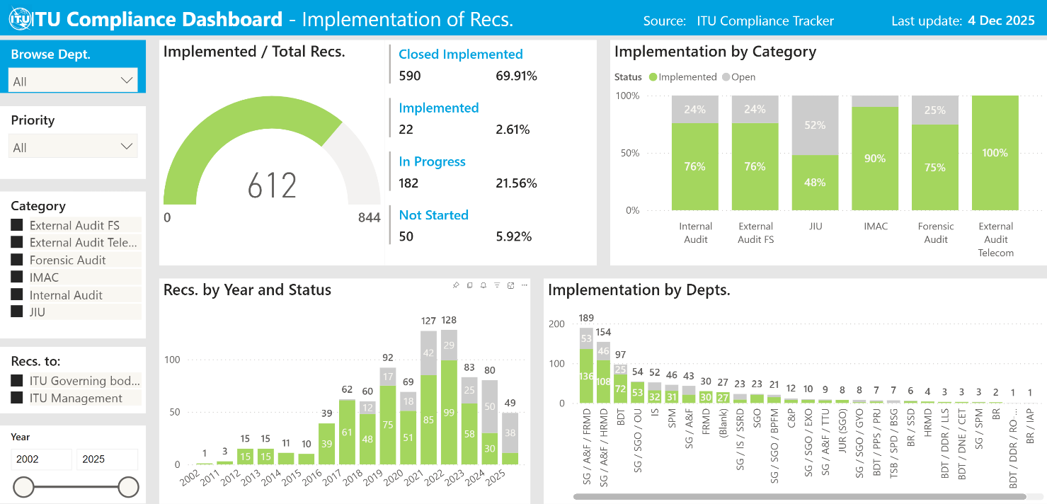
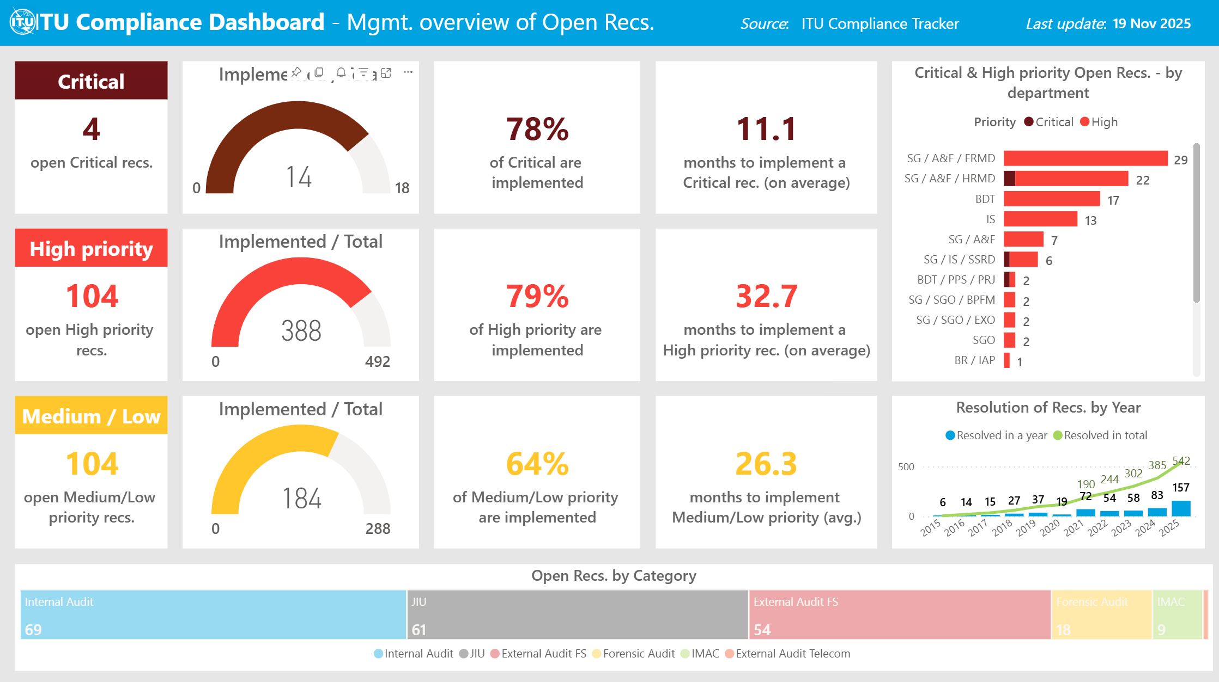

6 Delegation of authority framework
The delegation of authorities for financial matters is governed by the ITU Financial Regulations and Rules, as well as various services orders, notably for expenses and invoices, procurement, and travel. However, some areas for improvement have been identified in the articulation of delegated authorities at the bureau, department, division and unit levels, including for operational matters. The Union is currently at the final verification and revision stage of a comprehensive framework that was developed by an expert consultant to ensure that authorities are clearly documented, appropriately delegated and consistently exercised across the Union.

______________

COSO Guidance: Enterprise Risk Management – Integrating with Strategy and Performance (www.coso.org).
On 8 October 2014, the UN Chief Executive Board for Coordination (CEB) adopted the High-Level Committee on Management’s Reference Risk Management, Oversight & Accountability Model for the UN System which notably recommended the adoption of the TLM. Under the Model, the First Line comprises managers who have day-to-day ownership and management of risks and controls in their business areas; the Second Line regroups various functions to provide support to First Line managers regarding their risk and control responsibilities; and Third Line functions (e.g. internal audit) provided independent assurance to governing bodies and senior management regarding the internal control system. In 2022, the Council also adopted the new ITU Accountability Model and Framework, which drew on the 2013 COSO Internal Control – Integrated Framework (www.coso.org) and also championed the TLM for roles and responsibilities.
NAO Report, Document C25/41.
Document C24/49.
The template will continue to be adjusted and simplified as required to improve focus on key elements notably residual risks and risk appetite, mitigation either planned or in progress, to support risk management as a continual process.
Document CWG-SFP-3/6, 8 August 2025.
Documents C24/49 and C25/49.
Document C25/41.
The articulation of this approach rests on Annex B of the ITU Risk Management Policy, which set out ITU risk different appetite statements set out different risk appetites depending on risk perspectives or categories concerned (e.g. fiduciary risks: low appetite regarding, for instance, safety and security; strategic risks: high appetite, for instance, for innovation and technological advances). Open channels with IMAC and NAO on progress made, including seeking timely validation of implementation, will complement this approach.
For instance, Service Orders 18/11: Delegation of authority for approval of expense commitments and invoices; and 22/13: Procurement Manual; and 18/07: Delegation of Authority for Approval of Travel Authorization.

