Document CWG-FHR-22/12
11 December 2025
English only
Report by the Secretary-General
PEOPLE AND CULTURE INITIATIVES
Purpose
In line with the People and Culture pillar of the ITU Transformation Roadmap and the Human Resources Transformation Plan, ITU continues to advance initiatives under the People and Culture framework to foster an inclusive, engaged and high-performing workforce. This information document provides an update on key initiatives, including the Leadership Development Programme, the Mental Health and Well-being Action Plan, the Reward and Recognition Framework and the Employee Engagement Survey and its follow-up actions.
Action required
The Council Working Group on financial and human resources is invited to note this document.
_______________
References
CWG-FHR website; Document C23/INF/13

1 Background
As part of the implementation of the Human Resources Transformation Plan, ITU has continued advancing initiatives under the People and Culture pillar of the ITU Transformation Roadmap.
These efforts reflect ITU’s commitment to fostering an inclusive, engaged, and high-performing workforce, aligned with its strategic objectives. The initiatives focus on leadership development, mental health and well-being, reward and recognition, and employee engagement.

2 People and Culture Initiatives

2.1 Leadership Development
In 2025, ITU continued a comprehensive Leadership Development Programme that integrated the principles of inclusive and adaptive leadership, aimed at strengthening leadership capabilities and alignment across all levels of the organization. The programme seeks to foster a cohesive leadership culture built on accountability, trust, and collaboration, while supporting the Union’s transformation priorities.
The programme focused on inclusive leadership (managing bias, identity and microaggressions, advancing gender and racial equity and inclusion, and fostering psychological safety) and adaptive leadership principles to support our management in leading effectively through uncertainty and change, engaging elected officials (with a dedicated workshop to enhance strategic leadership and alignment on key priorities), senior managers (building leadership capabilities to manage effectively in times of change), and change makers (to strengthen their role as champions of change across the organization).

2.2 Mental Health and Well-being Action Plan
Implementation of the ITU Mental Health and Well-being Action Plan remains a cornerstone of the People and Culture agenda. The Plan takes a holistic approach to well-being —encompassing physical, psychological, and social dimensions— with a strong focus on prevention, early intervention, and sustained support.
Key initiatives include the introduction of an Ombudsman, the ‘Where to Go’ guide, effective communication sessions, mental-health literacy training for staff and managers, individual counselling support, the incorporation of stigma-reduction interventions, and return-to-work programmes, among others (shown below in Figure 1). These measures are reinforced by cross-cutting actions related to leadership, investment, participation, and compliance, creating an enabling environment for lasting impact. The Employee Engagement Survey and the Mental Health and Well-being Action Plan are closely aligned and operate in a mutually reinforcing feedback loop.
Figure 1
Progress update as of November 2025
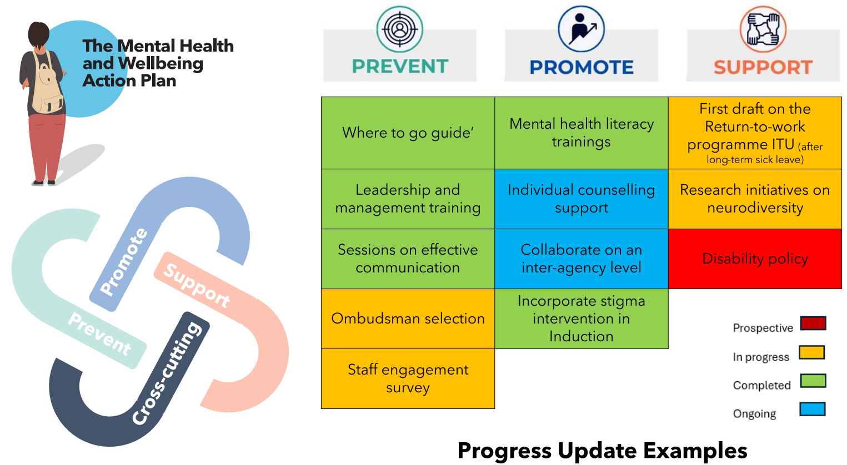

2.3 Reward and Recognition
ITU is developing a comprehensive Reward and Recognition Framework to strengthen a culture of appreciation and performance across the Union, with the aim of fostering a highly motivated workforce. The Framework combines both formal and informal mechanisms to acknowledge individual and collective achievements that contribute to ITU’s strategic objectives and values.
Key elements include encouraging managers to give informal shout-outs to promote day-to-day appreciation and feedback among colleagues, long-standing service awards recognizing years of dedication and commitment, a team award to highlight collaborative achievements across all levels, and an ITU-wide recognition of excellent performance celebrating excellence, innovation and teamwork. This people-centred approach to recognition –highlighted by the Secretary-General as essential to nurturing a strong sense of community within the Union – came to life on 8 December 2025 during a hybrid recognition ceremony. Speaking to a full room in Popov, the Secretary-General personally presented long-standing service awards to staff members, joined by the other elected officials in honouring those with more than 20 years of dedicated service. This ceremony was a testament that the dedication and commitment of colleagues across the various department is fundamental to ITU’s achievements over its 160-year history.

3 Employee Engagement Survey and follow-up

3.1 Employee Engagement Survey
As part of the Human Resources Transformation Plan, ITU conducted its first Employee Engagement Survey (EES) in early 2025. The survey served as a diagnostic tool to understand employees’ levels of commitment, motivation and connection to their work and to the Organization, to drive efficiency and effectiveness, and to pinpoint strengths and areas for improvement in workplace culture, management practices and operational efficiency.
With a participation rate of 72 per cent of all ITU colleagues, the EES provided a solid evidence base for identifying strengths and areas requiring further attention. Building on the survey results and to maintain staff engagement in the follow-up process, ITU convened an all-staff townhall and workshop to discuss the findings and jointly brainstorm on actions to address the key challenges identified. The findings and subsequent grassroots exercise, which took place across all departments and Bureaux, informed the design of targeted actions to enhance employee experience and strengthen collaboration, feedback, and communication.

3.2 Employee Engagement Survey follow-up
The follow-up to the EES is being designed and operationalized by staff at the grassroots level through departmental teams and designated Engagement Ambassadors, with HRMD exercising overarching facilitation and support.
At the corporate level, an ITU-wide action plan, at the request of the Secretary-General, is being developed and led by the Chief of HRMD with the participation of the Secretary-General’s office and the Staff Council. As part of this plan, four key actions will be introduced in 2026: Open-Door Sessions with Elected Officials will provide regular, bookable opportunities for individual staff members to engage directly with elected officials in short informal meetings, thereby strengthening transparency, dialogue and trust; a Brown Bag Lunch Series will create an informal, hybrid forum for cross-departmental knowledge-sharing, showcasing ongoing work and lessons learned, and building mutual understanding; Innovation Days will set aside a protected day each month for staff to experiment with new ideas, tools and ways of working, including cross-team collaboration and peer review; and an ITU-wide Mentorship Programme, open to staff from all grades, categories and duty stations, will foster professional and personal development through structured mentoring relationships supported by workshops, peer exchanges and online resources. Taken together, these actions are mutually reinforcing and help embed a culture of openness, learning, and accountability.

______________

