Document C26/INF/23
24 April 2026
English only
Note by the Secretary-General
BACKGROUND AND USER GUIDE FOR THE ITU COMPLIANCE DASHBOARD
Purpose
The ITU Compliance Dashboard for Councillors provides enhanced, interactive reporting for Councillors on ITU’s implementation status of oversight recommendations deriving from Internal Audit, External Auditors, and IMAC. This information document serves as both a background document and “user guide” for the tool.
Action required by the Council
This document is transmitted to the Council for information.
_______________
References
Council document C26/49 on Strengthening Risk Management and the Internal Control System

1 Introduction
1 The ITU Compliance Dashboard for Councillors was developed to enhance transparency, accessibility and strategic oversight of the Union’s compliance with recommendations issued by internal and external oversight bodies. The dashboard consolidates information into a single, interactive platform accessible through a web browser.
2 The Compliance Dashboard is intended to provide Councillors with a clear, up‑to‑date overview of the status of recommendations addressed to the Union, including those emanating from the External Auditor, Internal Audit, and the Independent Management Advisory Committee (IMAC). It is designed to support informed consideration of compliance trends, implementation progress, and areas requiring sustained management attention. The Compliance Dashboard reflects all recommendations since 2016.
3 To avoid duplication and to ensure a “single source of truth” for reporting, the recommendations of the UN Joint Inspection Unit (JIU) are reported via the JIU Recommendation Tracking System (RTS) (see Document C26/INF/17 on JIU).

2 User Guide to the Compliance Dashboard
4 Implementation Status page. Provides a snapshot of the overall compliance landscape across external audit, internal audit, and IMAC recommendations. It summarizes the total stock of recommendations and their current implementation status (i.e. closed (by the oversight body) and implemented / implemented / in progress / not started).
Please note the difference between “Closed implemented” and “Implemented”. “Implemented” indicates recommendations that have been implemented by the ITU but not yet certified by the issuer, while “Closed implemented” is the status reflected when the issuer of the recommendation (External Auditors, Internal Audit, and IMAC) certifies that implementation status. The green portions of charts on this page of the Dashboard represent the sum of “Implemented” and “Closed Implemented”, while the grey portions of charts represent open recommendations.
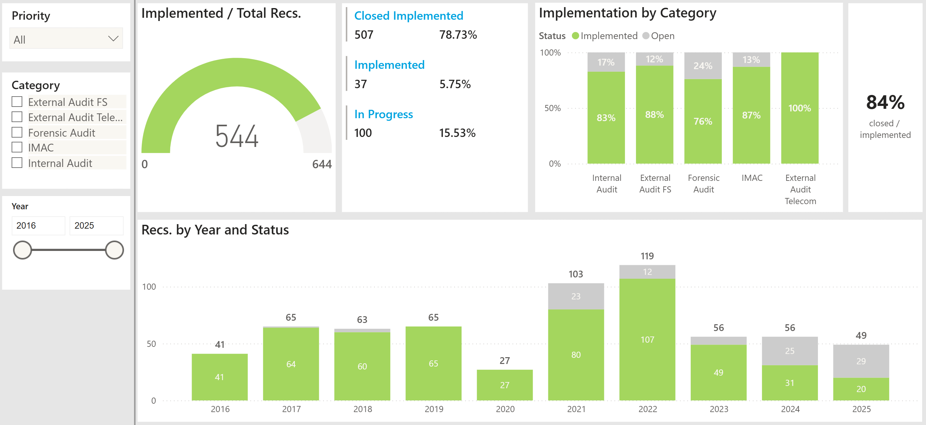
5 Open Recommendations page. This page allows users to explore all open recommendations, grouped by their category (i.e., the source of the recommendation) and criticality level. Interactive filters enable Councillors to narrow the analysis to specific oversight bodies or criticality levels of interest, as well as by year of recommendation issuance, making it possible to understand the exact recommendations which remain open and how implementation efforts are evolving across different governance domains.
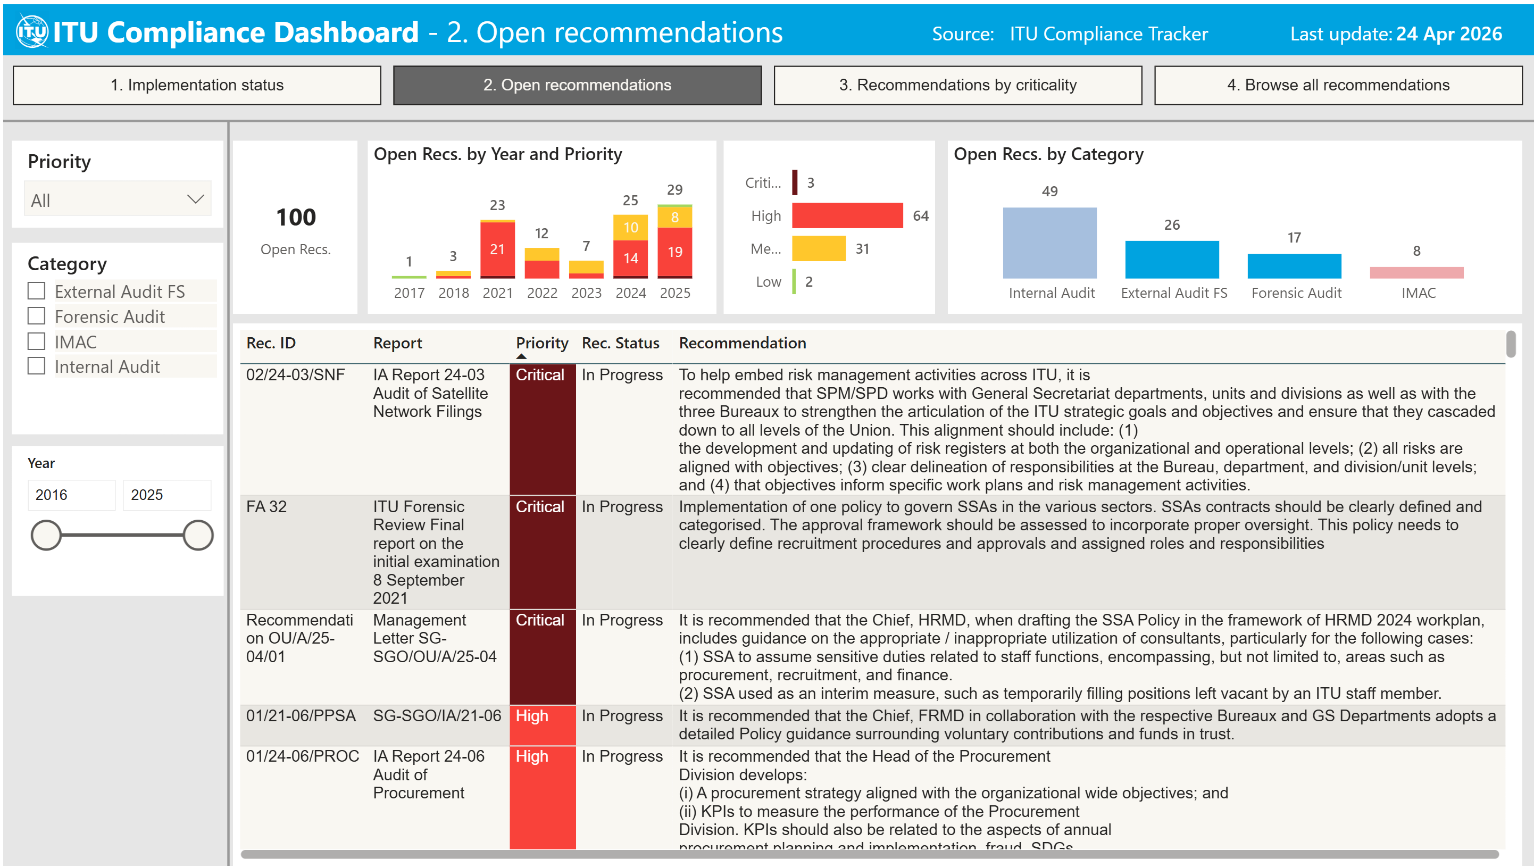
6 Recommendations by Criticality page. The third page presents recommendations from a priority perspective, showing also how critical and high priority recommendations are distributed across organizational units. It also indicates the average time elapsed between the issuance of recommendations and their implementation, by criticality level. Please note here that “Implemented” represents the sum of “Implemented” and “Closed Implemented” status categories.
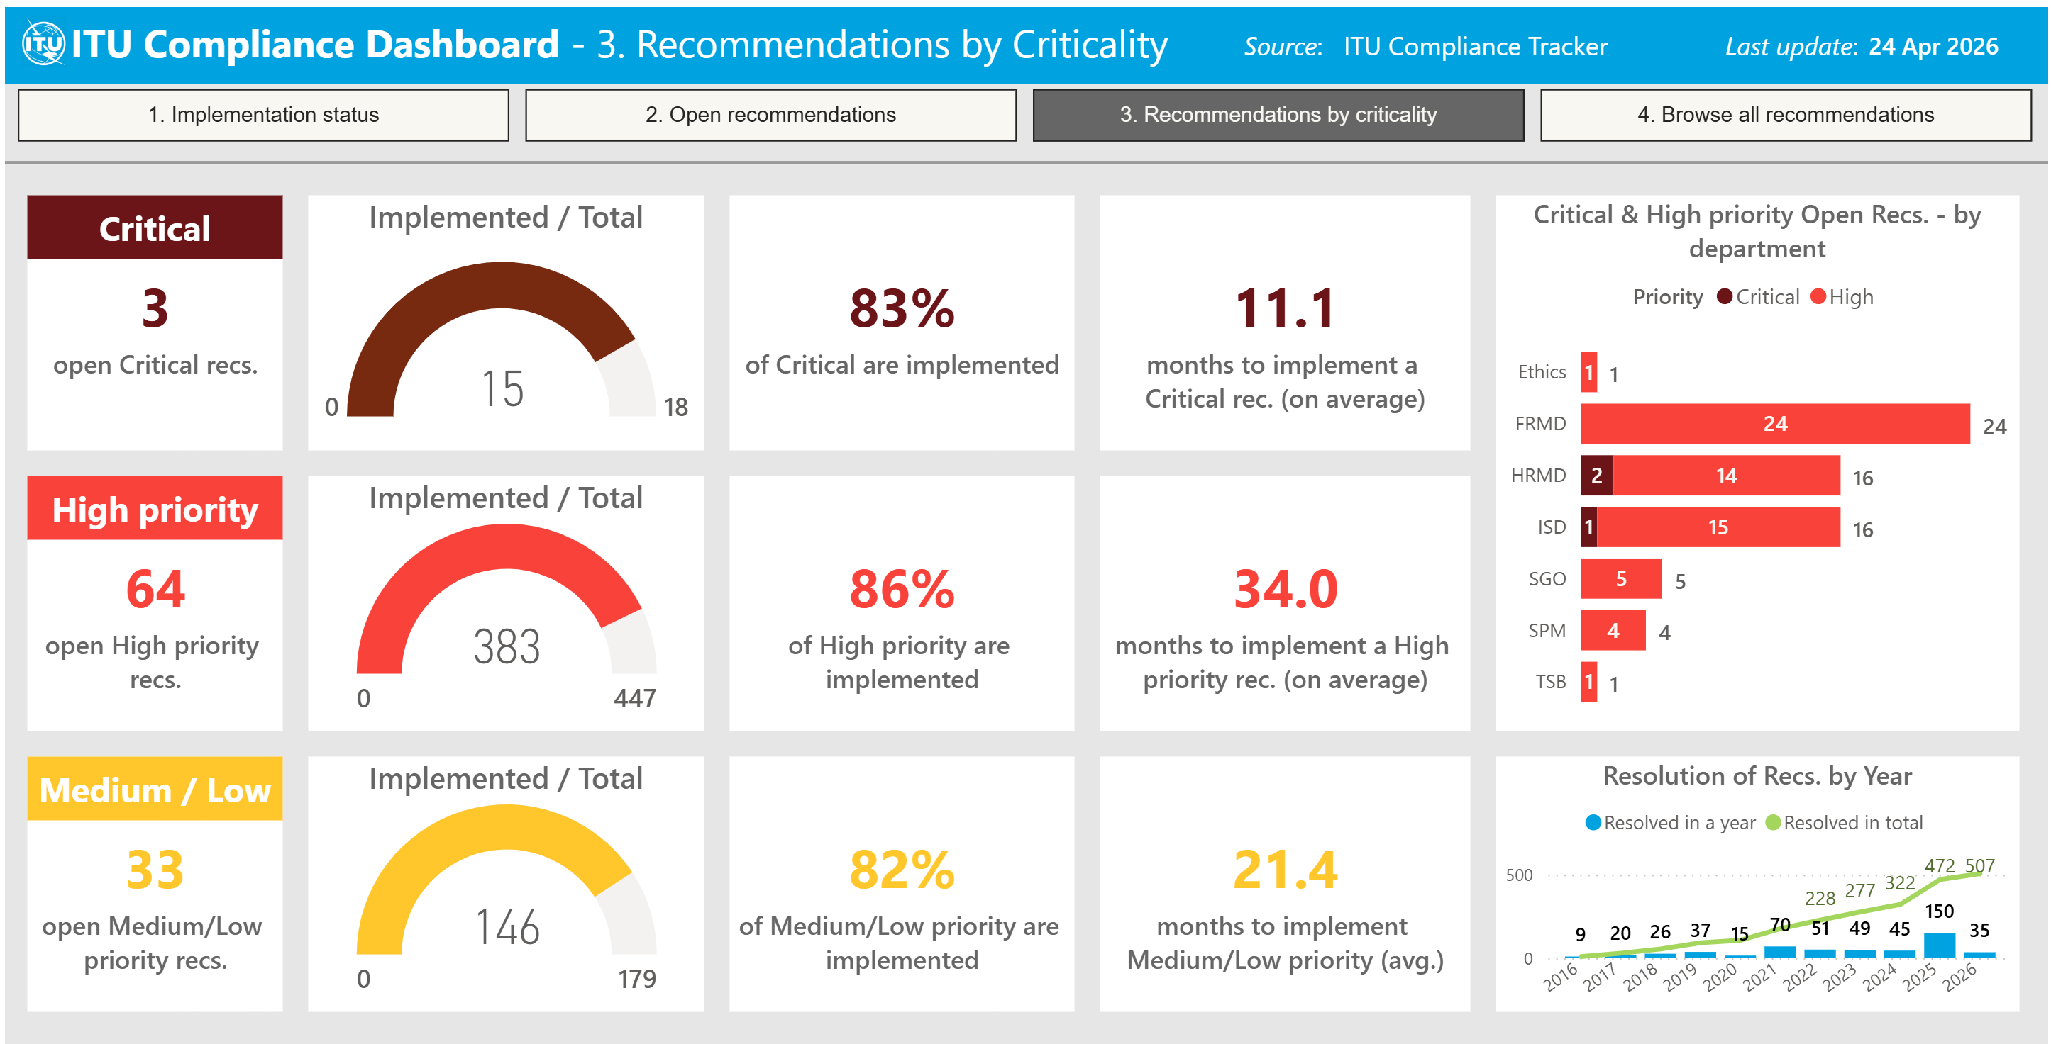
7 Browse All Recommendations page. This page provides a detailed, tabular view of all recommendations, sorted by category / source report and including also implementation status. Councillors can browse all recommendations (including those implemented and closed). Built‑in sorting and filtering functions allow Councillors to focus on selected subsets of recommendations.
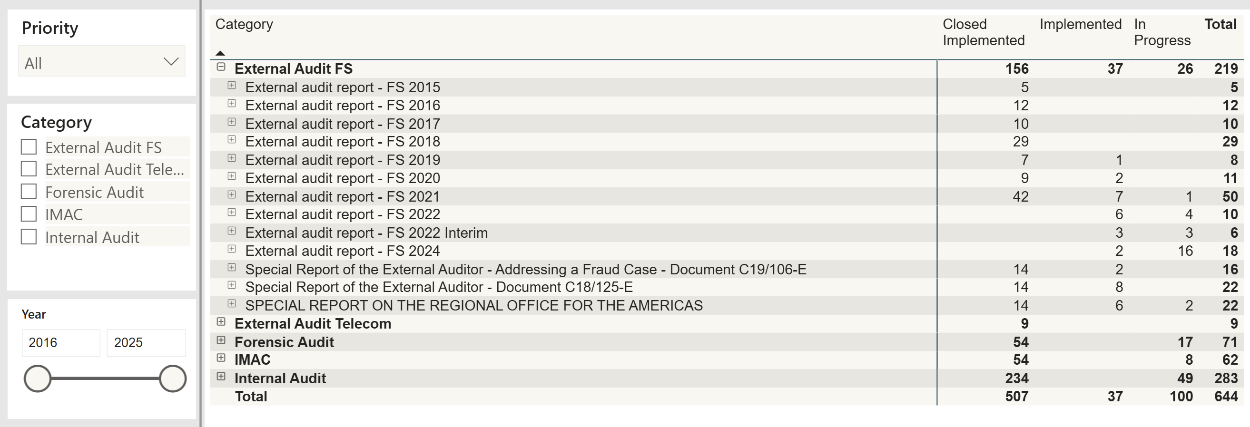
In order to expand the selection and browse all recommendations, Councillors are invited to click on the small “plus sign” at the top left of each row, which allows viewers to see the text comprising each individual recommendation, as indicated below.
_____________

