Document C26/INF/17
10 April 2026
English only
Note by the Secretary-General
UPDATE ON ITU’S IMPLEMENTATION OF RECOMMENDATIONS FROM THE JOINT INSPECTION UNIT OF THE UNITED NATIONS (JIU)
Purpose
This report provides enhanced context and reporting to complement both Document C26/57, on JIU reports on United Nations system-wide issues for 2025 and recommendations addressed to the legislative bodies and Document C26/49 on strengthening risk management and the internal control system.
Action required by the Council
This document is transmitted to the Council for information.
_______________
References
Documents C26/49 and C26/57.

1 Introduction
1 The Joint Inspection Unit (JIU) is the independent external oversight body of the United Nations system, mandated to improve efficiency, effectiveness, and accountability across organizations.
2 Since late 2025, ITU has undertaken a comprehensive, organization‑wide effort to review, and more effectively manage and report upon, the status of the JIU recommendations, as a key pillar of the ITU’s strengthened oversight architecture.

2 Current acceptance and implementation status
3 ITU has achieved substantial and measurable progress in terms of implementation and reporting accuracy for all outstanding JIU recommendations. This has resulted in a comprehensive and significant update of ITU data in the JIU Recommendation Tracking System (RTS).
4 For the full period 2004-2025, ITU’s cumulative acceptance rate is 82 per cent, reflecting the proportion of JIU recommendations formally accepted by the ITU. For the same period, the cumulative implementation rate stands at 87 per cent, representing the proportion of JIU recommendations (addressed to ITU and accepted) reported as implemented.
5 For the period 2017-2024, the period reflected in the latest JIU Annual Report, the acceptance rate currently stands at 93 per cent, while the implementation rate has reached 77 per cent. This data is now fully reflected in the JIU Recommendation Tracking System, as illustrated in the figures on the following pages.
6 The progress achieved for the 2017-2024 period is particularly significant, as it directly concerns the data underpinning the most recent JIU Annual Report and the related comparative analysis across the UN system. During this period, 37 Reports, 3 Notes and 1 Letter relating to ITU, have generated a total of 226 recommendations. Of these, ITU has accepted 211 recommendations and has already implemented 162. ITU management remains fully committed to the continuous strengthening of the organization’s oversight, accountability and internal control frameworks, to address the remaining recommendations.
7 Earlier discrepancies in reporting stemmed primarily from ITU’s reliance on its internal Compliance Dashboard as the principal tracking tool, and lack of automatic synchronization with the JIU data. This gap has now been resolved, establishing a single authoritative source within the JIU system. The figures below now provide an accurate and transparent overview of ITU implementation efforts. As of the present session of the Council, ITU has established regular and structured reporting to the Council on the status of acceptance and implementation of the JIU recommendations.

Acceptance and implementation status for JIU recommendations issued to ITU (2004-2025)
Data for ITU (2004-2025) | Acceptance/Implementation rates across the UN system
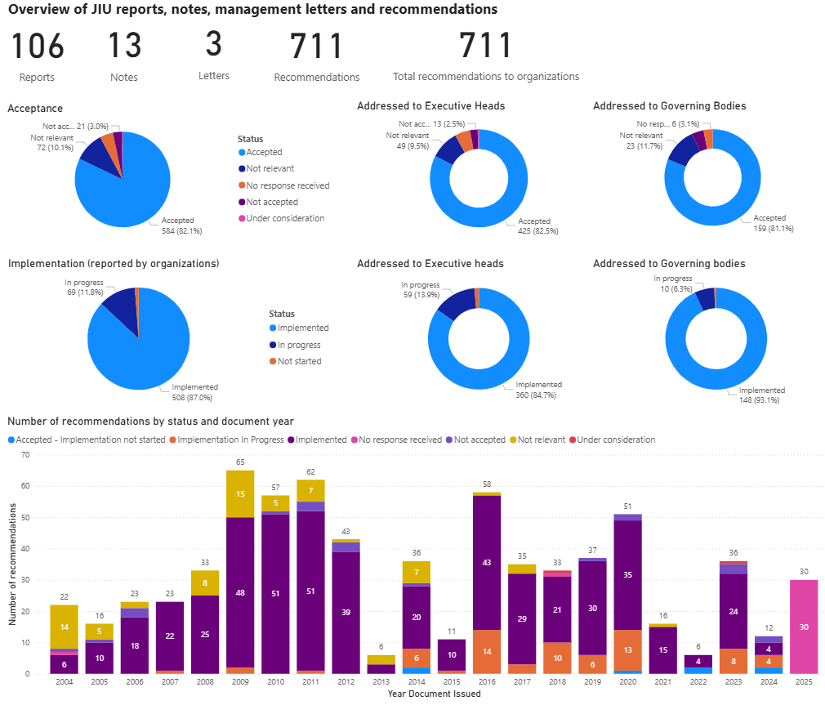 | 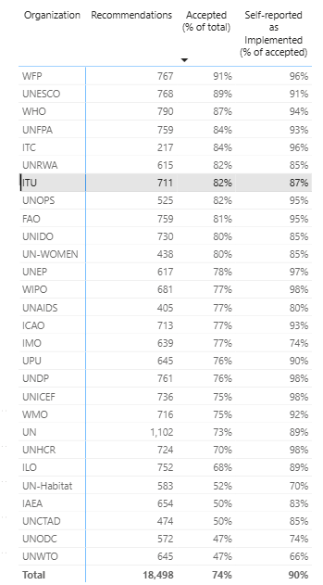
Source: Joint Inspection Unit of the United Nations System | Recommendation Tracking System (RTS). Date of retrieval: 31 March 2026.
Acceptance and implementation for JIU recommendations issued to ITU (period 2017-2024)
Data for ITU (period 2017-2024) | Acceptance/Implementation rates across the UN system
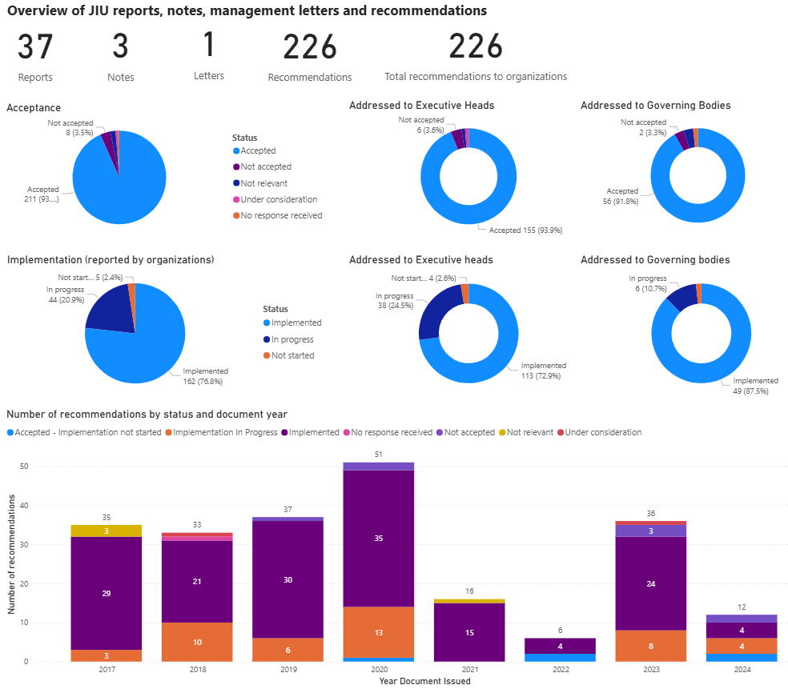 | 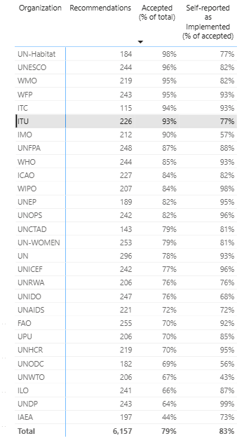
Source: Joint Inspection Unit of the United Nations System | Recommendation Tracking System (RTS). Date of retrieval: 31 March 2026.
______________

