Agenda item: PL | Revision 1 to  Document C26/140-E
Agenda item: PL | 27 October 2026
Agenda item: PL | Original: English
Report by the Secretary-General
RESOLUTION 1436: IMPACT ON CIVILIAN TELECOMMUNICATIONS/ICT INFRASTRUCTURE IN BAHRAIN, KUWAIT, THE UNITED ARAB EMIRATES AND JORDAN, AND ITS IMPLICATIONS FOR REGIONAL AND GLOBAL CONNECTIVITY
INTERIM REPORT
Purpose
As per Council Resolution 1436, this document provides an interim report on the impact of attacks on telecommunication/ICT infrastructure in Bahrain, Kuwait, the United Arab Emirates and Jordan, including a damage assessment. It presents preliminary impacts, particularly those arising from the damage to data centres in Bahrain and the UAE. In addition, the report highlights the increased vulnerability risk of submarine cables and the Internet backbone connecting the respective countries.
Action required by the Council
The Council is invited to note this report and defer the decision to extend the submission of the full report to the Council session in 2027 to the Plenipotentiary Conference.
Relevant link(s) with the Strategic Plan
N/A
Financial implications
No additional implications.
_______________
References
ITU Council Resolution 1436 (C26).

1 Background
At its 2026 session, the ITU Council adopted Resolution 1436 on the impact of attacks on civilian telecommunications/ICT infrastructure in Bahrain, Kuwait, the United Arab Emirates, and Jordan, and its implications for regional and global connectivity. Resolution 1436 instructs the Directors of the three Bureaux to monitor and provide regular reports on the attacks on telecommunications and ICT infrastructure in Bahrain, Kuwait, the United Arab Emirates, and Jordan, and to assess the impact of these attacks on telecommunications infrastructure, services, and ITU programmes.
Therefore, based on the instructions stated in Resolution 1436, this interim report aims to provide an analytical assessment addressing:
- Identification of events and affected telecommunications and ICT infrastructure assets and services in Bahrain, Kuwait, the United Arab Emirates, and Jordan.
- Damage and impact assessment of the attacks on telecommunications services and infrastructure in Bahrain, Kuwait, the United Arab Emirates, and Jordan, including their global implications.
This interim report presents preliminary results based on literature and desk review of publicly available information and data. Further data collection and analysis, including from primary sources, is required to complete the final report. If the Council and/or ITU Plenipotentiary Conference finds it appropriate, the final report can be presented at the Council meeting in 2027.

2 Events, Affected Assets, and Impact
This section lists events in which attacks have affected telecommunications and ICT infrastructure. Based on publicly available information, it was possible to identify related events in Bahrain and the United Arab Emirates, which are listed in this section. As the assessment progresses with incorporating additional data sources, particularly from primary sources, it may reveal additional direct impacts on ICT and telecommunications infrastructure in the four countries.

2.1 March 2026: Damage to Amazon Web Services data centres in the United Arab Emirates and Bahrain
On 1 March 2026, Amazon Web Services (AWS) reported degraded services in two of its Regions, namely ME-CENTRAL-1 in the United Arab Emirates and ME-SOUTH-1 in Bahrain . The initial announcements indicated that power and connectivity issues were degrading services in one Availability Zone in each Region. Subsequent updates on 1 and 2 March continued to highlight that AWS services were impacted by power and connectivity issues, while also indicating that AWS teams were working to restore service.
Later, in the early hours of 3 March 2026 (Gulf Standard Time), AWS connected the service impact with the conflict in the Middle East and clearly stated that both regions were hit by drones and advised customers to “exercise their disaster recovery plans, recover from remote backups stored in other regions, and update their applications to direct traffic away from the affected regions” .
According to the AWS service health website⁵ ⁶, AWS initially reported that the damage was limited to two of the three Availability Zones in the United Arab Emirates (ME-CENTRAL-1) Region, and one of the three Availability Zones in Bahrain (ME-SOUTH-1) Region. Later, on 30 April 2026, AWS’s update indicated that all Availability Zones in both AWS Regions had been affected by the situation in the Middle East and that the recovery for both ME-CENTRAL-1 and ME-SOUTH-1 regions would take several months. On 15 September 2026, AWS reported that data hosted exclusively in the ME-SOUTH-1 Region (Bahrain) could not be restored, and that the same applied to one of the three Availability Zones in ME-CENTRAL-1 (the United Arab Emirates). AWS reiterated its advice to customers to re-establish operations in alternative Regions.
Data from Cloudflare Radar show a rapid traffic decline in both Regions, which may reflect both service unavailability and migration of customer workloads to other Regions. As shown in Figure 1, HTTP requests to IP addresses served from the ME-CENTRAL-1 and ME-SOUTH-1 Regions have severely declined since 2 March 2026.
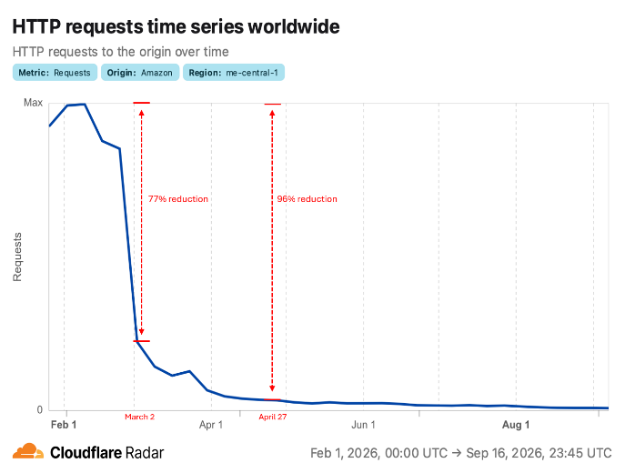 | 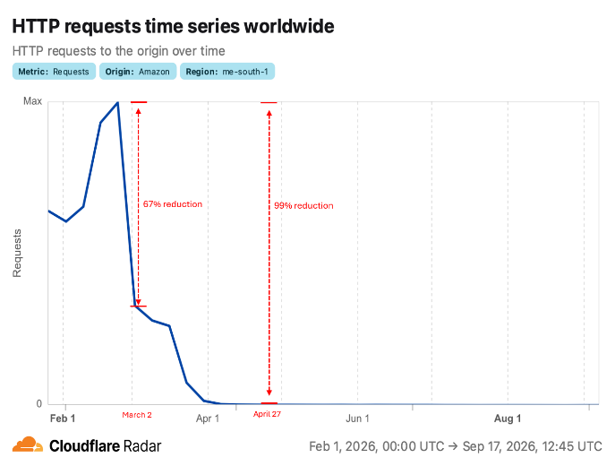
Figure 1: HTTP request volume for ME-CENTRAL-1 (UAE) and ME-SOUTH-1 (Bahrain) AWS Regions. Source: Cloudflare Radar ⁷ ⁸.

2.2 Importance of AWS data centres in the United Arab Emirates and Bahrain for public and private ICT services
The two AWS Regions in Bahrain and the United Arab Emirates represent critical ICT infrastructure for both countries and the wider region. The AWS ME-CENTRAL-1 Region in the United Arab Emirates, established in 2022, and the ME-SOUTH-1 Region in Bahrain, established in 2019, are the only two AWS Regions in the Gulf area; aside from the AWS Region in Israel, they are the only active AWS Regions in the entire Middle East and North Africa.
AWS reported that the two Regions in Bahrain and the United Arab Emirates serve many private customers within each country and worldwide. AWS also highlighted the advantage of three Availability Zones for business continuity and the low latency these Regions offer due to their proximity.
In addition, data centres in these two AWS Regions were seen as a building block for national digital transformation initiatives. Bahrain, in particular, launched a “Cloud First” strategy in 2017, implying that cloud computing is a key enabler for digital transformation and should be preferred over on-premises infrastructure. As a result, 85% of all government data has been transferred to AWS, as of April 2023. By 2025, Bahrain’s Cloud Transformation Program reported that 72 government entities, offering more than 1,385 government services and 570 e-services, have migrated to the cloud.
Furthermore, data sovereignty and protection laws require certain data types to reside within each country’s territory. For example, according to the United Arab Emirates’s Federal Law No. (2) of 2019, it is prohibited to store or process any healthcare data outside the United Arab Emirates. Similarly, the Central Bank of the United Arab Emirates requires licensed financial institutions to ensure consumer and transaction data remain within the United Arab Emirates .
Therefore, data centres hosted in Bahrain and the United Arab Emirates not only help public agencies in these two countries meet local regulations, but also enable other countries in the region to benefit from proximity when regulations allow. For example, Kuwait’s Communication and Information Technology Regulatory Authority (CITRA) Chief Information Technology Sector, highlighted opportunities to utilize public cloud infrastructure with appropriate data classification in an interview with AWS.

2.3 The impact of the attacks on AWS data centres in the United Arab Emirates and Bahrain
While the detailed impact and damage assessment of the AWS data centre attacks in Bahrain and the United Arab Emirates will be covered in the next steps, early signs indicate significant losses across several categories. The first damage category covers digital service disruptions or unavailability that began with the attacks and continued until a migration to a new AWS Region was completed, or business backup plans were executed. For example, Abu Dhabi Commercial Bank (ADCB) stated that it took 48 hours to restore online banking services.
The second damage category stems from the extra cost of migrating and operating digital services across different Regions and cloud providers, including contingent business continuity plans, such as backing up data in different locations.
The third category relates to the Middle East’s long-term ambition as a hub for AI and digital infrastructure. The subsequent unavailability of the ME-SOUTH-1 Region and AWS's confirmation that data hosted exclusively there could not be restored appear to be without precedent in an armed conflict.
As Rice University’s Baker Institute for Public Policy notes, the implications of such attacks go beyond financial damage and extend to investors’ confidence in building and operating data centres in the region. However, because the conflict is still ongoing, the full impact on trust and the region's long-term image will remain unclear.

2.4 March-April 2026: Attacks on Telecommunication Service Providers
Media reports indicated several attacks were launched on telecommunication service providers in the region (e.g. Thuraya Telecom office, du Telecommunications office). As this interim report is based on desk research methodology and due to the lack of publicly accessible details that can be used to validate the attacks and the damage caused, further data and evidence collection will be performed in the next steps of this assessment to evaluate these media reports and evaluate any damage caused by them, as well as any other attack that might have been reported by media outlets.

3 Global navigation satellite systems interference (GNSS)
Over the past several years, harmful interference affecting the radionavigation-satellite service (RNSS), which supports global navigation satellite systems (GNSS), has emerged as a growing concern for the Radio Regulations Board (RRB).
In 2024, the RRB observed a marked increase in reports of harmful interference affecting GNSS receivers across multiple regions. The reported incidents were not limited to isolated disruptions; they increasingly affected critical navigation and timing applications supporting civil aviation, maritime operations, and telecommunications. The RRB repeatedly expressed concern about the use of jamming and spoofing techniques, noting that such practices could undermine the safe and effective functioning of critical infrastructure and safety-of-life services.
In the Middle East, administrations reported interference affecting GNSS receivers used for navigation and safety applications. The RRB encouraged the administrations concerned to investigate the cases, cooperate directly, and take immediate steps to eliminate harmful interference. Through a series of discussions and coordinated actions facilitated by the Radiocommunication Bureau, the administrations involved demonstrated a willingness to cooperate, and by late 2025 the RRB noted positive progress in addressing several of the reported cases.
In addition, publicly available industry assessments and reports highlighted a significant increase in disturbances affecting GNSS signals across the Gulf region. The region was already experiencing elevated levels of GNSS interference before the conflict. For example, in a 2025 survey by the Royal Institute of Navigation, over 80 per cent of mariners who had operated in the Persian Gulf reported experiencing GNSS interference. Similarly, the International Air Transport Association (IATA) identified increased levels of GNSS radio-frequency interference in and around the Gulf region in its 2025 safety risk assessment.
Available monitoring data indicate that interference activity increased further during 2026. Commercial monitoring data indicate that the first quarter of 2026 recorded the highest concentration of maritime GNSS interference events observed to date, with 98 percent of them in the Gulf region. Media reports have also described disruptions affecting GNSS navigation systems, particularly global positioning system (GPS) receivers, used by maritime, aviation and terrestrial users.
The reported disruptions have affected positioning, navigation and timing services used by maritime, aviation and terrestrial users. Increased levels of interference may elevate operational risks for sectors that rely on accurate and reliable GNSS signals, including transportation and telecommunications networks.

3.1 ITU efforts to address the increasing global navigation satellite systems (GNSS) interference
Recognizing the increasing scale and international significance of the problem, the RRB requested the Radiocommunication Bureau to create a public webpage containing information on reported cases, applicable regulatory provisions and RRB’s decisions . The RRB also endorsed continued reporting and coordination efforts, stressing that harmful interference to GNSS signals presents risks not only to national radiocommunication systems but also to international transport, navigation and safety.
By 2026, the RRB continued to receive reports of GNSS jamming and spoofing. While some individual cases had shown signs of improvement through dialogue and operational measures, the RRB concluded that harmful interference to RNSS remained a significant and unresolved issue requiring continued international cooperation. Throughout its deliberations, the RRB consistently emphasized that administrations must work together to investigate incidents, resolve cases of harmful interference promptly and safeguard the integrity of satellite-based navigation systems supporting critical navigation, timing and safety applications.

4 Risks to submarine cables and the Internet backbone
The joint contribution submitted to Council 2026 (now Resolution 1436) by Bahrain, Kuwait, the United Arab Emirates, and Jordan reports direct strikes on a submarine cable landing station in the United Arab Emirates on 31 March and 6 April 2026. While the impact of the attacks on the submarine cable landing station on 31 March and 6 April will be assessed in the next steps of this report, it is crucial to raise awareness of these risks in the region and ensure the protection of the Internet backbone in the region.
Industry assessments indicate that while terrestrial routes exist in the Gulf region, submarine cables represent the main source of international connectivity for the Gulf States.
As indicated by TeleGeography²⁹, “the capacity of terrestrial networks may not be sufficient to handle the complete re-routing of traffic if subsea systems in the Gulf are damaged. Terrestrial networks are not a perfect substitute for subsea systems, and are not immune to damage from hostilities themselves.” In particular, it is noted for Kuwait and Bahrain that “These countries have terrestrial network connections to Saudi Arabia, while Kuwait is also connected to Iraq. These terrestrial routes offer onward connectivity to the rest of the world” ²⁹.
The United Arab Emirates is better equipped to withstand disturbances to submarine cables , with also terrestrial connections to neighboring countries, and several submarine cables landing in Fujairah on the Gulf of Oman. This gives the United Arab Emirates greater resilience if cables are disrupted.
However, according to TeleGeography²⁹, although none of these countries rely entirely on submarine cables for international connectivity, terrestrial networks may lack the capacity to handle a complete rerouting of traffic if subsea cables in the Persian Gulf are damaged.

5 Impact on ITU programmes
As a result of the conflict, the following ITU programmes have been impacted:
- ITU Global Cyberdrill, which was planned to be held in Dubai between 5 and 7 May 2026, was initially postponed and subsequently canceled. The initial decision to postpone the event was directly related to the conflict in the region, as many countries could not participate, including Kuwait and Jordan. Since the conflict is still ongoing, ITU later decided to cancel the event.
- The Regional Development Forum for Arab States (RDF26-ARB), which was planned to be held in Jordan, has been postponed to 2027. The ITU Arab Regional Office postponed the event after consultations with Member States and inviting stakeholders to choose between holding the Forum virtually in 2026 or postponing it to 2027 for an in-person meeting. The decision was to postpone the event to 2027.
- The Arab Regional Policy and Regulatory Dialogue was postponed to 2027 to enable all countries to participate, including the four countries mentioned in this resolution.

6 The next steps of the assessment
The next steps of the assessment are planned to cover the following activities:
- Collect data from primary sources, including interviews with relevant stakeholders in the four countries.
- Analyse the data using qualitative and quantitative methodologies, including potentially applying the Post-Disaster Needs Assessment (PDNA) framework to assess the damage.
- Complete the assessment of the impact on the ITU programmes in Bahrain, Kuwait, the United Arab Emirates, and Jordan.
- Submit a final assessment report to the Council session in 2027.

ITU Council Resolution 1436 | https://www.itu.int/md/S26-CL-C-0130/en
An AWS Region is a geographically distinct cluster of data center facilities. Each Region comprises several Availability Zones, three in each of Bahrain and the UAE, and each Availability Zone consists of one or more physically separate facilities with independent power and connectivity | AWS Global Infrastructure: Regions and Availability Zones | https://aws.amazon.com/about-aws/global-infrastructure/regions_az/
AWS service health update, ME-SOUTH-1 (Bahrain) | https://health.aws.amazon.com/health/status?eventid=arn:aws:health:me-south-1::event/multiple_services/aws_multiple_services_operational_issue/aws_multiple_services_operational_issue_e6426_01ad72b4e1e
AWS service health update, ME-CENTRAL-1 (UAE) | https://health.aws.amazon.com/health/status?eventid=arn:aws:health:me-central-1::event/multiple_services/aws_multiple_services_operational_issue/aws_multiple_services_operational_issue_5e6b8_ef2498889b5
AWS service health update, ME-CENTRAL-1 (UAE) | https://health.aws.amazon.com/health/status?eventid=arn:aws:health:me-central-1::event/multiple_services/aws_multiple_services_operational_issue/aws_multiple_services_operational_issue_5e6b8_ef2498889b5
AWS service health update, ME-SOUTH-1 (Bahrain) | https://health.aws.amazon.com/health/status?eventid=arn:aws:health:me-south-1::event/multiple_services/aws_multiple_services_operational_issue/aws_multiple_services_operational_issue_e6426_01ad72b4e1e
Cloudflare Radar | HTTP requests time series for ME-CENTRAL-1
Cloudflare Radar | HTTP requests time series for ME-SOUTH-1
Nasdaq News: AWS launches region in the UAE | https://www.nasdaq.com/press-release/aws-launches-region-in-the-united-arab-emirates-2022-08-30
Amazon News: AWS launches first Middle East Region | https://press.aboutamazon.com/2019/7/aws-launches-region-in-the-middle-east
Bahrain’s cloud-first success story| AWS | https://aws.amazon.com/blogs/publicsector/bahrains-cloud-first-success-story/
85% of Government Data Transfer to Amazon | Bahrain Information and eGovernment Authority | https://www.iga.gov.bh/en/article/85-of-government-data-transfer-to-amazon-more-than-300-sites-connected-to-the-government-data-network
UAE Federal Law No. (2) of 2019 | https://uaelegislation.gov.ae/en/legislations/1209/download
CBUAE Rulebook, article 6.1.6.3 | https://rulebook.centralbank.ae/en/rulebook/consumer-protection-standards
Interview with Mohammad Altura, Kuwait’s CITRA Chief | AWS Summit Bahrain
ADCB Confirms Restoration of Retail Mobile Banking Services | https://www.adcb.com/en/about-us/media-centre/news/2026/march/adcb-confirms-restoration-of-retail-mobile-banking-services
Dubai banks rack up millions in costs as AWS disruption continues | https://www.thebanker.com/content/fd078db2-7f55-436d-9d2e-62a0a742ad02
What the Iran War Is Costing Joint Gulf-U.S. Ambitions for AI | The Center for Strategic and International Studies (CSIS)| https://www.csis.org/analysis/what-iran-war-costing-joint-gulf-us-ambitions-ai
AWS service health update, ME-SOUTH-1 (Bahrain), September 2026 | https://health.aws.amazon.com/health/status?_sp=d6244f1c-0cb2-498b-b35e-cd0e2a94502e&tag=itechguides04-20
Gulf States Retain Advantages in the AI Race Despite War | https://www.bakerinstitute.org/sites/default/files/2026-04/20260410_Global%20AI%20Race.pdf
Sharjah handles drone attack on "Thuraya" building | Sharjah 24 | https://sharjah24.ae/en/Articles/2026/03/31/a32
Authorities in Fujairah respond to incident targeting 'du' building by drone from Iran| Emirates News Agency (WAM) | https://www.wam.ae/en/article/175otv1-authorities-fujairah-respond-incident-targeting-du
Report Into The Impacts of GNSS Interference on Maritime Safety | Royal Institute of Navigation | https://rin.org.uk/page/RIN_Maritime_Report
Global Navigation Satellite System GNSS Radio Frequency Interference Safety Risk Assessment | IATA | https://ic.iata.org/sites/default/files/iata_sih_document_attachment/IATA%20Safety%20Risk%20Assessment%20-%20GNSS%20Interference%20V5.pdf
GPS Jamming Is Now a Mainstream Maritime Threat: What Changed Between 2025 and 2026 | Windward | https://windward.ai/blog/gps-jamming-is-mainstream-changes-between-2025-and-2026/
GPS Is the New Battlefield: Why Your Maps Aren’t Working | Wired | https://www.wired.me/story/gps-is-the-new-battlefield-why-your-maps-arent-working
Finland – ‘Cellular also impacted by interference’ | The Resilient Navigation & Timing (RNT) Foundation | https://rntfnd.org/2026/04/23/finland-cellular-also-impacted-by-interference/
Harmful Interference to Radio Navigation Satellite Service | ITU | https://www.itu.int/harmful-interference-to-rnss/#102nd-rrb-meeting
Navigating Hostile Waters: Submarine Cable Infrastructure and the Strait of Hormuz | TeleGeography | https://resources.telegeography.com/submarine-cable-infrastructure-strait-hormuz
ITU Global Cyberdril ; Cancelled| https://www.itu.int/en/ITU-D/Cybersecurity/Pages/CyberDrill-2026/GlobalCyberDrill-26.aspx
Regional Development Forum for Arab States (RDF26-ARB) – Postponement to 2027 | https://www.itu.int/dms_pub/itu-d/md/26/dm/cir/D26-DM-CIR-0027!!PDF-E.pdf
ITU Events in 2026 | https://www.itu.int/en/ITU-D/Regional-Presence/ArabStates/Pages/events.aspx
Post-Disaster Needs Assessment | UNDP | https://www.undp.org/publications/post-disaster-needs-assessment

